**ATLAS JUNIOR SCHOOL – LUGOBA NABWERU**

**MID TERM TWO ASSESSMENT 2024**

**SUBJECT : ENGLISH**

**AGE GROUP : 5 – 6 YEARS (TOP CLASS)**

**MY NAME IS : ___________________________________________**

**MY SCHOOL IS : __________________________________________**

1. **Name these things.**

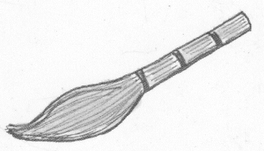

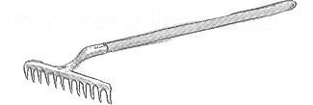

**________ _______**

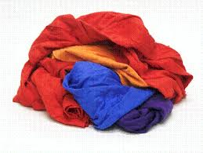

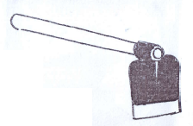

__________ _________

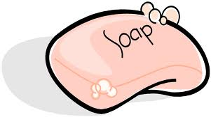

**________**

1. **Read and draw good pictures.**

|  |  |  |  |  |
| --- | --- | --- | --- | --- |
|  |  |  |  |  |
| plants | hills | birds | stones | insects |

1. **Match correctly.**

slashing

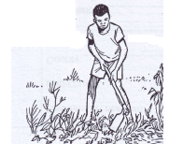

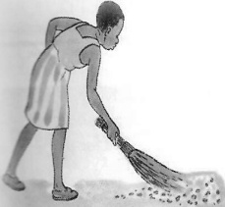dusting

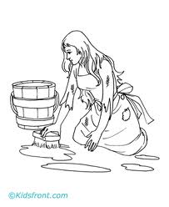digging

D:\JULIANA\juliana\BACKUP\lower pictures 1\My scans\My Scans 043.tifsweeping

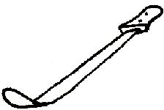mopping

1. **Write in plural.**

**one many**

kite kites

stick ________

bird _________

star _________

balloon __________

bee ___________

1. 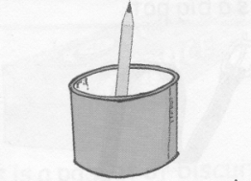**Fill in over , in , on , under, near , in the given spaces.**

The pencil is _________the tin.

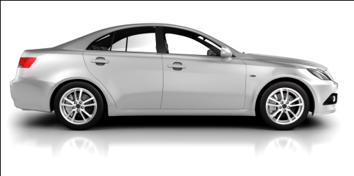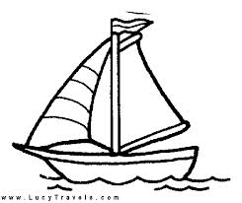 The boat is sailing _______the water.

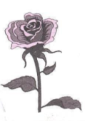

The flower is ______the car.

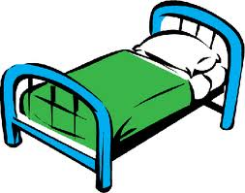

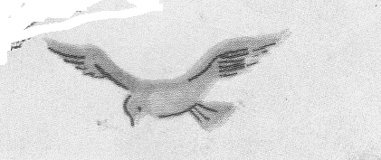The ruler is ____________the bed.

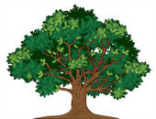The bird is flying ________the tree

1. **Make good sentences using ;**

Here is ……....

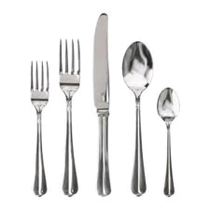

Here is a spoon.

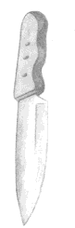

 ______________________________­­­­­­­­________

___________________________________

pillar examination 007

_____________________________________

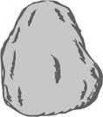

___________________________________

_________________________­­___________

1. **Write words in small letters.**

MOSQUE mosque

SCHOOL ___________

BANK ___________

HOSPITAL ___________

SHOP ___________

MARKET ____________

1. **Fill in the missing letters.**

a, b, ___, ____, e , f , ___ , ___ , i , j, ___ , ___ m , n , ___ , ___q , r , ____ ____ u , v , ____ , x , _____ z

1. **Write words correctly.**

kesna __________

tra _________

oatg________

itrabb _______

cwo ________

1. **Complete these sentences.**

A dog barks ____________________________

A cat mews ____________________________

A pig grunts ____________________________

A snake hisses __________________________

A baby cries ____________________________

***Success***