**TWALIBAH ISLAMIC PRIMARY SCHOOL**

**PLE-MOCK EXAMINATION 2019**

**PRIMARY SEVEN**

**SOCIAL STUDIES AND RELIGIOUS EDUCATION**

***Time allowed: 2 hours 15 minutes***

**Index No.**

**Candidate’s Name: _____________________________________________________**

**Candidate’s Signature: __________________________________________________**

**School Name: _________________________________________________________**

**Read the following instructions carefully:**

1. The paper has **two** sections: **A** and **B**
2. Section **A** has 40 questions (40 marks)
3. Section **B** has 15 questions (60 marks)
4. Answer **ALL** questions. All answers to both Sections A

and B must be written in the spaces provided.

1. All answers must be written using a blue or black ball

point pen or ink. Diagrams should be drawn in pencil.

1. Unnecessary crossing of work may lead to loss of marks.
2. Any handwriting that cannot be easily read may lead to

loss of marks.

1. Do **not** fill anything in the boxes indicated;

For Examiner’s use only.

***Turn over***

**SECTION A**

1. Give one basic need of man?

_______________________________________________________________

1. On which river are Victoria Falls located?

_______________________________________________________________

1. Why is mechanized farming commonly practiced in central Uganda?

_______________________________________________________________

1. Who was the Ugandan founder of the first East African Community?

_______________________________________________________________

1. Give any one way how your family is important to you.

_______________________________________________________________

1. Which Ministry is responsible for refugee problems in Uganda?

_______________________________________________________________

1. Give a reason why some parts of river Nile are navigable.

_______________________________________________________________

1. Write ECOMOG in full.

______________________________________________________________________________________________________________________________

1. How are polythene bags / papers a danger to our environment?

______________________________________________________________________________________________________________________________

1. What type of trade replaced barter trade?

_______________________________________________________________

1. How is Uganda trying to promote peace in its neighbouring countries?

_______________________________________________________________

1. How does the government of Uganda gain from foreign tourists?

_______________________________________________________________

1. Which was the first European Country to get a colony in Africa?

_______________________________________________________________

1. Why was Mt. Rwenzori referred to as the “Mountains of the moon”?

______________________________________________________________________________________________________________________________

1. Suggest any one way the government of Uganda can improve on its labour force.

______________________________________________________________________________________________________________________________

1. Give any one reason why the colonial government introduced taxes.

______________________________________________________________________________________________________________________________

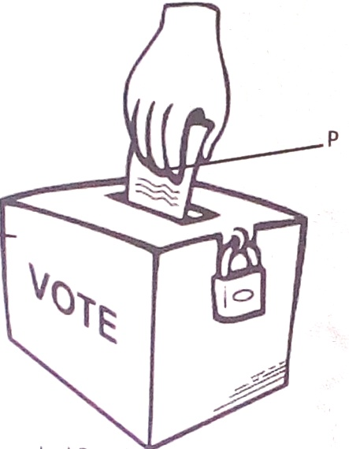

1. **Name the voting item marked with letter P.**

**________________________________________________________________________________**

1. Give any one danger of land fragmentation.

_______________________________________________________________

1. How did L. Victoria contribute to the rise and expansion of Buganda Kingdom?

______________________________________________________________________________________________________________________________

1. How does the climate in the Sahara desert influence people’s ways of dressing?

______________________________________________________________________________________________________________________________

1. Give one factor that qualifies Uganda to be a member of the East African Community?

_______________________________________________________________

1. How did Slave trade affect food production in E. Africa?

_______________________________________________________________

1. State the importance of having one local language in East Africa.

_______________________________________________________________

1. Give any one advantage of good feeder roads.

______________________________________________________________________________________________________________________________

1. How is a Post office useful to a community?

_______________________________________________________________

1. How did Captain F.D Lugard solve the problem of religious wars in Uganda?

______________________________________________________________________________________________________________________________

1. Why do some people fail to meet their needs?

_______________________________________________________________

1. Name any one man-made cause of environmental degradation.

_______________________________________________________________

1. Give any one way in which climate influences economic activities.

______________________________________________________________________________________________________________________________

1. Identify any one social activity that unites people in a community.

_______________________________________________________________

1. State one factor that led to the building of a factory at Hima.

_______________________________________________________________

1. Why is the government of Uganda encouraging people to grow non-traditional cash crops?

______________________________________________________________________________________________________________________________

1. Why is the equatorial Climate described as hot and wet?

________________________________________________________________

1. Who was the founder of Bunyoro-Kitara Kingdom?

_______________________________________________________________

1. Mention any one product got from natural forests.

_______________________________________________________________

**For questions 36-40, answer Christianity or Islamic questions but NOT both in a number.**

1. **Either**: Why did the three wise men give gifts to baby Jesus?

____________________________________________________________

**Or:** Why did early Muslims face Jerusalem while praying?

**______________________________________________________**

1. **Either:** Why do Christians work?

**______________________________________________________**

**Or**: Why do Muslims work?

**______________________________________________________**

1. **Eithe**r: Why do Christians take the Bible to be a holy book?

____________________________________________________________

**Or**: Why do Muslims take the Quran to be a holy book?

**______________________________________________________**

1. **Either**: Who was the first disciple to be called by Jesus?

**______________________________________________________**

**Or:** Who was the first person to convert to Islam

____________________________________________________________

1. **Either**: Who was the last prophet according to the Bible?

_____________________________________________________________

**Or**: Who was the last Prophet according to the Quran?

_____________________________________________________________

**SECTION B (60 MARKS)**

1. a) What title is given to the highest elected leader in a district local council?

___________________________________________________________

b) Identify any two duties of Local Councils?

1. ___________________________________________________________
2. ___________________________________________________________

c) Give any one duty of a sub-county Chief.

___________________________________________________________

1. a) How is Uganda’s fish for export preserved?

____________________________________________________________

b) How does fish poisoning affect Uganda’s fish exports?

____________________________________________________________

c) Give any two problems that fish face in Uganda’s lakes.

1. ___________________________________________________________
2. ___________________________________________________________
3. a) State the difference between internal trade and bilateral trade.

____________________________________________________________

____________________________________________________________

b) Give any two problems facing traders in Uganda.

i) ____________________________________________________________

ii) ___________________________________________________________

c) How has the government of Uganda tried to solve any of the given

problems (in 43.b)

____________________________________________________________

1. a) Name the agreement which introduced hut and gun tax.

____________________________________________________________

b) Which group of people were supposed to pay each of these taxes?

i) Hut tax : ____________________________________________________

ii) Gun tax. ____________________________________________________

c) How did the Agreement named in (a) above affect Toro Kingdom?

____________________________________________________________

____________________________________________________________

1. a) Which National game park in Uganda is famous for zebras?

___________________________________________________________

b) Identify any two problems faced by people living near National Game Parks.

i) ___________________________________________________________

ii) ___________________________________________________________

1. How can tourism be a disadvantage to a country’s security?

____________________________________________________________

1. 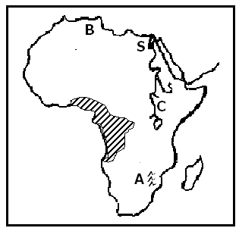*Use the map of Africa below to answer the questions that follow.*

1. **Name the city marked S.**

**__________________________________________________________**

1. **Name mountain ranges marked A.**

**_________________________________________________________**

**c) Why does river marked C flow northwards?**

**___________________________________________________________**

**___________________________________________________________**

**d) Why are forests in area shaded ever green?**

**_____________________________________________________**

1. *Sudan is one country in Africa that largely depends on irrigation farming.*
2. State any two advantages of growing crops by irrigation.
3. ___________________________________________________________
4. ___________________________________________________________
5. Mention any two problems faced by farmers on the Gezira Irrigation

Scheme.

i) ___________________________________________________________

ii) ___________________________________________________________

1. a) Give one reason why government provides social services to its people.

____________________________________________________________

____________________________________________________________

1. Mention any two problems government faces as it provides social services

to its people.

i) ____________________________________________________________

ii) ____________________________________________________________

1. What does the word development mean?

___________________________________________________________

___________________________________________________________

1. a) How did Rwanda join the Common Wealth yet it was not colonized by

Britain?

____________________________________________________________

____________________________________________________________

b) Why were each of these countries at one time suspended from the

Common Wealth?

1. South Africa: ________________________________________________

___________________________________________________________

1. Nigeria : ____________________________________________________

__________________________________________________________

c) How does Uganda benefit from the activities of the Common Wealth?

___________________________________________________________

___________________________________________________________

1. ***Study the picture below and use it to answer question 50*.**

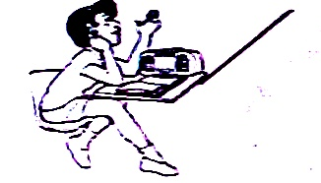

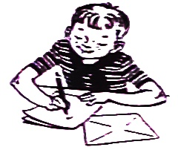

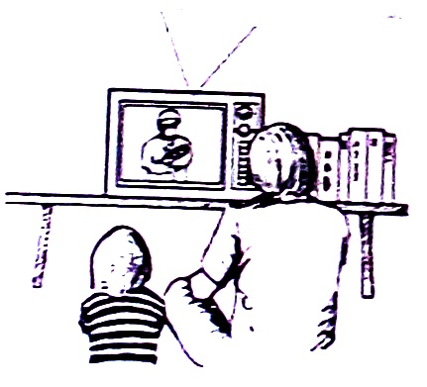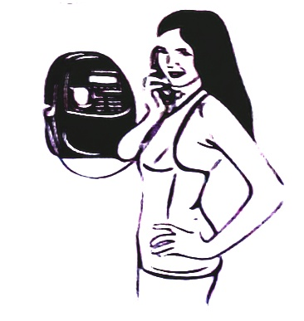

a) Which means of communication is shown in picture,

1. **A** _____________________________________________________
2. **C**  _____________________________________________________

b) Why is communication means in picture **D** commonly used by most people

in Uganda today?

___________________________________________________________

___________________________________________________________

c) Give one disadvantage of the government would face if it uses

communication means **C** when sending information to its citizens.

__________________________________________________________

__________________________________________________________

**For questions 51 to 55, answer either Christianity or Islamic but not both**.

1. **Either:**

a) What is the first sacrament according to Christianity?

___________________________________________________________

b) Mention the symbol for the mentioned Sacrament (in 51. a)

___________________________________________________________

c) State two benefits of the sacrament mentioned in (51. a)

1. ___________________________________________________________
2. ___________________________________________________________

**Or:**

a) What is the second pillar in Islam?

___________________________________________________________

b) Give any two ways Muslim believers benefit from this pillar.

1. __________________________________________________________

ii) __________________________________________________________

c) How do believers prepare for this pillar?

__________________________________________________________

1. **Either**:

a) Name the Prophet who survived floods.

__________________________________________________________

b) Why did God send floods?

__________________________________________________________

c) Why did the named Prophet (in 52. a) survive the floods?

__________________________________________________________

1. How many people survived the floods?

__________________________________________________________

**Or**:

a) Name the Prophet who survived floods.

____________________________________________________________

b) Why did Allah send floods?

___________________________________________________________

c) Why did the named Prophet in (52.a) survive the floods?

____________________________________________________________

1. How many people survived the floods?

____________________________________________________________

1. **Either:**

a) Why did God give Commandments to the Israelites?

____________________________________________________________

b) Mention two greatest commandments of God as taught by Jesus Christ.

1. ____________________________________________________________

ii) ___________________________________________________________

c) What was the last commandment that Jesus gave to his disciples?

___________________________________________________________

**Or:**

a) Give any two ways a Muslim should keep the Qur’an.

i) ___________________________________________________________

ii) ___________________________________________________________

b) Mention any two kinds of people who should not touch the Qur’an.

i) ___________________________________________________________

ii) ___________________________________________________________

1. **Either**:

a) Who led the Israelites across R. Jordan?

__________________________________________________________

b) Why was it necessary for Moses to rescue the Israelites?

___________________________________________________________

1. Why were the Israelites’ baby boys being killed by the authorities in

Egypt?

__________________________________________________________

__________________________________________________________

d) Where in Egypt were the Israelites staying?

__________________________________________________________

**Or**:

1. Who led the Banu - Israelites across the Red Sea?

__________________________________________________________

b) Why was it necessary for Musa to rescue the Israelites?

__________________________________________________________

c) Why were the Israelites’ baby boys being killed by the authorities in

Egypt?

__________________________________________________________

d) Where in Egypt were the Israelites staying?

__________________________________________________________

**FOR BOTH**.

1. Name the Prophet in Islam / Christianity remembered for;
2. Deliverance: ______________________________________________
3. Great rule of wisdom: ______________________________________
4. Endurance and Perseverance: ________________________________
5. Seal of Prophets: __________________________________________

**GOOD LUCK**