MEVID EXAMINATIONS BOARD

**PRE – PLE SPOT ON SET THREE 2023**

MATHEMATICS

***Time Allowed: 2 hours 30 minutes***

|  |  |  |  |  |  |  |  |  |
| --- | --- | --- | --- | --- | --- | --- | --- | --- |
| ***Random No.*** | | | | | | ***Personal No.*** | | |
|  |  |  |  |  |  |  |  |  |

**Candidate’s Name**………………………………………………………………………

**Candidate’s signature:**…………………………..…………………………………….

**READ THE FOLLOWING INSTRUCTIONS CAREFULLY:**

**FOR EXAMINER’S USEONLY**

|  |  |  |
| --- | --- | --- |
| **Qn. No** | **MARK** | **EXR’S NO.** |
| **Page 2** |  |  |
| **Page 3** |  |  |
| **Page 4** |  |  |
| **Page 5** |  |  |
| **Page 6** |  |  |
| **Page 7** |  |  |
| **Page 8** |  |  |
| **Page 9** |  |  |
| **Page 10** |  |  |
| **Page 11** |  |  |
| **Page 12** |  |  |
| **TOTAL** |  |  |

1. This paper has two sections: **A** and **B**.

Section **A** has **20** questions and section **B** has

**12** questions.

2. Answer **all** questions. **All** answers to both

sections **A** and **B** must be written in the

spaces provided.

3. All answers **must** be written using a **blue** or **black**

ball point pen or ink. Any work written in pencil

will **not** be marked.

4. Unnecessary **changes** in your work and handwriting

that cannot be easily read may lead to **loss of marks.**

5. Do not fill anything in the table indicated:

**ʺfor examiner’s use only˝** and boxes

inside the question paper.

**SECTION A (40 marks)**

1. Divide 10 $÷$ 5
2. Write the unshaded fraction.

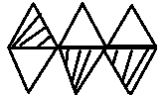

#

1. Given that 3 + 4 = y (finite 6), find the value of y.
2. Write the morning time shown on the clock below.

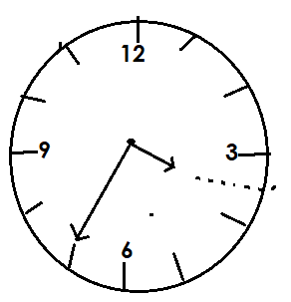

1. The bearing of the hospital from the church is 125 $°$. Draw a sketch diagram showing the location of the two places and indicate 125 $°$.
2. A farmer fenced his circular garden by placing poles at intervals of 120cm. How many poles did he use if the circumference of the garden is 9.6 metres?
3. 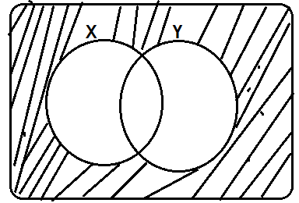Describe the shaded part below.
4. Convert 202**three** to the decimal base.
5. Solve the inequality; 3p – 4 ≤ 8 +p
6. Without diving show that 837 is exactly divisible by 9.
7. A water meter reading in a certain home raised from 384754 to 384815. How many units of water were used in this home?
8. Find the mean of m – 3, 4m, 2m +14 and m+5.
9. Round off 709 to the nearest tens.
10. Given that 3p x 3 x 1 = 35, find the value of p.
11. 3 men can clear a piece of land in 10 days. How many more men are needed to clear this land in 6days?
12. 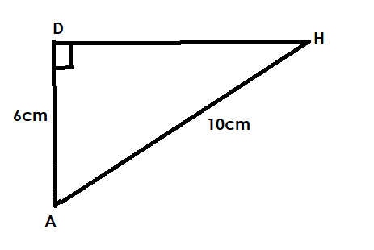On the figure below find the length DH.
13. 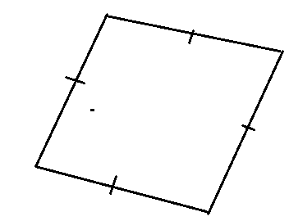How many lines of folding symmetry does the figure below have?
14. A motorist covered a distance of 108km in 3hours. Calculate his speed in m/sec.
15. Write the number whose scientific rotation is 3.43 x 105
16. Today is Thursday, what day of the week was it 89days ago?

**SECTION B (60 MARKS)**

1. Three ladies Mariam, Teddy and Joan contributed money to start a business in the ration of 3:5:6 respectively. Given that Teddy and Joan both contributed sh. 550,000, how much money did Mariam contribute? **(3marks)**

b. Express Mariam’s contribution as a percentage of Teddy’s contribution.

**(2marks)**

1. On a village wedding, 40 guests ate rice (R), 2y – 7 ate matoke (M) only, y – 4 ate none of the two foods while the number of guests who ate both matoke and rice is a half the guests who ate rice.
2. Use the above information to complete the Venn diagram below. **(2marks)**

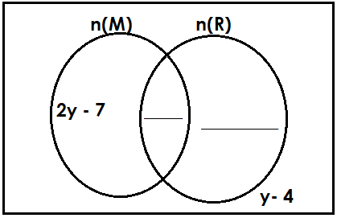

b) Given that 23 guests did not eat

Matoke, find the value of y. **(2 marks)**

c) How many guests attended the party? **(1mark)**

1. The table below shows the rate at which different currencies are bought and sold at a certain forex bureau during the month of August.

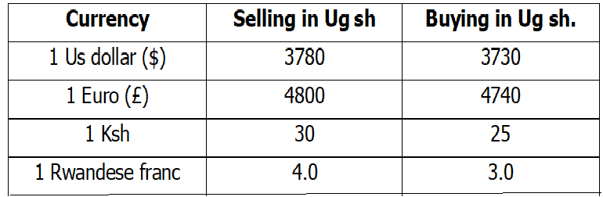Use it to answer the questions that follow.

1. Gashumba returned from Rwanda with 250,000 Rwanda francs, how much in Uganda shillings did he get? **(2 marks)**
2. A tourist from Europe came with 420 Euro and exchanged it into Kenya shillings. How much money did he get? **(3 marks)**
3. 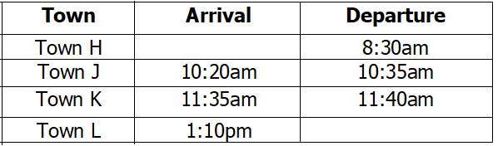The table below shows the distances covered by Link bus from town H to L. through town J and K. study it carefully and answer the questions about it.
4. How long did the bus take to move from Town H to Town J? **(2marks)**
5. If the distance between town K and L is 120km, calculate the speed the motorist used to cover that distance. **(3marks)**

c) Write the time the bus left town H in 24 hour clock system. **(1 mark)**

1. (a). Write 469 in Roman numerals. **(2marks)**

b). Angella had CCLIV eggs, 140 got broken on her way home. How many eggs remained? (Give your answer in Roman Numerals)

**(3 marks)**

1. Joel in 3 times as old as Moen. In 10 years time, the ratio of Moen’s to Joel’s age will be 5:11. How old is Moen now? **(3marks)**

b. How old will Joel be then? **(2marks)**

1. The diagram below shows tanks of water. Tank A is filled with water. ($π=\frac{22}{7}$)

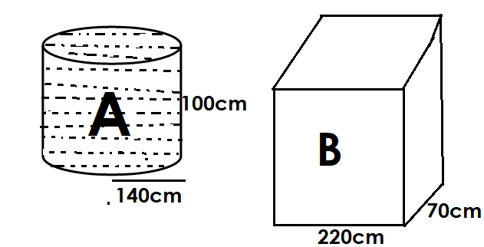

If the water in tank A is poured in tank B, calculate the height the water will take in container B. **(4 marks)**

1. Using a ruler, a pencil and a pair of compass only, construct a quadrilateral LMNO, where LN= 6.5cm and MO= 8.5cm. **(4marks)**

b. Measure length MN. **(1mark)**

1. The pie chart below shows how different animals are distributed in Mana’s farm.

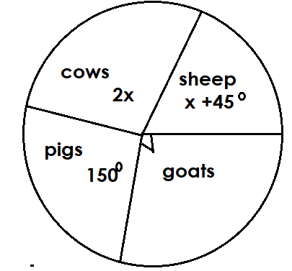

a) Find the value of x **(2 marks)**

b) If there are 50 more pigs than cows on the farm, how many goats are on the farm? **(3marks)**

c) Express the number of pigs as a fraction of the total number of animals. **(1mark)**

1. The area of a square game board is 256cm2.
2. The board is divided into smaller square boxes. Calculate the area of each square box. **(4marks)**

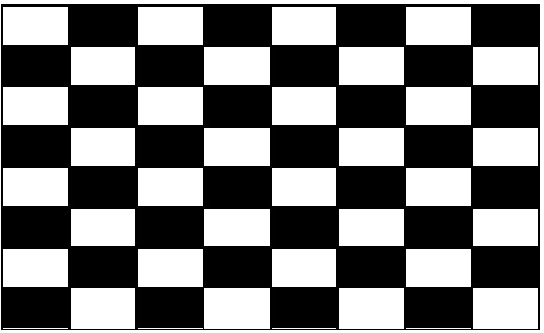

1. What is the total area covered by shaded squares only. **(2marks)**
2. 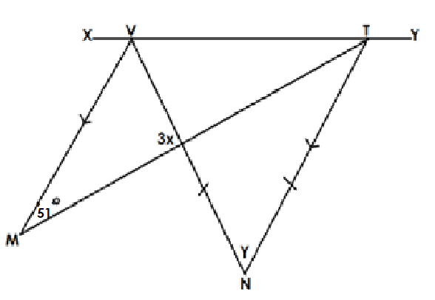In the figure below, XVTY is a straight line. Line MT bisects angle VTN. Line MV is parallel to NT. NTV is an isosceles triangle. Angle VMT is 51 $°$.

a) Find the size of the angle marked y.(3 marks)

b) Calculate the size of the angle marked 3x. **(2marks)**

1. Study the diagram below and calculate its area. (Take $π=\frac{22}{7}$)

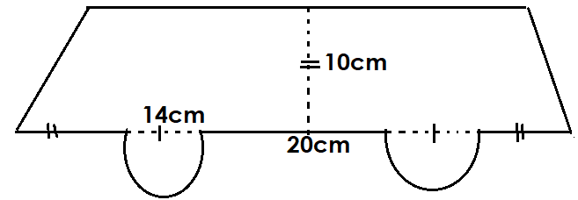 **(4 marks)**