**NEW JERUSALEM MIXED DAY AND BOARDING LEARNER’S SCHOOL-BULAMU KASANGATI**

**END OF TERM III ASSESSMENT 2023**

**TOP CLASS ENGLISH**

**Name ________________________________________________________**

**INSTRUCTIONS**

1. **Write well.**
2. **Avoid unnecessary crossing of your work.**
3. **Wrong spellings will lead to loss of marks.**
4. What is a noun?

____________________________________________________________

1. Write five words of common nouns.

(i)________________

(ii)________________

(iii)________________

(iv)________________

(v)________________

1. Use article “an” or”a” to fill in the sentences.

Here is _____________book.

That is _____________orange.

It is ____________cow.

Please help me with ___________ apple.

I can see ____________king.

Here is _____________envelop.

1. Write four words which start with consonant letters.

Book

(i)________________

(ii)________________

(iii)________________

(iv)________________

1. Change letters from capital to small letters.

A a .

B__________

E__________

Y__________

M__________

L___________

1. Read and draw pictures for the words.

|  |  |  |
| --- | --- | --- |
| Broom | Chair | Chalkboard |
|  |  |  |
| table | Pencil | Ruler |
|  |  |  |

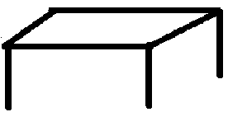

1. Use preposition “in”, “on”, “between” and “under” to fill in the sentences.

The girl is sitting____________ the mat. 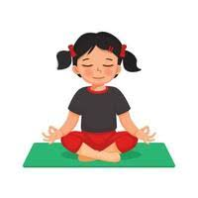



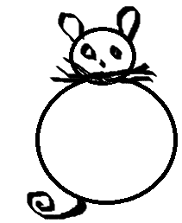The cat is ____________ the table.

The milk is ___________ the glass. 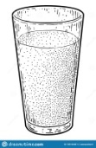

The boy is ___________ the girls. 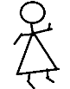 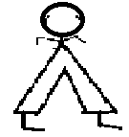 

1. Read words and draw pictures.

cup _____________

book ____________

hen_____________

goat____________

1. Use Yes, it is… or No, it is ….… to answer the questions.

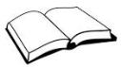Is this a girl?

____________________________________________________________

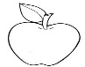 Is this an apple?

____________________________________________________________

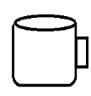 Is this a plate?

____________________________________________________________

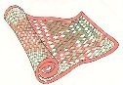 Is this a mat?

____________________________________________________________

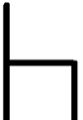 Is this a book?

____________________________________________________________

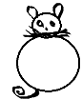 Is this a bucket?

____________________________________________________________

1. Read the dialogue and answer them correctly.

**Teacher:** Good morning my friend?

**Child:**___________________________________________

**Teacher:** What is your name?

**Child:**___________________________________________

**Teacher:** In which class are you?

**Child:**___________________________________________

**Teacher:** What is the name of your teacher?

**Child:**___________________________________________

**Teacher:** Thank you my friend.

**Child:** Your welcome.

1. Write the plural form of the following;

**Singular(one) Plural (more than one)**

goat __________________

ball __________________

dog __________________

cat __________________

tree __________________

book __________________

boy __________________

1. Read the picture composition and answer the questions correctly.

**Maria Aiden**

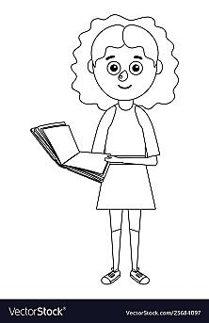 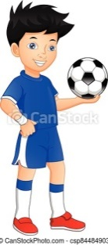

**Peace Tyron**

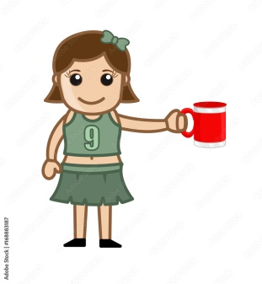 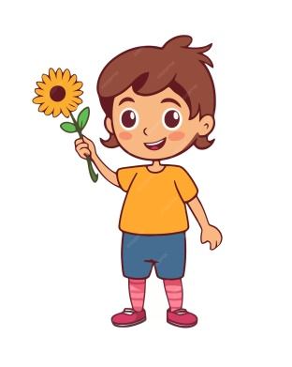

**Questions**

1. Who has ball?

__________________________________________________________

1. Who has a flower?

__________________________________________________________

1. Who has a cup?

__________________________________________________________

1. Who has a book?

__________________________________________________________

_____END_____