**NEW JERUSALEM MIXED DAY AND BOARDING LEARNER’S SCHOOL-BULAMU KASANGATI**

**END OF YEAR ASSESSMENT 2023**

**BABY CLASS ENGLISH**

**Name:________________________________________________________**

1. **Copy again.**

|  |  |
| --- | --- |
|  |  |
|  |  |
|  |  |
|  |  |

1. **Copy again.**

|  |  |  |  |  |
| --- | --- | --- | --- | --- |
| o | a | e | u | i |
| o | ____ | ____ | ____ | ____ |

1. 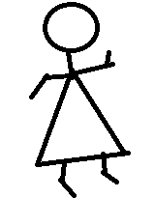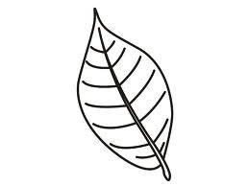**Ring the different pictures.**

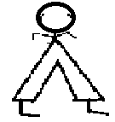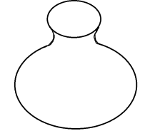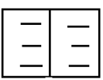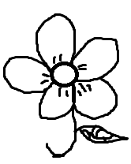



1. **Match and draw again.**



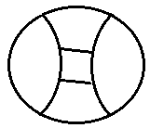













1. 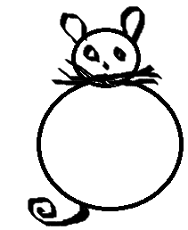**Name the picture.**

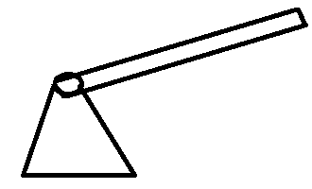

___________ ___________ ___________

**(axe, cat, cup)**

1. **Circle the big one.**

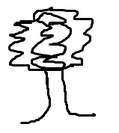



1. ******Circle the word for the picture.**

ant

axe



cat

dogg

fish

box



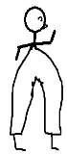

man

mat

cat

cup

pot

box