**NEW JERUSALEM MIXED DAY AND BOARDING LEARNER’S SCHOOL-BULAMU KASANGATI**

**END OF TERM III ASSESSMENT 2023**

**TOP CLASS SOCIAL DEVELOPMENT**

**Name ____________________________________________**

**INSTRUCTIONS**

1. **Write well.**
2. **Avoid unnecessary crossing of your work.**
3. **Wrong spellings will lead to loss of marks.**
4. What are domestic animals?

__________________________________________________________________________________________________________________________

1. Write six examples of domestic animals.

(i)_____________________

(ii)_____________________

(iii)_____________________

(vi)_____________________

(v)_____________________

(vi)_____________________

1. Match animals and their young ones.

cow piglet

goat kitten

sheep calf

dog kid

cat lamb

pig puppy

1. What is the motto of your school?

_____________________________________________________________

1. Name the road signs

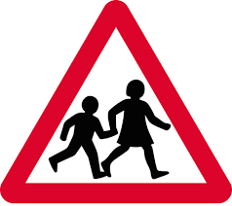

____________ ______________

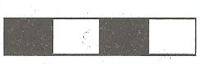

____________ _______________

1. Write four types of transport.

(i)_____________________

(ii)_____________________

(iii)_____________________

(iv)_____________________

1. Draw a boat as a means of water transport.
2. Colour and name the traffic lights.

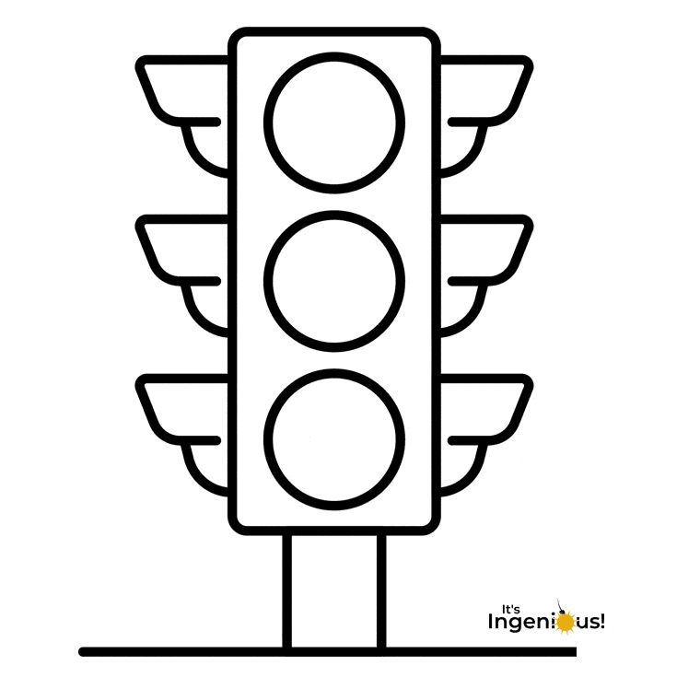

red

green

orange

1. Write the meaning of each colour.

Red means _________________

Orange means _______________

Green means ________________

1. Write four things found in class.

(i)_____________________

(ii)_____________________

(iii)_____________________

(vi)_____________________

1. What is the mission of your school?

____________________________________________________________

1. What is the name of your school?

____________________________________________________________

1. What is the name of your class teacher?

____________________________________________________________

1. Give four examples of wild animals.

(i)_____________________

(ii)_____________________

(iii)_____________________

(vi)_____________________

1. Write three members found at home.

(i)_____________________

(ii)_____________________

(iii)_____________________

1. Fill in the missing letters

sch___ol

b___nk

ch___rch

h___spital

1. Write four important people in the community.

(i)_____________________

(ii)_____________________

iii)______________________

iv)______________________

1. Colour the cow eating grass.

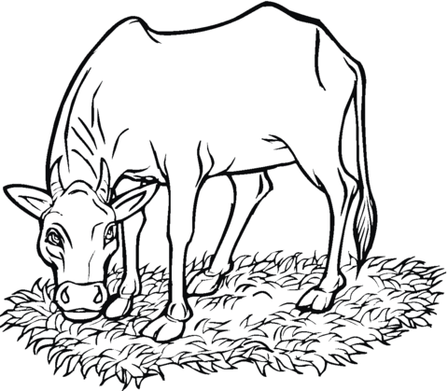

___END____

****I WISH YOU SUCCESS****