NAME: ........................................................................................................................................

SCHOOL: ………………………..……………… CLASS: ………………. STREAM: ………...

112/1

**ENGLISH PAPER**

(Comprehension & Grammar)

TIME: 1 HOUR 40 MINS)

INSTRUCTIONS TO CANDIDATES

* Write your name and stream in the spaces provided.
* All your answers must be written in the spaces provided in this question paper.

**FOR EXAMINER’S USE ONLY**

|  |  |  |
| --- | --- | --- |
| Question | Maximum Score | Candidate’s Score |
| 1 |  |  |
| 2 |  |  |
| 3 |  |  |
| **TOTAL SCORE** |  |  |

1. Read the following passage and answer the questions that follow.

In Uganda, most schools in the primary and secondary levels have a uniform dress. Due to the similarities in the colour of the uniforms, many schools go further to design a badge with an accompanying logo or motto that they identifying themselves with “The school uniform act as an identification of students belonging to a particular school. It enhances neatness but above all, it creates uniformity. ‘’among the student’s community’’, says Andrew kirabira, a professional teacher.

In the more affluent schools, the students must have more than two sets of uniforms. A set of games of uniform has to be provided as well. Having more than one uniform on the other hand, enables the students to have time to wash the dirty set before the end of the week.

According to an education officer in wakiso who preferred anonymity, schools especially those that target the well -to-do, use expensive ad well -designed uniforms as a form of identity ‘’To the student, parents and the general public, certain uniforms are regarded as a sign of class’’. He said uniforms are a sign of orderliness, inspiring confidence in the student as well as the parent in the school. Likewise, the good schools have corresponding smartly dressed teachers who are clean and exemplary to the students they teach.

However, in rural areas, the parents can hardly afford the payment of school fee. Let alone school uniform. In addition to the fees, the parents cannot buy text books and other school requirements. In such situations, the children attend school without uniforms. A few may be able to attend dressed in the stipulated uniform. The majority can only manage to attend wearing second second hand clothes. To school. During the physical education lessons, the rural pupils remove their shirts and girls remain in panties, to avoid soiling uniforms.

School uniforms have also been used to motive students to work harder. In some schools, prefects wear different colours or fashions of uniform. This motivates children to aspire for such posts.

In some school’s students wear different uniforms at ‘’O’’ and ‘’A’’ Levels. This encourages the students to work extra hard at lower levels to be re-admitted to these schools for their ‘‘A’’ Level.

In many boys’ schools, trousers are worn by prefects and ‘‘A’’ Level students. All the other boys wear shorts. This also, motivates boys to work harder to get to such levels where they will wear trousers at school.

QUESTIONS.

In not more than 120 words, summarise the importance of school uniforms.

ROUGH COPY

…………………………………………………………………………………………………………………………………………………………………………………………………………………………………………………………………………………………………………………………………………………………………………………………………………………………………………………………………………………………………………………………………………………………………………………………………………………………………………………………………………………………………………………………………………………………………………………………………………………………………………………………………………………………………………………………………………………………………………………………………………………………………………………………………………………………………………………………………………………………………………………………………………………………………………………………………………………hi………………………………………………………………………………

FAIR COPY

……………………………………………………………………………………………………………………………………………………………………………………………………………………………………………………………………………………………………………………………………………………………………………………………………………………………………………………………………………………………………………………………………………………………………………………………………………………………………………………………………………………………………………………………………………………………………………………………………………………………………………………………………………………………………………………………………………………………………………………………………………………………………………………………………………………………………………………………………………………………………………………………………………………………………………………………………………………………………………………………………………………………………………………………………………………………………………….

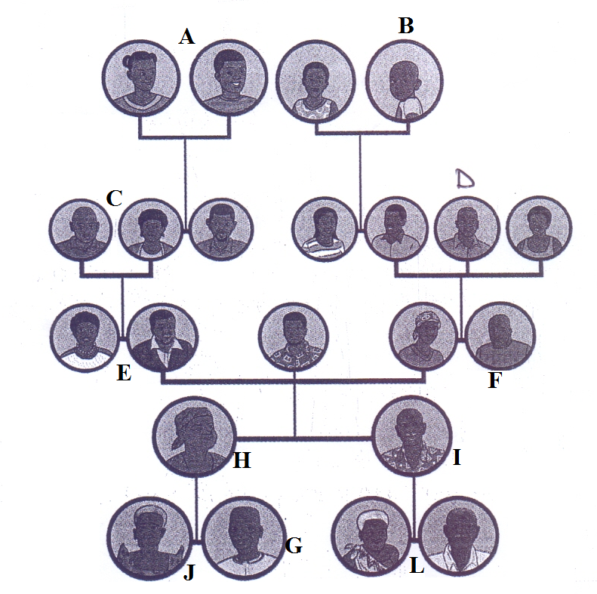**SECTION B: NON CONTINOUS COMPREHENSION**

**Questions**

1. What kind of family is the above picture? Give reasons for your answer  
   ………………………………………………………………………………………………………………………………………..………………………………………………………………………………………………
2. Describe the following relations
3. G and D

………………………………………………………………………………………………………………………………………..………………………………………………………………………………………………………………………………………..…………………………………………………………………………

1. J and L

………………………………………………………………………………………………………………………………………..………………………………………………………………………………………………………………………………………..…………………………………………………………………………

1. L, J and A

………………………………………………………………………………………………………………………………………..………………………………………………………………………………………………………………………………………..…………………………………………………………………………

1. H and C

………………………………………………………………………………………………………………………………………..………………………………………………………………………………………………………………………………………..…………………………………………………………………………

1. Describe the challenges that such a family setting could face.

………………………………………………………………………………………………………………………………………..…………………………………………………………………………………………………………………………………..………………………………………………………………………………………………………………………………………..…………………………………………………………………………………………………

1. At which point in the family tree would you place yourself? Give reasons for your answer.

………………………………………………………………………………………………………………………………………..…………………………………………………………………………………………………………………………………..……………………………………………………………………………………………………………

1. What makes problem-solving in the above family setting easy or difficult? Give reasons for your views.

………………………………………………………………………………………………………………………………………..…………………………………………………………………………………………………………………………………..……………………………………………………………………………………………………………………………………………………………………………………………………………………………………………………………………..…………………………………………………………………………………………………………………………………..……………………………………………………………………………………………

1. **Fill in the blank spaces below with the correct form of the verb in brackets (3mks)**
2. The team was __________________ for coming late (qualify)
3. They were ____________ attacked by the gangsters (vicious)
4. The ___________________ of the matter brought the president to their county. (grave)
5. **Use the correct collective nouns in the foll**

………………………………………………………………………………………………………………………………………..………………………………………………………………………………………………………………………………………..………………………………………………………………………………………………………………………………………..………………………………………………………………………………………………………………………………………..………………………………………………………………………………………………………………………………………..………………………………………………………………………………………………………………………………………..………………………………………………………………………………………………………………………………………..………………………………………………………………………………………………………………………………………..………………………………………………………………………………………………………………………………………..………………………………………………………………………………………………………………………………………..………………………………………………………………………………………………………………………………………..………………………………………………………………………………………………………………………………………..………………………………………………………………………………………………………………………………………..………………………………………………………………………………………………………………………………………..………………………………………………………………………………………………………………………………………..………………………………………………………………………………………………………………………………………..………………………………………………………………………………………………………………………………………..………………………………………………………………………………………………………………………………………..………………………………………………………………………………………………………………………………………..………………………………………………………………………………………………………………………………………..………………………………………………………………………………………………………………………………………..………………………………………………………………………………………………………………………………………..………………………………………………………………………………………………………………………………………..………………………………………………………………………………………………………………………………………..………………………………………………………………………………………………………………………………………..………………………………………………………………………………………………………………………………………..………………………………………………………………………………………………………………………………………..………………………………………………………………………………………………………………………………………..………………………………………………………………………………………………………………

End