241/1
History and
Political education
Paper 1
2024
1 hour 40 mins

BSR JOINT EXAMINATIONS - 2024
UGANDA CERTIFICATE OF EDUCATION

1 HOURS 40 MINUTES

HISTORY AND POLITICAL EDUCATION

Paper 1

INSTRUCTIONS TO CANDIDATES:

This paper consists of three items.

Answer ONLY TWO items in all.

Any additional item answered will not be scored.

All responses must be written in the answer sheet(s) provided.

© 2024 BSR joint Examinations Board.

Turn Over
Item I:
A certain white man supporting one of the football clubs in Italy called African soccer
players monkeys after his team had lost the match. The management of the club disowned him and forced him to apologise and never to watch the matches again. The club manager emphasised that if Africans are monkeys, Whites are monkeys too.

Task: Write an essay supporting the club manager

Item II:
A given school in Uganda has got many students from various tribes across the country. This has helped learners to get exposed to various cultures and create friends across the country. It’s unfortunate however that some student leaders don’t show respect to certain cultural values of some tribes which has led to their failure in their duties. Some learners nolonger listen to them and they have rejected them. The school administration has demoted some of these prefects including the head boy, head girl and sanitary prefect. Their supporters however are in great opposition of the action of the school administration.

Task.
Support the school administration

Item III.
A certain old man who was moving in a tiny road in one of the villages in upcountry heard certain boys making plans of saving money together for 3 years after which they use it as transport fee to migrate to another country and stay there. The old man intervened and told them not to migrate but instead use that money to invest in some small-scale businesses. They however told the old man to keep quite because they have already decided and therefore not willing to listen to any more advice.

Support material
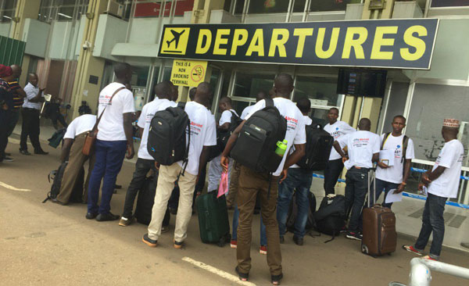
A photo of Uganda’s young men at Entebbe international airport, departure department preparing to leave the country. The Independent, March 22, 2022

Task: Write an essay explaining why the young men are not willing to listen to anyone else on the matter and advise the government on what it can do to solve the problem

DEVELOPED BY BAGUMA SSENTAMU RICHARD

For facilitations and other resourceful books and handouts, contact him on 0750025446/0784114269

