**Befor Running**

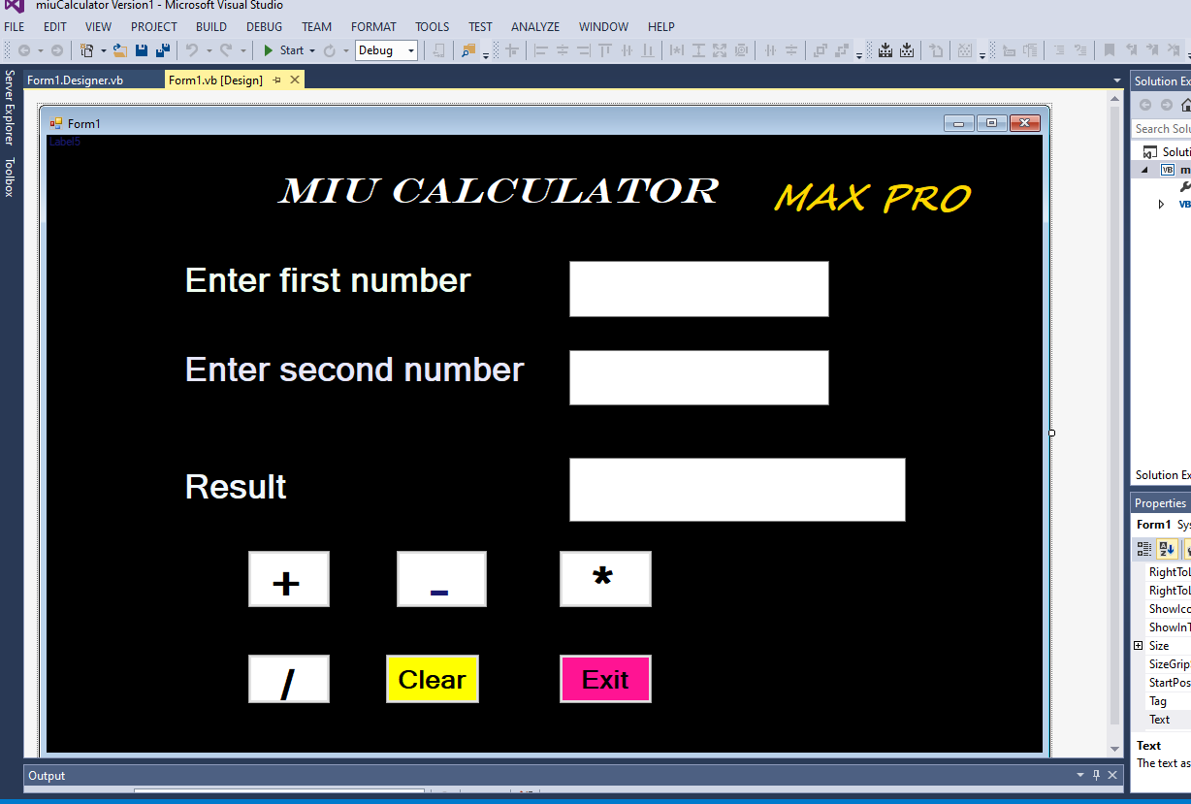

**After Running**

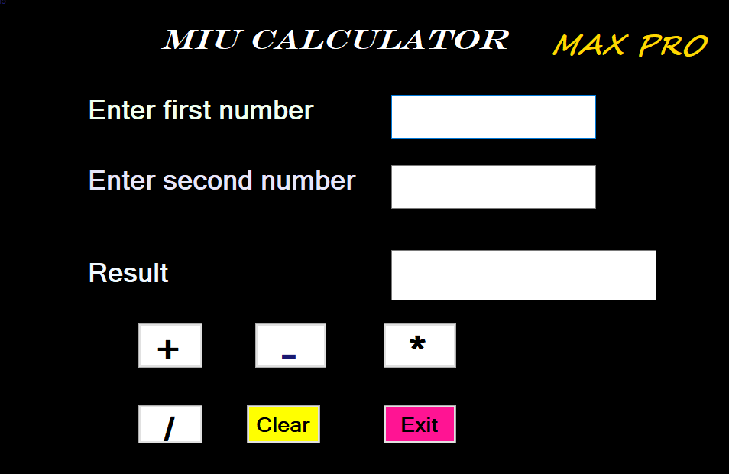

**Testing Addition Button**

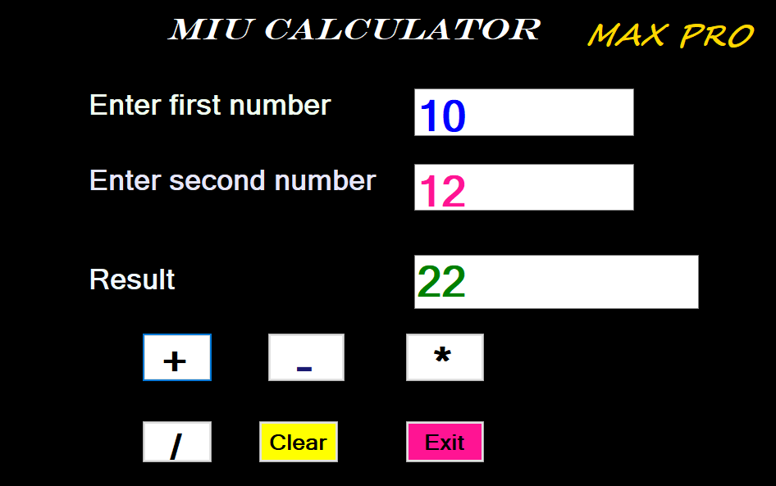

**Testing Subtraction Button**

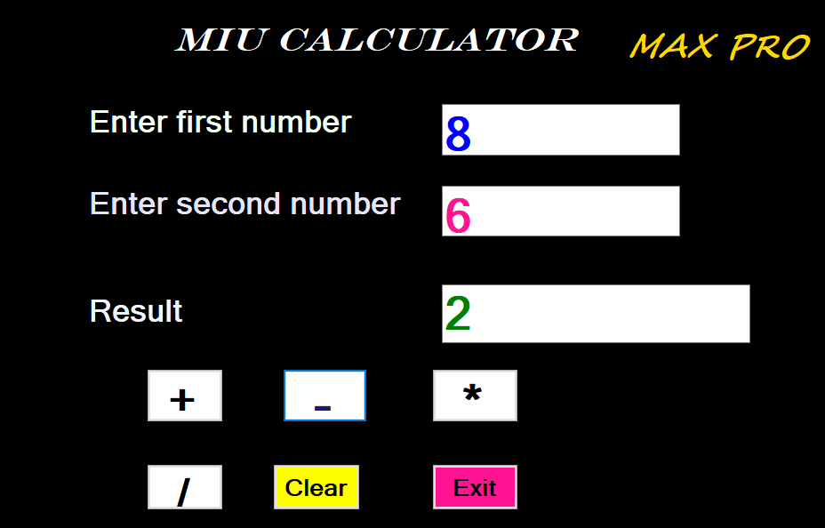

**Testing Multiplication Button**

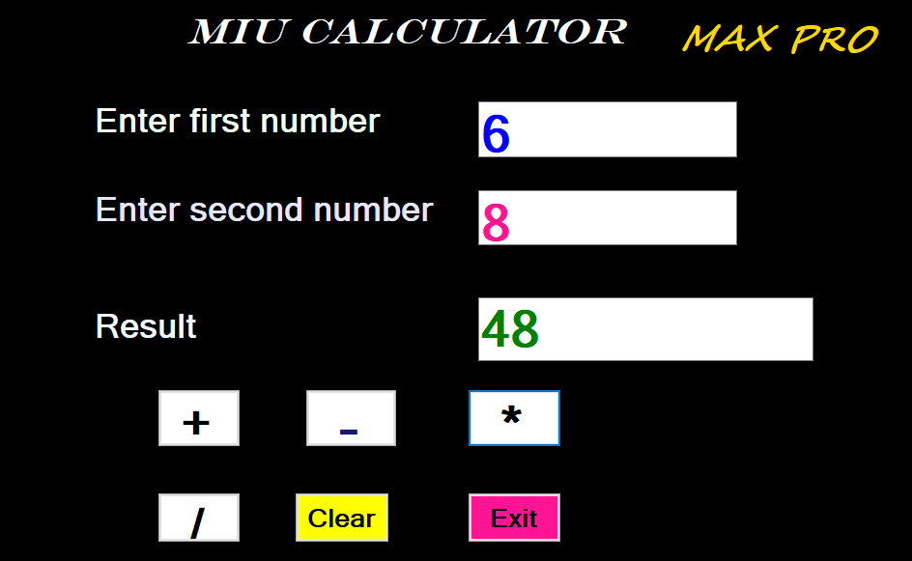

**Testing Division Button**

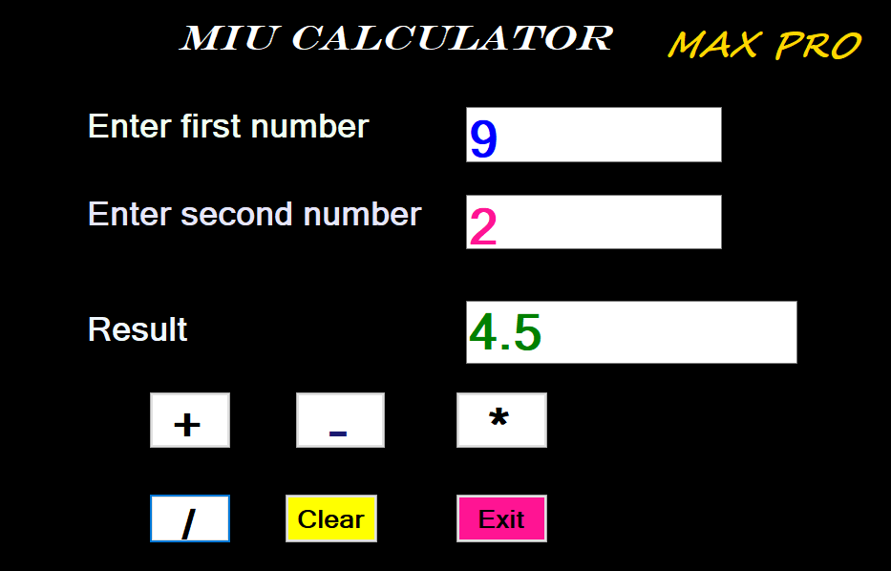

**Codes Behind the process**

Private Sub btnAdd_Click(sender As Object, e As EventArgs) Handles btnAdd.Click

Dim num1 As Double =

Convert.ToDouble(txtFirstNumber.Text)

Dim num2 As Double =

Convert.ToDouble(txtSecondNumber.Text)

lblResult.Text = (num1 + num2).ToString

End Sub

Private Sub btnSubtract_Click(sender As Object, e As EventArgs) Handles btnSubtract.Click

Dim num1 As Double =

Convert.ToDouble(txtFirstNumber.Text)

Dim num2 As Double =

Convert.ToDouble(txtSecondNumber.Text)

lblResult.Text = (num1 - num2).ToString

End Sub

Private Sub btnMultiply_Click(sender As Object, e As EventArgs) Handles btnMultiply.Click

Dim num1 As Double =

Convert.ToDouble(txtFirstNumber.Text)

Dim num2 As Double =

Convert.ToDouble(txtSecondNumber.Text)

lblResult.Text = (num1 * num2).ToString

End Sub

Private Sub btnDivide_Click(sender As Object, e As EventArgs) Handles btnDivide.Click

Dim num1 As Double =

Convert.ToDouble(txtFirstNumber.Text)

Dim num2 As Double =

Convert.ToDouble(txtSecondNumber.Text)

If num2 <> 0 Then

lblResult.Text = (num1 / num2).ToString

Else

MessageBox.Show("Connot divide by zero")

End If

End Sub

Private Sub btnClear_Click(sender As Object, e As EventArgs) Handles btnClear.Click

txtFirstNumber.Clear()

txtSecondNumber.Clear()

lblResult.Clear()

End Sub

Private Sub btnExit_Click(sender As Object, e As EventArgs) Handles btnExit.Click

Me.Close() End Sub End Class