LITTLE MUHEJI SCHOOL

REVISION WORK 2020

MIDDLE CLASS SET I CLASS

NAME:

CLASS: _ _STREAM:_ _

1. **Read and match**.

eye 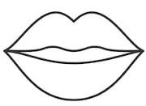 nose 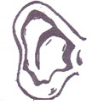 leg 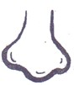

ear 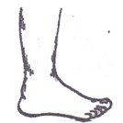

mouth 

1. **Circle the correct word**.

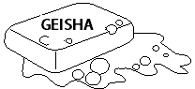 soap poas  ngespo sponge 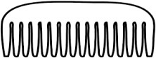 comb mbco

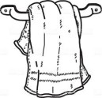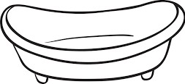 sinba basin

towel welto

1. **Match and draw fruits we eat**.

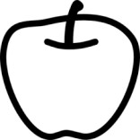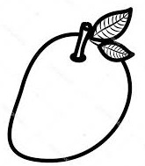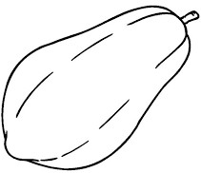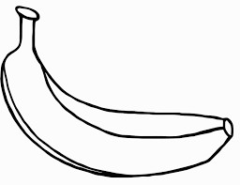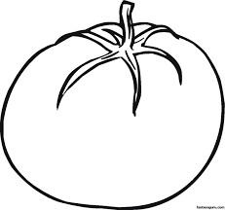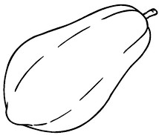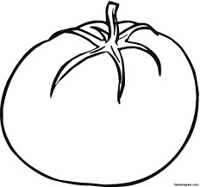

1. **Colour**.

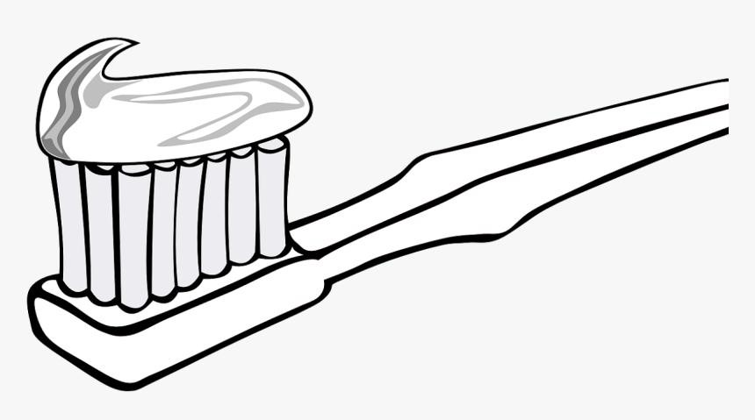

1. **Write the picture number.**

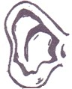

2

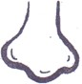

5

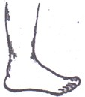

1

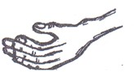

3



4

eye leg

nose arm

ear

**MATHEMATICAL CONCEPTS**

1. **Match and write.**

3 2

2

1 6

5

5 3

6 1

2

1. **Trace and learn.**
2. **Copy and learn.**

|  |  |  |  |  |  |
| --- | --- | --- | --- | --- | --- |
| 1 | 2 | 3 |  | 5 | 6 |
| **1** |  |  |  |  |  |
| 7 | 8 | 9 | 10 | 11 | 12 |
|  |  |  |  |  |  |

1. **Count and shade.**

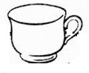





3 1

0 5 2

9 6 8

3 5

7 0 2

1. **Tick the different number.**

2

6

6

3

7

2

7

1. **Fill in the missing number.**

1 2 3 5 7 9

11 19.

13

15

17

1. **Draw for the number.**

|  |  |
| --- | --- |
|  | = 1 |
|  | = |
|  | = 6 |
|  | = 3 |
|  | = 5 |

1. **Copy the same.**

|  |  |  |  |  |
| --- | --- | --- | --- | --- |
|  |  |  |  |  |
| circle | star | oval | kite | cone |
|  |  |  |  |  |
|  |  |  |  |  |

1. **Match the same.**

four five

two one

three two

one three

five four

1. **Trace and write.**

|  |  |
| --- | --- |
|  |  |
|  |  |

0

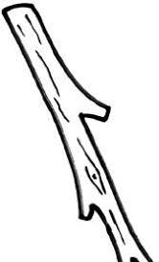

LIMS-MIDDLE CLASS REVISION WORK SET I 202

# LANGUAGE DEVELOPMENT II

( **ENGLISH**)

1. **Write letters a - j.**

|  |  |  |  |  |
| --- | --- | --- | --- | --- |
|  |  |  |  |  |
|  |  |  |  |  |

1. **Circle the same pictures.**

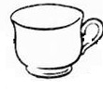

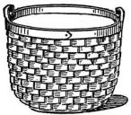

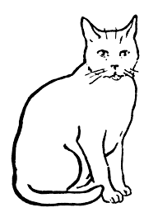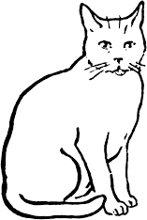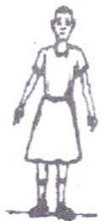



1. **Write the picture number.**

1 5

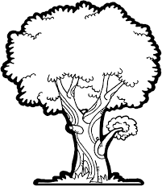

2

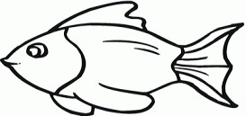

6



3

fish ball

tin hat

book tree

1. **Write letters correctly.**





1. **Match and draw.**

p mat

a cat

m bag

|  |  |  |
| --- | --- | --- |
| c | pot |  |
| b | axe | _ |

1. **Read and trace.**

|  |  |  |
| --- | --- | --- |
|  |  |  |
|  |  |  |

1. **Read and draw.**

It is a ball. It is a cup. It is a hut. It is a box.

It is a door.

# SOCIAL DEVELOPMENT

1. **Match the same words.**

rake basket

hoe panga

axe knife

basket rake

panga hoe

knife axe

1. **Draw and colour mother.**

LIMS-MIDDLE CLASS REVISION WORK SET I 2020

1. **Draw and copy.**

|  |  |  |  |
| --- | --- | --- | --- |
|  |  |  |  |
| mosque | church | school | Hospital |
|  |  |  |  |
|  |  |  |  |

1. **Write the picture number.**

5

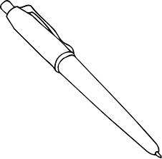

3

2



1

book

pen

chair

tin ball

1. **Colour me please.**

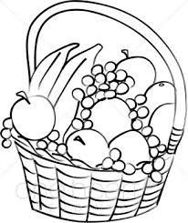

# LEARNING DEVELOPMENT ll

1. **Sound and draw.**

**s a t**

**i p n**

1. **Sound and write.**

a e

LIMS-MIDDL~~E CLASS REVISION WORK SET I 2020~~

s i

o u

1. **Ring for the sound.**

s  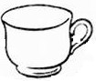 a  t 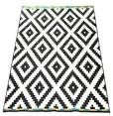 p 



n

1. **Read and draw.**

sun

egg

box

LIMS-MIDDLE CLASS REVISION WORK SET I 2020

tin

pot

1. **Read and draw for the syllable.**

su

po

ti

ma ca

1. **Write the missing syllables**.

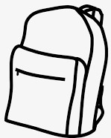 g n



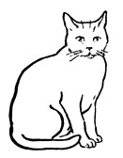 t 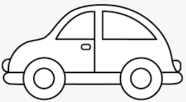 r

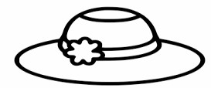 t

1. **Tick the correct word.**

tca tac cat

tin itn nti

|  |  |  |  |
| --- | --- | --- | --- |
| oxb | box | xob | |
| egg | geg | gge | |
| agb | gba | bag | |
| 8**. Read for mummy.**  s ba | | su | ma |
| book ck | | po | flower |
| su tree | | m | ti |
| bag tin | | stool | r |

( Please, parent, tick what he/she can read)

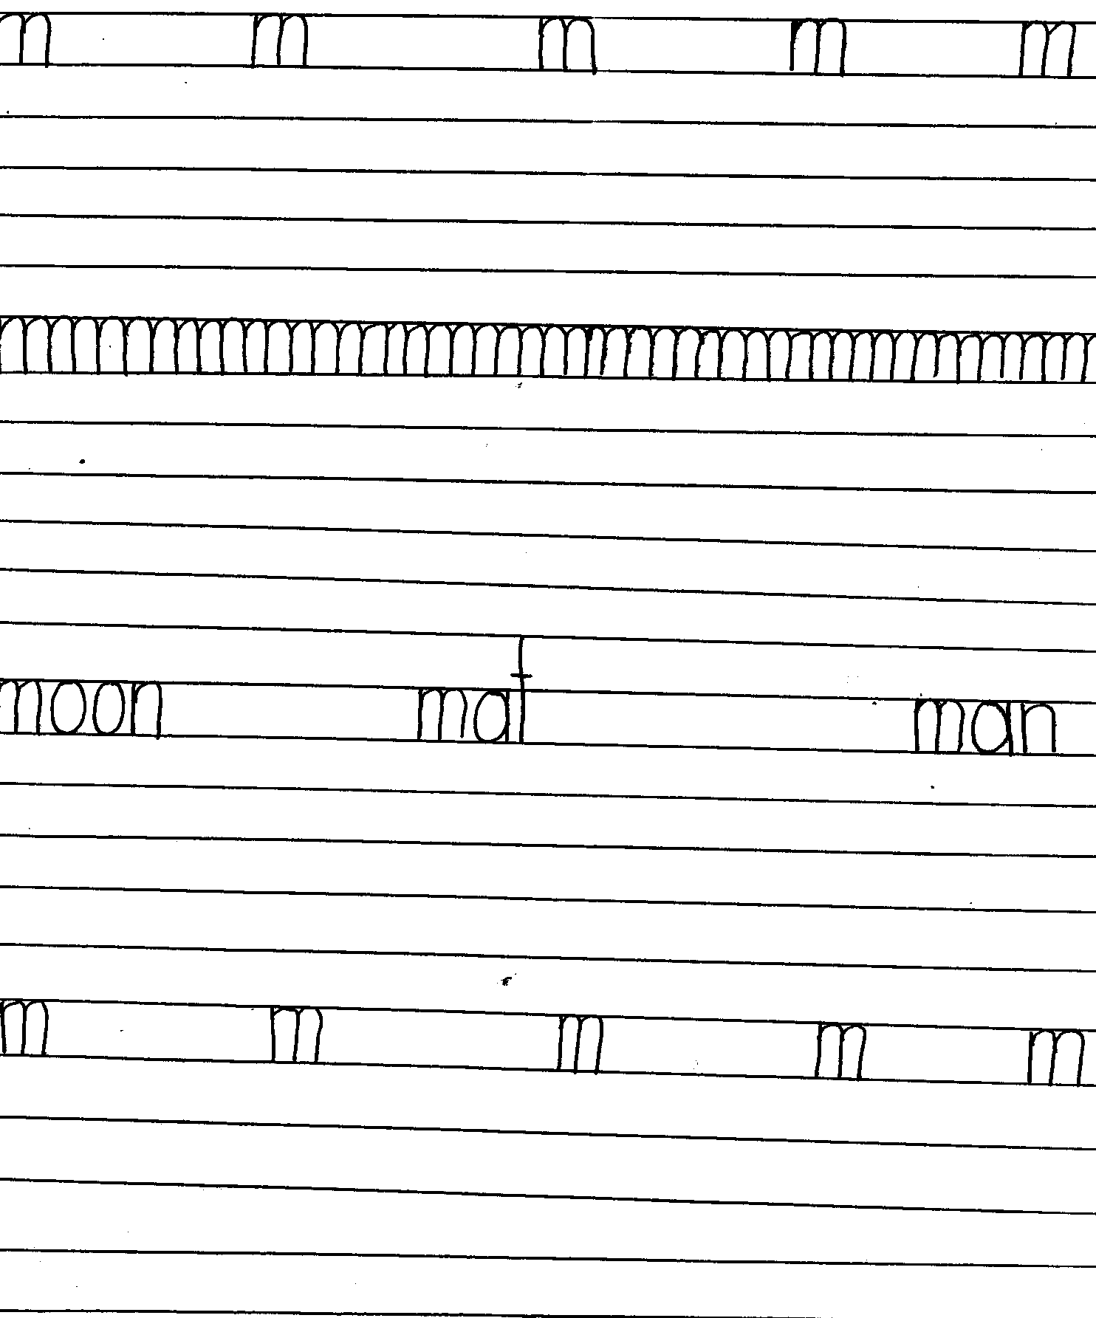

LANGUAGE DEVELOPMENT ll ( writing)

1. **Copy**

LIMS-MIDDLE CLASS REVISION WORK SET I 2020

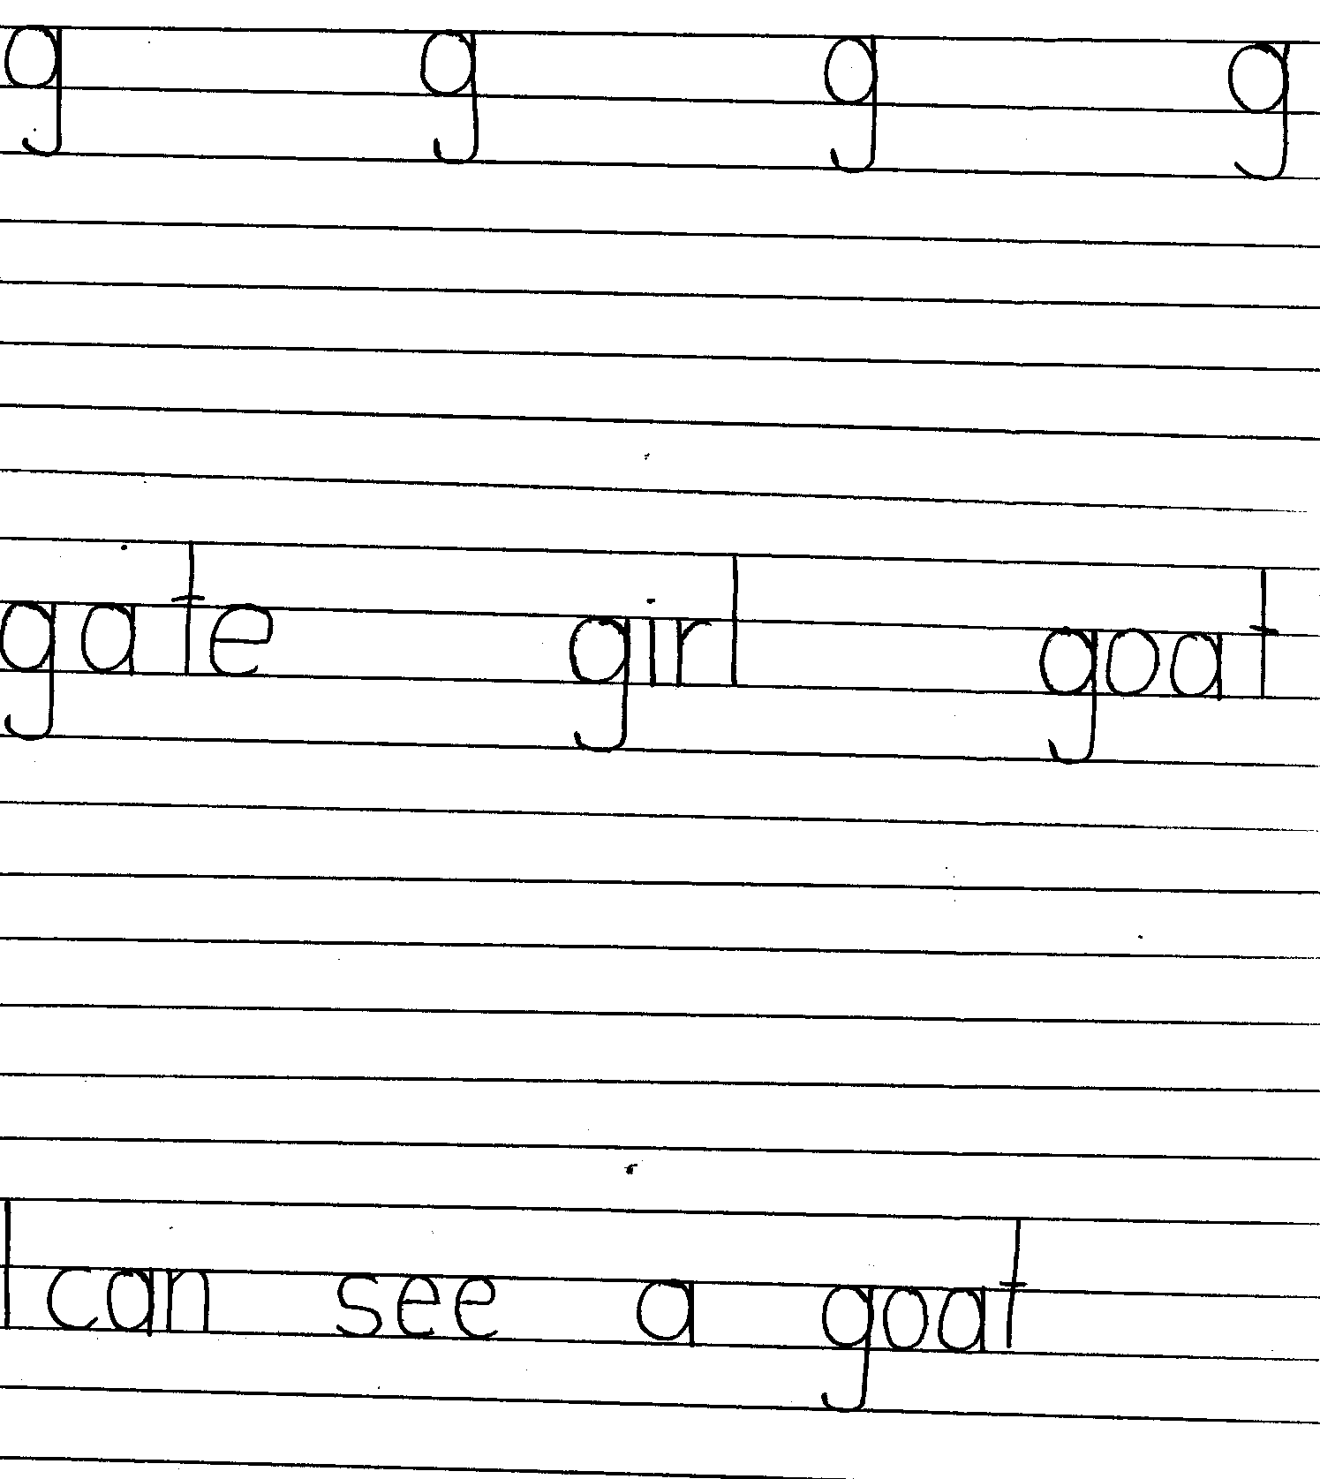

1. **Copy**

LIMS-MIDDLE CLASS REVISION WORK SET I 2020

19

1. **Copy**

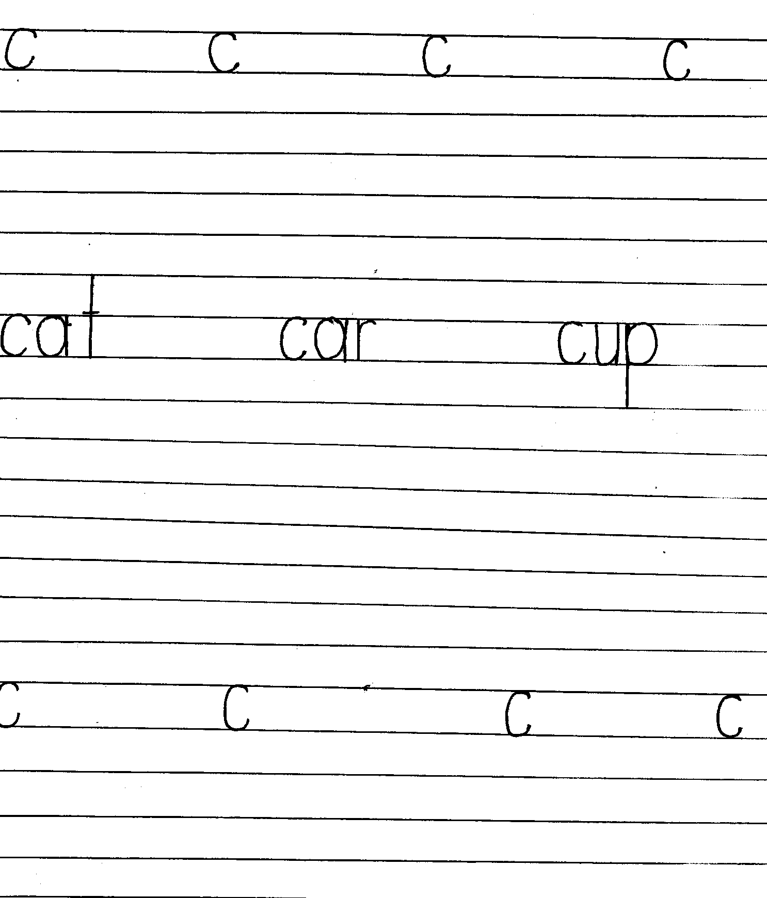

LIMS-MIDDLE CLASS REVISION WORK SET I 2020

20

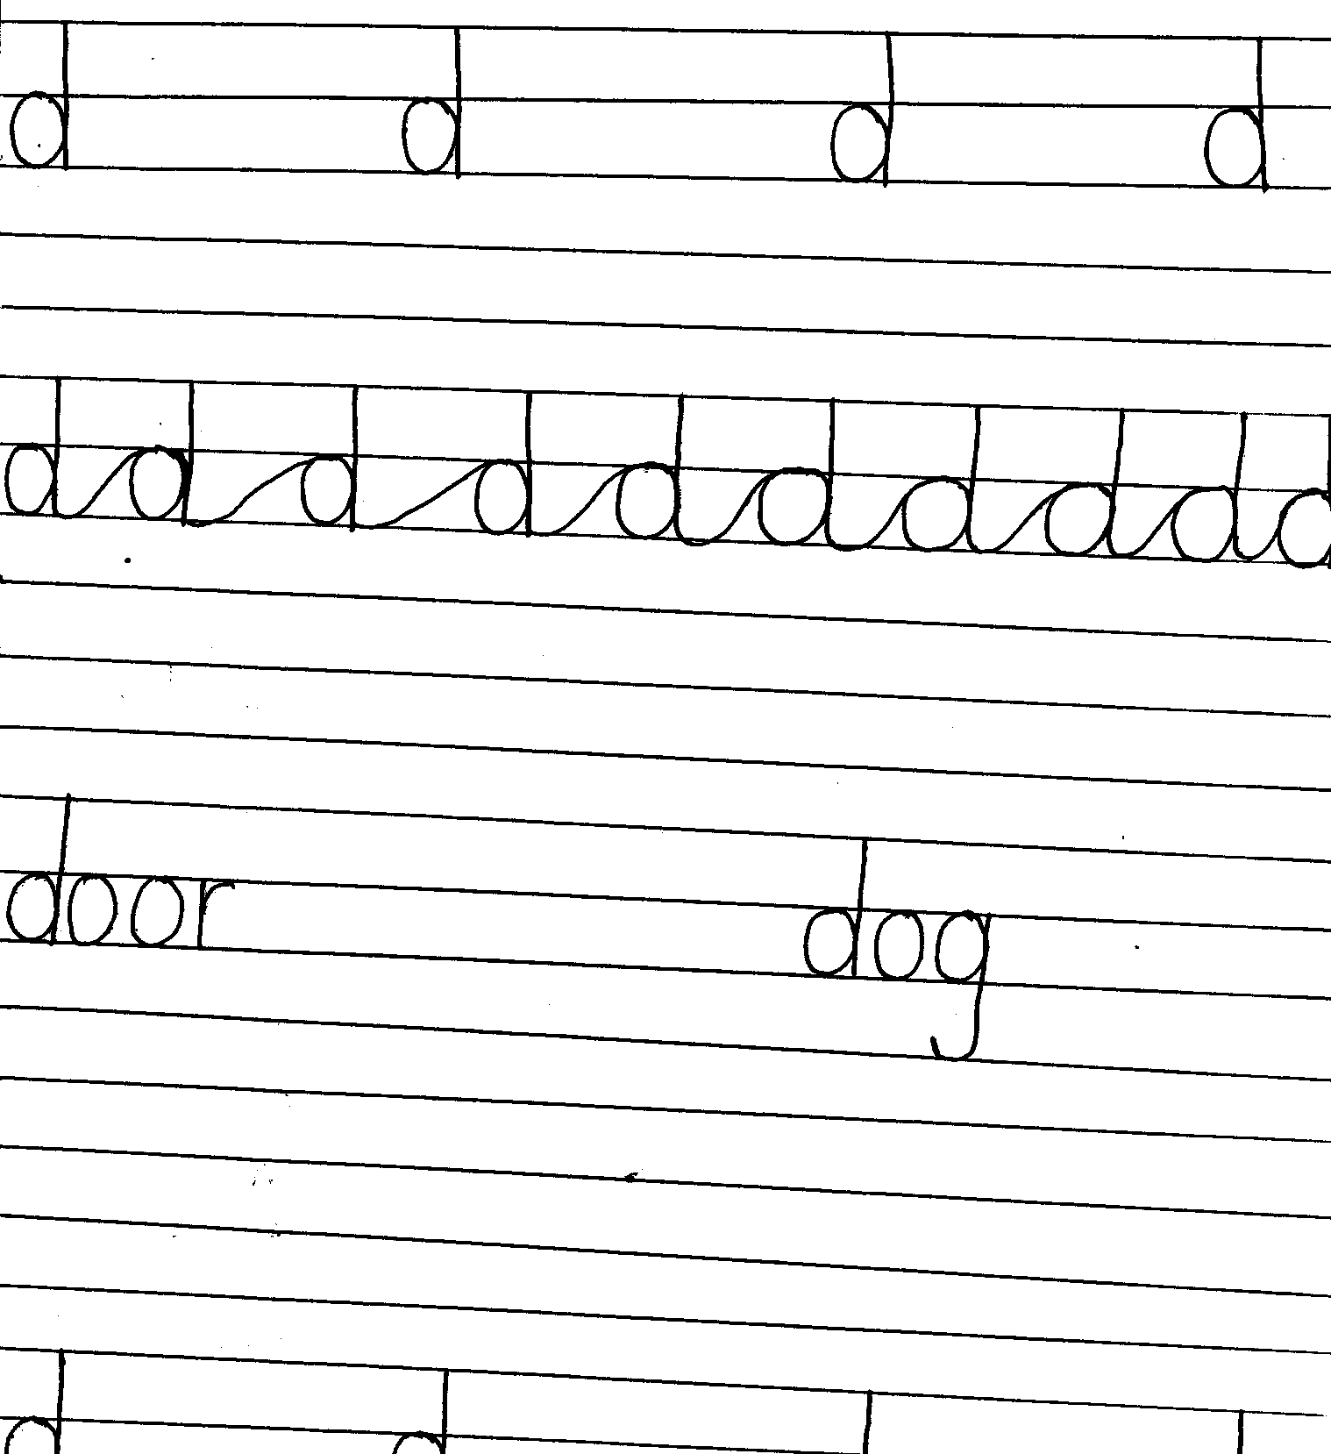

LIMS-MIDDLE CLASS REVISION WORK SET I 2020

21

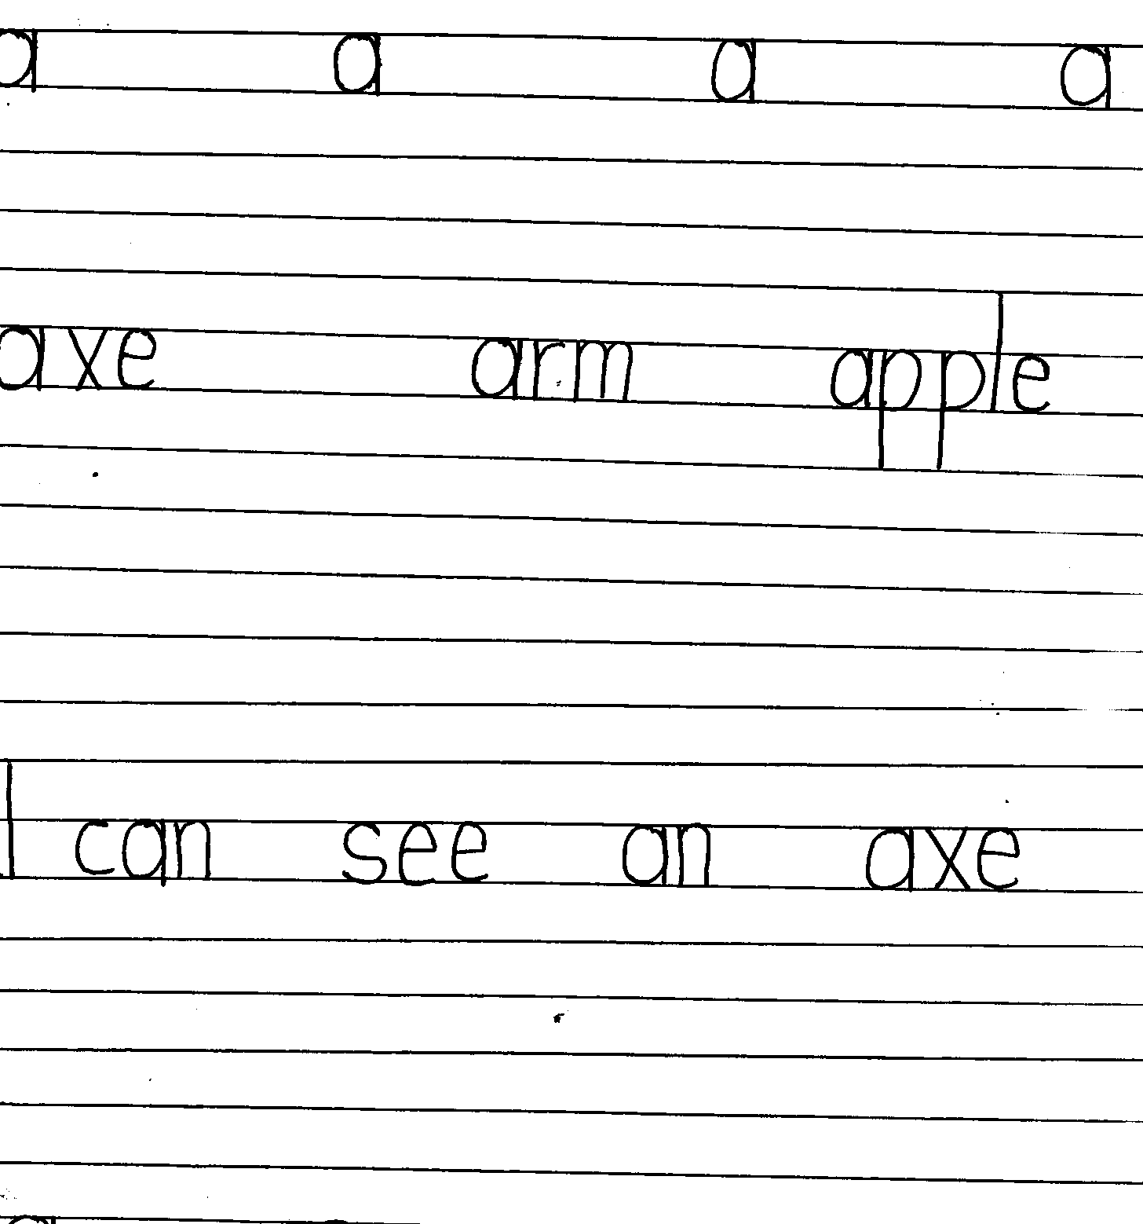

LIMS-MIDDLE CLASS REVISION WORK SET I 2020

22

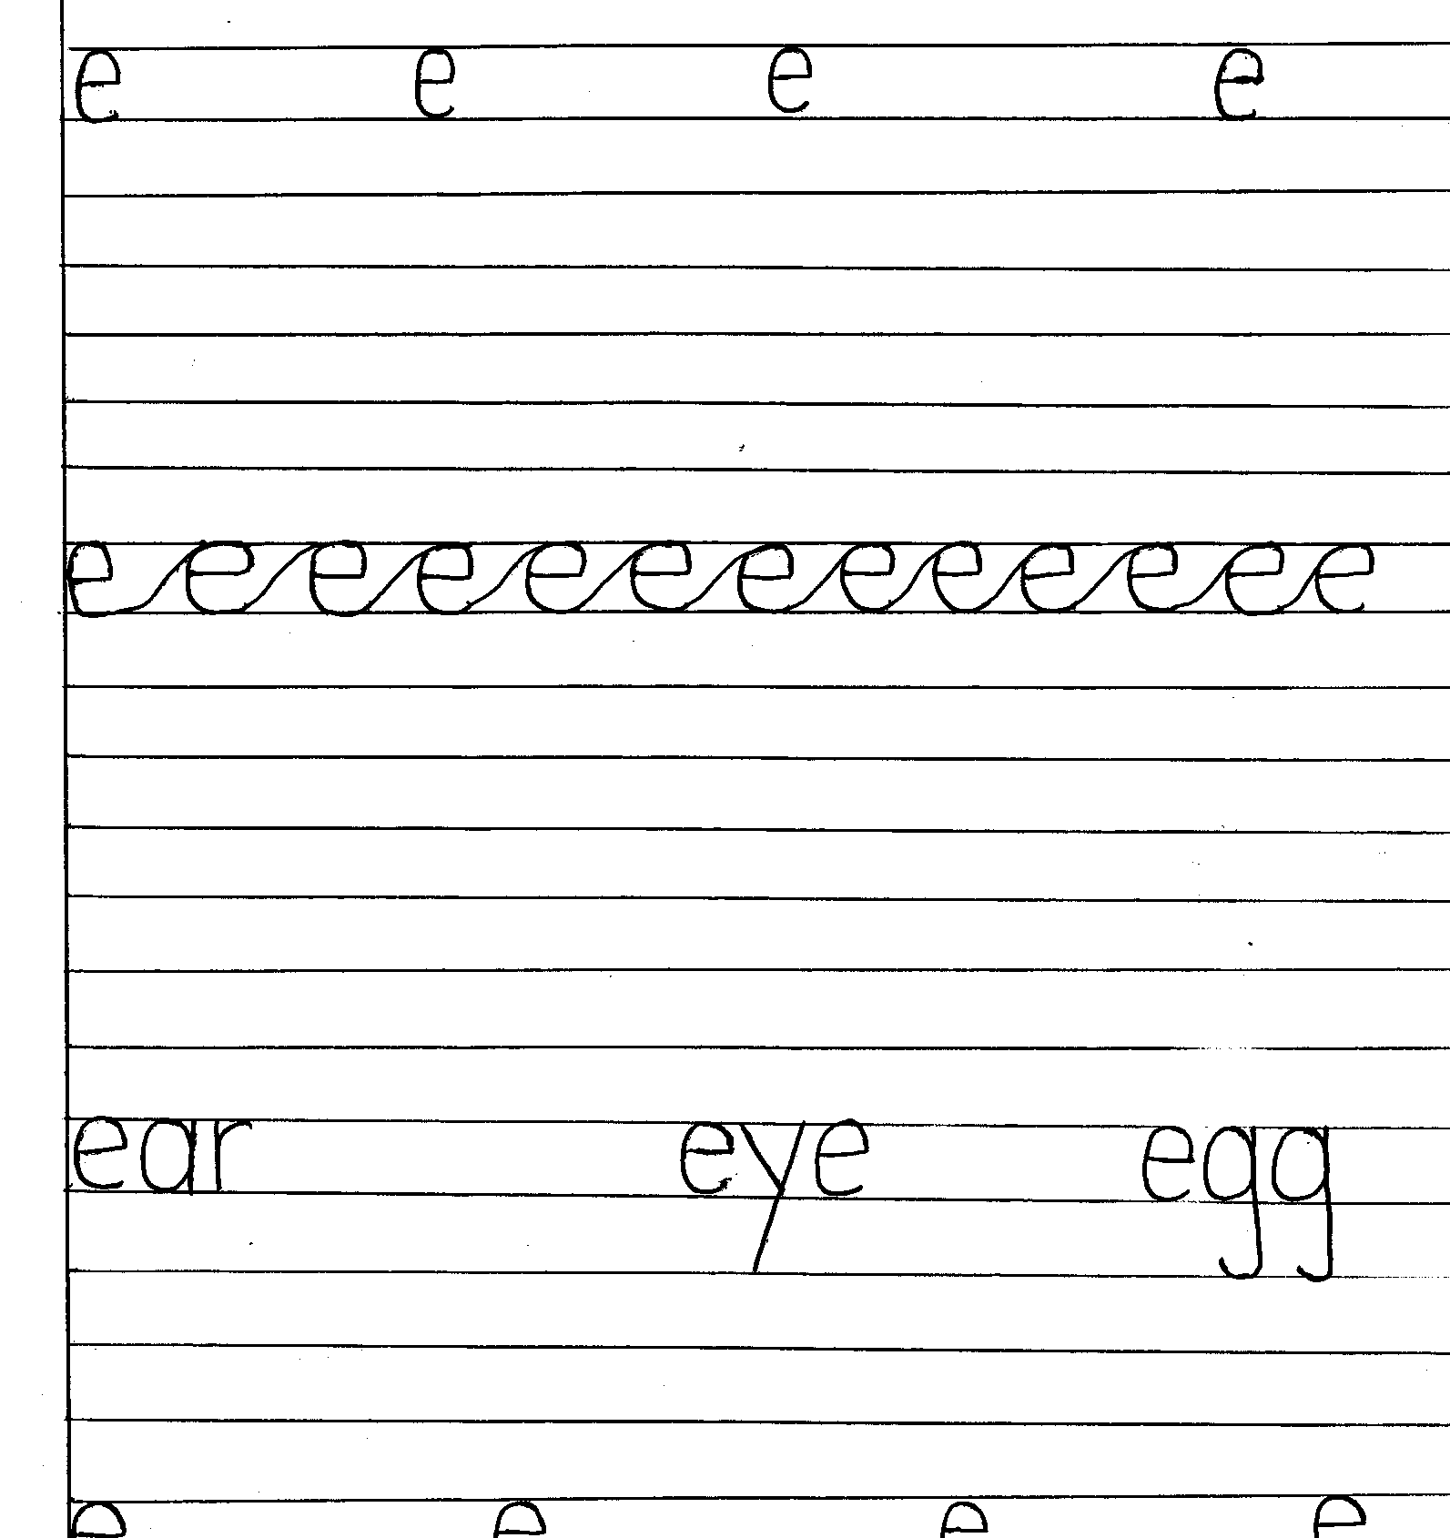

LIMS-MIDDLE CLASS REVISION WORK SET I 2020

23

END

LIMS-MIDDLE CLASS REVISION WORK SET I 2020

24