S3 holiday package

**MATHEMATICS**

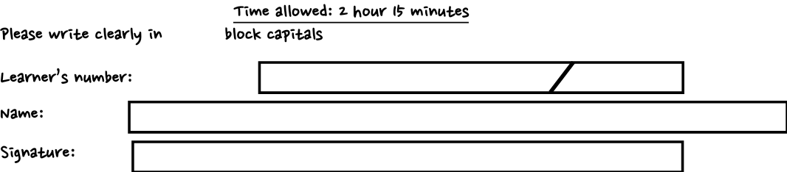



**Materials**

For this paper you must have: ✔ a ruler 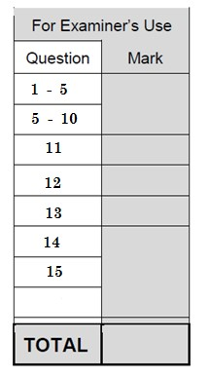

**Instructions:**

* Use black ink, blue or black ball-point pen.
* Fill in the boxes at the top of this page.
* Answer **ALL** questions
* For section B use a separate answer booklet

**Information**

* There are 90 marks available on this paper.
* The marks for questions are shown in brackets.
* You are reminded of the need for clear presentation in your answers

SECTION A

*(Attempt* ***all*** *questions in both sections*) 1. The test scores of 14 students are shown below.

21 21 23 26 25 21 22 20 21 23 23 27 24 21

Find the median and mean of the test scores (04 marks)

Median = ...........................................................................................................

Mean = ……………………………………………………………………………….

2. 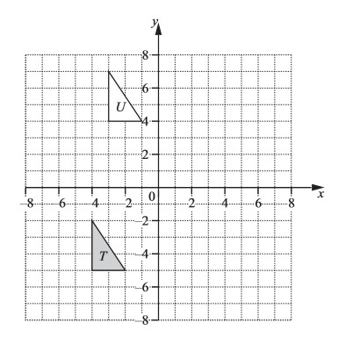

| (i) Draw the reflection of triangle T in the line x = 0. | (02 marks) |
| --- | --- |
| (ii) State the coordinates of the vertices of the image | (02 marks) |

…………………………………………………………………………………………….

1. The table shows part of a Global bus timetable (04 marks)

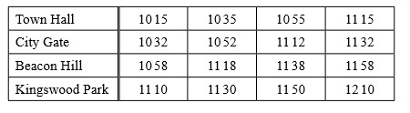

* 1. Jamila leaves home at 10 50. She takes 14 minutes to walk to the bus stop at City Gate. At what time does she reach the bus stop?

…………………………………………………………………………………………….

……………………………………………………………………………………………. …………………………………………………………………………………………….

* 1. She gets on the next bus at City Gate and travels to Kingswood Park. At what time does this bus arrive at Kingswood Park?

…………………………………………………………………………………………….

…………………………………………………………………………………………….

…………………………………………………………………………………………….

* 1. Work out how many minutes the bus takes to get from City Gate to Kingswood Park.

…………………………………………………………………………………………….

…………………………………………………………………………………………….

1. Joel asks 30 students to guess the number that the spinner will land on next. This pie chart shows the results.

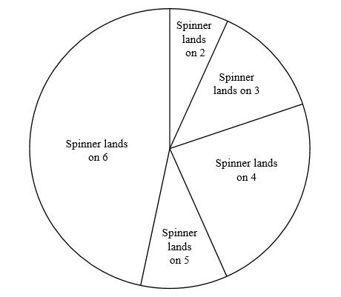

1. The sector angle for the number 6 is 168°. How many students

guessed the number 6? (02 marks)

…………………………………………………………………………………………….

…………………………………………………………………………………………….

…………………………………………………………………………………………….

1. Find the percentage of the students who guessed a number less than 5.

…………………………………………………………………………………………….

…………………………………………………………………………………………….

…………………………………………………………………………………………….

5. Write down the mathematical name for; (04 marks)

1. an angle which is less than 90°

…………………………………………………………………………………………….

1. a polygon with 5 sides

…………………………………………………………………………………………….

1. a quadrilateral with exactly one pair of parallel sides

…………………………………………………………………………………………….

1. **hexagon perpendicular isosceles regular congruent**  Put a ring around the word that describes two polygons that are the same shape and size

6. 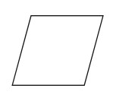

(a) The diagram shows a rhombus, On the diagram,

Draw all the lines of symmetry. (02 marks)

(b) 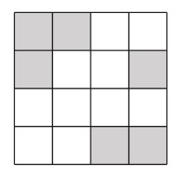

Shade more squares so that the unshaded part has a fraction of 

(02 marks)

7. 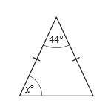

1. The diagram above shows an isosceles triangle. Find the value of *x.*

…………………………………………………………………………………………….

…………………………………………………………………………………………….

1. A regular polygon has an interior angle of 172°.

Find the number of sides of this polygon (04 marks)

…………………………………………………………………………………………….

…………………………………………………………………………………………….

1. Find the length of the line joining the points A (− 4, 8) and B(−1,4).(04 marks)

…………………………………………………………………………………………….

…………………………………………………………………………………………….

…………………………………………………………………………………………….

…………………………………………………………………………………………….

1. Without using your calculator, workout  −(  × 1 ) Write down all the steps of your working. (04 marks) …………………………………………………………………………………………….

…………………………………………………………………………………………….

…………………………………………………………………………………………….

…………………………………………………………………………………………….

10.

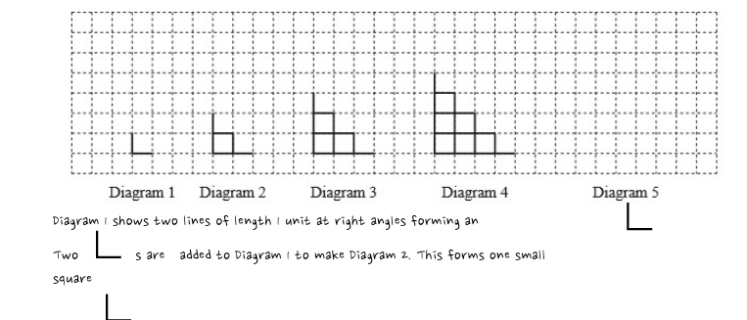Three s are added to Diagram 2 to make Diagram 3. This forms three small squares. The sequence of Diagrams continues

1. Draw Diagram 5. (01 mark)
2. Complete the table. (02 marks)

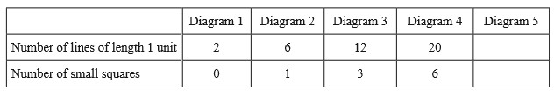

1. Find an expression, in terms of n, for the number of lines of length 1 unit in Diagram n. (01 mark)

…………………………………………………………………………………………….

…………………………………………………………………………………………….

…………………………………………………………………………………………….

…………………………………………………………………………………………….

…………………………………………………………………………………………….

…………………………………………………………………………………………….

SECTION B

11.

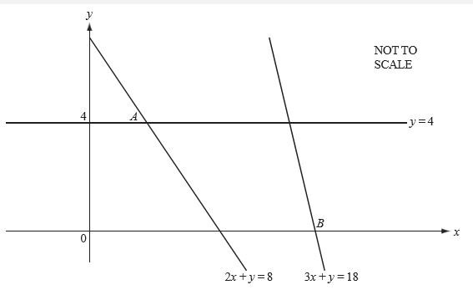

(a) The line y = 4 meets the line 2x + y = 8 at the point A. Find the co-ordinates of

A. (02 marks)

1. The line 3x + y = 18 meets the x axis at the point B. Find the co-ordinates of B. (02 marks)
2. (i) Find the co-ordinates of the mid-point M of the line joining A to B.(02 marks)

(ii) Find the equation of the line through M parallel to 3x + y =18.(04 marks)

12. In a Busiika national safari rally, there were several contestants. They all had different types of vehicles namely, Nissan, Toyota, Isuzu and Daihatsu. The following pictograph shows how many vehicles of each type were used during the safari rally.

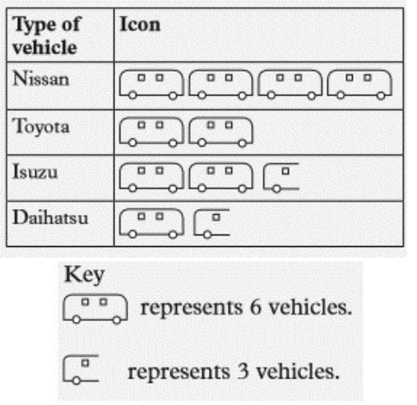

1. How many Toyota participated in the rally? (03 marks)
2. Which type of vehicle participated most in the rally? (01 mark)
3. How many vehicles participated in the rally altogether? (03 marks)
4. Draw a frequency table to display the information above.(03 marks)

13. Using the edges of a ruler, draw a pair of parallel lines as shown in Figure below such that AB = CD =7cm. Put arrow heads at the centre of the line to show that the two lines are parallel.

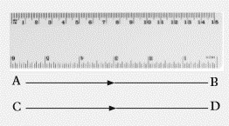

Draw a straight line to cut lines AB and CD at points E and F respectively. Prolong this line (ST) on either sides of the parallel lines (01 mark)

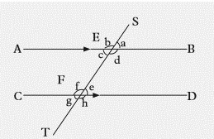

1. What is the name of the line such as line ST above? (01 mark)
2. On your diagram drawn, measure and record angles (i) SEB (01 mark)
   * 1. CFE (01 mark)
     2. CFT (01 mark)
     3. AES (01 mark)
3. What is the name of the angle pairs
   1. a and b (01 mark)
   2. c and d (01 mark)
   3. e and f (01 mark)
   4. h and g (01 mark)

14.

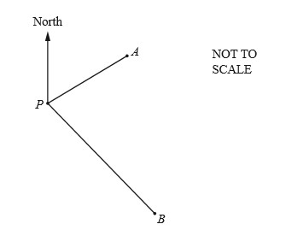

Scale 1cm = 20km

1. Copy and complete the statement

Ship A is …………………………………..kilometres from port P on a bearing of ….….°

Ship B is ………………………………….. Kilometres from P on a bearing of ………°

(04 marks)

1. Calculate AB, the distance between the two ships in kilometres (02 marks)
2. If it takes 2  ℎ𝑜𝑢𝑟𝑠 to sail from position A to B, find the average speed along this

path (04 marks)

15. (a) Given the following sets A = {a, b, c, d, e, f} and B = {a, b, c, h, i}, find:

1. n(A)
2. n(B)
3. n(A ∪ B) (06 marks)

(c) Given;

Set A = {mangoes, pawpaw, oranges}, Set B = {apples, pawpaw, strawberry}, Set C = {strawberry, apples, passion fruit}.

Identify elements of set:

(i) A which do not belong to set B. (ii) B which do not belong to set C.

(iii) B which do not belong to set A.

END