

# Physical geography Chapter 14: Soils in East Africa

Soil refers to the thin surface (outermost) layer of the earth's crust that supports life. It is composed of organic and inorganic material, air moisture, all existing in a complex relationship.

Importance of soil

Soil has positive and negative importance

Positive soil importance

* Soil support plant growth and promote agriculture
* Clay soil is used in pottery and molding tiles
* Soil is used in making bricks for construction house
* Sandy soil is used to make concrete in road and building construction
* Soil may contain expensive minerals like gold
* Soil contain spring water
* Provides employment through agriculture, cleaning, brick making, construction, etc.

Negative importance

* Dirties clothes, buildings etc.
* Dust damages electronics - Soil hinder construction of roads
* Some soils prevent plant growth.

*Soil* types in East Africa fall under three major/broad groups, namely, Zonal, Intrazonal and Azonal.

## Zonal soils

* Refer to the well developed and mature soils resulting from the maximum effects of climate and organic matter upon parent rock over a long time.
* Zonal soils commonly occur on gently sloping and well drained areas of East Africa such as the Lake Victoria basin, the lower slopes of the highland areas of *East* Africaetc.

Examples of such soils include the:

* Pedocals e.g. those rich in CaCO3 (limestone)
* Pedalfers e.g. the lateritic soils, the tropical red earth and tropical black earth’s etc.
* Loamy soils (sand and clay basins) etc.

## Intrazonal soils

* Intrazonal soils occur where special conditions of relief or parent materials exert a stronger influence on the resultant soil type than other factors e.g. climate and vegetation.
* Examples include bog/peat/gleyed soils in marshy areas of East Africa such as t.ie coastal region meadow soils in the river flood plains (silt and mud), saline soils in semi-desert areas etc.

## Azonal soils

These are young and less developed compared to intrazonal soils

These includemountain scree soils, alluvial soils (clay silt and sand), marine soils in the coastal areas, glaciated/**morainic soils**, loess soils, young volcanic soils, dry sandy soils or regosols etc. such as those found in the East African rift valley, North and Central Kenya, Karamoja etc.

Factors that affect soil formation

• ***Nature of the parent rock.*** It provides the basis upon which soil forming processes operate. The soil formed possess similar characteristic as those of the parent rock in terms of structure , texture ,

minerology, porosity, colour etc. ·

* It is the parent rock which is weathered to produce a particular soil type. E.g. volcanic rocks.
* The parent rock also determines the extent to which the agents of weathering can take place to produce soils: Hard crystalline rocks resist weathering and produce skeletal or thin soils e.g. scree soils on mountains. The soft parent rocks are easily weathered to produce deep and mature soils.

• ***Climate*** influences soil formation through the physical and chemical weathering processes that break down and decompose the parent rocks.

* In dry climates (semi-arid areas) such as Northern Kenya, Central Tanzania, North Eastern Uganda, Physical weathering has produced shallow and infertile soils of azonal nature. On the other hand, chemical weathering processes that occur in the humid areas of East Africa have led to the development of deep fertile soils such as clay, loamy such as Nitisols found in the highland areas of East Africa.
* On other hand, high rainfall totals received in some parts of East Africa encouraged leaching hence formation of Lateritic soils e.g. around lake Victoria shores, dry conditions generally lead to the development of luvisols as in Eastern Kenya.

-

### • Relief/ Topography

* This influences soil formation by forming various slopes that control the rate of erosion and deposition as well the mature soil and soil depth.
* Steep slopes are more susceptible to erosion and rapid transportation resulting into thin skeletal soils although soil formation is rapid due to constant exposure of fresh surface rock to weathering factors, the resultant soils are thin and skeletal due to rapid rates of erosion.
* Gentle/moderate slopes have a relatively slower rate of erosion but encouraged deposition leading to the formation of deep, mature and well drained soils such as loam soils.
* Valleys/flat areas have extensive deposition leading to the development of deep/thick soils found along the Lake Victoria shores, river valleys etc. However, they have limited organic matter due to the poor drainage; in addition the impeded drainage in the valleys leads to partial decomposition that forms grey/gley soils.

• ***Biotic factors.***This refers to the influence of living organizations in soil formation.

* When plants/vegetation die and rot, they add humus to the soil and produce compounds which may break down complex rocks to form soils.
* Burrowing animals like rabbits and moles, worms, etc. through their passages underground also contribute to the soil formation by allowing air and moisture necessary for chemical weathering.
* Human activities also influence soil formation through physical and chemical means. Through milling and quarrying man accelerates the rate at which rocks are broken down and therefore soil formation through addition of manure, fertilizers etc. man introduces chemicals which help break down rocks and eventually form soils. Industrial pollution also causes acidic rain which is also a contributing factor.

• **Influence of time:**Ample time is required to form mature soils. Along time is required for weathering to occur as well as the soil forming processes in order to produce deep mature soils. If time is short, immature, shallow soils will be formed.

## Soil profile

**Soil profile** refers to the vertical arrangement /section through the soil from the surface up to the parent rock. It is composed of soil layers referred to as horizons which are differentiated in terms of color and texture.

Soil profiles differ from place to place however an ideal soil profile is composed of horizons A.B, C and D as shown below.

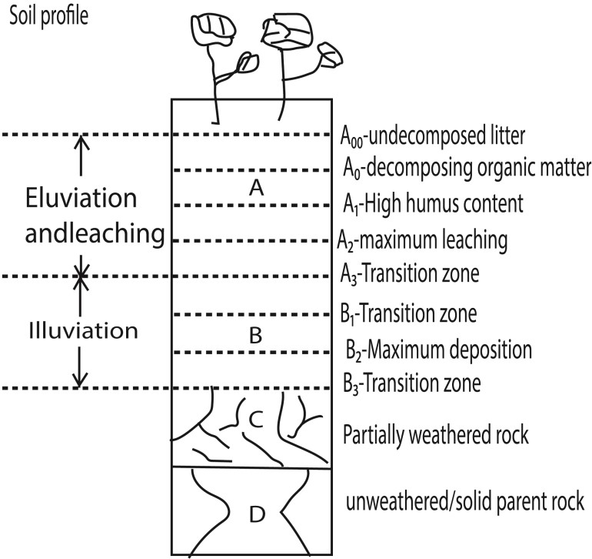

***Horizon A.***

* It's the topmost layer sometimes referred to as the top soil
* The top designated as A00 consists of un-decomposed litter of dead leaves and vegetation.
* It's followed by A0 which is decomposing organic matter and A1 which has high humus content and which gives this horizon its dark colour.
* It's followed by *A2* which is poor in nutrients because of the effect of leaching (removal to solution of nutrients) and eluviation (movement of material /clay particles in suspension) and which make it light coloured /bleached. It's followed by a transition zone.

### Horizon B

* It's the soil layer below horizon A and it’s the zone where nutrients and materials removed from horizon A accumulate in a process known as illuviation (in washing of materials).
* It's therefore often richer in nutrients than the zone above it, and may be darker *in* colour.
* It's sometimes characterized by a hard pan caused by the accumulation of large quantities of clay and other nutrients.

***Horizon C***

Consists of recently/partially weathered parent material (regolith) resting on the bed rock.

***Horizon D***

It's the last layer of the profile and consists of solid parent rock or bedrock.

## The conditions that influence soil profile development

### Nature of the parent Rock

* Hard rocks which are not easily weathered such as granite lead to formation of thin soils and poorly developed profiles while soft rocks which are easily weathered such as volcanic ash and limestone lead to the development of a deep soil profile.
* Rocks with joints and cracks are also easily broken down to produce deep/mature soil profiles as compared to those without
* Dark coloured rocks responsive to heat are also easily weathered to produce deep /well developed profiles as compared to light coloured rocks which are difficult to break up.
* Basic igneous rocks which are difficult to weather as well as some sedimentary rocks (composed of previously weathered materials are difficult to breakdown and produce shallow soils in immature/ poorly developed soil profiles.

' Permeable/ porous rocks are easily weathered by chemical processes to produce deep mature soil profile as compared to impermeable rocks which may produce shallow soil profiles etc.

### Climate

* It determines the character and rate of weathering.
* In hot humid climates, chemical weathering occurs at a fast rate leading to the formation of deep soils and well developed/ mature soil profiles.
* In hot dry climates physical weathering predominates leading to the formation of thin/ skeletal soils/ azonal soils which do not have well developed profiles.

### Vegetation

* Thick vegetation cover decays and leads to the formation of humus which is added to horizon A of the soil profile
* Plant roots also lead to the disintegration of rocks and the formation of soil in a soil profile.
* Forested areas such as Mabira, Kakamaga, Kissi in Kenya therefore tend to have deep soils in well- developed profiles while areas with thin vegetation cover have thin skeletal soils and poorly developed profiles.

### Drainage

* Water logged conditions do not allow the easy development of a soil profile such *as* Lutembe wetlands, Katonga, Awoja wetlands, etc.
* Well drained areas lead to the formation of a well-developed mature soil profile such as areas around L. Victoria

### Human activities

- Such as mining, quarrying, road construction etc. lead to the breakdown of rocks and the formation of deep soils characteristic of well-developed profiles e.g. mining in Tororo, cultivation around L.

Victoria.

### Living organisms

* In the soil such as ants, earthworms and mammals like rats and moles also break down rocks as the construct their passages underground leading to the formation of deep soils and well developed soil profiles ***Time***
* Ample time is required to the formation of mature, fertile and deep soils in a well-developed soil profile.

If time is short immature/ azonal soils will formed with poorly developed /shallow soil profiles.

***Topography.***

* Steep-s lopes are- more susceptible to soil erosion, and thin soil profile
* Gentle **slopes** - erosion is slower, there is a lot of deposition of soil eroded on steep slopes and water percolates to assist in soil profile development leading to deep, mature soil profile.
* Valleys; lowlands; extensive deposition and percolation of water lead to deep mature soil profiles where there are waterlogged conditions there is immature soil profile.

# Soil erosion

S*oil erosion* as the removal/washing away of the top thin layer of soil by agents like wind, running water, glaciers etc. transported and deposited in some other place

*Soil erosion occurs* e.g. highland areas like Kabale, Elgon, Kenya highlands. Other areas like Kondoa region in Tanzania, dry areas like Ankole - Masaka corridor, Kotido, Machakos in Kenya etc.

**T**ypes/processes of soil erosion which include**:**

* Splash erosion caused by the impact of rain drops which dislodge rock particles and scatter them in several directions.
* Sheet erosion which involves uniform removal of a thin layer of soil mainly on gentle slopes.
* Rill erosion which is the uneven removal of surface soil by running water in small channels/furrows as rills.
* Gulley erosion is where wide channels/grooves are created by running water. Common in areas with steep slopes and areas which receive heavy rainfall.
* Deflation by wind which removes soil material from one part of the earth's surface to another. Common in arid areas.

## Factors that cause soil erosion include the following;

* Climate through heavy short torrential rainfall results into run off and loss of soil through surface flow.
* Prolonged but gentle rainfall leads to minimal erosion.
* Presence of strong winds especially in areas of very-low rainfall lead to wind erosion.
* Relief/topography: Steep gradients especially in highland areas accelerate the rate of soil erosion causing massive gullies.
* Gentle slopes encourage sheet erosion.
* Scanty or limited vegetation cover may also lead to soil erosion e.g. areas of limited vegetation cover experience high rates of erosion like wind erosion yet areas of thick vegetation cover, the rate of soil erosion is reduced e.g. areas of Mabira forest.
* Nature of soils also influences soil erosion. The poor porous and unconsolidated soils offer less resistance to forces of wind and running water e.g. volcanic soils, sandy soils leading to soil erosion.
* Biotic factors like harvester ants common in pastoral and semi-arid areas eat all the grasses leaving the land bare such that wind or runoff water easily carry away the soils leading to soil erosion.

## The human factors that cause soil erosion include the following;

* **Deforestation** which is the clearing of forests by man reduces the protective cover of soil and encourages run off which leads to soil erosion in form of sheet, gulley etc.
* **Overgrazing/overstocking:** The large herds of animals lead to emergence of bare patches of land. Such land is easily eroded by agents of erosion especially in areas of nomadic pastoralism.
* **Bush burning** by pastoralists e.g. Bahima, Masai in Kenya, Tanzania and cultivators distort the soil binding factors. It exposes soil to agents of erosion like wind and running water thus sheet, rill and wind erosion.
* **Monoculture** which is the persistent growing of a single crop on a particular piece of land which leads to soil exhaustion. The soils are left loose and can easily be carried away by agents of erosion.
* **Up and down slope cultivation** without using proper methods of cultivation along the slope encourages run off leading to gulley erosion on steep slopes.
* **Over cropping** which involves continuous cultivation and growing of crops on the same piece of land for a long time without putting it to rest, leads to soil exhaustion. The soils become loose and are easily washed away by agents of erosion.
* **Mining/quarrying** accelerates the rate of soil erosion because the vegetation cover is removed and land is left bare prone to soil erosion.
* **Construction works e.g**. roads and railway construction lead to exposure of soil leaving it unprotected and exposed to harmful effects of rain drops and running water. In addition running water easily takes advantage of transport routes to create gullies paving way to soil loss.
* **Growing of poor cover crops** e.g. cotton, tobacco, leaves bare land in between the rows that easily encourage soil removal by running water.

## Effects of soil erosion

The negative effects of soil erosion include

* Loss of soil fertility leading to unproductive soils which lead to low crop yields thus famine/hunger.
* Creates waste land/ Bad Lands with gullies that hinder transport and communication as well as mechanization.
* Wind erosion leads to water and air pollution due to sand dust.
* Flooding in broad river valleys due to siltation leading to destruction of property and lives.
* Results into limited vegetation cover because badly eroded soils are unable to support plant growth. This results into problems e.g. reduced transpiration, scarcity of pastures for animals.
* Dust, particles earned by wind are deposited on social infrastructure like roads, buildings etc.

leading to increased costs of maintenance.

**The positive effects of soil erosion include:**

* Alluvial soils are transported and deposited in low lands which soils are fertile and can be used for farming/ growing of crops.
* Soil erosion exposes Isenberg which attract tourists thus promote tourism industry.
* Soil erosion exposes minerals that can be mined like granites and limestone and when exported, revenue is earned.
* Removal of top soil exposes the parent rock to agents of weathering leading to formation of fresh/new soils.

## Measures taken to control soil Erosion

* Terracing is adopted in Kigezi highlands to slow down the speed of running water
* Strip cropping along Mt. Elgon and Mt. Kilimanjaro to slow down the speed of running water
* Piling of soil to form raised platforms/ridges are used in Ntungamo to reduce the speed of running water.
* Sacks and Gabions filled with soil are place along loose surface to protect the soil from surface runoff in Kampala
* Crop rotation is practiced in many parts of Uganda to maintain soil texture such that it resists the agents of soil erosion.
* Cover crops such as sweet potatoes are grown as food crops in Uganda but also help to control soil erosion by protecting the top soil from agents of soil erosion
* Contour ploughing is adopted in Highlands of Kigezito reduce soil erosion
* Afforestation and re-afforestation is adopted in Kenya, Tanzania and Uganda to protect Highlands from soil erosion
* Controlled grazing is practiced in Kenya Highlands to control soil erosion
* Stone walls are built along road cuts and steep slopes in urban areas to prevent soil erosion
* Environment Protection agents such as NEMA (National Environment Management Authority) are put in place to educated and protect the environment including protecting land from soil erosion

Soil catena

* Soil catena is a sequence of soil types along a slope. It’s a horizontal arrangement of soils down a slope due to water movement
* A soil catena usually has four to five different types of soil with different characteristics.
* Differences in soil catena are caused by variations in relief and drainage. An example of the soil catena from Buganda shows the following soil types, at the top is laterite/lateritic capping characterized by thin skeletal soils; followed by a vertical slope/free face with bare rock; followed by concave slope with deep loam soils and lastly in the broad valleys are fine clay soils rich in organic matter.

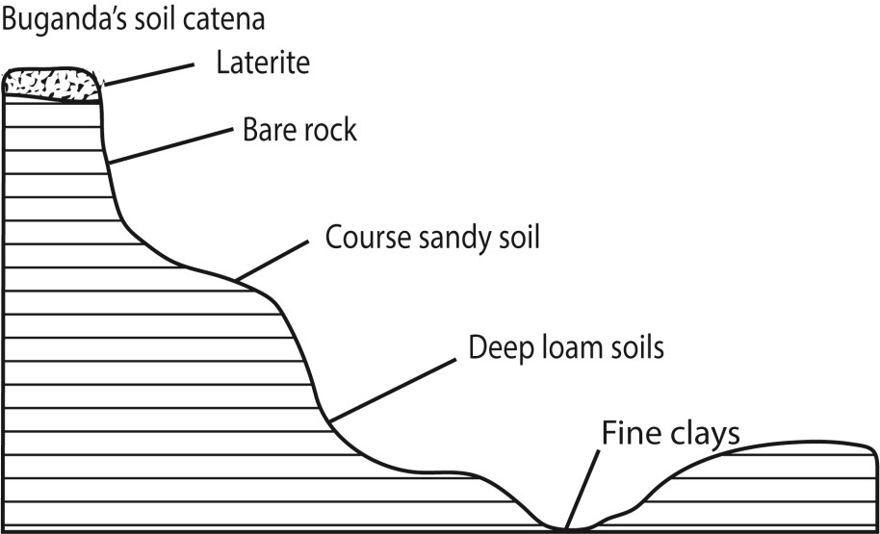

**The factors which have led to the development of soil catena in East Africa**

## Relief

The nature of a slope/topography influences the development a soil catena for example in Buganda the hill top/ridge tends to accumulate organic matter that allows formation of an adequate thickness of soil. Steeper slope or crest sections tend to be freely drained, while at the bottom of slopes or toeslopes there is usually higher in moisture content due to poor drainage.[[5]](https://en.wikipedia.org/wiki/Catena_(soil)#cite_note-5) Toeslope soils are not only higher in moisture content, but are also known to be richer in clay and organic matter.

## Drainage

The moisture content of the soil influences the development of the catena as soil changes along the slope. Well drained mature soils are found on the gentle slope while thin, stony dry, immature soils are found on the steep slopes. Clay/boggy soils are generally found in the valley bottoms where drainage is poor/water logged.

### Nature of parent rock

The characteristics of parent rock in terms of hardness, porosity, structure etc. will determine the rate of erosion thereby influencing the type of soil formed downslope. In addition the different soil along the slope could be the result of different parent materials.

### Human activities

Man’s activities like deforestation, settlement, agriculture etc. result in removal of surface vegetation which encourage erosion on the upper slopes and deposition on the lower slopes.

### Vegetation cover

Soil catena development is faster in areas without vegetation cover sind the rate of erosion is fast. Thick vegetation slow down the rate of erosion and the rate of soil catena development.

**Time**

Time is required to form a well developed soil catena

### Climate

Heavy rainfall in East Africa in areas around Lake Victoria promote leaching leading to the development of lateritic soils at the hill top.

**Heavy rainfall** encourage erosion on the upper slopes and deposition on the lowers slopes and valleys. Water logging due to heavy rainfall results in clay soils.

Thank you

Dr. Bbosa Science