# Bonding

Bonding is the chemical combination of atoms or elements to form compounds. The force of attraction holding atoms or elements together in a molecule/crystal is referred to as a chemical bond. Chemical bonding /combination occurs mainly in four forms as:

1. Ionic/electrovalent bonding-this involves transfer of electrons from a metal atom to a non metal atom. It occurs between metals and non metals.
2. Covalent bonding-this involves sharing of electrons between two or more non metal atoms/elements. The atoms/elements involved contribute to the bonding electrons.
3. Dative/co-ordinate bonding-this involves sharing of the bonding electrons which are donated by one molecule or atom involved.
4. Metallic bonding-this occurs between atoms of metal elements.

**Electrovalent/ ionic bonding**  
This involves transfer of electrons from a metal to a non metal. The number of electrons lost by the metal atom or gained by non metal atom is equivalent to its valency. The loss of electrons from a metal atom leads to formation of a positively charged ion (cation) and the gain of electrons by a non metal atom leads to the formation of a negatively charged ion (anion). The positively charged ion and the negatively charged ion are attracted to each other and the force of attraction holding them together is known as electrovalent/ionic bond. The compounds formed are referred to as ionic/ electrovalent compounds. Metal atoms lose electrons so as to gain stable electronic configuration of noble gases and non metal atoms also gain electrons to become stable.

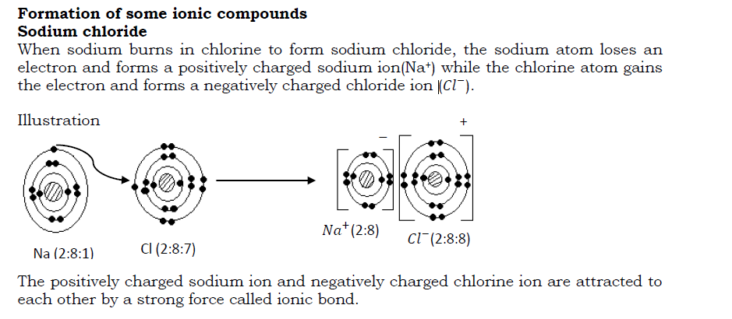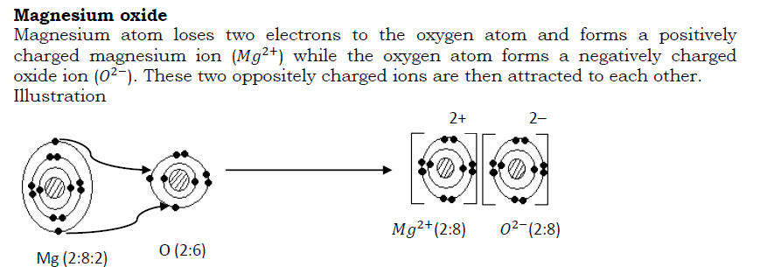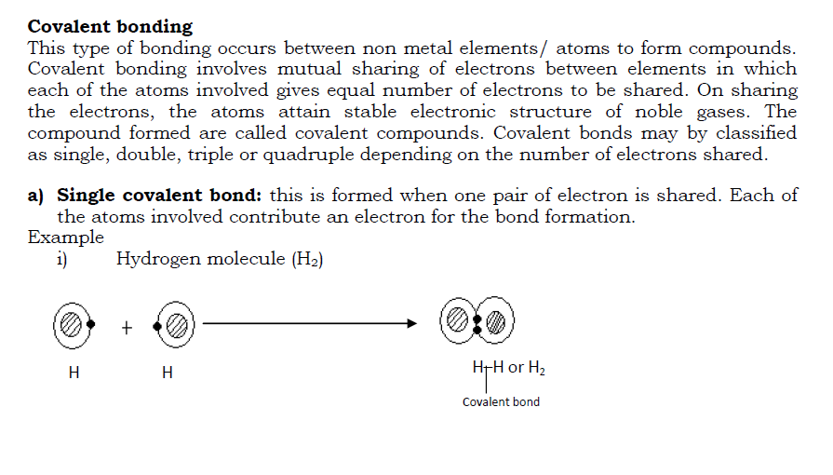

ii) Water molecule (H2O)

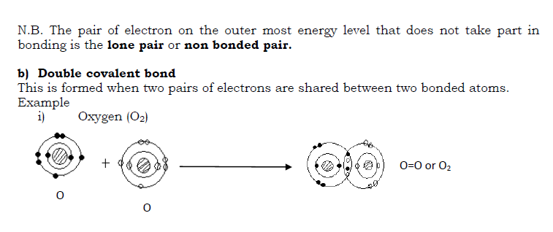

Dative/ co-ordinate bond  
This involves sharing of electrons but the shared pair of electrons is donated by one atom/ molecule. Here, one molecule/ atom donates the pair of electrons to be shared with an ion or another atom. Normally it is atoms/ molecules with lone pair of electrons that form this bond-by donating the lone pair of electrons to be shared with another atom/ion. The bond may be represented by an arrow originating from the donor atom (atom that donates electrons to be shared) to the atom accepting the electrons.

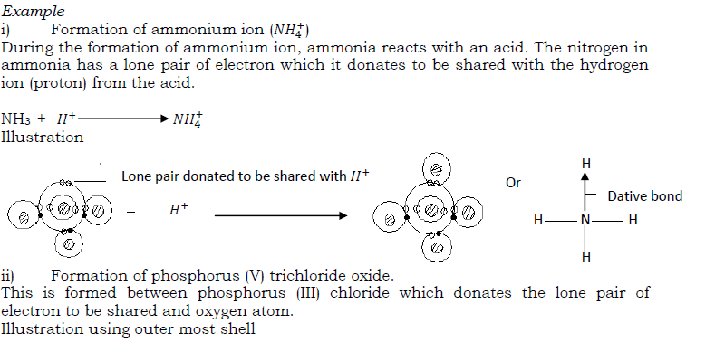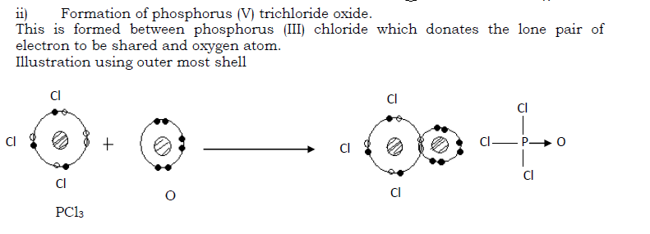

Metallic bonding  
This is the type of bonding in metals due to the attraction between metal ions and the valency electrons within the structure of the metal (metal lattice). In the structure of a metal, the loosely held valency electrons (electrons in the outer mos energy level) are released in to a general pool and the atoms become positively charged. These electrons move freely around the ions formed and are termed as mobile/delocalized electrons.

The ions formed and the electrons attract each other forming metallic bond.  
The strength of metallic bond increases with increase in the number of electrons released in to the electron cloud. Thus the bond is very strong in metals like iron and aluminum that release up to three electrons each to the electron pool and weak in metals like sodium and potassium that only release one electron each to the electron pool.

Illustration

Each sodium ion is surrounded by six chloride ions and each chloride ion is also surrounded by six sodium ions. The co-ordination number is there fore 6:6.

**Properties of ionic compounds**

1. They are solids with a regular shape. This is because of the strong electrostatic forces of attraction keeping the ions closely packed.
2. They have high melting points. This is due to the strong electrostatic force af attraction between oppositely charged ions.
3. They do not conduct electricity in solid states but do conduct in their molten states or solution form. This is because in solid states, the ions are localized and the electrons are not mobile but in molten form, the ions and electrons are free to move (electrons become delocalized) and thus conduct electricity.
4. They have high density as the ions are closely packed.
5. Ionic compounds are soluble in water and other polar solvents but they a re insoluble in organic solvents like benzene. Ionic compounds dissolve in polar solvents like water as the ions are attracted by the polar molecule.  
   A polar compound is a covalent compound in which charge separation exist between atoms. This is due to the differences in electro negativity between the atoms.  
   Electro negativity is the tendency of an atom to attract bonding electron towards itself. Electro positivity is the tendency of an atom to push away bonding electrons from itself.  
   For example, in a water molecule oxygen is more electro negative and attracts the bonding electrons towards itself giving it a partial negative charge. Hydrogen attains a partial positive charge.  
   Structure of a water molecule

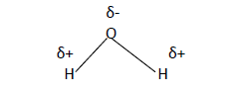

**NB** Most metals are malleable and ductile. This is because, since the bonding agent in a metal is a moving electron cloud, the ions of the metal; usually slide relative to one another under stress (without shattering the lattice and produce a new position of stability).

Simple molecular structures  
The structure consists of simple independent molecules joined together by weak intermolecular forces of attraction. E.g. Vander Waal‘s force of attraction. The atoms in the molecule are held together by strong covalent bond. Compounds with this structure exist as gases, liquids or solids with low melting points. Examples include iodine, carbon dioxide , ammonia and water.

Structure of iodine

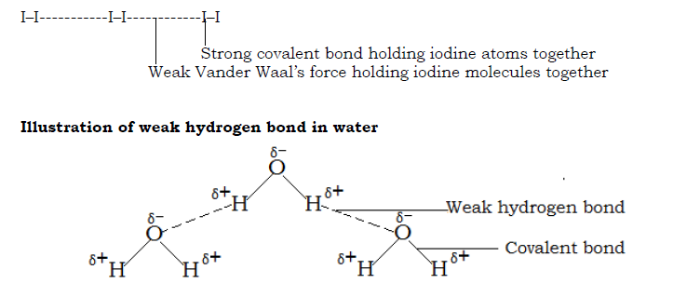

Properties of simple molecular structures

* They have low melting and boiling points because the molecules are held by weak intermolecular forces of attraction.
* They are non conductors of electricity because they do not have mobile electrons/ ions.
* Most of them are gases and liquids. Very few are solids.
* They have low densities as the molecules are not closely packed.
* They dissolve in organic solvents.  
  Giant atomic/molecular structure  
  Compounds with such structures consist of molecules /atoms linked together by strong covalent bonds resulting into a giant three dimensional or three dimensional structures like in graphite and diamond respectively (see details under Carbon and its compounds)  
  Properties of giant molecular structures
* They have high melting and boiling pints because of great energy needed to break the bonds.
* They do not conduct electricity except graphite which has delocalized electrons.
* They are insoluble in water.  
  Giant metallic structure  
  Giant metallic structure consists of very many metal ions surrounded by a sea /cloud of electrons. These electrons are released by metal atoms.  
  Properties of giant metallic structures
* They are solids with high melting and boiling points except mercury which is a liquid.
* They conduct electricity in both liquid and solid states due to the presence of mobile electrons.

Sample questions on bonding and structure  
Bonding and structure

1. Describe briefly what is meant by the following types of bonding: electrovalent, covalent, coordinate and metallic. Use examples to illustrate how the above bonds are formed between any two named atoms or molecules.
2. Explain what is meant by metallic bond. Explain why a typical metal is (a) a good conductor of electricity (b) a good conductor of heat (c) in some conditions at leas malleable and ductile.
3. The compounds named below are all covalent compounds. With the aid of the table of electron structures, give a diagram for a molecule of each of these compounds showing the outer most electron shells only: (i) tetra chloromethane CCl4, phosphorus(III) chloride PCl3 (iii) silane SiH4 (iv) tri chloromethane CHCl3 (v) phosphine PH3 and (vi) dichloromethane CH2Cl2
4. Explain briefly why ammonia and oxygen molecules participate readily in coordinate bonding. Give an example for the formation of an ion by ammonia by this means. Show by means of electronic diagram the formation of a coordinate linkage between phosphorus tri chloride and oxygen.
5. By means of electronic diagrams, show the structure of (a) calcium atom (b) chlorine atom (c) calcium chloride. State the differences between electrovalent and covalent compounds.
6. Describe how structures of the following compounds account for their property in term of electrical conduction (a) copper (b) graphite (c) diamond
7. With the aid of well labeled drawings explain the structure of the following: Graphite, diamond, sodium chloride and chlorine molecule.

# Introduction to alloys

Back to: [O level chemistry notes full Uganda syllabus](https://revisionug.com/course/o-level-chemistry-notes-full-uganda-syllabus/)

An alloy is a mixture of two or more metals. Alloys are formed by thoroughly mixing molten metals. It has been found that alloying produces metallic substance with more useful properties than the original pure metal it is made from. Examples of alloys include:

* 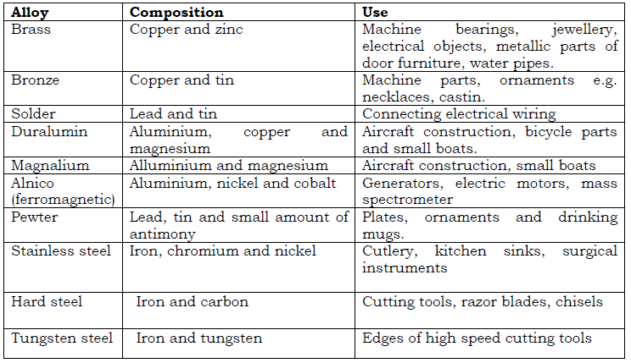

**Differences between mixtures and compounds**

* 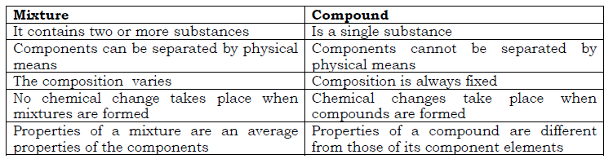

**Simple Criteria for purity**  
A pure substance is one which has distinct physical and chemical properties that are only unique it. These physical and chemical properties can be reproduced at ant time under the same conditions.  
Physical properties such as taste, smell, and color of a substance cannot give accurate measurements of purity. For instance, sea water looks like pure water, impure

naphthalene has the same smell as pure naphthalene (smell of moth balls), pure copper wire feels like a wire made of copper alloy.  
However, the following properties can be used to determine the degree of purity of substances. The values are constant for a pure substance.  
• Melting points of solids (is constant and the solid melts sharply )  
• Density of solids and liquids  
• Boiling point of liquids  
• Freezing point of liquids  
• Refractive index for liquids  
The experimental values of the above properties are compared to the standard values and if they coincide, then the substance being investigated is pure.  
N.B. The experiment for the investigation of purity must be carried out under the same conditions (of pressure and temperature) in which the standard values were obtained.

SOLUTIONS AND SUSPENSION  
SOLUTIONS  
A solution is a uniform mixture of two or more substances. Examples of solutions include: Air-a solution of gases; aqueous solution-a solution of any substance in water; alloy-a solution of metals.  
Solutions are formed when solutes completely mix with solvents.  
I.e. Solute + Solvent = Solution  
A solute is a substance that dissolves in a solvent. Examples are salts and sugar.  
A solvent is a substance that dissolves solutes. E.g. water.  
A solute is said to be soluble in a given solvent if it can dissolve in the solvent and insoluble if it does not dissolve in that given solvent.  
Depending on the amount of solute in the solvent, solutions can be classified as unsaturated, saturated and super saturated.  
Unsaturated solution: This is a solution that can dissolve more solutes at a particular temperature.  
Saturated solution: This is a solution that cannot dissolve any more solute at that temperature in the presence of undissolved solutes.  
Super saturated solution: This is a solution that contains more solutes than it can hold at that temperature in the presence of undissolved solutes.  
SUSPENSION  
A suspension is a liquid containing small particles of solids which are spread throughout it and the solid particles settle on standing. Examples of suspensions include:  
Paint – a suspension of colored substances in water or oil: Muddy water- a suspension of mud in water: suspension of chalk dust particles in water.

**N.B**. A suspension of a liquid in another liquid is called an emulsion and not a suspension.  
Characteristics of a suspension

1. Tinny solid particles are visibly seen spread throughout the liquid.
2. On standing, the tinny solid particles settle at the bottom leaving a clear liquid. Centrifuging makes the solid particles to even settle faster.
3. The tinny solid particles in a suspension can be separated from the liquid by filtration.  
   CRYSTALS  
   A crystal is a solid that consists of particles (atoms, molecules or ions) arranged in an orderly and repeatitive manner resulting into a definite shape. Crystals have regular shapes with flat sides and sharp edges. Examples of crystals include: sugar crystals, blue copper(II)sulphate crystals, common salt (sodium chloride) crystals, potassium nitrate crystals and potassium aluminium nitrate(Alum). Crystals are formed by the process of crystallization.  
   Crystallization is the process of evaporating a solution making it more saturated with the solutes such that the excess solutes are deposited as crystals. The solution is evaporated by either heating it or exposing it to sunlight.  
   Growing of a large crystal  
   Large crystals can be grown from saturated solutions.  
   Growing of a large crystal of copper(II)sulphate.  
   **Procedure**  
   **Drawing**

* 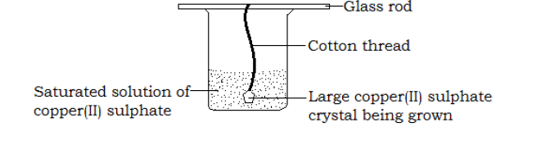
* Pour a saturated solution of copper(II)sulphate in a beaker
* Dip a cotton thread into the solution and remove it. Allow the thread to dry, as small crystals form on it.
* Put back the thread containing small crystals into the saturated solution of copper(II)sulphate and allow the beaker to stand for some days in a warm place.  
  **Observation**  
  Large blue crystals of copper (II) sulphate will form on the cotton thread.  
  **Water of crystallization**  
  This is the definite amount of water with which some substances chemically combine when they form crystals (from their solutions in water). A compound that contains water of crystallization is referred to as a hydrated compound (hydrate). Examples of hydrated compounds include
* 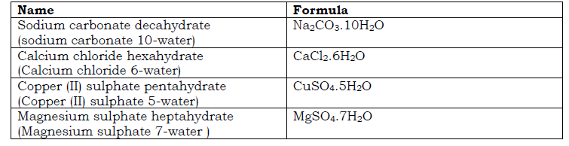

Some crystals do not have water of crystallization e.g. sodium chloride (NaCl) and lead(II)nitrate (Pb(NO3)2).  
Dry compounds that do not contain water of crystallization are called anhydrous compounds. E.g. anhydrous copper(II)sulphate (white powder); anhydrous calcium chloride (white powder). They normally exist in powdery forms and not as crystals.  
Exchange of water takes place between some crystals and the atmosphere. Some substances absorb water from the atmosphere while some release water to the atmosphere. These substances are grouped in to three as:

1. Hygroscopic substance  
   This is a substance that absorbs water from the atmosphere and remains physically unchanged. I.e. does not dissolve to form solution. Examples include: anhydrous copper(II)sulphate (CuSO4); calcium oxide (CaO); Copper(II)oxide (CuO);anhydrous calcium chloride (CaCl2) and concentrated sulphuric acid(H2SO4). Hygroscopic substances are used for drying gases.  
   Hygroscopy is the process of absorbing moisture/water from the atmosphere without the substance changing physically.
2. Deliquescent substance  
   This is a substance that absorbs water

from the atmosphere and dissolves in it to form a solution. E.g. sodium hydroxide pellets(NaOH); Potassium hydroxide pellets (KOH); and Copper(II)chloride (CuCl2).  
Deliquescence is the process whereby a substance absorbs water from the atmosphere and forms a solution.

1. Efflorescent substance  
   Is a substance that loses its water of crystallization to the atmosphere. The process in whereby a substance loses its water of crystallization to the atmosphere is called efflorescence. Examples of wfflorescent substances include; sodium carbonate decahydrate (Na2CO3.10H2O); Sodium suphate decahydrate (Na2SO4.10H2O).

* 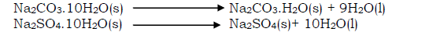

When hydrated compounds are heated, they lose their crystalline shapes as the water of crystallization escapes, become powdery and as well their colours change.  
For example when hydrated copper(II)crystals are heated, the blue crystals turn into white powder (anhydrous copper(II)sulphate) and a colorless liquid (water) condenses on the cooler parts of the test tube

* 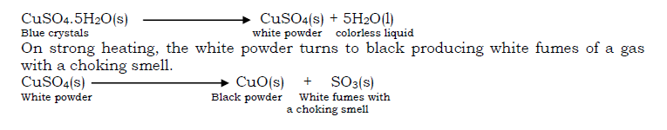

Sample questions on Laboratory apparatus; Matter; Elements, Mixtures and compounds  
Bunsen burner and flames

1. A Bunsen burner is one of the apparatus used for heating in the laboratory.  
   a) Define the term laboratory  
   b) Make a labeled drawing of a Bunsen burner and give the functions of all labeled parts.  
   c) How are you able to light a Bunsen burner?
2. Define a flame? Mention the two common types of flames and conditions under which each is produced. Make labeled drawings of the two types of flames and explain what happens in each of the labeled zones. Give four differences and two similarities between the two types of flames. What is strike back?  
   Matter
3. What is matter? Mention the different states of matter and give the characteristics of each state.
4. State kinetic theory of matter? Use kinetic theory of matter to explain why a solid object changes into a liquid and finally a gas when heated. Uses a schematic diagram to illustrate the different processes involved in the transition of matter from one state to another. Define the processes mentioned in the schematic diagram.
5. Define Brownian motion and diffusion. Describe experiments to demonstrate Brownian motion and diffusion in liquids and gases. Outline four factors that affect the rate of diffusion of gases. Describe an experiment to show that ammonia and hydrogen chloride gases diffuse at different rates.
6. Define the terms melting, freezing and boiling points. Describe experiments to show how you can determine the melting point of naphthalene and boiling point of ethanol. Sketch a temperature-time graph for cooling liquid naphthalene. Identify the melting point and label it T on the graph axis.
7. Define the terms physical and chemical changes and state at least two examples of each. Mention the characteristics of physical and chemical changes and clearly give the differences between them.
8. Describe the observations you would make when each of the following substances are heated: candle wax; magnesium, iodine; potassium permanganate; lead(II) nitrate; hydrated copper(II) sulphate; sulphur and zinc oxide.  
   Elements, mixtures and compounds
9. Define the terms element, mixture and compounds giving three examples of each (where applicable write the symbol or formula). Give the names and formulae of five compounds stating clearly the elements that they are composed of. What are the differences between a mixture and a compound?
10. On what property is each of the following methods of separation of mixtures based: fractional distillation; fractional crystallization; sublimation; chromatography and magnetic separation?
11. Describe how the following mixtures can be separated: oil and water; salt from water; sugar from sand; sand and water; ethanol and water; diesel and kerosene; a mixture of different colours; iodine and common salt; potassium chloride and potassium nitrate; iron and sulphur.
12. What an alloy, mention three examples is of alloys any their uses. Brass, bronze, duralumin, solder and stainless steel are alloys. Mention the components in each alloy.  
    Solutions, suspension and crystals
13. Define the following terms as applied to chemistry: solution, suspension, solute, solvent, saturated solution, unsaturated solution, super saturated solution and crystallization.
14. What is a crystal? Explain with a the aid of a drawing how a large crystal of copper(II) sulphate can be grown.
15. Some compounds are said to have water of crystallization. What is water of crystallization? Mention three examples of hydrated compounds and write their formulae.
16. Define the following terms: hygroscopy, deliquescence and efflorescence. What are hygroscopic and efflorescent substances (illustrate with at least two examples of each)