**ATLAS JUNIOR SCHOOL – LUGOBA NABWERU**



**MID TERM TWO EXAMINATIONS 2024**

LITERACY ONE

***PRIMARY THREE***

***Time allowed: 2 hours 15 Minutes***

Name: ………………………………………………………………………………Stream: …………………….…………

|  |
| --- |
| **FOR EXAMINER’S USE ONLY** |
|  |

|  |  |  |
| --- | --- | --- |
| **FOR EXAMINER’S USE ONLY** | | |
| ***Qn. No.*** | ***MARKS*** | ***EXR’S NO.*** |
| **1-15** |  |  |
| **16-29** |  |  |
| **30 - 40** |  |  |
| **41 - 43** |  |  |
| **44 - 46** |  |  |
| **47 - 50** |  |  |
| **51-54** |  |  |
| **55** |  |  |
| **TOTAL** |  |  |

**Read the following instructions carefully.**

1. *This paper has two sections:* ***A*** *and* ***B***
2. *Section* ***A*** *has* ***40*** *questions (40 marks)*
3. *Section* ***B*** *has* ***15*** *questions (60marks)*
4. *Answer* ***all*** *questions. All answers to both sections* ***A*** *and* ***B*** *must be written in spaces provided.*
5. *All answers must be clearly written using* ***blue*** *or* ***black*** *ball point pen or ink.*
6. *Unnecessary changes of work may lead to loss of marks.*
7. *Any handwriting that cannot be easily read, may lead to loss of marks.*
8. *Do* ***not*** *fill anything in the boxes indicated. For official use only.*

**SECTION A (40 MARKS)**

1. Name any **one** animal that lives in water.

______________________________________________________________________

1. Write down any **one** example of a physical feature.

______________________________________________________________________

1. Which part of the plant is commonly visited by bees?

______________________________________________________________________

1. Draw this local mean of communication.

**horn**

1. What does a snail use to protect itself?

______________________________________________________________________

1. Write any **one** role of a child at home.

______________________________________________________________________

1. Why is a lizard called a living thing?

_____________________________________________________________________

1. Write any **one** physical body exercise.

______________________________________________________________________

1. Give any **one** element of weather.

_____________________________________________________________________

1. Give any **one** example of a common accident.

______________________________________________________________________

1. Why do we eat food?

____________________________________________________________________

1. Write any **one** importance of a mobile phone at home.

____________________________________________________________________

1. Give any **one** way of protecting ourselves from malaria.

____________________________________________________________________

1. Why do we need police officers in our sub-county?

___________________________________________________________________

1. Why should people smoke latrines?

___________________________________________________________________

1. Write the place where children at school go for treatment.

___________________________________________________________________

1. What helps a bird to move in air?

___________________________________________________________________

1. Write any **one** importance of rivers.

___________________________________________________________________

1. Name the best season for planting crops.

___________________________________________________________________

1. How many members make up the local council I executive committee?

___________________________________________________________________

**Use the diagram below to answer question 21 and 22.**

 **X**

1. Name part marked with letter **X**.

____________________________________________________________________

1. How many legs does the animal above have?

____________________________________________________________________

1. Draw and name **one** mean of road transport in the space provided.
2. Why should we brush our teeth?

____________________________________________________________________

1. What do plants use for breathing?

___________________________________________________________________

1. Which level of education does Sarah of Primary five attend?

__________________________________________________________________

1. Write down any **one** role of leaders in our division.

__________________________________________________________________

1. Why do people cut down trees?

__________________________________________________________________

1. Name any **one** item that can be made by a potter.

___________________________________________________________________

1. Name the gas used in a fire extinguishers. (oxygen, carbon dioxide)

___________________________________________________________________

1. How can you control accidents at home?

___________________________________________________________________

1. ___________________________is the vertical arrangement of soil layers. (soil profile , soil erosion)
2. Give any **one** social service provided in our division.

____________________________________________________________________

1. Identify the property of air shown below.

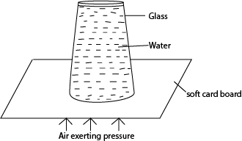

____________________________________________________________________

1. Which product do we get from sugarcane?

____________________________________________________________________

1. Name any **one** place where we find germs.

___________________________________________________________________

1. Why do people plant trees?

___________________________________________________________________

1. Give any **one** use of a hoe to a crop farmer.

____________________________________________________________________

1. What do we get from a sheep?

___________________________________________________________________

1. Why do plants need sunlight?

___________________________________________________________________

**SECTION B (60 MARKS)**

1. a) Name the place of work of the following;
2. Teacher ____________________________________________________
3. Market trader ___________________________________________________

b) Name these tools used at work.

|  |  |
| --- | --- |
|  |  |
|  |  |

1. The diagram below shows a flowering plant. Study it carefully and answer questions that follow.

**c**

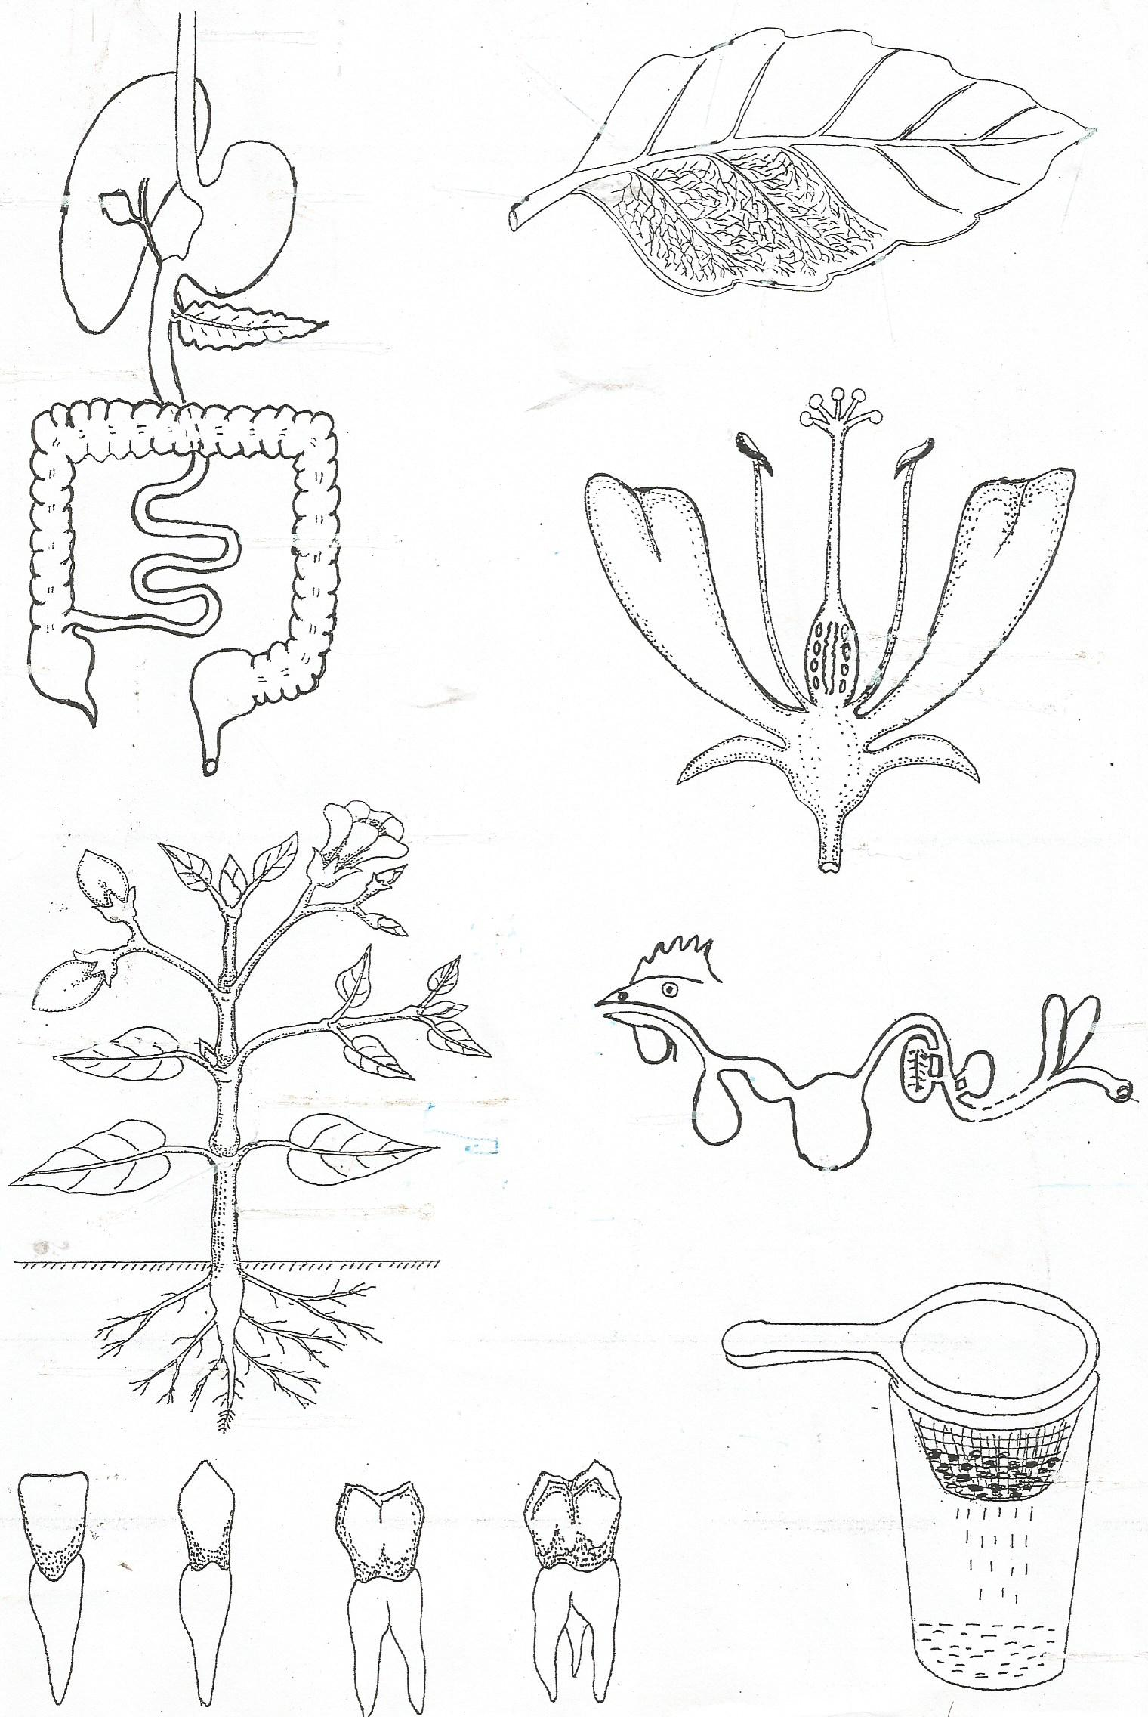

**b**

**a**

1. Name parts marked **A, B** and **C**.

A____________________ B_________________________

C____________________

1. Give any **one** example of a flowering plant.

___________________________________________________________________

1. a) Name any **one** source of materials used to make crafts.

___________________________________________________________________

b) Mention any **two** examples of materials used to make crafts.

i)______________________________ ii)_______________________________

c) Draw any **one** craft made from animals.

**The diagram below is of an insect. Use it to answer question 44.**



1. a) Name the insect shown above.

________________________________________________________________

b) Give any **one** way we can control diseases spread by the insect above at home.

____________________________________________________________________

1. Give any **two** diseases spread by the insect above.

i)_________________________ ii)_____________________________________

1. a) Write down any **one** example of ethnic group of people in our division.

___________________________________________________________________

b) Write the languages the following tribes speak;

i) Basoga _________________________________________________________

ii) Baganda ________________________________________________________

d) Give any **one** cultural practice done by the Baganda tribe.

____________________________________________________________________

1. Match the body part to its use.

**Body parts Use**

Tongue feeling

skin seeing

Eyes tasting

Nose smelling

Tongue _____________________________________________

skin ______________________________________________

Eyes ______________________________________________

Nose ______________________________________________

1. Match the social service to the social provider.

**Social service Social service provider**

Education service surgeon

Transport service teacher

Health service police officer

Security service pilot

Education service __________________________________________

Transport service __________________________________________

Health service __________________________________________

Security service __________________________________________

1. The diagram below is a fish. Study it carefully and answer the questions that follow.

B

A

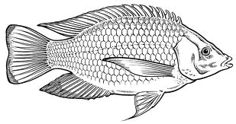

1. Name parts A and B.

A_______________________________ B_____________________________

1. What is the home for fish?

____________________________________________________________________

1. Why do people catch fish from water?

___________________________________________________________________

1. a) What are children rights?

________________________________________________________________________________________________________________________________________

b) Give any two examples of children’s right.

1. _______________________
2. _______________________

c) Give two people who protect children rights.

i)______________________________ ii) _________________________________

1. a) Give any two ways a farmer can care for crops in the garden.
2. ________________________________________________________________
3. ________________________________________________________________

b) Draw and name any one example of a garden tool in the space provided below.

1. Write the use of the garden tool above.

____________________________________________________________________

1. a) What do we call an act of keeping resources for future use?

___________________________________________________________________

b) Give any two ways of saving resources.

i)_________________________________________________________________

ii)________________________________________________________________

c) Write down any one reason why people save.

____________________________________________________________________

1. Complete the table below correctly.

**Living organism Method of protection/weapon**

___________________________ prickly hair

bedbug ____________________________

__________________________ horns

snake ____________________________

1. a) What do we call a group of people related by blood, marriage or adoption?

__________________________________________________________________

b) What can you do to your parents to show that you are a disciplined child?

____________________________________________________________________

c) Write **two** groups of people who help you at school.

i)________________________________ ii)________________________________

1. a) What are living things?

________________________________________________________________________________________________________________________________________

b) Give the two main groups of living things.

i)_________________________________ ii)_______________________________

c) Name any one example of a non-living in the environment.

____________________________________________________________________

1. **Read the passage below and answer questions that follow.**

**Insects**

There are two types of insects, these are social insect and solitary insects. Social insects do live and work together. Examples of social insects are bees, wasps, termite and ants. Solitary type of insects do not live and move together. Examples of solitary insects are butterfly, cockroach, locusts and grass whoppers.

Characteristics of insects are, have six legs, wings , pair of feelers and three main body parts, breathe through spiracles.

1. Name any one type of insects.

____________________________________________________________________

1. Write down any one example of insects.

____________________________________________________________________

1. How many legs does an insect have?

____________________________________________________________________

1. What does an insect breathe through?

____________________________________________________________________

***Success***