

# Physical geography Chapter 8: Lakes in East Africa

A lake is a depression or basin filled with water

Lakes in East Africa differ in permanency, salinity, shape, size and depth.

Methods for formation of lakes

Lakes may be formed by

* earth movements such coastal warping, faulting and folding;
* vulcanicity,
* erosion and deposition
* landslides
* human activity

1. Formation of lakes by earth movements

## (a) Coastal warping

The extensive downward and upward movement of the crust led to formation of depressions and uplands. Down warping occurred in central and South Eastern Uganda to form depressions occupied by lakes Victoria, Kyoga, Wamala and Nakivale.

* Before warping took place, land in central Uganda was sloping to the West and rivers like Katonga, Kagera, Rwizi, Kafu were flowing to the west.
* During warping, Eastern and Western Uganda were up warped while central Uganda down warped forming basins.
* After warping, rivers reversed their flow eastwards; emptying their waters into the basins to form lakes Victoria and Kyoga. Diagram(s) to illustrate river flows

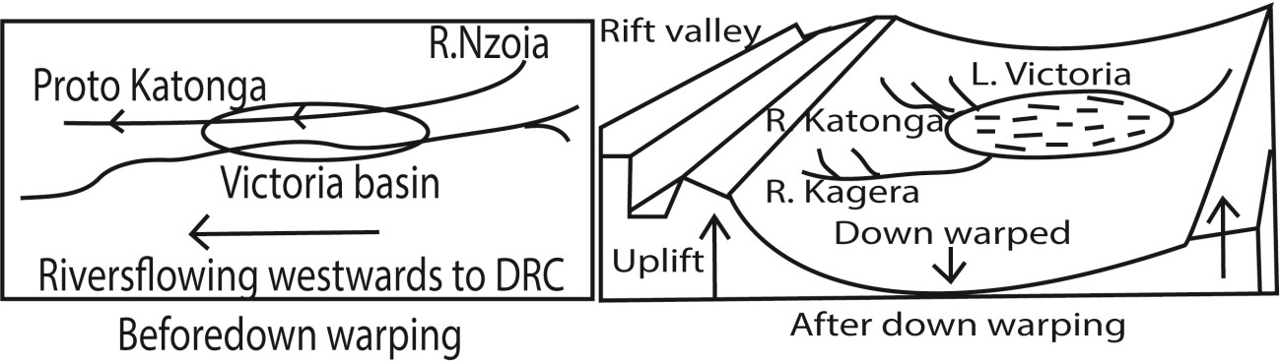

* The formed lakes are shallow in depth, having fresh water, irregular outlines/shore lines and extensive swamps around them bays/headland.

## (b) Faulting

The breaking and subsequent displacement of crustal rocks by forces of tension or compression led to the formation of following types of lakes:

## Grabens

• Grabens are hollow lakes/Rift valley lakes found in rift valley floor occupying graben hollow. Grabens result from forces of tension, compression forces. E.g. Albert, Tanganyika, Edward, George, Natron, Eyasi etc.

According to tensional forces

* Radioactive and convective currents from the mantle caused lines of weakness.
* Normal faults were created in the crust.
* Displacement occurred in the crust forming the rift valley.
* Secondary faulting took place in the rift valley to form grabens.
* Formed grabens were later occupied by water to from rivers, rain to form lakes.

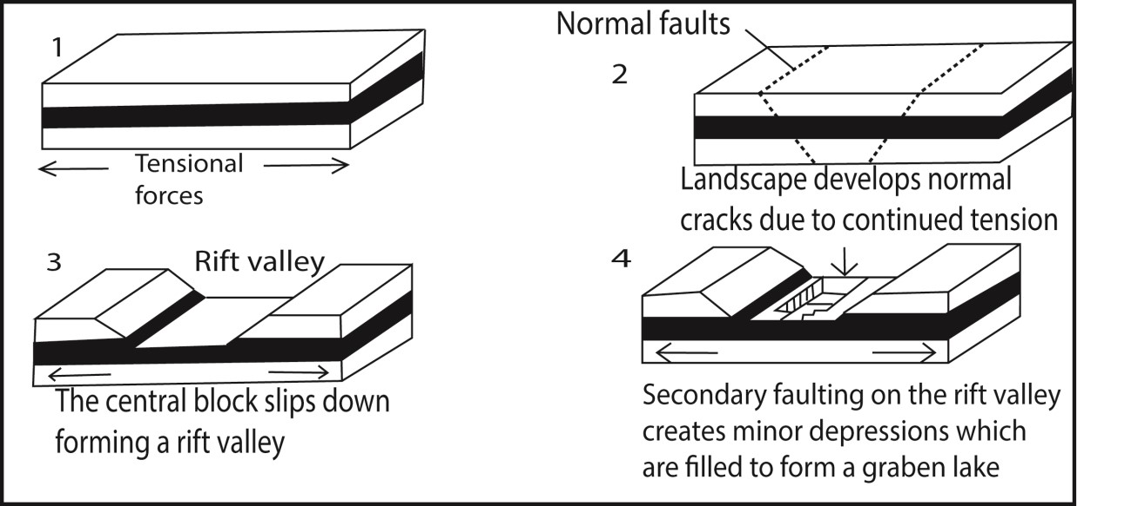

According to compressional forces

* Radioactive and convective currents from the crust produced lines of weaknesses.
* Reversed faults were formed in the crust
* Crustal displacement occurred to form the rift valleys
* Secondary faulting took place in the rift valley forming grabens.
* The formed grabens were occupied by water from rivers, rain to form lakes.

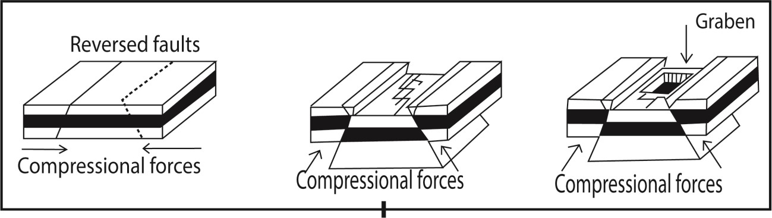

* The formed lakes are characterized by being narrow, elongated and deep with steep bank, taking shape of the grabens.
* Examples include lakes; Albert, Tanganyika, Turkana, Edward etc.

## Tilt block lakes

Tilt block lakes occupy depressions between tilted uplands/ridges.

* Tension and compression forces led to formation of several parallel faults dividing up the crust into several blocks.
* Faulted landscape was then subjected to uplift or sinking at different rates and then tilting in one direction forming angular ridges and depressions.
* Water from rain /rivers fill the depressions to form a lake(s) e.g. Lake olbolossat in Aberdares in Kenya.

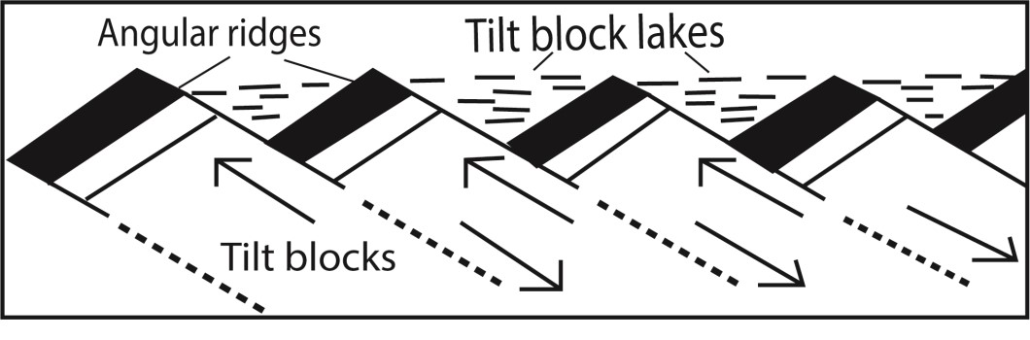

# Formation of lakes by vulcanicity

These lakes are formed when volcanic eruption blew off the mountain tops leaving behind funnel shaped depressions. They include

Crater lakes are formed due to eruption leaving behind depression/craters less than two miles. These are filled with water to form lakes Examples include L. Katwe, L. Nyamunuka, etc.

Caldera lakes such as Ngorongoro in Tanzania and Longonot in Kenya are similar to crater lakes except that they bigger

Lava lakes are formed when flowing lava from a volcano block a river valley leading to formation of lava dammed lake e.g. L. Muhehe, L. Bunyonyi etc.

# Deposition lakes

Formed by deposition of load of a slowly flowing river. They include **Ox-bow lakes**

**Ox-bow lakes** are horse-shoes shaped lakes or pool that forms when a wide meander of a river is cut off, creating a free-standing body of water. Examples are L. Makara on river Tana..

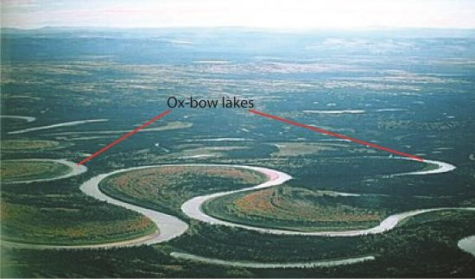

Lagoons like L. Nabugabo are formed by wave deposition

Delta lakes like L. Mchengu on R. Rufigi were formed when the river deposited excess alluvial that blocked some tributaries creating a small lake

Lakes formed by glacial deposition include moraine dammed lakes such as Tyndall lake on Mt. Kenya; Ribbon/trough lakes like L. Bujuki on Mt. Rwenzori; Rock basin lakes like Carr lakes and Enchanted lake on Mt. Kenya

Solution lakes

These are formed when soluble rocks like limestone dissolve in acidic water e.g. L. Nyakasura in western Uganda.

Man- made lakes

These are dug by human e.g. Kabaka’s lake in Kampala

Landslides, avalanches and other waster debris form temporary barrier that dam and form temporary lakes, e.g. L. Mbaka which formed in Tanzania in 1955 across Mbaka valley

Importance of lakes

Positive importance of lakes

* Provide water for irrigation
* Provide domestic water e.g. L. Victoria
* Provide fishing grounds
* Are used for transport
* Clay and sand along the shores are used for pottery and construction
* Papyrus vegetation are used in making art crafts
* Evaporation from lakes leads to formation of rainfall
* Promote tourism due to many plant and animal species they contain.
* For extraction of mineral such salt from L. Katwe

Negative importance of lakes

* Provide habitat vectors that spread diseases
* May cause flooding and destroy human property - Provide habitat for dangerous animals like crocodile - May lead to drowning of fishermen.

# Revision question

1. (a) Asses the influence of vulcanicity on lake formation in East Africa (b) Explain the importance of lakes in East Africa.
   1. candidate should define and explain the origin of vulcanicity; should define a lake and then explain how lakes are formed by vulcanicity; a candidate should the evaluate the question by giving other process through which lakes are formed. Marks are always awarded for an evaluation showing your stand points to a big extent or small extent. Finally explain the positive and negative importance of lakes)
2. To what extent has faulting been responsible for formation of lakes in East Africa?
   1. candidate should define a lake and then explain how lakes are formed by faulting; then evaluate the question by giving other process through which lakes are formed.)

1. To what extent have down warping influenced lake formation in East Africa

* 1. candidate should define a lake and then explain how lakes are formed by down warping; then evaluate the question by giving other process through which lakes are formed.)

Thank you

Dr. Bbosa Science