matter

**2023**

kintu

[Type the company name]

1/1/2023

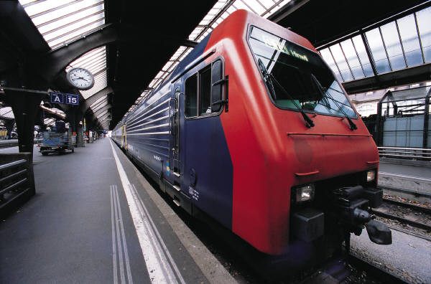

Matter.

Matter is anything that occupies space and has weight. Matter is made up of very tiny particles known as ions, atoms or molecules.  
An atom is the smallest electrically neutral particles of an element that takes part in a chemical reaction.  
A molecule is the smallest electrically neutral particle of a compound or element that can exist on its own.  
An ion is an electrically charged particle of an atom or a group of chemically combined atoms after losing or gaining electrons.  
Matter exists in three state i.e. liquid, solid and gas.

**Properties of the states of matter**  
**Solids**

* Consist of particles that are fixed together i.e. particles that are not mobile.
* The particles are held by very strong forces of attraction.
* Solids have fixed shape.
* Solids have very high density.
* Solids are practically incompressible.  
  **Arrangement of particles in a solid**

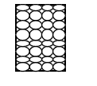

**Liquids**

* A liquid has a definite volume but no definite shape i.e. it takes up the shape of the container in which it is placed.
* Particles in a liquid are held together by weak intermolecular forces of attraction making the particles to move freely to some extent around each other.
* Liquids are slightly compressible
* Liquids are less dense compared to solids.
* Particles in a solid are relatively spread apart

**Arrangement of particles in a liquid**

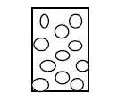

**Gases**

* Particles in a gas are far apart from each other.
* Particles in a gas are free to move randomly as they have negligible forces of attraction.
* Gases are easily compressible
* Gases have no definite shape and volume.
* Gases are very light.  
  **Arrangement of particles in a gas**

**KINETIC THEORY OF MATTER**

Kinetic theory of matter states that; Particles that make up matter have kinetic energy and they are always in motion. The extent of the movement of the particles depends on the amount of kinetic energy the particles have.

In solids, the particles are held together by very strong intermolecular forces of attraction; the particles donot have enough kinetic energy to make them move from one place to another but they can vibrate in their mean position. When a solid is heated, the kinetic energy of the particles increase as they absorb the heat energy which weakens the forces of attraction between the particles. When the melting point is reached, the molecules break free and the solid changes to liquid.

In liquids, the particles are held together by weak forces of attraction. However, they have enough kinetic energy to enable the particles move from one place to another within the liquid. When a liquid is heated, the forces of attraction between the particles are weakened further until when they are completely broken and at this point, the liquid changes to a gas. This is the boiling point of the liquid.

In a gas, the particles are free to move randomly as they posses much kinetic energy and the particles are not held together by any particular forces of attraction(or negligible forces of attraction)

**CHANGE OF STATES**

* The process by which a solid changes into a liquid is the melting.
* The constant temperature at which a solid changes into a liquid is called melting point
* The process by which a liquid changes into a gas is called boiling or evaporation.
* The constant temperature at which a liquid changes into a gas is the **boiling point**.
* The process by which a liquid changes to a solid is freezing or solidification.
* The constant temperature at which a liquid changes into a solid is referred to as **freezing point.**
* The process by which a gas changes into a liquid is called condensation.
* The process by which a gas changes directly to a solid is referred to as sublimation and vice versa

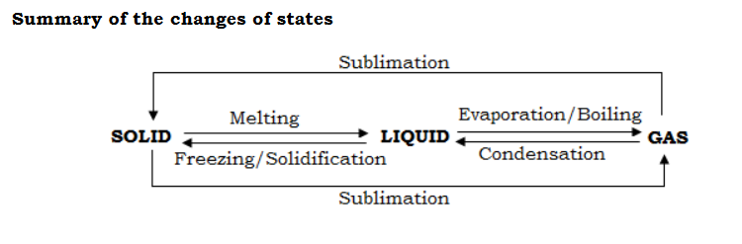

**Experiments to demonstrate that particles in liquids and gases move**

a)Brownian motion

This is the continuousrandom movement/motion of solid particles in liquids and gases.

**1.Demonstration of Brownian motion in Liquids**

When pollen grains are poured in water, they are seen to be moving in a continuous random zigzag manner. The movement of the pollen grain is due to bombardment of the particles by the moving particles of water.

**2.Demonstration of Brownian motion in gases**

When smoke particles are trapped in a glass cell and observed under a microscope, the particles are seen to be moving in a random zigzag manner. The movement of the smoke particles is due to bombardment by the moving gas particles.

Or

When a beam of light is directed into a dark room, the dust particles are seen to be moving in a continuous random manner. The movement of the dust particles is due to the bombardment of these particles by gas particles.

**b)Diffusion**

This is the spreading of particles or molecules from aregion of high concentrationto a region of low concentration.

**1.Demonstration of diffusion in liquids**

Place a crystal of potassium permanganate in a beaker of water and watch. After sometimes, the water turns pink due to the particles of potassium permanganate spreading through out the water.

**2.Demonstration of diffusion in gas**

Open a bottle of concentrated ammonia solution and place the bottle at the corner of aroom. After sometimes, ammonia smell will spread through out the room due to diffusion of the ammoniaparticles.

**Rate of diffusion of gases**

The rate of diffusion of a gas depends on;

* -Density of the gas. The lighter the gas, the higher the rate of diffusion.
* -Density of the diffusion medium. The lighter the density of the diffusion medium, the faster is the rate of diffusion.
* -Concentration gradient. The steeper the concentration gradient, the higher the rate of diffusion.
* -Surface area. The smaller the surface area of diffusion, the higher the rate of diffusion.
* -Temperature of the diffusion medium. The higher the temperature, the faster is the rate of diffusion of the particles.
* -Size of the particles. Smaller particles diffuse faster the larger particles.
* -Distance through which diffusion occurs. The smaller the diffusion distance, the faster is the diffusion.

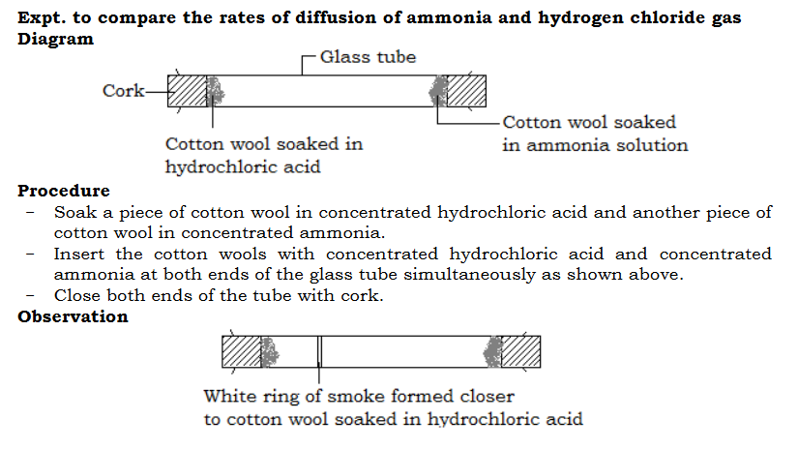

[Previous Lesson](https://revisionug.com/lesson/zones-of-a-luminous-flame-2/)

[Kinetic theory of matter](https://revisionug.com/lesson/zones-of-a-luminous-flame-2/)

[Kinetic theory of matter states that;  
Particles that make up matter have kinetic energy and they are always in motion. The extent of the movement of the particles depends on the amount of kinetic energy the particles have.  
In solids, the particles are held together by very strong intermolecular forces of attraction; the particles do not have enough kinetic energy to make them move from one place to another but they can vibrate in their mean position. When a solid is heated, the kinetic energy of the particles increase as they absorb the heat energy which weakens the forces of attraction between the particles. When the melting point is reached, the molecules break free and the solid changes to liquid.  
In liquids, the particles are held together by weak forces of attraction. However, they have enough kinetic energy to enable the particles move from one place to another within the liquid. When a liquid is heated, the forces of attraction between the particles are weakened further until when they are completely broken and at this point, the liquid changes to a gas. This is the boiling point of the liquid.  
In a gas, the particles are free to move randomly as they posses much kinetic energy and the particles are not held together by any particular forces of attraction (or negligible forces of attraction)](https://revisionug.com/lesson/zones-of-a-luminous-flame-2/)

**[CHANGE OF STATES](https://revisionug.com/lesson/zones-of-a-luminous-flame-2/)**

[The process by which a solid changes into a liquid is the melting. The constant temperature at which a solid changes into a liquid is called melting point  
The process by which a liquid changes into a gas is called boiling or evaporation. The constant temperature at which a liquid changes into a gas is the boiling point.  
The process by which a liquid changes to a solid is freezing or solidification.  
The constant temperature at which a liquid changes into a solid is referred to as freezing point.  
The process by which a gas changes into a liquid is called condensation.  
The process by which a gas changes directly to a solid is referred to as sublimation and vice versa.](https://revisionug.com/lesson/zones-of-a-luminous-flame-2/)**[Summary of the changes of states](https://revisionug.com/lesson/zones-of-a-luminous-flame-2/)**

* [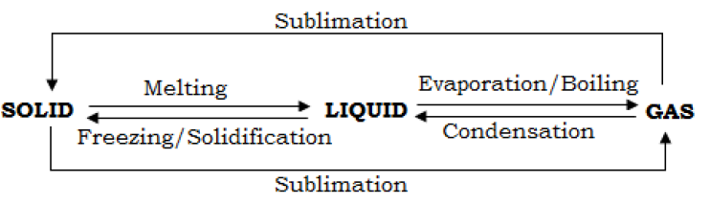](https://revisionug.com/lesson/zones-of-a-luminous-flame-2/)

**[Experiments to demonstrate that particles in liquids and gases move](https://revisionug.com/lesson/zones-of-a-luminous-flame-2/)****[a) Brownian motion](https://revisionug.com/lesson/zones-of-a-luminous-flame-2/)** [This is the continuous random movement/motion of solid particles in liquids and gases.](https://revisionug.com/lesson/zones-of-a-luminous-flame-2/)

1. **[Demonstration of Brownian motion in Liquids](https://revisionug.com/lesson/zones-of-a-luminous-flame-2/)** [When pollen grains are poured in water, they are seen to be moving in a continuous random zigzag manner. The movement of the pollen grain is due to bombardment of the particles by the moving particles of water.](https://revisionug.com/lesson/zones-of-a-luminous-flame-2/)
2. **[Demonstration of Brownian motion in gases](https://revisionug.com/lesson/zones-of-a-luminous-flame-2/)** [When smoke particles are trapped in a glass cell and observed under a microscope, the particles are seen to be moving in a random zigzag manner. The movement of the smoke particles is due to bombardment by the moving gas particles.](https://revisionug.com/lesson/zones-of-a-luminous-flame-2/)**[Or](https://revisionug.com/lesson/zones-of-a-luminous-flame-2/)** [When a beam of light is directed into a dark room, the dust particles are seen to be moving in a continuous random manner. The movement of the dust particles is due to the bombardment of these particles by gas particles.](https://revisionug.com/lesson/zones-of-a-luminous-flame-2/)

**[b) Diffusion](https://revisionug.com/lesson/zones-of-a-luminous-flame-2/)**

[This is the spreading of particles or molecules from a region of high concentration to a region of low concentration.](https://revisionug.com/lesson/zones-of-a-luminous-flame-2/)

1. **[Demonstration of diffusion in liquids](https://revisionug.com/lesson/zones-of-a-luminous-flame-2/)** [Place a crystal of potassium permanganate in a beaker of water and watch. After sometimes, the water turns pink due to the particles of potassium permanganate spreading throughout the water.](https://revisionug.com/lesson/zones-of-a-luminous-flame-2/)
2. **[Demonstration of diffusion in gas](https://revisionug.com/lesson/zones-of-a-luminous-flame-2/)** [Open a bottle of concentrated ammonia solution and place the bottle at the corner of a room. After sometimes, ammonia smell will spread through out the room due to diffusion of the ammonia particles.  
   Rate of diffusion of gases](https://revisionug.com/lesson/zones-of-a-luminous-flame-2/)**[The rate of diffusion of a gas depends on;](https://revisionug.com/lesson/zones-of-a-luminous-flame-2/)**

* [Density of the gas. The lighter the gas, the higher the rate of diffusion.](https://revisionug.com/lesson/zones-of-a-luminous-flame-2/)
* [Density of the diffusion medium. The lighter the density of the diffusion medium, the faster is the rate of diffusion.](https://revisionug.com/lesson/zones-of-a-luminous-flame-2/)
* [Concentration gradient. The steeper the concentration gradient, the higher the rate of diffusion.](https://revisionug.com/lesson/zones-of-a-luminous-flame-2/)
* [Surface area. The smaller the surface area of diffusion, the higher the rate of diffusion.](https://revisionug.com/lesson/zones-of-a-luminous-flame-2/)
* [Temperature of the diffusion medium. The higher the temperature, the faster is the rate of diffusion of the particles.](https://revisionug.com/lesson/zones-of-a-luminous-flame-2/)
* [Size of the particles. Smaller particles diffuse faster the larger particles.](https://revisionug.com/lesson/zones-of-a-luminous-flame-2/)
* [Distance through which diffusion occurs. The smaller the diffusion distance, the faster is the diffusion.](https://revisionug.com/lesson/zones-of-a-luminous-flame-2/)

**[Expt. to compare the rates of diffusion of ammonia and hydrogen chloride gas  
Diagram](https://revisionug.com/lesson/zones-of-a-luminous-flame-2/)**

* [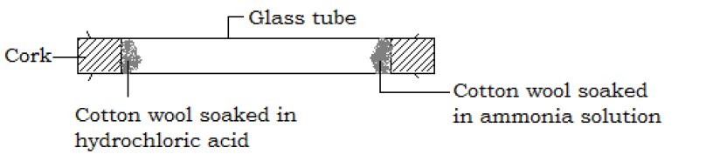](https://revisionug.com/lesson/zones-of-a-luminous-flame-2/)

**[Procedure](https://revisionug.com/lesson/zones-of-a-luminous-flame-2/)**

* [Soak a piece of cotton wool in concentrated hydrochloric acid and another piece of cotton wool in concentrated ammonia.](https://revisionug.com/lesson/zones-of-a-luminous-flame-2/)
* [Insert the cotton wools with concentrated hydrochloric acid and concentrated ammonia at both ends of the glass tube simultaneously as shown above.](https://revisionug.com/lesson/zones-of-a-luminous-flame-2/)
* [Close both ends of the tube with cork.](https://revisionug.com/lesson/zones-of-a-luminous-flame-2/)**[Observation](https://revisionug.com/lesson/zones-of-a-luminous-flame-2/)**
* [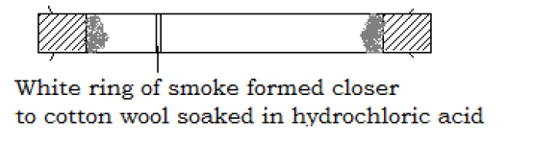](https://revisionug.com/lesson/zones-of-a-luminous-flame-2/)

[After some times, a white ring of smoke of ammonium chloride is formed in the tube, indicating the ammonia and hydrogen chloride gas diffused through some distance before they met. The white ring was formed closer to the end of the tube with cotton wool containing hydrochloric acid indicating that ammonia diffused through a longer distance than hydrogen chloride.](https://revisionug.com/lesson/zones-of-a-luminous-flame-2/)**[Conclusion](https://revisionug.com/lesson/zones-of-a-luminous-flame-2/)** [Ammonia gas diffuses faster than hydrogen chloride gas.](https://revisionug.com/lesson/zones-of-a-luminous-flame-2/)

**[Determination of the melting point of naphthalene  
Drawing of the setup](https://revisionug.com/lesson/zones-of-a-luminous-flame-2/)**

* [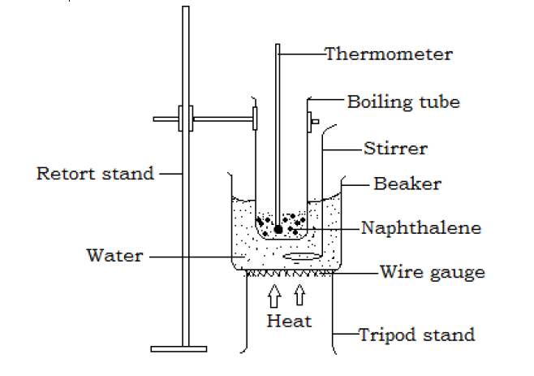](https://revisionug.com/lesson/zones-of-a-luminous-flame-2/)

**[Procedure](https://revisionug.com/lesson/zones-of-a-luminous-flame-2/)**

* [Place some naphthalene in a boiling tube and insert a thermometer in it.](https://revisionug.com/lesson/zones-of-a-luminous-flame-2/)
* [Place the boiling tube in a beaker of water and arrange the apparatus as shown above.](https://revisionug.com/lesson/zones-of-a-luminous-flame-2/)
* [Heat gently the water in the beaker while stirring.  
  When the naphthalene begins to melt, stir with the thermometer and note the steady temperature at which the solid naphthalene melts. This is taken to be the melting point of naphthalene.](https://revisionug.com/lesson/zones-of-a-luminous-flame-2/)**[Note](https://revisionug.com/lesson/zones-of-a-luminous-flame-2/)**

1. [Water bath with a stirrer is used so as heat is distributed uniformly to all parts of naphthalene](https://revisionug.com/lesson/zones-of-a-luminous-flame-2/)
2. [The water is heated gently to prevent violent boiling of the water.](https://revisionug.com/lesson/zones-of-a-luminous-flame-2/)**[Factors that affect melting point](https://revisionug.com/lesson/zones-of-a-luminous-flame-2/)**

* [Impurity. The presence of an impurity lowers the melting point of a substance.e,g. pure naphthalene melts at 80 ⁰C but impure naphthalene containing benzoic acid melts at a temperature less than 80 ⁰C. A mixture of ice and common salt cools](https://revisionug.com/lesson/zones-of-a-luminous-flame-2/)

[faster than pure ice because common salt acts as an impurity which lowers the freezing point of ice.](https://revisionug.com/lesson/zones-of-a-luminous-flame-2/)

* [Pressure. Pressure affects the melting points of substances differently. Substances that decrease in volume when melted e.g. water, their melting points are decreased with increase in pressure. But substances that increase in volume on melting e.g. tin, paraffin wax, their melting points are increased with increase in pressure.](https://revisionug.com/lesson/zones-of-a-luminous-flame-2/)**[Graph of temperature against time for heating naphthalene](https://revisionug.com/lesson/zones-of-a-luminous-flame-2/)** [When solid naphthalene is heated and its temperature recorded after a certain time interval, a graph of temperature against time as below is obtained.](https://revisionug.com/lesson/zones-of-a-luminous-flame-2/)
* [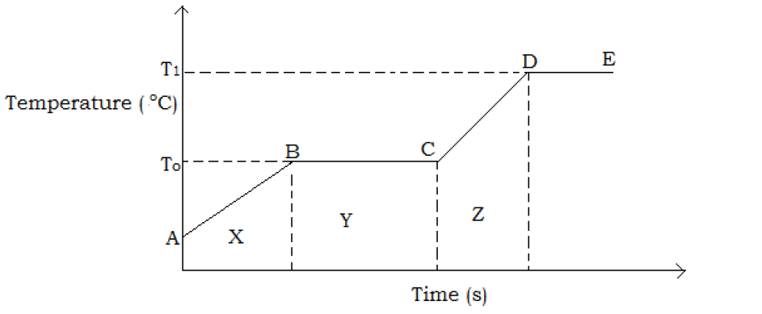](https://revisionug.com/lesson/zones-of-a-luminous-flame-2/)

**[Points and regions on the graph](https://revisionug.com/lesson/zones-of-a-luminous-flame-2/)** [A is a point at which heating of naphthalene starts  
B is the point at which melting of naphthalene starts  
C is the point at which melting of naphthalene stops  
D is the point at which boiling of naphthalene starts.  
X is a region where naphthalene exists in solid states.  
Y is a region in which both solid and liquid naphthalene exists.  
Z is a region where liquid naphthalene exists.  
Along AB, the temperature of the solid naphthalene increases steadily as the solid naphthalene is heated.  
Along BC, the melting point is reached and the temperature remains constant. The corresponding temperature, To is the melting point of naphthalene. The heat absorbed is used to break the intermolecular forces of attraction in solid naphthalene turning it into a liquid.  
Along CD, the temperature of the liquid naphthalene rises steadily.  
Along DE, the boiling point of the naphthalene is reached and the temperature remains constant. The corresponding temperature T1 is the boiling point of naphthalene.](https://revisionug.com/lesson/zones-of-a-luminous-flame-2/)**[Freezing point of naphthalene](https://revisionug.com/lesson/zones-of-a-luminous-flame-2/)**

[When solid naphthalene has fully melted, allow the naphthalene to cool slowly in air while stirring with a thermometer. As the liquid cools it becomes cloudy and temperature remains constant as the liquid changes to solid. Record this temperature as the freezing point of naphthalene.](https://revisionug.com/lesson/zones-of-a-luminous-flame-2/)**[A graph of temperature against time for cooing of a liquid naphthalene](https://revisionug.com/lesson/zones-of-a-luminous-flame-2/)**

* [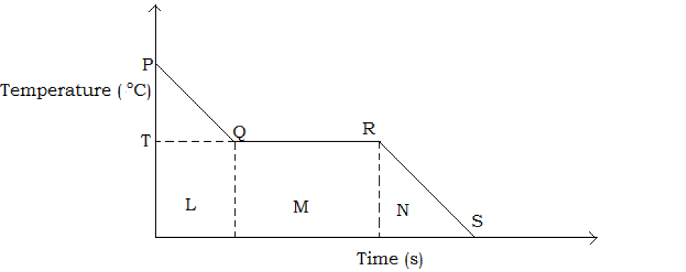](https://revisionug.com/lesson/zones-of-a-luminous-flame-2/)

**[Points and regions of the graph](https://revisionug.com/lesson/zones-of-a-luminous-flame-2/)** [P is a point at which cooling of liquid naphthalene starts.  
Q is the point at which freezing of naphthalene starts.  
R is the point at which freezing of naphthalene stops.  
S is the point at which cooling of solid naphthalene stops.  
Along PQ, temperature of the liquid naphthalene falls.  
Along QR, the freezing point of naphthalene is reached and temperature remains constant as liquid changes to solid. The corresponding temperature, T is the freezing point of naphthalene,  
Along RS, the temperature of the solid naphthalene falls steadily.  
L is a region where liquid naphthalene exists  
M is a region where there is both solid and liquid naphthalene.  
N is a region with solid naphthalene.](https://revisionug.com/lesson/zones-of-a-luminous-flame-2/)**[Determination of boiling point of ethanol  
Drawing of the set up](https://revisionug.com/lesson/zones-of-a-luminous-flame-2/)**

* [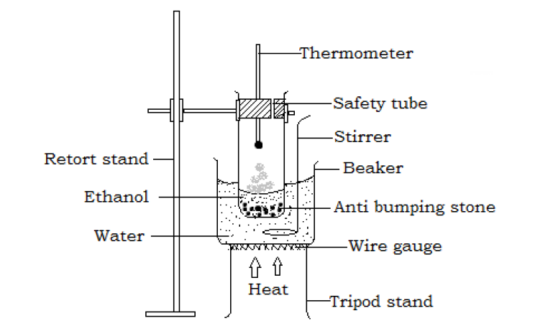](https://revisionug.com/lesson/zones-of-a-luminous-flame-2/)

**[Procedure](https://revisionug.com/lesson/zones-of-a-luminous-flame-2/)**

* [Place about 5cm3 of ethanol in a boiling tube and add some anti bumping stones.](https://revisionug.com/lesson/zones-of-a-luminous-flame-2/)
* [Suspend a thermometer to about 2cm above the surface of ethanol and place the boiling tube in a beaker of water as shown above.](https://revisionug.com/lesson/zones-of-a-luminous-flame-2/)
* [Heat the beaker gently and record the temperature at which ethanol boils, this occurs when ethanol vapor condenses at the bulb the thermometer and drops back. This is recorded as the boiling point of ethanol.](https://revisionug.com/lesson/zones-of-a-luminous-flame-2/)**[N.B.](https://revisionug.com/lesson/zones-of-a-luminous-flame-2/)**

1. [If the thermometer is dipped into the ethanol, it will be measuring the internal temperature of ethanol instead of the boiling point.](https://revisionug.com/lesson/zones-of-a-luminous-flame-2/)
2. [The safety tubes allow excess ethanol vapor to escape,](https://revisionug.com/lesson/zones-of-a-luminous-flame-2/)
3. [Water bath in used for heating ethanol, because;](https://revisionug.com/lesson/zones-of-a-luminous-flame-2/)

* [Ethanol is highly flammable (catches fire easily) and cannot be heated directly](https://revisionug.com/lesson/zones-of-a-luminous-flame-2/)
* [The water bath distributes heat evenly (uniformly).](https://revisionug.com/lesson/zones-of-a-luminous-flame-2/)**[Factors that affect boiling pot of liquids](https://revisionug.com/lesson/zones-of-a-luminous-flame-2/)**

1. [Atmospheric pressure. The higher the atmospheric pressure, the higher he boiling point, this is because boiling takes place then the vapor pressure of the liquid is equal to the atmospheric pressure. Atmospheric pressure varies with altitude. The lower the atmospheric pressure, the lower the boiling point.](https://revisionug.com/lesson/zones-of-a-luminous-flame-2/)
2. [Dissolved impurity. The presence of dissolved impurity increases the boiling point of the liquid e.g. water boils at 100 ⁰C at one atmospheric pressure but water containing dissolved salts boils at a temperature higher than 100 ⁰C at one atmosphere.](https://revisionug.com/lesson/zones-of-a-luminous-flame-2/)