**ROCKS**

Rocks are aggregates of mineral elements that are formed within the

Lithosphere or earth’s crust. Some rocks consist of a single mineral element for example Diamond, Copper, and Gold etc

Most rocks however are composed of a complex combination of mineral elements.

# Classification of rocks

Rocks are classified according to their mode of formation, geological age or their mineral composition. Basing on the mode of formation/origin, rocks are categorised into **three** that is **igneous, sedimentary** and **metamorphic** rocks. **Igneous rocks**

These are fire formed rocks. They are formed by the process of vulcanicity where magma (molten rock) cools, crystallizes and solidifies either within the crust or at the earth’s surface forming intrusive and extrusive rocks respectively.

Vulcanicity is due to intense heat generated by the geophysical radioactivity and geochemical reactions that melts rocks in the mantle to form magma (molten rocks). Convective currents from the molten rock exert pressure on crustal rocks creating lines of weaknesses/vents/fissures through which magma is intruded or extruded.

# Characteristics of igneous rocks

Generally, igneous rocks are characterised by the following;

* They are crystalline in nature, the size of the crystals depends on the rate of cooling for example the longer the cooling, the larger the crystals and the shorter the cooling, the finer the crystals.
* They do not contain fossils.
* Have no strate/layers.
* Some are spongy – like in appearance due to once having contained a lot of gases for example pumice.
* Some are glassy- like in appearance due to fast rate of cooling for example obsidian.
* Igneous rocks may be acidic, basic or intermediate in their chemical composition.

**Types of igneous rocks** Igneous rocks are categorised basing on;

1. The rate of cooling of the molten rock or the depth at which magma is deposited and the,
2. Chemical composition of the rock.

Basing on the depth at which magma is deposited, igneous rocks are subdivided into **two** types;

# A) Extrusive rocks/Volcanic rocks

These are formed when magma is ejected onto the surface of the earth where it cools and solidifies fast in the open air, forming very small (fine) crystals. Examples include;

* Obsidian, which is glassy-like in appearance.
* Pumice, spongy like in nature due to enclosure of gases at cooling time.
* Basalt, which is dark in colur.
* Others include andesite, rhyolite, trachyte, scoria etc.

**NB**: Volcanic rocks are mainly found in volcanic features such as volcanic mountains like Kilimanjaro, Elgon, Mufumbira, Kenya etc. Lava plains like Yatta plateau, Kisoro plains etc.

# B) Intrusive rocks

These are formed when magma is injected within the crust, where it cools and solidifies . Intrusive rocks are further subdivided into **two** depending on the depth where magma is deposited.

# (i) Plutonic rocks/Abyssal rocks

These are formed when magma is injected into the crust at great depth, where it cools and solidifies slowly due to no contact with open air, forming large crystals. Examples include granite, gabbro, diorite, syenite etc.

Plutonic rocks are also referred to as **deep seated** rocks and are associated with batholiths or inselbergs for example Mubende batholith , Singo batholith etc.

# (ii) Hypabyssal

Form when magma is injected near the surface of the earth or at shallow depth, where it cools and solidifies moderately, forming medium sized crystals. For example dolerite, quartz, porphyry. They are associated with laccolith, sills, dykes in Turkana land of Kenya.

# ILLUSTRATION OF IGNEOUS ROCKS

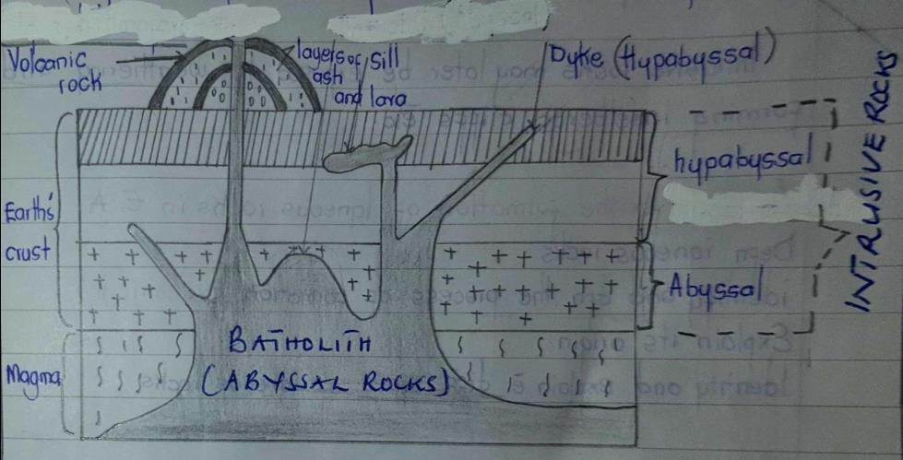

Igneous rocks may be classified basing on the **chemical composition**. Magma from the mantle varies in chemical composition which has an effect on its viscosity. This in turn influences the cooling rate and the process of crystallisation. Under this category, rocks include;

# (iii) Acidic/Felsic rocks

These have a high amount of silica (65 %) and (35%) or less basic oxides. They are light coloured, have low density and highly immobile. Examples include rhyolite, granite, andesite etc.

# (iv) Basic rocks

These contain much mica and olivine. They are rich in iron and magnesium but with less silica content of about 45 – 55 %. They are dark coloured, dense and highly mobile, able to flow for long distance before cooling. Examples include gabbro, basalt, olivine, dolerite etc.

# (v) Intermediate rocks

They have a moderate silica content of 55 % - 65 %. Have a mixed mineral structure of acidic and basic. They have an average density and fairly mobile. Examples include diorite, poryphyites.

**Question**;

Account for the formation of Igneous rocks in East Africa.

# SEDIMENTARY ROCKS

These are rocks composed of minerals and rock fragments deposited in layers at the earth’s surface or on the floor of water bodies by water, wind or moving ice. The fragments are produced by mechanical and chemical weathering of former rock masses or by organic action.

# Characteristics of sedimentary rocks

They are characterised by the following;

* Have stratified layers.
* Strata/layers are separated by bedding planes of cementing materials.
* The strata are either horizontal, gently sloping or steeply dipping.
* They contain fossils of dead plants and animals.
* They are non- crystalline in nature.

# ILLUSTRATION OF SEDIMENTARY ROCKS

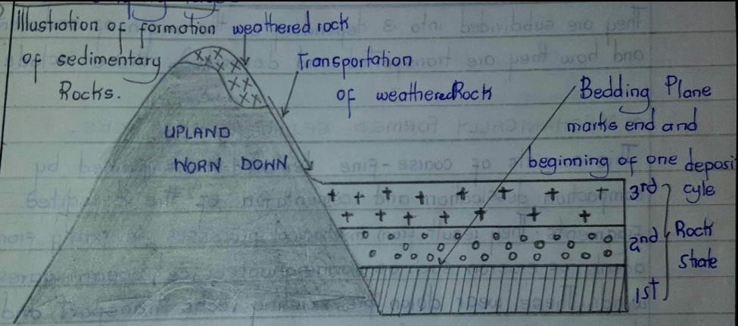

# Processes of formation

It involves the **weathering** of the already existing rocks into fragments.

The weathered material is **eroded,** **transported** and then **deposited** in layers by agents of wind, water or moving ice. **Stratification** of the deposited material occurs.

The stratified materials are **compressed** by the overlying weight resulting into **compaction** and hardening of layers. The material becomes **consolidated** into layers and gets **cemented** by materials such as silica, calcium, ferrogenous etc

The cemented sediments are gradually **transformed** into a hard sedimentary rock.

# Types of sedimentary rocks

They are subdivided into **three** depending on the origin of sediments and how they are transported and deposited. These include;

# (a) Mechanically formed sedimentary rocks

These consist of coarse to fine textured rocks. They are formed through mechanical processes of weathering and erosion of the rocks. These wear down pre- exiting rocks, transport the weathered materials by erosional agents of water, wind or ice and deposit them at the earth’s surface or under water. The deposited materials accumulate and become compact and harden up due to compression by overlying layers to form a sedimentary rock. Examples include Loess deposited by wind such as in Karamoja, alluvials by running water like on river Nzoia, moraines by ice like in the Mubuku valley along Mt. Rwenzori, Teleki valley of Mt.

Kenya, Karanga valley on Mt. Kilimanjaro, Marine deposits on oceans. Other examples include sandstone, mudstone, boulder clay, gravel etc.

# (b) Chemically formed sedimentary rocks

These are formed from chemical precipitation and/or evaporation of solutions. Soluble rocks get dissolved in water or any other solvent to form a solution and later experiences evaporation under extreme hot and dry conditions leaving behind salt deposits. For example rock salt in Lake Katwe Kasese district, calcium carbonate formed when water evaporates from calcium hydrogen carbonate. As more evaporates, the calcium carbonates accumulates and dries up to form a hard travertine rock. These calcite rocks form features such as stalactites, stalagmites, pillars for example at Nyakasura in Fortportal ,Western Uganda.

Other examples include soda ash from Lake Magadi, Gypsum from hydrated calcium sulphate, laterites from iron and aluminium deposits on Buganda hills.

# (c) Organically formed sedimentary rocks

These are sedimentary rocks formed from decomposition, deposition and accumulation of remains of plants and animals. For example coral reefs form from the deposition of coral polyp’s skeletons that are composed of calcium carbonate. The skeletons become accumulated, compressed cemented and hardened up to form the coral reefs for example at Mombasa, Tanga, Mayotte along the East African coast.

Carbonaceous rocks such as coal are a result of deposition of remains of plants and animals. Plants and animal remains with time get decomposed and harden up to form coal. Examples of coal include Bituminous. Lignite, anthracites, calcerous , peat and brown coal. Coal exists in Ruhuhu valley in Tanzania.

Siliceous rocks are organically formed sedimentary rocks formed from remains of sponges, roderians that have silica content in their bodies. Examples include biotomite rock.

# Question

1. (a) Account for the formation of sedimentary rocks in East Africa. (b)Explain the importance of sedimentary rocks to people of East Africa.
2. Describe the processes which have led to the formation of sedimentary rocks in East Africa.

# METAMORPHIC ROCKS

These are changed rocks. They are formed when igneous or sedimentary rocks are chemically and/or physically changed by great heat, pressure or both.

Metamorphism may be as a result of tectonic processes that cause great heat and pressure which change the rock character.

There are **three** types of metamorphism namely dynamic, **contact/thermal** and **thermal-dynamic** metamorphism.

Metamophism due to pressure is referred to as **dynamic metamorphism**. For example when clay is subjected to pressure ( compression, it changes into shale and when shale is further subjected on to pressure it turns into slate.

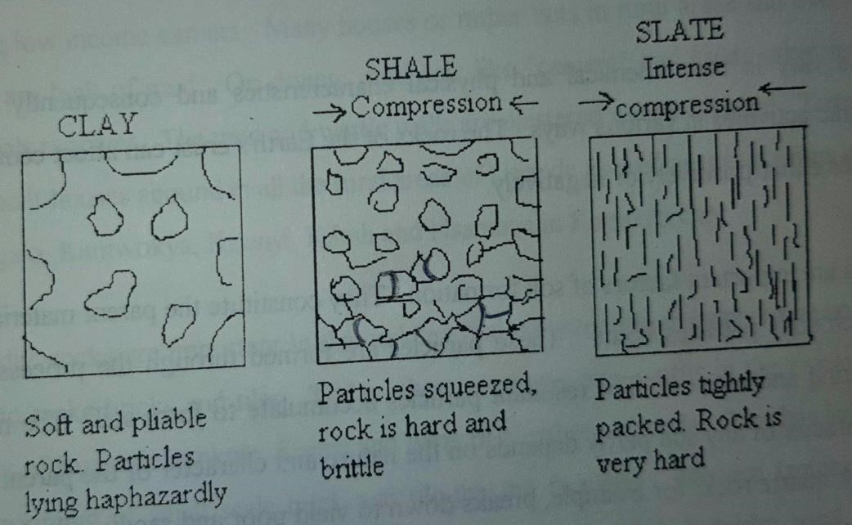

Metamorphism due to great heat is termed as **thermal** or **contact** metamorphism. When hot magma comes into contact with country rocks, the nearby rocks get heated up and re-crystallise to get a metarmorphic rock. The area where contact metamorphism takes place and rocks are made to recrystallise is known as a **metamorphic aureole**. An example of a metamorphic rock resulting from thermal metamorphis include gneiss originating from granite, marble originating from limestone, quartzite from sand stone.

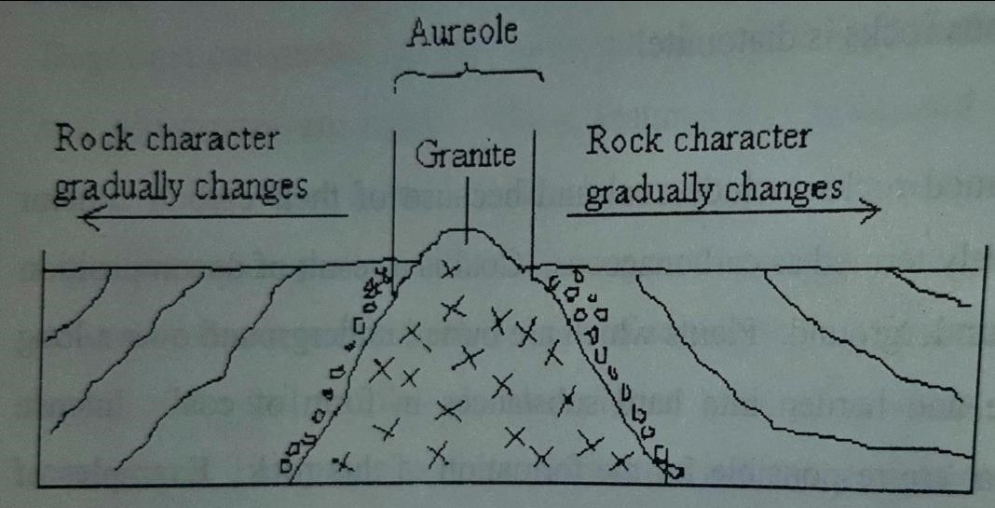

Metamorphism due to both pressure and heat is termed as **thermal dynamic** **metamorphism**. It’s the most effective type of metamorphism that changes rock character for example it changes coal to graphite, shale to schists etc.

**NB :** Generally the result of metamorphism is extremely complex producing recrystallized rocks characterised by ;

* More compact and resistant than the original rock.
* Laminated in thin layers which easily split apart. - Tend to be brittle.
* Have shiny crystals

# THE ROCK CYCLE

The rock cycle refers to the existing relationship between the three principle rock types that is igneous , sedimentary and metamorphic.

Igneous rocks form by cooling, crystallisation and solidification of molten materials . When igneous and other rock types are exposed at the earth’s surface, they are weathered down. The weathered materials are transported by erosional agents of water, wind or ice and deposited at the earth’s surface or under water. The deposited materials get compressed, compacted and consolidated into a sedimentary rock.

When sedimentary and igneous rocks are subjected to heat, pressure or both for a prolonged period of time, they turn into metamorphic rocks.

If other pre- existing rocks ( igneous, sedimentary or metamorphic rocks ) are subjected to intense heating, they melt and on cooling down they form igneous rocks again . This continuous circular flow of rocks changing from one type to another and back, is termed as the rock cycle.

**ILLUSTRATION OF THE ROCK CYCLE.**

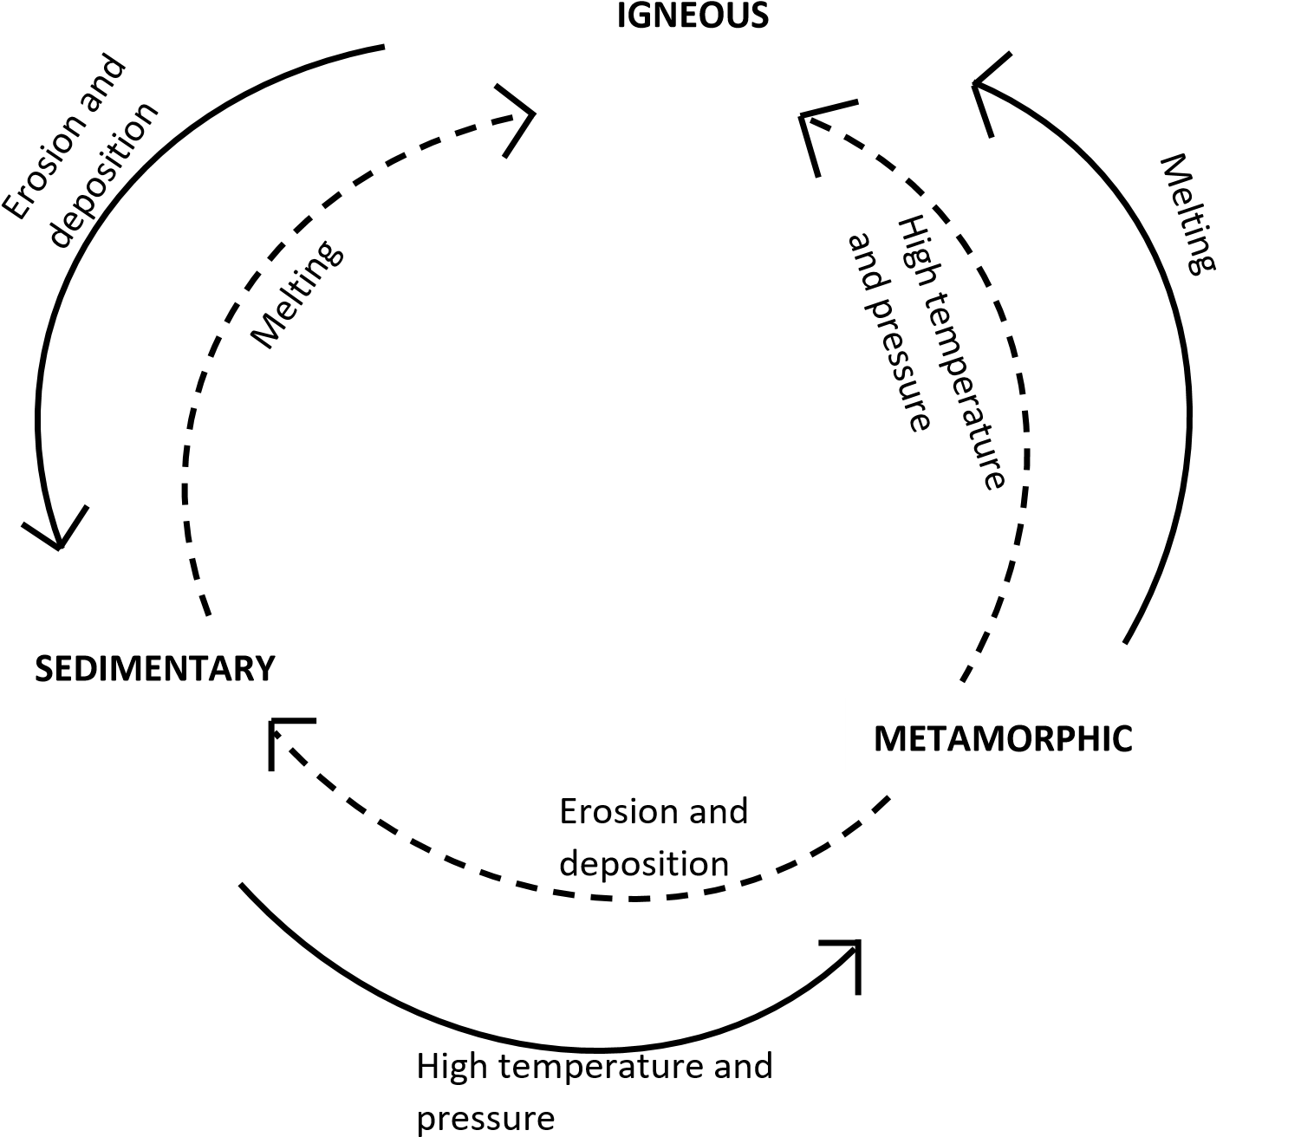

**EFFECTS OF ROCKS ON LANDFORM EVOLUTION.**

# Rock type

Each type of rock has an effect on landform evolution. Sedimentary rocks such as limestone when subjected to weak carbonic acid is dissolved to form the **karst landscape** for example sink hole, stalagmites, stalactites, pillars. Poljes, uvala, clints, grikes etc

**NB**: Refer to Karst landscape for details on the landforms.

Sedimentary rocks are also associated with formation of coral reef landform. They are formed when coral polyps die and deposit their skeletons at the sea floor. The skeletons get accumulated, compacted and cemented to form coral reefs such as fringing reefs, barrier reefs, a toll reefs along the East African coast.

Igneous rocks are associated with formation of intrusive and extrusive land forms depending on the depth of magma either into or onto the earth’s crust respectively.

Intrusive land forms are subjected to weathering and erosion and finally exposed onto the earth’s surface eg. Batholith which is exposed to form inselbergs eg Mubende, Napak , Nakasongola etc. Dykes are exposed to form ridges and trenches eg Isingiro ridges and trenches in Kenya , sills form cliffs etc

**NB:** Refer to intrusive vulcanicity for details.

When basic or acidic lava/intermediate lava is extruded onto the earth’s surface, various land forms are formed for example composite volcano, cumulo dome, ash and cinder, basalt dome etc. ( NB: Refer to extrusive )

Metamorphic rocks are associated with formation of tectonic land forms eg rift valleys, block mountains, folded landscape .

**NB:** Refer to earth movements for details. **Question**

1. Examine the influence of rock types on land form evolution in East Africa.
2. Define rocks

# Rock structure

There is a close relationship between rock structure and land form evolution. The structure of rocks ie physical, chemical characteristics rock resistance, hard/soft , jointed or unjointed influence land form evolution. Rocks when subjected to denudation processes (weathering, erosion, mass wasting) may result into land form development.

Hard rocks such as granite are characterised by residual hills such as inselberg which are due to difference in rock structure. Inselbergs are composed of hard granite which were once surrounded by soft rocks , easily weathered and eroded away leaving the hard resistant granite rock standing up as an **inselberg**, eg Mubende, Nakasongola, Sukuma land etc.

If granite rocks are less resistant to erosion than surrounding country rocks , granite rocks are eroded to a much lower level to form **arenas** for example Rubanda arena in western Uganda.

Other land forms related to rock hardness include **trench**, a narrow and shallow depression formed when a less resistant dyke is eroded.Examples can be seen around L. Turkana in Kenya.

If a dyke is more resistant than the surrounding rocks and then subjected to erosion, a steep land form known as a **ridge** is formed eg Sukulu hills in eastern Uganda.

**NB**: (Refer to intrusive vulcanicity for illustrations)

When a hard and resistant central core of solidified lava in the vent of a volcano is exposed by weathering and erosion of the surrounding softer parts, a steep and vertical land form known as a **volcanic neck** is formed. For example Tororo volcanic neck in Eastern Uganda.

Alternating hard and soft rocks along the coast influence formation of **headlands** and bays. **Soft rocks** are eroded extending towards the mainland forming a wide open depression known as a **bay** while the resistant hard rocks that alternate with soft rocks along the coast, remain projecting into the sea forming **headlands.** Examples of bays and headlands can be seen at Kasenyi landing site on L. Victoria.

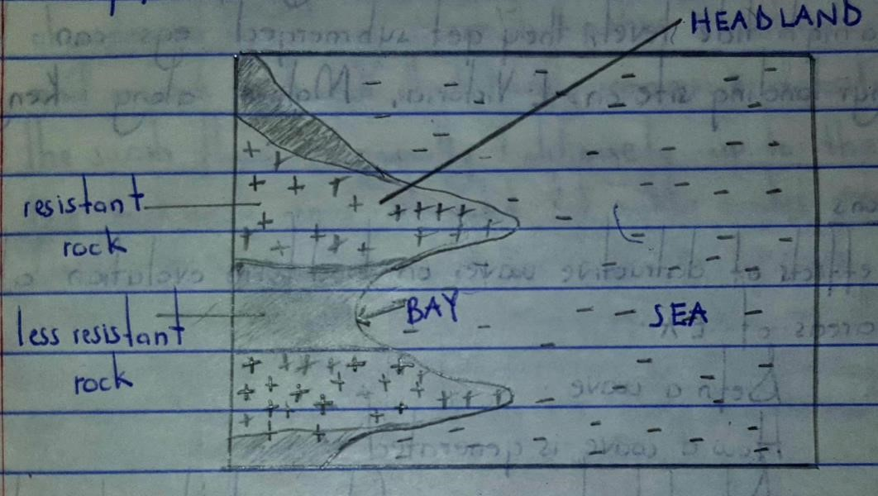

# Rock solubility

This has an influence on landform development . Soluble limestone rocks dissolve in weak carbonic acid to form the karst landscape. Examples of karst landscape include sink holes , stalagamites, stalacites, pillars, poljes, lints, grikes, caves etc.

Karst landscape can be seen at Nyakasura in Western Uganda, Nyanyuki along the East African coast.

NB: For illustrations and formative process refer to notes on land form evolution under weathering )

# Rock jointedness

Joints or cracks in rocks indicate areas of weakness within the rock that can be exploited by weathering and erosion forming features such as caves in the coastal areas. Joints at the base of a cliff can be widened by wave erosion through the processes of hydraulic action and abrasion to form a cylindrical tunnel known as a **cave**. Examples can be seen at Kasenyi landing site, Botanical beach, Lutembe beach on L. Victoria.

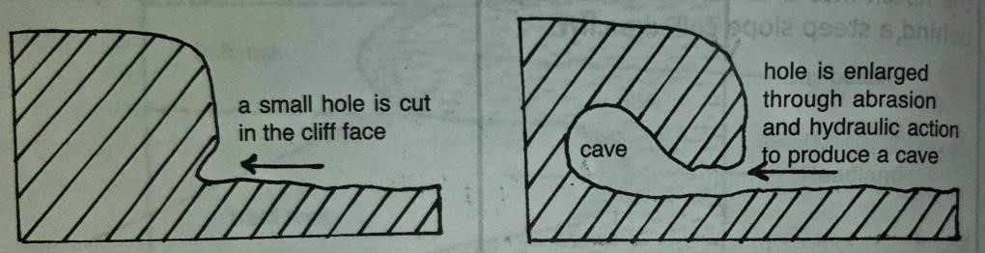

Exfoliation domes, which are smooth and rounded upland features are due to rock jointedness. They are formed in semi-arid areas that experience wide temperature fluctuations, causing expansion and contraction in the rock. Continued expansion and contraction creates cracks in the rock. With time, the cracked rock surface peels off due to erosion to form an **exfoliation dome**. For example at the Nyika plateau in Kenya , Soroti hills in Soroti town, Akia hills in Lira, Uganda

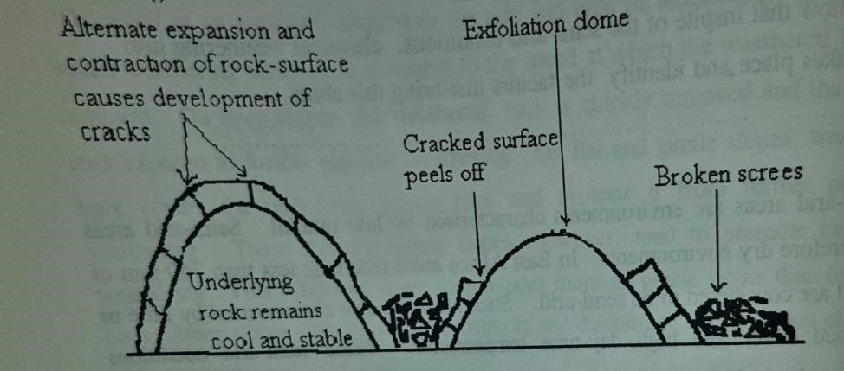

Fault guided valleys also result from cracked rocks. These form when faulting shatters the rocks which are later subjected to weathering and erosion. The crushed rocks are easily removed by erosion to form an elongated depression/valley known as a **fault guided valley**. For example Aswa river valley in Northern Uganda.

Other features related to rock jointedness include the cirque, granite tors.

# Rock permeability

Running water is one of the main agents of erosion on the landscape. Rocks that allow water to percolate or seep, reduce the rate of run off and therefore less erosion.

Areas of permeable rocks tend to form uplands e.g carbonatite rocks forming Sukulu hills in Tororo , Kalyango hills in Nyakasura, coral reefs along the East African coast also form raised landforms, Bamburi along the Kenyan coast. Impermeable rocks are eroded to form **lowlands** as they promote water runoff that aid erosion.

# Question

Examine the influence of rock structure on landforms development in East Africa.

# Mesa and Butte

These are flat topped isolated hills with steep sides and a resistant rock cap overlying weaker layers. They are formed in raised areas of hard laterite rocks ( duricrust) alternating with softer rocks in some parts. When the area is subjected to weathering and erosion, the softer rocks are eroded to form broad valleys/lowlands while the hard rocks of duricrust form the flat – topped hills termed as **Mesa or** **butte** depending on their sizes.

**NB**: Mesas are broader than buttes. Examples include the Buganda hills in central Uganda.

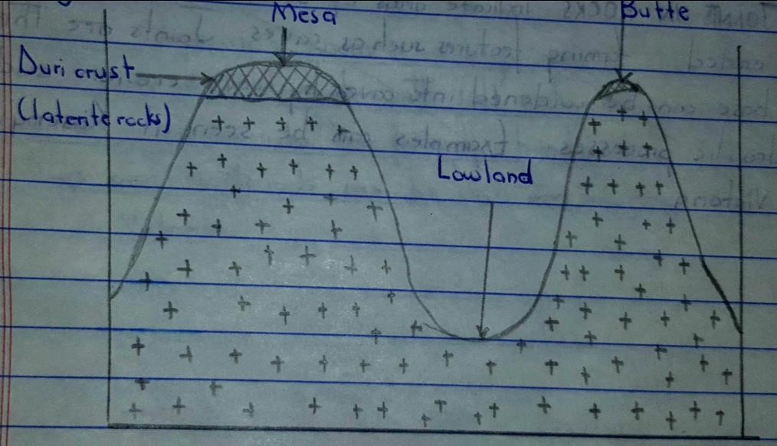

# Cuesta

This is a ridge or upland with a steep scarp slope on one side, and a gentle back slope on the other. It is formed where there are alternating hard and soft rocks that have been tilted and then subjected to differential erosion. The weaker rocks are worn down leaving the more resistant rocks to form a **Cuesta.**

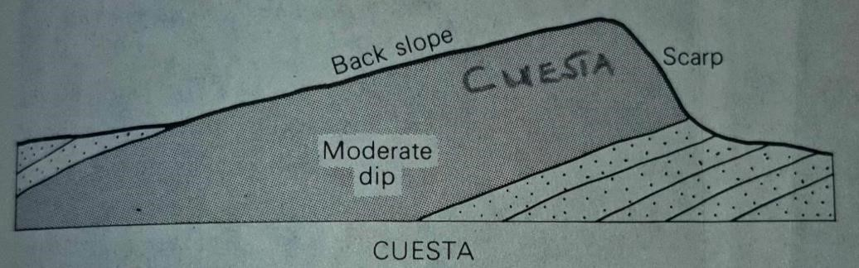

**ECONOMIC IMPORTANCE OF ROCKS**

# Positives

* Rocks weather down into productive fertile soils that encourage crop cultivation. For example volcanic soils on the slopes of Mt. Elgon used for Arabic coffee growing, the alluvial soils on the flood plains of R. Manafwa used for rice growing on Doho rice scheme, weathered coral reefs form soils suitable for coconut growing along the East African coast, slate & shale metamorphic soils in Nyanza province of Kenya.
* Rocks contain a wide range of minerals that have been extracted and used as raw materials in industries. For example rock salt from Katwe crater lake used in the manufacture of common salt, graphite for making pencil tips, kimberlite for drilling tips, coral limestone for making cement for example at Bamburi cement factory, Limestone from Tororo volcanic neck for manufacturing cement at Tororo cement industry .
* Rocks form unique and beautiful scenery that attracts tourists earning foreign exchange and revenue to the region. For example the coral reefs along the East African coast, karst landscape at Nyakasura in Fort- portal – Western Uganda, the granites rocks making up inselbergs, the volcanic rocks for the mountains, the metamorphic rocks at Bismark, Mwanza in Tanzania.
* Some rocks such as coal, graphite, petroleum are sources of fuel while hot igneous rocks generate geothermal power for example at Olkaria in Kenya. This is used in industrial, domestic and automative sectors.
* Rocks provide building and construction materials for example quartzites used for road surfacing, slates for roofing, granite for aggregates and road tarmacking, sand, clay for making bricks and tiles , for example at Kajjansi clays . Granite is also used for kitchen counter tops.
* Some rocks are used for decoration or ornamental purposes such as metamorphic marble, sedimentary coral reefs and igneous diorite.
* Rocks are reservoirs for underground water acting as sources of water for domestic use.
* Because of their hardness and resistance to erosion, some rocks such as quartzite, gneiss, granite out crops form highlands that are good sites for installation of defence bases, water tanks and communication masks.
* Rocks such as quartzite , gneiss, granite form firm and stable basements for construction of roads, dams , railways, canals, tunnels.
* Rocks such as coral reefs, basalt , granite, slate provide opportunities for study and research .
* Rocks like clay are used for pottery work for instance making cups, pots , flower vases.
* Rocks are sources of medicine for example pumice added to tooth paste for scrubing teeth, clay for iron, rock salt for salt.
* Some rocks like gneiss, granite, quartizite are used as grinding stones.
* Some rocks like pumice is used as an abrasive for smoothening the skin.
* Coral reefs along the East African coast shelter harbours against strong winds enabling shipping to take place for example at Mombasa.
* Sedimentary rocks making up sand beaches along the coasts are used for recreational purposes, for example at Mombasa along the East African coast, Lido beach, Kasenyi beach, Botanical beach on L. Victoria.
* Lagoons formed by sand bars and fringing coral reefs along the coasts act as fishing grounds.
* Mining sectors provide employment and are a source of income to people and revenue to governments. For example at Mwadui diamond mines in Tanzania.

# Negative

* Some rocks like coral limestone, sandstone , granite, gneiss, quartzite breakdown into coarse infertile soils that don’t favour agriculture.
* Hard rocks like quartzite, granite act as barriers to transport and general construction work .
* Hard rocks such as granite, quartzite hinder agriculture mechanization.
* Hard and exposed rocks like quartzite, granite, gneiss hinder settlement.
* Clay and silt deposits in lowlands lead to flooding and formation of acidic peat soils hindering settlement and agriculture.
* Coral lime stone rocks act as barriers to shipping at the coast for example at Kilindini.
* Coral lime stone rocks are barriers to fishing along the coast by tearing the nets.
* Areas with permeable and porous rocks have limited surface water supplies for example the volcanic rocks in Kisoro , limestone rocks and Nyakasura in Fort portal , Western Uganda . Metamorphic rocks such as slate is also an impediment to drainage.
* Steep rock surfaces accelerate landslides such as rock falls that destroy crop fields, settlements and general infrastructure.
* Some rocks habour pests such as squirrels, snakes, rats that destroy crops.

# Questions

1. Distinguish between igneous and metamorphic rocks.
2. Explain the importance of rocks to East Africa.
3. Explain the importance of metamorphic rocks to people living in East Africa.