

**Our country, our future**

**525/2**

**S6 CHEMISTRY**

**Exam 10**

***PAPER 2***

**DURATION: 2 HOUR 30 MINUTES**

**For Marking guide contact and consultations: Dr. Bbosa Science 0776 802709.**

**INSTRUCTIONS**

**-Answer any five questions**

**- Time 2hr 30minutes**

1. (a) A compound X, vapour density 58, contains carbon 62.07%, hydrogen 10.34% and the rest being oxygen. X does not burn with a sooty flame.
   * 1. Calculate the empirical formula of X (C=12, O=16, H=1) (3 marks)
     2. Determine the molecular formula (2 marks)

b. Hydrolysis of X yielded compounds, Y, C4H10O and Z, C2H4O2. Both Y and Z react with metallic sodium. Z reacted with sodium carbonate but Y did not.

* + - 1. Identify Z. (1 mark)
      2. Write names and the structural formulae of all the possible isomers of Y.

(4 marks)

* + - 1. Name a reagent that can be used to distinguish between the isomers in (b) (ii) and state what would be observed if the reagent you have named is reacted separately with each of the isomers. (4 marks)

c. When Y was warmed with acidified potassium dichromate solution, there was no observable change.

* + - * 1. Identify Y.
        2. write the structural formulae of Y

d. (i) write equation and outline a mechanism for the reaction between Y and concentrated phosphoric acid (3½ marks)

(ii) Write the IUPAC name of the product in d(i). (½ mark)

2. (a) state **Raoult’s Law.** (3 marks)

**(b)** A mixture of ethanoic acid (B.P 1180C) and pyridine (b.p. 1230C) show negative deviation from Raoult’s law.

(i) Draw the vapour pressure/composition curve for the mixture of ethanoic acid and pyridine and indicate the line of Ideal behavior. (4 marks)

(ii) Explain the shape of the curve in relation to Raoult’s Law. (6 marks)

(c) (i) Explain what is meant by ‘**steam distillation**‘ (3 marks)

(ii) When a compound Y, was steam distilled at standard atmospheric temperature and pressure, the temperature of distillation was 960C. The vapour pressure of water t this temperature was 730mm Hg and the distillate contained 74% of water.

Calculate the relative molar mass of Y (4 marks)

3. Complete the following equations and in each case outline a mechanism of the reaction

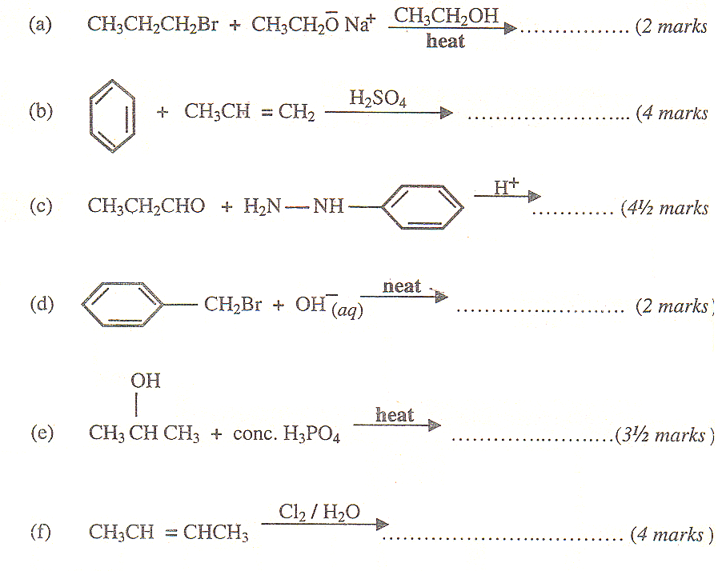

4. (a) Define the term *eutectic mixture*. (3 marks)

(b) The table below shows the melting points f various mixtures of lead and tin.

|  |  |  |  |  |  |  |
| --- | --- | --- | --- | --- | --- | --- |
| % tin | 0 | 20 | 40 | 70 | 80 | 100 |
| Melting point/0C | 327 | 280 | 234 | 193 | 206 | 232 |

(i) Draw a fully labeled diagram for the tin-lead system. (5 marks)

(ii) Determine the eutectic temperature and the composition of the eutectic mixture

(3 marks)

(c) Describe the changes that would take place when a liquid mixture of the above system containing 40% tin is cooled from 4000C to 1000C.

(d) (i) State one application of the lead-tin eutectic mixture (1 mark)

(ii) Name one other pair of metals which can give a similar phase diagram as in (b) (i). (1 mark)

(iii) State one similarity between a eutectic mixture and pure metal (1 mark)

5. (a) Describe the spectrum of a hydrogen atom.

Use diagrams to illustrate your answer (7 marks)

(b) Explain how the spectrum of a hydrogen atom

(i) is formed ( 4 marks)

(ii) Provides evidence for the existence of energy levels in an atom (7 marks)

(c) The frequency of hydrogen at the point of ionization id 32.8 x 1014HZ

Calculate the ionization energy of hydrogen. (Planks constant = 6.6 x 10-34JS

(2 marks)

6. (a) The first ionization energies of an element B are shown below

|  |  |  |  |  |  |  |  |
| --- | --- | --- | --- | --- | --- | --- | --- |
| Ionization Energy/kJMol-1 | | | | | | | |
| 1st | 2nd | 3rd | 4th | 5th | 6th | 7th | 8th |
| 786 | 1580 | 3230 | 4360 | 16000 | 20000 | 23600 | 29100 |

(I) explain what is meant by the term *Fist ionization energy*?

(ii) State the factors that determine the value of first ionization energy

(ii) To which group of the periodic table does element B belong

Give reason for your answer

(b) Explain the term *electronegativity*.

State the factors that determine the value of electronegativity of an element.

(c) Explain how the following factors affect the value of electronegativity of an element

(i) Atomic radius

(ii) Nuclear charge

(iii) The screening effect of the inner electrons

(d) Explain the difference between electronegativity and electron affinity.

7. (a) (i) Define “ Standard Electrode potential” (2marks)

(ii) Why is it not possible to measure standard electrode potential absolutely? (2marks) (iii) Discuss the factors which affect the value of standard electrode potential (5½marks) (b) Describe a standard hydrogen half cell (2marks)

(c) How would you measure standard electrode potential of a metal in solution of its ions? (3marks)

(d) Ca2+(aq) + 2e- Ca (s) E0 = -2.87V

Mg2+(aq) + 2e- Mg(s) E0 = -2.37V

A cell was set up as below

Mg(s)/Mg2+(aq)║Ca2+(aq)/Ca(s)

(i) Calculate the e.m.f of the cell (2marks)

(ii) What conclusion can you draw from your e.m.f value in (d)(i) above (3marks)

8.(a) Write the name and formula a of one ore from which aluminium can be extracted and describe how aluminium is extracted from the ore (08marks)

(b) Write equations and state conditions under which aluminium reacts with

(i) Air

(ii) Sodium hydroxide

* + - 1. hydrochloric acid

(c) State what is observed and write equation for the reaction which take place when aqueous ammonia is added drop-wise to a solution containing aluminium ions (2½ marks)

(d) Write equation for the reaction that take place when aluminium chloride is dissolved in water (1½ marks)

END