**MARKING GUIDE S.6**

1. a)
2. 6.3km
3. 1400 -1390-1410

b)Annular drainage pattern around Bukigai ridge/ hill by

* Zuzu
* Tsutsu

Radial Drainage pattern name;

1. River manafa
2. Sume . S.E
3. Kasune.
4. Sakusaku.

Dendritic drainage pattern by;

* R. Namatala
* R. Sanoli etc

b)(ii) By constructing motorable roads in hilly areas of South East etc

* Winding roads in hilly areas ie Bugambi, Budadiri, Bugitimwa.
* Construction of foot bridges a cross river valleys in Hilly area ie around Bukalasi
* Gazeting forests ie
* Bukigai Forest reserve
* Nakiwondwe forest reserve
* Elgon forest reserve

1. 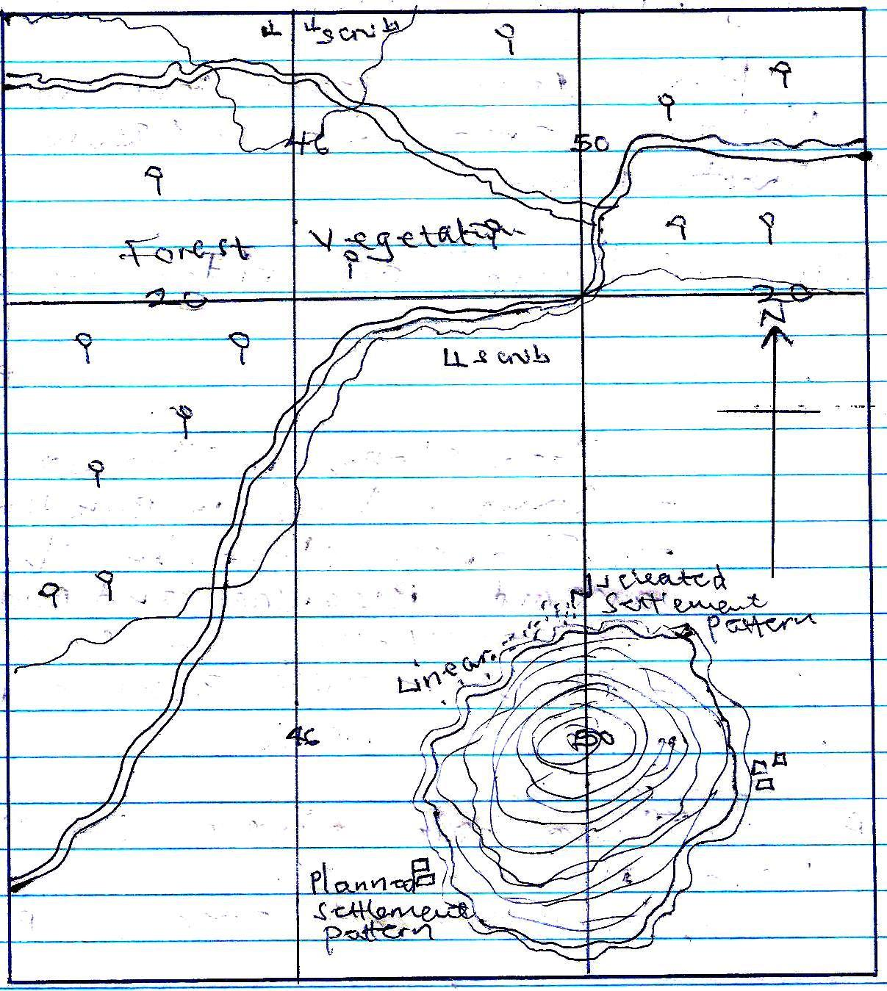A reduced sketch map of Budadiri by 1.6 South of northing’s 23 and west of Easting 54 showing 2 types of boundaries 3 settlement patterns, 2 vegetation type

**Key**

 Planned settlement pattern

Nucleated settlement pattern

 Forest vegetation

1. i) There are ridge i.e

Busulami

Buyola

Bukigai etc

* Step slopes in the South East
* Conical hills in Bukitibo
* Gentle slopes in the north around Bugwagi and Bumatofu
* River valleys ie Sanoli
* Cliffs around Bukhiende N.E etc

d(ii)There are rivers i.e Sanoli, Pasa, Namatala etc

* Well drained areas i.e Bududa

d (iii) River flow from highlands to lowlands e.g river Sanoli,

River flow in narrow valleys in highland areas e.g river Kasune, Nabulalo in the south east.

River form radial drainage patterns in upland area ie R. Pasa and others in South west.

The steep slopes, upland, gentle slopes are well drained e.g Namugambwe, ridge, Busulani ridge etc

Rivers form straight flows in the upland areas i.e R. Kasune in South East.

1. 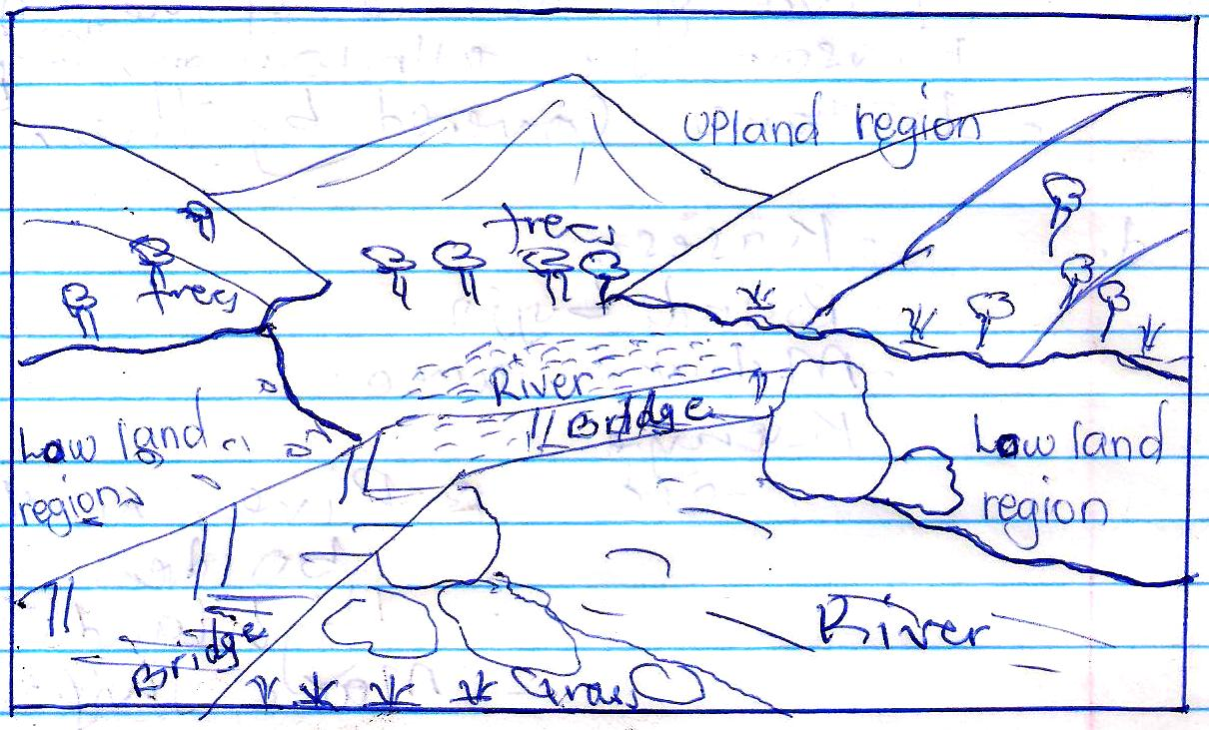A relief sketch of the area shown on the photograph showing two physiographic regions, two vegetation types and major drainage feature.

Key trees

B. Describe the characteristics of the drainage feature

* It has rapids
* It has large volume of water
* It is flowing on a gentle slop
* Deposition has started taking place
* It is flowing in wide valley
* It is in the mature stage of the river
* It’s major work is to transport the load

ii) Describe the relief of the area

* There is a river valley in the fore ground
* There are uplands in the back ground
* There are steep slopes on the back ground
* There are lowlands in the fore ground
* There are rock bolders in the fore ground

iii) Vegetation

* There are trees in the back ground
* There are forests in the middle ground
* there is grass in the fore ground

C) - Weathering initial stage of disintegration

* Nature of the rock bolder
* Nature of the bed of the river
* Erosion i.e attrition on the bolder rocks
* Distance covered/ distance travelled by the bolders

D) – Kasese

* Bundibujjo
* Mubuku area
* Kenyan highlands
* Bukwo
* Kapchorwa etc

evidences

* Rivers with rock bolders
* Highlands/ uplands
* Make shift bridges

1. a) **Differentiate between normal and reversed fault line**

* Define
* Give example
* Illustrate

Normal faults are lines of weakness that develop as a result of tensional forces pulling the earth’s crust e.g the Eastern arm of the rift valley.

***Illustration***

Whereas

Reversed fault lines are as result of compression forces push to towards each other causing them to over ride e.g the Western arm of the rift valley

***Illustration***

1. b) - Define faulting

* Origin of faulting
* Effects of tension and compression forces

Tension and compression forces are as a result of faulting.

* Faulting is the breaking/ fracturing/ cracking and disintegration of rocks followed by displacement.
* It can be vertical or horizontal (tension and compression)
* Due to radio active decay, geo – chemical and geo physical reactions in the core/ mantle (earth’s interior)
* These reactions generate a lot of heat about 45000c Hot & pressure which melt the rocks to form magma.
* Magma starts moving upwards towards the surface in form of giant convective currents
* These currents can be tensional if the currents are in diverging motion leading to normal faults.
* Or Compression forces if the current are in converging motion leading to reversed faults.

landforms/ include

* tilt block
* These are angular ridges/ uplands with depressions which are inclined on the surface.
* Formed when one side of block is up rifted higher than the other side or by general up rift. e.g Kichwamba in Uganda and Aberdare ranges in Kenya.

**Illustration**

**Block** mountain/ Horst

* It is upland bordered by fault scarps on one or more sides. It stands above the surrounding land as a result of the middle block of land being raised by an uplift

**Block mountain by Tension forces.**

* Divergent convective current produced the tension forces.
* the rocks of the earth’s crust were subjected to tension forces. Pressure from the tension forces pulled apart the land mass leading to normal fault lines on either side of the central block.
* The continuous tension of the landmass pulled apart the side blocks causing them to sink.
* The middle block was left to form a block mountain.

Illustration:

* **Block mountain**
* Convergent convective current produced the compression forces. The pushed the rocks of the earth’s crust from either side leading to the development of reversed fault lines.
* Continuous pressure from the compression forces resulted into uplift/ up thrust of the central block leaving the blocks stable.
* The uplifted central block formed a block mountain separated from the surrounding land by fault scarps.
* E.g’s include Mt. Rwenzori, Mathew range, Ndoto and Nyiru ranges, Usambara Uluguru, Ufipa, Pare, Mahenge and Iringa mountains.

Illustrations:

**Rift valley**

* It is an elongated trough/ depression bordered by in facing fault scarps along more or less parallel faults**.**
* The rift valley has two major section I.e eastern arm and the western arm.

**Rift valley formation by Tension forces**

* Radio activity, geophysical and geochemical reactions led to divergent convective currents.
* These produced the tension forces that acted/ pulled apart in opposite direction from a central point within the earth’s crust hence normal fault lines
* The side blocks were pulled apart as the central block was lowered or sink under its own weight to form a rift valley.
* This is applicable to the eastern arm of the rift valley.

***Illustration***

* Rift valley formation by compression forces
* Radio activity, geophysical and geochemical reactions produced the compression forces
* The forces moved or pushed in the same direction and acted on the earth’s crust hence reversed fault lines.
* The side blocks were forced to override/ uplifted above the central block that remained stable to form a rift valley.
* E.g’s is the western arm of the East African rift valley

**Illustration:**

* Graben hollows:
* Is a narrow trough between parallel fault formed at the floor of the rift valley due to secondary/ multiple faulting.
* Graben formation by tension forces;
* T=Radio activity, geochemical and geographical reactions resulted into divergent convective currents that spread within the earth’s crust hence tension forces.
* Tension forces pulled apart a block of land from a central point hence normal fault lines.
* Continuous tension resulted into lowering of the central block leaving the side block stable.
* The central block hence became a rift valley
* Secondary/ multiple faulting took place at the floor of the rift valley to create a depression deeper than the rift valley called a graben.
* E.g’s include L. Turkana, L. Naivasha and Nakuru

Note: One can use the compression forces theory

***Illustration:***

* **Fault guided valley.**
* These are fault valleys/ depressions located a long a single fault line.
* Displacement of rocks along fault lines caused the rocks to be crushed and later easily removed by erosion and weathering.
* A depression is left behind called a fault guided river valley
* E.g’s include R. Aswa in Northern Uganda and Kerio valley in Kenya.

***Illustration:***

**Warping.**

* It is either up warping (uplift) and down warping (sinking) of the earth’s crust.
* Warping led to the formation of raised watershed/ plateaus and down warped basins as the resultant highlands and basins respectively.
* During the Pleistocene period, there was uplift of western Uganda and western Kenya to form the warped plateaus or raised watersheds.
* There was sinking or down warping of central and south eastern Uganda to form basins/ depressions.
* Examples of raised watersheds include the Bunyaruguru hills and basins include; L. Victoria, L. Kyoga, L. Wamala. L. Opeta, L. Bisinia and L. Mburo.
* **Folding**
* It is the bending of the earth’s crust due to the action of the compression forces.
* Synclines were formed as depressions while anticlines were formed as the highlands
* Compression forces acted on the young sedimentary rocks hence bent to form up folds called anticlines and down folds called synclines.
* E.g’s are found in the Buganda – Tooro rock system, Nyanza – Kavirondo rock system and Ankole – Karagwe rock system.

4. Examine the influence of chemical weathering processes on landform development:-

* Define chemical weathering and provide areas of occurrence
* Identify and explain conditions of chemical weathering
* Identify and explain processes of chemical weathering
* Identify and describe the landforms resulting from chemical weathering.
* **Chemical weathering** is the decay/ decomposition of rocks in “situ” at or near the earth’s surface.

It occurs in areas that receive heavy rainfall and hot temperatures e.g. around L. Victoria basin East African coast areas, Windward slopes of mountains.

Chemical weathering occurs through processes like carbonation, solution, hydration, hydrolysis, oxidation, reduction, chelation and spheroidal.

* **Solution** is a process that involves soluble rocks like limestone rock salt that get dissolved in water and are carried away in solution leaving cracks, hollows and joints.
* **Carbonation** is the reaction of carbon dioxide with rainwater to form a weak carbonic acid especially in the atmosphere the carbonic acid react with rocks to produce new compounds like calcium bi carbonate.
* **Hydration** is when some minerals absorb water and in the process expand to produce new compounds. They then decompose and new rocks e.g calcium sulphate absorb water and changes to gypsum.
* **Hydrolysis.** This involves exchange of ions the hydrogen ions combines with the metal ions hence react to give rise to new compounds like cay and potassium carbonate.
* **Oxidation** when oxygen reacts with minerals particularly ion and aluminum oxidation occurs the structures ofthe rocks are transformed to laterites and bauxite.
* **Reduction** is the removal of oxygen from a substance and addition of hydrogen to it. It occurs unsaturated conditions etc

**The landforms include:-**

* **Underground cave**
* It is a natural underground space.
* It is formed when there is chemical dissolution of limestone and dolomite.
* The limestone is dissolved by natural acid in the ground water or weak carbonic acids.
* The limestone is carried away by solution leaving a depression called a cave examples are found in Nyakasura in Western Uganda.
* **Stalacitites**
* These are protrusions of rocks at the roof of the cave.
* These are formed by carbonation. Rain water combines with carbonic acids.
* This dissolves calcium carbonate to form calcium hydrogen carbonate.
* When the solution reaches the roof of a cave, carbonate is deposited and dries up to form a stalactites.
* Examples are found in Nyakasura
* **Stalagmites**
* These are protrusion of rocks at the floor of the underground cave.
* Some drops of water containing calcium carbonate are deposited and grow upwards to form stalagmites

Examples are found in Nyakasura.

* **Pillars**
* These are formed in underground caves
* When stalactites from the roof and stalagmites from the floor of cave continue to grow towards each other. They eventually join to form pillar e.g Nyakasura
* **Swallow holes/ Sink holes**
* These are natural depression in the earth’s crust/ surface
* They are formed when limestone is dissolved in one or more joints.
* It is formed through the process of removal of the soluble limestone by the sinking water.
* **Dolines**
* These are depressions, larger than sink holes
* these are shallow circular depression formed either by solution of the surface limestone or by collapse of the materials of the underlying caves.
* **Uvalas**
* Are large depressions large than dolines
* Uvala are formed by solution of limestone
* They are formed when several dolines join together to form a very large depression called Uvalas.
* **Poljes**
* Is an elongated basin having a flat floor and steep walls.
* Poljes are formed through carbonation and solution of the limestone rocks.
* In some poljes, small residual hills called hums are formed.
* **Grikes and Clints**
* Grikes are hollows/depressions while clints are ridges formed as a result of carbonation.
* They are formed in limestone areas with rocks of different chemical compositions.
* Limestone is dissolved by acidic rains to form hollows while the undissolved rocks form ridges.

* **Limestone gorge**:
* It is a deep steep sided valley formed where there are limestone rocks
* It is formed when a large river erodes or weathers the soft limestome rocks by solution
* This forms a gorge with almost vertical sides.
* **Duricrusts**:
* **Is a hard crust formed at the earth’s surface or just below the ground due to oxidation**
* They are formed when weathered layers become mixed with iron solutions due to leaching
* On removal of the top layer laterites harden into duricrusts e.g. fat topped hills of Buganda landscape.
* **Rock tors**
* These are pillars rounded weathered rock boulders that prominently stand above the level surface.
* Rock tors are formed by chemical weathering associated with sub – surface weathering along joints followed by removal; of the weathered materials.
* Inselbergs
* These are isolated hills/ residual hills/ out crop rocks formed by physical and chemical weathering and erosion of the surface.

5. To a larger extent, lakes were formed as a result of deposition for example Glacial deposition include:

* Moraine dammed lakes

These are lakes formed when terminal moraine are deposited a cross or over the valley to form a ridge.

The terminal moraine dump and force water back into the river filling the basin hence forming moraine dammed lakes. For example Lac Gris and Noir on mountain Rwenzori.

Illustration:

* Kettle lakes

These are lakes formed when a mass of ice is enclosed in a terminal moraine. Due to hot temperatures the ice metals later creating a depression on top of a terminal moraine which is Kettle like and is later filled up with water from the melting ice to form a kettle e.g in Mohoma on mountain Rwenzori.

**River depositional lakes include:-**

* **Ox – bow lakes**
* These are horse – shoe shaped lakes formed when the pronounced meander is cut off from the main river. They are formed when erosion takes places on the outer banks of the meander which therefore cuts deep causing the adjacent bends to be closer.
* Erosion is supported by deposition on the inner banks.
* Further erosion leads to the meanders sutting through each other or during flood times the meander may break the narrow neck.
* The meander is then cut off and sealed off by all alluvial deposits to form ox-bow lake.
* For example in the lower valleys Nzoia, R. Rwizi, R. Semiliki and R. Tana.

Illustration

* Delta lakes

These are lakes formed in plains. They are formed when alluvial deposits form embankments that stop water within the flood plain from joining.

The water is collected in various distributaries and is separated by levees to form delta lakes e.g Lake Mangomeni and Mwananyama.

Illustration:

* Lagoon lakes
* Is a sheet of water that has been cut of from the main water body. These are formed at the coast where is accumulation of sand, pebbles, shingle and mud that form spits due to long share drift.
* Two spits develop from either side of the headland and converge off shore enclosing off part of the water from the main lake.
* The water enclosed appears calm to form a lagoon lake e.g. L. Nabugabo endorsed from L. Victoria , Tonya on L. Albert and coral reefs a long the East African coast.
* Lava dammed lake
* Is a lake found in a basin created when basic lava blacks the river channel. The lava cause back ponding of the river water hence collects upstream behind the lava dam. Basic lava flowing for a long distance before cooling and solidification takes place lava is deposited within the river channel and blocks to form a lava dammed lake e.g L. Mutanda in Kisoro, mulehe.

***Illustration:***

* Landslide dammed lakes

Are lakes that are formed when rock debris blocks the river valley to form a lake for example L. Nyabihoko in Ntugamo, L. Mbaka on R. Mbaka in Tanzania.

However to a smaller extent other processes are responsible for the formation of lakes.

Lakes resulting from faulting

Faulting is the fracturing of the hard rocks of the earth’s crust followed by displacement relatives to one another a long fault lines.

It has led to the formation of the following lakes like rift valley lakes.

A rift valley lake is a mass water contained in the depression at the floor the rift valley. They ate characterized as shown below.

* Deep and narrow.
* Salty because they have inlets but no outlets.
* They are hollow – shaped
* They are found in seep banks e.g L. Tanganyika, L. Albert.
* Formation of a rift valley/ Graben lake through Tensional forces
* Due to divergent – convective currents tension forces were produced in the earth’s crust. The tensions forces moved apart producing normal fault lines separating East African block. The side blocks remained stable in their original positions while the middle block was sunk under its on weight to form a rift valley.
* As convective currents continued, there was secondary faulting that resulted into the formation of a secondary depression hollow at the floor of the rift valley called graben.
* The graben was filled with water from streams and rainfall to form a graben lake, for example L.Nakuru, Naivasha and Turkana.

***Illustration:***

* Tilt Block lakes
* Are lakes found in depression separated by ridges or upland on a tilt block landscape.
* They are formed as a result of fault lines that develop due to tension and compression forces.
* The side block either sunk or rose and the middle block was uplifted higher than the side blocks and the uplift middle blocks titled in one direction.
* The blocks that remained formed depression which were filled with form rainfall hence title block lakes e.g L. Olbolossat in the Aberdare ranges of Kenya.

***Illustration***

Lakes resulting from warping

* **Down warped lakes**

Warping is the general uplift and sinking of the earth’s crust.

It led to the formation of down warped lakes like lake Victoria, Kyoga, Wamala, Mubro, and Opeta among others. They are characterized by;

* They are shallow
* They are saucer shaped
* Have an irregular shoreline
* Have fresh water
* Surrounded by extensive swamps
* Have numerous islands

***Formation of down warped lakes***

* Before warping and faulting rivers such as Kagera, Kafu were flowing westwards in the Congo.
* After faulting and warping, Western Uganda was uplifted while the central and south Eastern ........... were down warped hence sinking of the earth’s crust to form Basins.
* Reversed drainage occurred in rivers Kafu, Kagera, Katonga which filled the Basins especially Victoria to form a lake. River Kafu back ponded its water its tributes to form L. Victoria.

***Illustration:***

***Lakes resulting from volcanicity***

Volcanicity is a total process through which the molten rocks materials are ejected, cool, crystallize and solidify on the earth’s crust to form depression that are filled with water hence lake formation.

These include the following:

* Explosion crater lakes.
* these are lakes contained in explosion craters or circular depressions on the earth’s surface. A explosion crater was formed by violent eruptions.
* Gaseous materials built a lot of pressure resulting into an explosion blowing off the earth surface to create a wider circular shallow flat, floored depression called explosion crate.
* The depression was later filled with rainfall and underground streams hence an explosion crater lake e.g Katwe, Nyamunuka, Kikorongo, Kigera and L. Rutoto.

***Illustration***

* Mountain crater lakes
* Is a mass of water contained in a small depression on top of a dormant volcano.
* It is formed by violent eruption whose acidic lava blocks the vent in the course of the eruption. Pressure is built beneath the volcano and explosion takes place blowing off the top of the volcano to create a small depression called a crater. This filled with water from rainfall forming a crater lake e.g mountain Elgon crater lake, mountain Muhavura Crater lake.

***Illustration***

* Caldera lake is a lake found in a wide circular steep depression on top of a volcano.
* A caldera lake is formed as a result of the destruction of the upper part of the volcano either be cauldron subsidence.
* Caldera formation by cauldron subsidence occurs when eruption ceases to take place. Magma is depleted and a very wide space called chasm is left beneath the volcano.
* The weight of the cone becomes great and materials collapse to fill up to chasm.
* This results into a wide depression on top of the volcano called a caldera.

The caldera is later filled with water from rainfall to form a caldera lake examples include L. Longnot, Suswa, Ngozi

* Cirque lake
* Is water contained in a semi- circular steep sided rock depression.
* It was formed due to plucking abrasion and Basal sapping
* It was formed as a result of the existence of a pre – glaciated hollow, this hollow was widened by plucking and deepened by abrasion to form a semi – circular steep sided depression called a cirque
* The depression was later filled with water from the melting ice to form lakes e.g Lac du Speke Lac Catherine, Lac Noir, Lac Vent on mountain Rwenzori, Teleki on mountain Kenya.

***Illustration.***

***Rock basin lakes***

* Are lakes contained in small depression in the slopes of the glaciated highlands. They are formed when these are jointed rocks, soft rocks, variations in the thickness of the glaciers. They are formed in U – shaped valleys where soft rocks or jointed rocks are eroded by the glaciers to create small depressions on the surface of the U- shaped valley. These are refered to as rock basins.
* These depresstions are filled with water from the melting ice to form rock basin lakes e.f Carr Michaelson on Mountain Kenya, Lac Alice on mountain Rwenzori.

***Illustration***

* Glacial trough lakes/ U – shaped valley lakes.
* Are lakes that occupy elongated hollows executed by ice on the floor of the U- shaped valley.
* U – shaped valley lakes are formed as soft rock materials at the floor of the valley are removed creating depressions within the U- shaped valley. The depressions are filled with water from the melting ice to form U- shaped valley lakes e.g Michelson in the gorges valley in Kenya and L. Mahoma on mountain Rwenzori.
* Man – made lakes

They are as a result of mining especially sand and clay mining e.g the former lake Kajjansi and around Kajjansi.

6. Explain the causes and effects of river rejuvenation in East Africa.

Cands. are expected to:-

* Define river rejuvenation as the process by which a river renews its erosive activity within its old valley, Definition Rejuvenation may be common in the middle and old stages of the river.
* Explain the causes of river rejuvenation ie
* Heavy rainfall (Climate change) in the catcment areas increases the volume of water in the river. This increases the river’s erosive activity resulting into rejuvenation
* River capture/ piracy. As the river cuts back, it breaks into the adjacent valley and captures a nearby stream. This increase the volume of water in the pirate river channel leading to rejuvenation.
* Regional uplift a long the river course eg. through faulting, causes a gradual steepening of the river’s gradient. This increases its velocity (speed) and its erosive activity leading to rejuvenation.
* Isostatic and eustatic i.e adjustments. Negative changes in the sea – level (fall in sea – level) create a knick point close to the coast, resulting into increase in the river gradient increased speed and its erosive activity.
* Glaciation in the ice caps and ice sheets. This reduces the amount of water reaching oceans such as the Indian ocean. This results into a fall in the sea level and lowering of the base – level of rivers. A step gradient is produced and therefore, the velocity of the river and erosive activity increase.
* Reduction in the river load to an increase in the energy and erosive

Activity

* Identify and explain, with illustration the effects/ land forms due to river rejuvenation.
* Knick point: This is a sharp break of slope in the long profile of a river valley. It is a point in the river bed where the old profile changes to a new profile. Its position is some times marked by a water fall or rapids eg. R. Mkomazi (TZ)

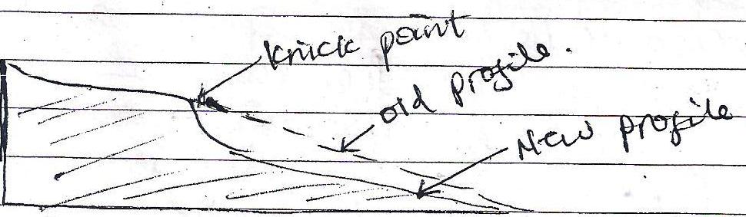

* Valley within: A valley/ rejuvenated gorge. This refers to a new valley which has been re – shaped from the old existing valley. A long rivers where rejuvenation was family rapid and the fall in base level quite large, the effect may produce a steep sided gorge within the former valley called valley within a valley eg. R. Nyando.

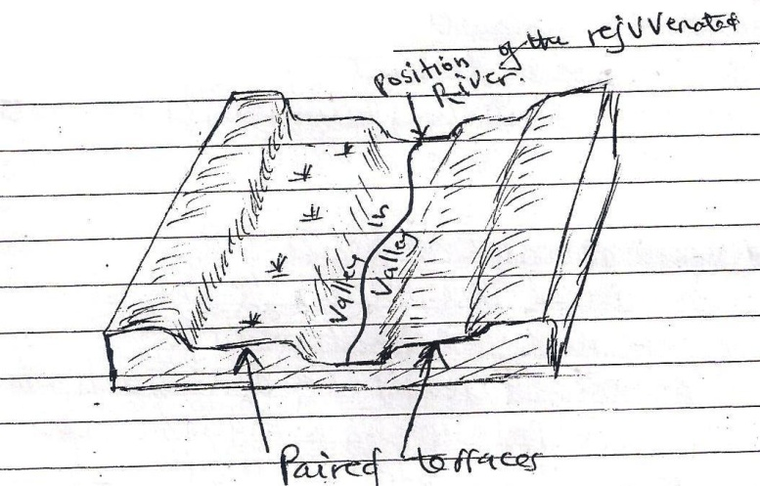

* Stream terraces/ paired terraces. These are bench/ step like strips of land found above a stream and its flood plain. They are benches cut in a rock or steps formed in sediments by deposition and subsequent erosion. Originally, the river deposited a thick section of flood plain. Sediments.
* Then the river changed from deposition to erosion, and cut into its old flood plain parts of which remain as terraces above the river. These terraces are generally of equal height and are called paired terraces eg R. Nyando and Ngaila.
* Incised meanders. These are steep deep gorges cut into a meandering channel. They are formed when there’s rapid verticial erosion of a channel within a meandering river. This results into a meandering valley with essentially no flood plains eg R. Mwachi, Kambeni, Cha – shimba incised meanders are divided into two:

1. In grown meanders. This is a valley with an asymmetrical cross – profile, where one side is a steeper than the other. It normally develops on more resistant rocks when vertical erosion increases. Eg R. Mubuku near the Kases – Fortportal road, R. Manafa near Busia a long the Tororo – Mbale road

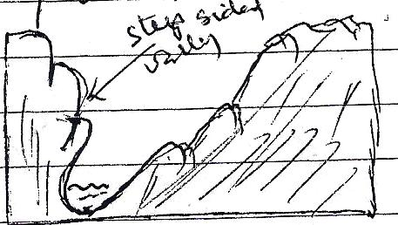

1. Entrenched meanders; These are valley with steep sided symmetrical profile. They develop on weaker rocks wjhere there’s rapid lowering of the base – level

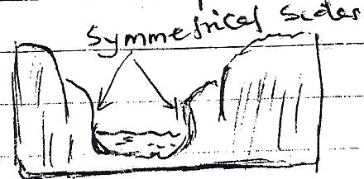

7. **Examine the cause and effects of land and sea breezes in East Africa.**

**Candidates are expected to;**

* Define land and sea breezes
* Give areas where they occur
* Give the cause of land and sea breezes
* Give the effects of land and sea breezes
* Land and sea breeze are local winds which occur in areas where land is lying close proximity to a water body
* Examples include; around the shores of L. Victoria, the coastal areas of East Africa, shore of L. Kyoga etc.
* Land breeze blows from land to sea/ lake and occurs during the night.
* Sea breeze blows from the sea to the land occurs during the day.

**Cause of land breeze (occurs during the nights**)

* Loss of terrestrial radiation at coastal lands at night. Land cools faster than the sea/ water hence temperature are cooler over land than the sea/ water which much of its heat
* Water loses heat more slowly such that the air above it also warms up.
* Low pressure is created over the warm sea and high pressure over the cold land.
* Cool air from the land under high pressure blow towards the sea to replace rising air hence land breeze.

**Diagram to show land breeze.**

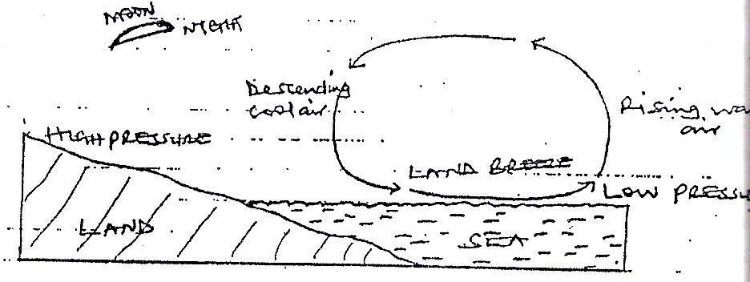

**Causes of sea breeze (occurs during the day)**

* There is intensive heating of coastal areas during the day
* Land warms faster than the sea hence temperature are high over the land colder over the sea.
* Convective currents of warm air rise over the land and create low pressure at the surface.
* Cool and moist winds from the sea blow towards land to replace the rising air i.e from high pressure to low pressure on land.

**Diagram to show sea breeze**

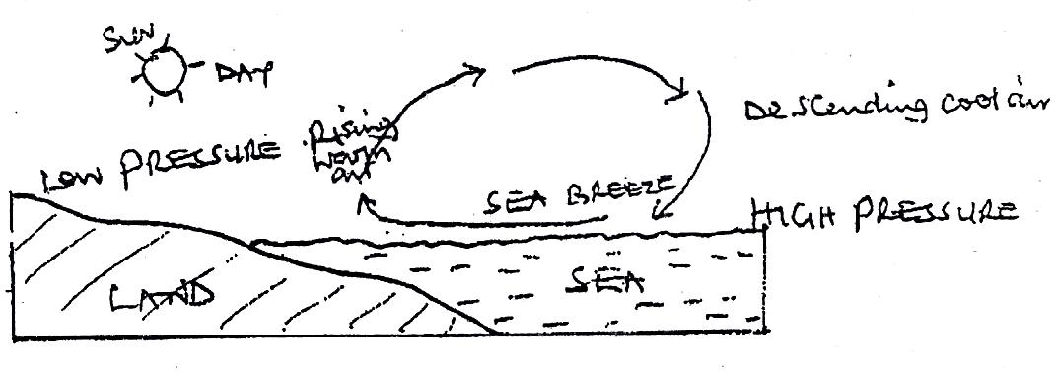

**General factors of land and sea breeze**

* Differences in specific heat capacities of land and sea.
* Mobility of water compared to solid land.
* Heat transmission through transparent water as opposed to opaque land.
* Differences in reflecting capacity of land and water.

**Effects of land breeze**

* Lowering of temperature over the sea
* Lead to information of foggy/ misty conditions over the lake which results into poor visibility
* Off – shore rainfall is formed
* Dry conditions on land because of little or no rainfall received
* It results into high violent thunderstorms.
* It results into high humidity in the sea/ lake
* There is formation of cloud cover over the sea.

**Effects of sea breeze**

* Lowering of temperatures on land especially in the afternoons.
* It leads to formation offoggy/ misty conditions on land which results into poor visibility
* On – shore rainfall is formed which is usually in early morning and afternoons.
* It results into violent thunderstorms
* It results into high humidity on land
* There is also formation of cloud cover over land.

Candidates are expected to illustrate their answer with valid examples