**GLACIATION**

This is the process by which glaciers shape the earth’s surface. Or it can be defined as the activities of a glacier.

In east Africa, glaciation can only take place on very high mountains that rise above the snow line at 5000m namely mountain Rwenzori, Kenya and Kilimanjaro. On mountain Rwenzori, there are 37 glaciers e.g. stanely, speke, Bujjuku, Mubuku, Edward, Backer, Moore etc.

Mountain kenya has the second largest coverage of glaciers and best examples here include lewis, Gregory, krapf, dawin, tyndal, ford, diamond, heim etc.

On mountain Kilimanjaro glaciers include kibo, great penk, furt wangler etc.

***A GLACIER***

A glacier is a mass of moving ice which moves down slope along a pre-existing river valley under the influence of gravity. Glaciers move continuously from higher to lower ground and is enclosed within valley walls.

**Formation of glaciers.**

When the temperatures in an area fall below 00, water vapor in the atmosphere condenses to form snow. The snow accumulates in pre glacial hollows. Under pressure, the air in it escapes melting and freezing occurs. Further compaction expels all the air and the bottom layers are compacted into ice. With time under the influence of gravity, the ice moves out of the hollow and is now known as a glacier.

**Types of glaciers.**

1. **Valley glaciers**; these are formed on highland or mountain peaks and upper valleys of mountain ranges. Valley glaciers move by sliding over the rock surfaces. Friction with the ground produces heat that in turn melts ice and helps to lubrication hence speeding up the sliding process.
2. **Lowland glacier**; this is a glacier found in colder and higher latitude areas mainly between 60° latitudes and the poles. They are mostly found in Greenland, Arctic and Antarctica.

NB There is limited glacier coverage in East Africa due to the following reasons;

**Latitudinal location of east Africa.** Latitude refers to the distance from the equator. East Africa lies along or astride the equator at approximately 5 degrees north and south of the equator. For this reason, whether the apparent overhead sun shifts north or south, the angle of incidence of the solar rays is still small. So the sun rays strike the earth’s surface at a wide angle and at a short distance hence ensuring maximum solar heating throughout the year. This implies that the temperatures in east Africa are high throughout the year. Therefore, its only in highland areas which rise above the snowline where temperatures drop to below freezing point that enables glaciers to form. However, these are very few areas where temperatures can drop below zero degrees hence limited coverage.

**Altitude**. Much of East Africa lies at a low altitude of less than 2000m above sea-level and this limits glacier formation because low altitude areas are associated with hot temperatures thus limiting glaciers to very few areas in East Africa rise to the current snowline of 4800m above sea level.

**Precipitation**. East Africa generally receives moderate rainfall of between 1000 to 1500m per annum. This is just sufficient to sustain life. However, glaciers form in areas where temperatures drop below freezing point and with torrential rainfall.

**Global warming**. The world temperatures have been rising with time and this is attributed to human activities like burning fuels e.g. coal, oil and natural gas which increases carbon-dioxide concentration in the atmosphere and other greenhouse gases. These gases absorb a lot of heat from the sun during day and prevent heat loss at night (they act as a blanket). This accounts for the increase in the global temperatures by 2.5°C. this increase in temperature has led to the melting away of glaciers to the point of extinction of some glaciers e.g. the sempaya glaciers on mountain Rwenzori.

**Aspect**. This refers to the angle at which the slope receives the sun’s insolation. East Africa lies between the tropics and therefore experiences direct over sun throughout the year. This implies that all slopes of the mountain are subjected to at least 10 hours of great sunshine a day without any sheltered slope or obstructed slope to enable glacier formation.

**Impact of volcanism**. Some of the high mountains where glaciation would have taken are volcanic in nature. The temperatures in these mountains are high due to the hot interior which brings about the warming effect on the surroundings. This is therefore preventing glacier formation.

***GLACIAL ACTIVITIES.***

***Erosion***

***Transport***

***Deposition***

***GLACIAL EROSION***

Glacial erosion occurs through the following processes;

**Plucking or exaration.**

It is the tearing away of the blocks of rocks which have become frozen into the sides and bottom of a glacier (glacial depressions). It is more effective where there well jointed rocks subjected to freeze and thawing.

**Abrasion.**

It's the wearing a way of rocks underneath a glacier by the swirling of rocks emborded in glaciers. In this process, the glaciers use the materials being carried or transported as the grinding tool which is used to break up rocks along the floor and sides of the glacial trough.

**Basal Sapping**.

This involves the breakup of rocks by alternate freezing and thawing of water in rock joints/cracks that exist on the sides and floor of a valley or the side of a mountain.

***GLACIAL EROSION FEATURES / GLACIAL UPLAND FEATURES***

***CIRQUES/CORRIE/TARNS.***

These are semi-circular steep sided rock basins which have been cut into the sides of a glaciated mountain. They are formed when water enters the rocks and freezes breaking them down. The joints become enlarged. Abrasion drags the debris over the rock floor deepening the depression; back wall cutting or recession also enlarged the depression as well as steepening the sides hence a Cirque/Corrie. When filled with water, it forms a tarn (lake) such as teleki and mawenzi on mountain Kenya and Kilimanjaro respectively. Others are Lac du Noir, Lac du Catherin and Lac du vent on mountain Rwenzori.

***illustration.***

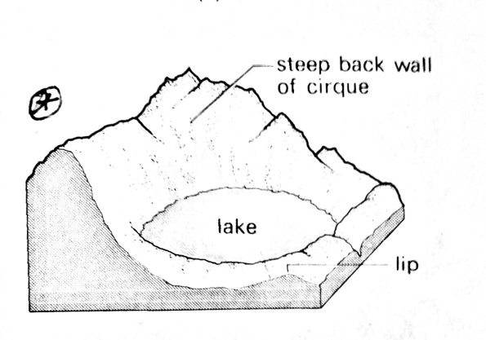

***Pyramidal peak /horn***

This is a jagged peak with a series of radiating aretes. It is formed by back wall recession of two or several cirques which lie on the sides of a glaciated mountain. Two or more cirques cut back into the original mountain sides leaving an isolated peak called a pyramidal peak. These peaks become shaped by frost action. Examples include kibo, mawenzi on mountain Kilimanjaro and margarita peak on mountain Rwenzori.

***Illustration.***

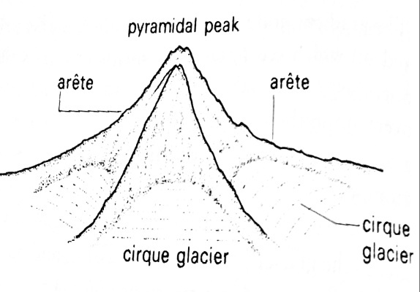

***Arête.***

This is a sharp knife like edged feature or narrow ridge in between two or more cirques on the mountain sides. It's formed when two or more cirques erode backwards (back to back) through the process of head Ward erosion. Best examples can be seen on my Rwenzori from Mount Backer up-to bujuku Valley and point John and midget peaks on mountain Kenya.

***U-shaped valleys or glacial troughs****.*

These are broad flat bottomed steep sided valleys with an open u shape in the cross profile. These were usually former river valleys which are filled by glaciers. Through the process of abrasion, plucking and sapping, the valley floor and sides were worn away hence deepening and widening the valley. So the valley is changed from a V-shape to an open U-shape hence a U shaped valley/trough.

Examples of u shaped valleys include Mubuku valley, Mugusu Valley and komusonso valleys on mountain Rwenzori, hobley and Teleki valleys on mountain Kenya and the karanga through on mountain Kilimanjaro.

***Illustration***

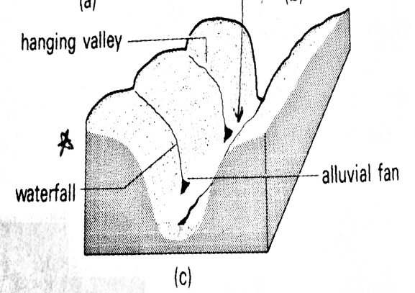

***Hanging valley***

These are small narrow short and V-shaped valleys laying above the main the main valley found in highland areas. They normally descend steeply into the main valley by a water fall. For example, Nithi river is joined by the little Nithi from a hanging valley on mountain Kenya.

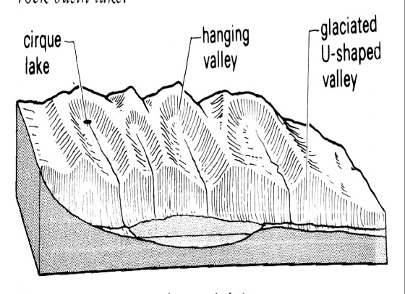

***Truncated spurs***

These are ridges with steep edges formed when former Interlocking spurs of a former river valley are cut off by lateral erosion resulting from accumulated glaciers in the valley forming a U-shaped valley with Truncated spurs instead of interlocking spurs for example around Mubuku and bujuku Valleys on mountain Rwenzori.

***Rock basins***

These are irregular depressions on the bed of the glacier trough. They are formed by un equal glacial erosion of the bed rock when out rock protrusions along the trough are removed to form hollows called rock basins.

Similarly, the path of the glacier may have rocks of different types and resistance to weathering and erosion where a band of soft rocks Alternate with bands of hard rocks, the soft rocks will be worn out to form a depression which is filled by water to form a basin lake. Best examples include lac Michaelson on mountain Kenya, Lac noir and Lac vert in the kamusoso valley on mountain Rwenzori.

***Illustration***

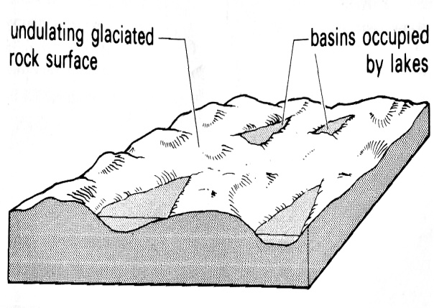

***Rock steps.***

These are step-like hard rock projections in the glacial valley formed as a result of differential erosion due to difference in rock resistance and variation in glacier thickness. The increased ice in the main valley makes it possible to cut deep in the valley creating step like features known as rock steps for example at Vivian falls on mountain Kenya

***illustration.***

***Crag and tail.***

This is an elongated rock mass with a steep slope on the upstream which protects the softer lee ward rock from being eroded or worn out by the glacier. Its formed when advancing ice meets a resistant rock protecting a weaker rock downstream from erosion leading to the formation of an elongated tail on the side of the weaker rocks while the resistant rock mass forms a crag with a steep slope.

***Illustration.***

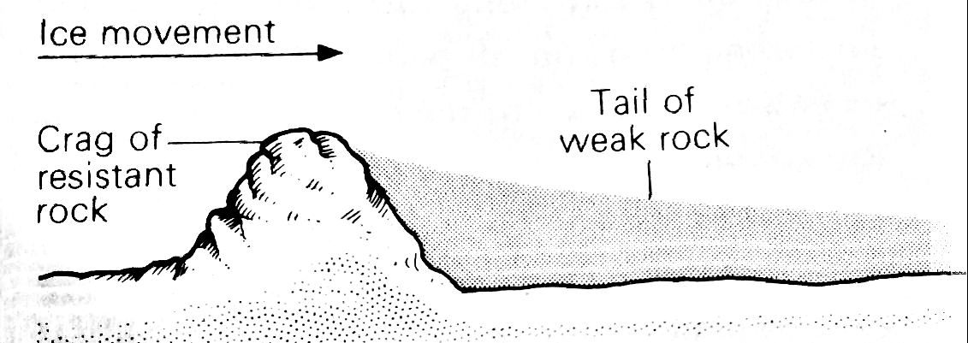

***Roche montannes.***

These are resistant rock masses smoothened on the upstream side by abrasion of ice and steepened on the downstream side. The downstream side is worn by plucking of ice making it rough. Examples can be found at the mobuku valley along the slopes of mountain Rwenzori and along the George valley on mountain Kenya.

**Illustration**

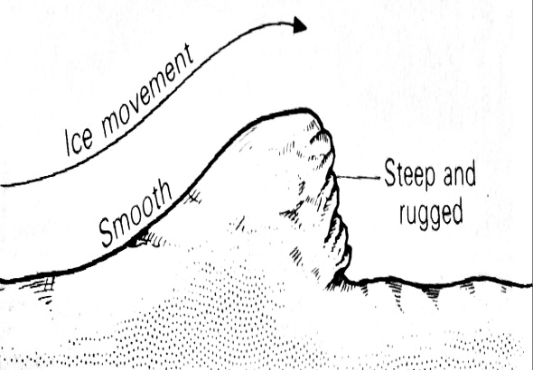

**Stratitions**

These are thin parallel scratches on glaciated areas formed by abrasion when large fragments of angular rock debris embodied in the ice tend to leave a series of parallel scratches. Such scratches can be seen in Stanley valley on Mt Rwenzori and near Peters hut on Mt Kilimanjaro.

**Question**

1. Account for the formation of upland glacial landforms in east Africa.

Approach

Define glaciation

Identify areas where glaciation is taking place in east Africa

Factors or conditions for the formation of glaciers.

Processes of glaciation

Identify and describe the landforms

1. Describe the processes responsible for the formation of glacial erosion landforms in east Africa

***Glacial deposition – landforms formed due to glacial deposition***

Glaciers transport a variety of materials ranging from fine rock flour to large boulders. All these materials are deposited in the valleys just beyond the point of melting and can modify the landscape markedly. Glacial depositional landforms are mainly found in the lowlands in the lower slopes of the mountains I.e. the valleys. The moraine transported and deposited by the glaciers results into the formation of depositional landform and these include:

***Moraine***

This refers to the rock debris that is eroded by flowing ice from the sides and base of the valley and deposited in the low lying areas. Moraine are large and small fragments that are detouched, transported and deposited when ice losses it's capacity to transport the materials.

***Terminal moraine,*** It's a ridge like feature formed by accumulation of unsorted fragments of all sizes extending across the valley as a belt of low hills for many kilometers. It's formed by extensive deposition along the snout of an ice sheet and may cover a reasonable distance and height of 50 meters. It builds up when the glacier is static. Examples can be seen in the low lying areas of Rwenzori i.e. bujuku, Mubuku valley kimberly plains of South Africa etc.

***Lateral moraine ,***This is an elongated ridge or moraine formed along the valley glacier sides. The deposition is as a result of friction between the moraine and the valley sides. Lateral moraine can be seen along Bujjuku, Mubuku and Kamsuso troughs on my Rwenzori and at the point where little Nithi river joins the main stream of river Nithi in the Teleki valley on my Kenya.

***Medial moraine***

When two glaciers meet, lateral moraine of the inner sides of both glaciers joins to form medial moraine. Medial moraine forms at the center of the glacier when a glacier retreats and drops its moraine.

***Ground or basal moraine.***This is formed when moraine is deposited at the bed of the glacier. It's composed of mainly fine glacial moraine dropped by retreating ice. Ground moraine almost covers the whole width of the valley.

***Illustration***

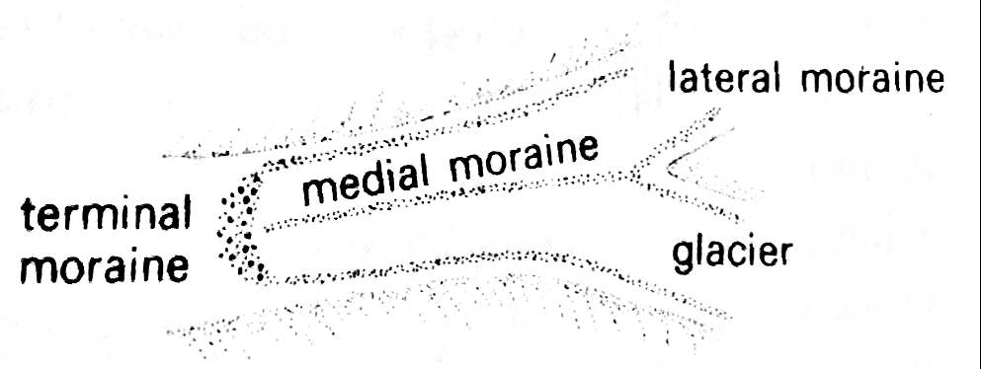

***Erratics***

These are rock fragments of varying sizes which are eroded, transported and deposited in areas where they are far different from the surrounding rocks where it's deposited. They are useful in determining the direction and source of ice movement. Best examples can be seen at kamusoso and bujuku Valleys on mountain Rwenzori in western Uganda.

**Illustration**

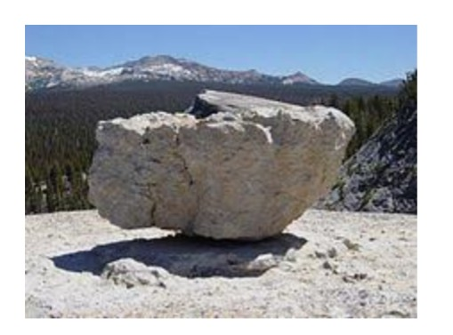

***Till plains.***

These are extensive areas of monotonous relief or landscape formed when moving Ice transports boulders, sand and clay hence burying former valleys and protruding rocks to form an almost leveled landscape. e.g. Teleki valley on mountain Kenya and Mubuku valley on mt Rwenzori.

***Illustration***

***Eskers***

These are long winding steep sided ridges of sand and gravel lying parallel to the direction of ice movement. They are more than 30 meters high and several kilometers long. Sometimes they are formed by rivers flowing beneath or within ice. they develop on areas of stagnant ice where rivers maintain sub glacier tunnels.

It's process of formation is attributed to stagnant ice sheets under hydrostatic pressure hence the ice develops melt water streams flowing within the ice following permanent sub glacial tunnels thereby deposition taking place within the tunnels. When the ice finally melts, it leaves behind long and steep sided ridges known as Eskers.

**Illustration**

***Drumlins***

These are low, rounded and elongated hills composed of bolder and clays lying parallel to the direction of ice movement. They are usually about 30m high and cover an area of up-to 1km. Drumlins occurs till plains in large groups or swarms aligned to the direction of the former ice advance. They are mostly formed when fragments or ground moraine are compressed by ice movements. Best examples are to be found in the teleki valley on mountain Kenya.

***Illustration.***

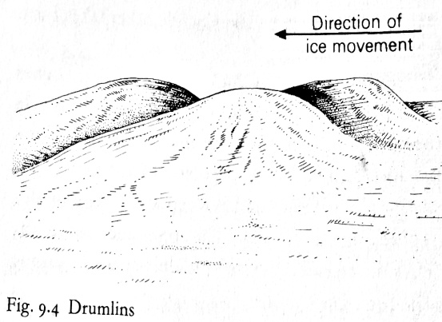

***Out wash plains***

These are wide gently sloping plains of gravel, fine sand and silt. They are formed when volumes of melt water redeposit sorted materials further down slope. Best examples can be seen at kibo and mawenzi on mt. Kilimanjaro, Mubuku and bujuku Valleys on mt. Rwenzori.

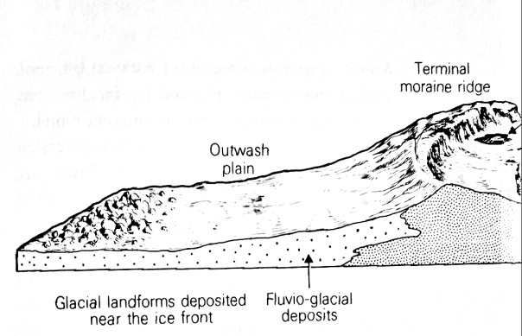

***Kettle holes***

these are circular holes in fluvial glacial deposits formed when an ice block is detached from the main glacier as it retreats. Such a block is then buried within the till by fluvial glacial deposits. The subsequent melting of Ice blocks leaves behind depressions to form kettles. When water collects in these depressions, they form kettle lakes.

**Illustrations**

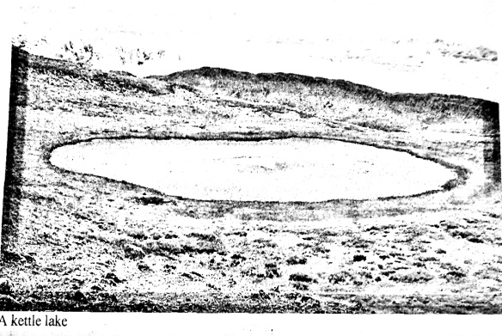

***Kame moraine***

These are ridges of sand and gravel on the sides of the glacial valley. They are laid down by streams melt water depositing materials of the same weight and size on the sides of the trough. Examples are found in Mubuku valley on mt Rwenzori and Hobley valley on mt Kenya.

***Illustration***

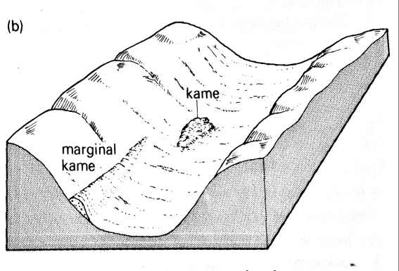

**ECONOMIC IMPORTANCE OF GLACIATION OR GLACIATED REGIONS TO THE PEOPLE OF EAST AFRICA.**

Melt waters from glaciers form important sources of rivers used for various uses e.g. the chagga on the slopes of mountain Kilimanjaro use it for irrigation.

The water falls formed at the hanging valleys are potential sites for hydroelectric Power generation e.g. at Corinne falls on mountain Kenya.

The beautiful scenery provided by glaciated landforms such as arêtes, pyramidal peaks etc. attract tourists who bring in foreign exchange.

The moraine deposited contains sand and gravel which can be extracted for building and construction purposes e.g. in kasese.

The boulder clay plains in the glaciated low lands are sometimes very fertile and suitable agriculture especially arable farming e.g. in the mobuku valley on the lower lands of mountain Rwenzori.

Glaciated areas may act as recreation and Sports centers for example mountain climbing

The U-shaped valleys form natural routes or ways for mountain climbers on the mountainous lands.

Glacial lakes such as lac-Gris, lac-Catherine are potential fishing grounds on my Ruwenzori.

***Negative***

Glacial regions are associated with avalanches which move downhill leading to extensive loss of property and life e.g. on the low lands of Ruwenzori

Glacial regions are associated with cold temperatures which limit agriculture and settlement.

Upland glaciation has removed most of the fertile top soil making the region unstable for agriculture eg on mts Ruwenzori and Kenya.