**SPECIAL PRE-PRIMARY LEAVING EXAMINATION, 2024 P.7 MATHEMATICS**

***Time Allowed: 2 hours 30 minutes***

|  |  |  |  |  |  |  |  |  |
| --- | --- | --- | --- | --- | --- | --- | --- | --- |
|  |  |  |  |  |  |  |  |  |

**Index No.**

**Candidate’s Name: ……………………………………………………...**

**School: ………………………………………………………………….**

**Candidates’ Signature ……………………………Stream…………….**

**Read the following instructions carefully.**

1. This paper is made up of two sections: A and B.
2. Section A has **20** question (40 marks)
3. Section B has **12** questions (60 marks)
4. Answer all questions in both sections A and B.
5. All answers must be written in the space provided in blue or black ball point pens and ink. Only diagrams should be done in pencil.
6. Unnecessary crossing of answers will lead to loss of marks.
7. Any handwriting which cannot be easily read, may lead to loss of marks.
8. Do not fill anything in the boxes indicated for “Examiners’ use only”.

**FOR EXAMINER’S USE ONLY**

|  |  |  |
| --- | --- | --- |
| **SECTION A** |  | **Total (%)** |
|  |
| **SECTION B** |  |  |

**SECTION A (40 Marks)**

**Answer all questions in this section.**

**Question 1 to 20 carry two marks each.**

1. Workout the Value of 8 hundreds.
2. Given that set P = {all composite numbers between 0 and 10} and set Q= {0,2,4,6,8,10}. Find P∩Q
3. Calculate 22 x 61 and then write the answer in Roman numerals.
4. Solve the equation; $5n-\left(n+4\right)=4$
5. Omolo packed 55.5kg (kilograms) of sugar in small bags weighing 0.5kilograms. find the number of small bags he used altogether.
6. Using a ruler and a pair of compasses only construct an angle of 150º at point N.

N

1. Round off 449.7 to the nearest ones.
2. Workout $\frac{2}{3} of 6-8÷4$
3. Umeme charges shs 250 for every 15 units of power consumed. A consumer paid sh. 65,000. How many units did he consume?
4. At St Agnes primary School a quiz which lasted for $2\frac{2}{3}hours$ ended at 4:30pm. What time did it start?
5. **The graph below shows 4 athletes who took a 100meter race at Soroti SS. Study it and use it to answer questions that follow.**

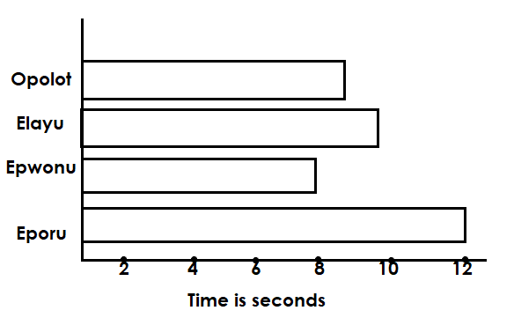

**No. of Athletes**

Who won the race and by how many seconds?

1. The temperature of the day rose from -5ºC to 25ºC. what was the rise temperature?
2. **Study the diagram below and use it to answer questions that follow.**

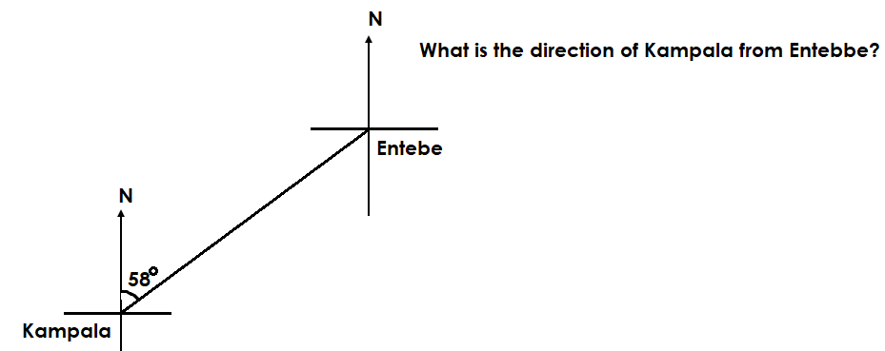

1. Musoke deposited sh. 45,000 in Equity Bank which offers an interest rate of 4% per month. What simple interest did he earn at the end of $1\frac{1}{2}$ years?
2. In a class, 25% of the pupils are girls, all of them were present on Wednesday, $\frac{1}{4}$ of the boys were absent. The class has 48 pupils. Find how many pupils were present altogether?
3. Find the product of the 3rd and 6th prime number.
4. In the figure below $PR=6cm and SQ=8cm.$ Find the area of PRQ.

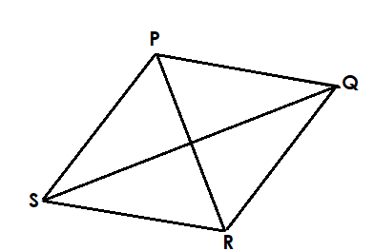

1. What single numeral has been expanded as shown.

(8 x103) + (5 x101) + (6x10-2)

1. By selling a radio for shs 92,000 trader made a loss of shs 8,000. Find his percentage loss.
2. What is the size of the interior angle of a regular hexagon?

**SECTION B (60 Marks)**

**Answer all the questions in this section.**

**Marks for each question are indicated in brackets.**

1. (a) In a class, there are $(2g+1)$ pupils who like Rice **(R)** only, 3g like Posho **(P)** only, if 5 pupils like both types of food and $2g-1$ like neither.
2. Represent the above information on the Venn diagram below. (02 marks)

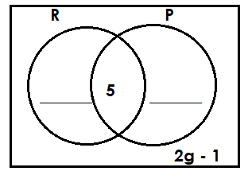

1. If 7 pupils like neither eating rice nor Posho. Find the value of g. (02 marks)
2. Find the total number of pupils in the class. (02 marks)
3. (a) Represent +5 - -8 on the number line below. (03 marks)



(b) Write a mathematical statement from the number line below. (02 marks)

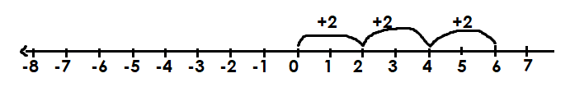

1. Mr. Omoit has to fence around his rectangular plot of land 225 metres by 165 metres. The fencing poles will be 3 metres apart.
2. How many poles will he need? (04 marks)
3. If each pole costs shs 2,000. How much will he spend on fencing his plot of land? (02 marks)
4. In the figure below SU is parallel to QR and PQR is a triangle. Angle STQ = 30º and angle PRQ = 70º.

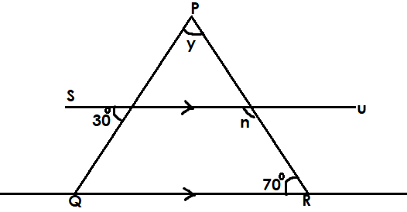

1. What is the size of angle PQR
2. What is the size of angle y and n? (02 marks)
3. (a) Write 69304 in expanded form using place values. (02 marks)

(b) A farmer collected 15,600 eggs a day on her farm and packs them on trays which carries 30 eggs each. Her vehicle carriers 40 trays per trip to the market. How many trips will the vehicle make in order to transport all the eggs. (04 marks)

1. (a) Solve and give the solution set for: $2-3y≥14.$ (03 marks)

(b) Solve: $3\left(3p-1\right)-6\left(p-3\right)=18$ (02 marks)

1. (a) Express 0.1333…… as a fraction in its lowest form. (02 marks)

(b) By selling a car shs 15,000,000, Mr. Okot lost 20% of his money. What was the buying price of the car? (02 marks)

1. **Study the coordinate graph below and use it to answer the questions that follow.**

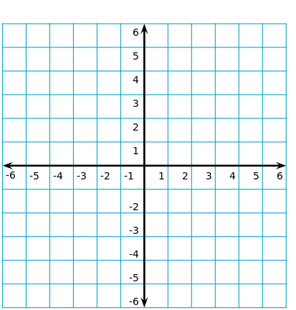

1. Write the coordinates of P. **(01 mark)**
2. Plot points Q(-4, +2), R(+1, +6), S(-4, -4) **(03 marks)**
3. Join points PQRS and name the shape formed. **(01 marks)**

____________________________________________________________

1. (a) A watch loses 3 seconds every after 2 hours. How long does it take to lose 1 $\frac{1}{2}minutes.$**(02 marks)**

(b) Convert 0930 hours to 12-hour clock system. (02 marks)

1. A box of mangoes weighs 60.5 kilograms when full. If the weight of the empty box is 5.5kg and one mango weighs half kilogram. How many mangoes are in the box? (04 marks)
2. (a) The table below show addition in base five. Complete it. (03 mks)

|  |  |  |  |
| --- | --- | --- | --- |
| + | 2 | 3 | 4 |
| 1 | 3 | 4 | 10 |
| 2 | 4 | 10 | ____ |
| 3 | 10 | 11 | 12 |
| 4 | 10 | ____ | _____ |

(b) If a dice is tossed once, what is the probability of a triangular number appearing on top? (02 marks)

1. **Pallisa town is 50 kilometers west of Mbale town and Busia town is 40 kilometers from Mbale town on a bearing of 150.**
2. Using a scale of 1 centimetre to represent 10 kilometers, draw an accurate diagram showing all the three towns. (03 marks)
3. What is the shortest distance from Pallisa to Busia? (01 mark)

**THE END**