**273/1**

**Geography paper one**

**Instructions**

**Attempt all**

1. In Africa, the investment is expanding in industry, mining, forestry and so many other sectors. The mining sector plays an important role in the region’s economy. Mineral exploration and exploitation have greatly contributed to infrastructural development such as roads, power supply networks and health facilities. Industries have been established to process the minerals in different parts of Africa. With the many opportunities that come along with mining, the sector is facing various challenges and those investing in the industry have almost failed to implement their investment plans.

**Support material:**

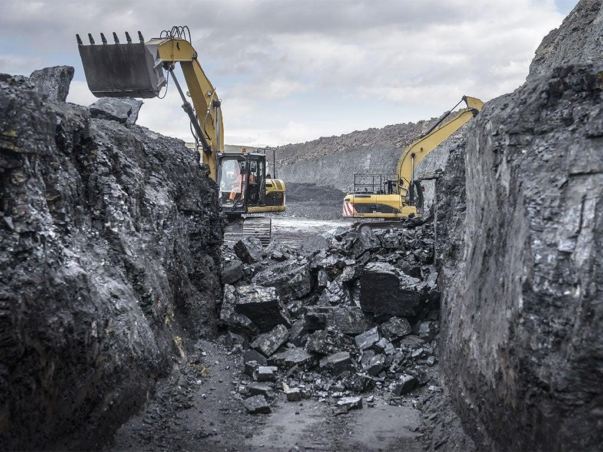

**Task**

Write an advice note that will help the investors to successfully implement their plans.

1

1. In the arid lands, drought frequently hits the communities. Crops wither and livestock perish from thirst leaving families with no solution. Tusu, one of the rural villages in sub-Saharan Africa, the local communities have been practicing irrigation farming for several years to supplement their food production and income. Of late, they are realizing that continued irrigation is impacting on the environment. A meeting has been organized by the local leaders to address the concerns of the community members.

**Support material**

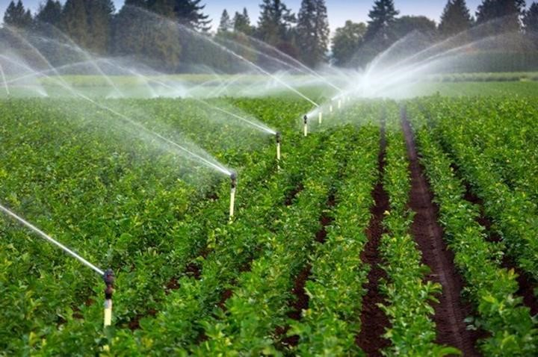

**Task**

Prepare a speech that you will present during the sensitization meeting for the Tusu community.

2