
THE TUBBIES SCHOOL
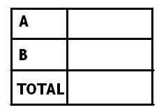END OF TERM II EXAMINATION, 2024
CLASS : P.1

SUBJECT : READING FLUENCY

DURATION : 2 HOURS 15 MINUTES

Name …………………………………………………………………..
1. Read the sounds.
a) scr b) ai
b) ee d) sk

2. Read the tricky words.
a) some b) again
c) do d) street

3. Read the words.
a) nsawo b) again
b) spring d) your

4. Read the sentences.
a) She has a green uniform.
b) I come from Kasese.
c) Monica is feeding a baby,
d) Nsereko has twelve toy cars.

5. Read the conversation. ( 4 marks)
Mukasa : Where are you going my little goat?
Goat : Am going to the market to buy a coat.
Mukasa : A coat for a goat ? People will laugh at the goat with a goat.

skill | 5 | 3 | 1 | 0
Accuracy
Speed
Confidence
Expression
Tricky word recognition

