SECTION A ( 60 MARKS)
- Add: 149 + 31

- Simplify: 4m – 3m + m.

- Write XCIX in Hindu Arabic numerals.

- Write 88018 in words.

- Express 0.7 as a fraction.

- Find the next number in the sequence 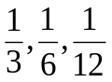_______________

- Simplify: ⁺6 - ⁻4.

- The base area of a cube is 36cm². Calculate the volume of the cube.

- Round off 13961 to the nearest thousands.

- Workout : 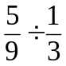

- Given that set A = {1, 3, 5, 7, 9} and Set B ={2, 3, 5, 7} find n(A B).

- Work out: 110_{two} + 11_{two}

- A die is tossed once. What is the probability that a number greater than 3 will appear on top?

- What integers are represented by letters c and d on the number line below?
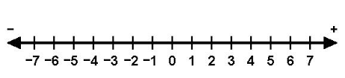
c
d

c……………………………………………………………
d……………………………………………………………

- Find the value of x in the figure below.
130⁰
x

- Solve: 3 – n= 2n

- If the circumference of a circle is 22cm, find its radius. (Take  = 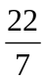)

- Mary has a bundle of five thousand shilling notes numbered consecutively form
AB534201 to AB534300. How much money does she have?

- In the triangle ABC, find the length BC.
C

B
A
8cm
6cm

- The exterior angle of a regular polygon is 60⁰ more than the interior angle. Find the exterior angle.

SECTION B.
- In a class of 40 pupils, 17 like English (E) only 9 like Science(S) only, 8 + y like both English and Science and y do not like any of the two subjects.
- Complete the Venn diagram. (3 mks)
………
………
………
8 + y
E
S
ε=40

- Find the value of y. (2mks)

- The manager of Samex hotel went to the market and bought the following items.
4kg of rice at shs. 4000 per kg.
4 kg of sugar at sh. 24000
5 litres of milk at shs. 4000 per litre.
- What was her total expenditure for all the items? (4mks)

- If she had two “fifty thousand shilling” notes, what was her change?(1 mk)

- (a) Using a ruler, pencil and a pair of compasses only, construct a triangle PQR where by PR = 7cm, angle QPR = 60⁰ and angle PRQ = 30⁰. ( 4mks)

(b) Measure angle PQR. (1mk)

- Sarah got the following marks in a series of mathematics tests.
40, 20, 44, 50, 50, 44, 26, 44.
- Calculate the modal mark. (2 mks)

- Find the mean mark. ( 2mks)

- The diagram below is a rectangle. Study it and answer the questions that follow.
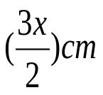
B
A
2(x + 1) cm
(5x -7) cm
D
C

- Find the value of x. (3mks)

- Find the area of the rectangle. (3 mks)

- (a) Work out: 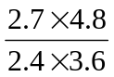 (3mks)

(b) Simplify: 1 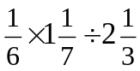 (2mks)

- The diagram below shows a sports field of length 100m, with semicircular ends of diameter 49m.

49m

100m

- What is the perimeter of the field? (Take =) (3mks)

- Calculate the area of the field. (3mks)

- John spent of his money on books and  of the remainder on transport.
- What fraction of his money was left? (3mks)

- If he was left with shs. 20,000, how much did he have at first? (2mks)

- Study the pie chart below and answer the questions that follow.
A pie chart about piggery project.

Paul
y⁰

Musa
Allan
144⁰

- Calculate the value of angle y. (2mks)

- If Paul contributed shs. 60,000 towards the piggery project, how much money did they contribute altogether? (3mks)

- A taxi leaves Kampala at 9:15a.m and reaches Ntungamo at 12:15pm. The same taxi leaves Ntungamo at 1:30pm and back to Kampala at 1:45pm. If the distance from Kampala to Ntungamo is 270km;
- Calculate the average speed of the taxi from Kampala to Ntungamo. (3 mks)

- Calculate the total time taken by the taxi to make the two trips. (2mks)

- Work out the average speed for the two journeys. (2mks)

- (a) On the abacus below, draw the beads to show the number 302. (2mks)
H T O

(b) Write 3409 in standard form. (1 mk)

(c) What is the place value of 4 in the number 240? (1mk)

- Joan left town X at 8:00am and drove at 90km/hr for 1 hour to town Y. She rested for  an hour at town Y. She left town Y and drove for 1 hour at 60km/hour to town Z. She rested for an hour at town Z. She then left town Z and drove back to town X at a steady speed of 50km/hour.

- Draw Joan’s journey on the graph provided. (2mks)
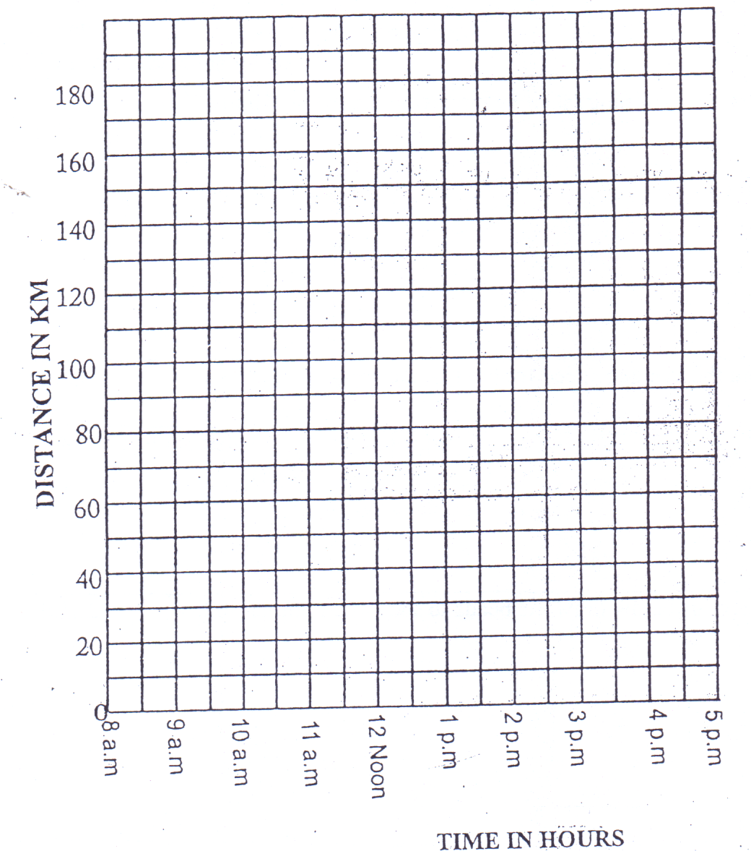

- Work out Joan’s average speed for the whole journey. (3 mks)

END.

