ATLAS JUNIOR SCHOOL – LUGOBA NABWERU
MIDTERM TWO EXAMINATION 2024
MATHEMATICS
PRIMARY SEVEN
Time Allowed: 2hours 30 Minutes

Random No. |  |  |  |  |  | Personal No.

Candidate’s Name: ………………………………………………………………… Candidate’s Signature: ………………………………………………………… School Name: …………………………………………………………………….. District No:
FOR EXAMINERS’

USE ONLY
Qn. No. | MARKS | EXR’S  No.
1 - 5
6 – 10
11 – 15
16 – 20
21 – 22
23 - 24
25 - 26
27 - 28
29 - 30
31 - 32
TOTAL

Read the following instructions carefully:

1. This paper has two sections: A and B

2. Section Ahas 20 short questions (40 marks)

3. Section B has 12 questions (60 marks)

4. Answer all questions. All the working for both sections A and B must be shown in the spaces provided.
5. All working must be done using a blue or blackball
point pen or ink. Any work done in pencil will NOT
be marked except drawings and diagram.
6. Unnecessary changes in your work and handwriting that cannot be easily read may lead to loss of marks.
7. Do not fill anything in the table indicated
“For examiners’ use only” and the boxes inside the question paper.

SECTION A: 40 MARKS
A n sw er all quest ion s in t h is sect ion
Qu est ion s 1 t o 2 0 carry t w o m ark s each
1. Workout: 126 – 16.

2. Given that set A = {a,b,c,d,e} and set B = {b,e,a,d}. Find ∩ (𝐴𝐴 ∩ 𝐵?)

3. Write “Thirteen thousand fourteen” in figures.

4. Find the next number in the sequence

1, 8, 27 ,64, ,

5. What is 25% of 200kg of meat?
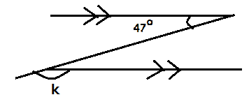

7. Simplify: -4 –7

8. The mean weight of 12 girls is 25kg. find the total weight of 12 girls.

9. A pilot told passengers that they were landing at 1510 hrs. Express this time in the 12 hour clock.

10. The cost of 4kg of sugar is sh.14,000. How many kg can one buy with sh.10,500?

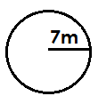

12. Simplify: 2𝑎𝑎 − 2𝑏𝑏 + 3𝑎𝑎 + 66

13. A set has 31 proper subsets. How many elements does it have?

14. Find the product of the value of 2 and 5 in numeral 2945.

15. What number has been expanded to give:
(4 × 104 ) + (2 × 102 ) + (3 × 100 ) + (2 × 10−1 ) + (3 × 10−2 )

17. Find the simple interest on sh.120,000 deposited in a micro finance that gives an interest rate of 5% per year for 6 months.

18. A regular polygon has its exterior angle measuring 72O. How many sides does the polygon have?

19. If represents 8 balls, how many balls are shown below.
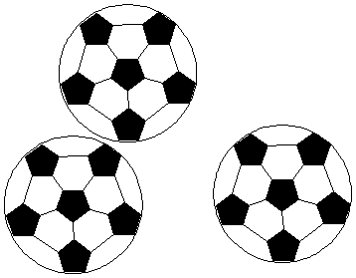

20. Given that the previous metre reading of a school was 0010200. If the current metre reading is 0010249, how many units did the school use?

Atlas Junior School Examination Board@ 2024

SECTION B: 60 MARKS

A n swer all t he quest ion s in th is sect ion

M ark s for each quest ion are in dicat ed in brack et s.

21. In a class of 75 pupils, (Y+5) pupils eat meat (M) only, Y eat both Meat and
Fish (F), 40 eat Fish only while 10 eat neither of the two foods.
(a) Complete the Venn diagram below. (3 marks)
∩ (∑) = 𝟕𝟕𝟕𝟕

∩ (𝑴𝑴)
∩ (𝑭?)

10

(b) How many pupils eat meat? (2 marks)

22. Given the numeral 37808 below
a) Write the numeral in words. (2 mks)

b) Find the difference between the place value of 7 and the place value of 0.
(2 mks)

c) Expand the numeral using place values. (2 marks)

23. a) Write 60000 in scientific notation. (2 mks)

b) Solve: 2𝑥𝑥 × 3 = 12 (3 mks)

24. The sum of three consecutive even numbers is 66. If their median in h. Find the numbers. (5 marks)

25. a) Simplify: 𝟎?.𝟒?𝟕𝟕 × 𝟎?.𝟒𝟒
𝟎?.𝟎𝟎𝟎𝟎𝟎

(2 marks)

b) Express 0.1818……. as a common fraction. (2marks)

26. a) With the help of a pair of compasses, a ruler and a pencil only, construct
triangle ABC where �A��B� = 7cm, angle BAC = 60O and angle ABC = 45O
(4 marks)

b) Measure
�A��C� (1 mark)

27. Study the number line below

B

A

C

a) Write the integers represented by arrows. (1 mark only )

C = B =
A =

b) What is the additive inverse of B? (2 marks)

c) Subtract integer B from A? (2 marks)

28. The table below shows marks scored by a P.7 group of pupils in a certain test.

Marks | 40 | 50 | 80 | 90
No. of pupils | 2 | 1 | 3 | 4
a) How many pupils did the test? (1 mark)
b) Find the modal mark (1 mark)

c) Calculate the average mark. (1 mark)

29. a) The District Education Officer started driving at 7:30a.m from Masaka and reached Mbarara at 10:00a.m covering a distance of 260km. At what speed was he driving? (3 marks)

b) Convert 20m/sec to km/hr. (2 mks)

Item | Quantity | Unit cost | Amount
Posho | kg | Sh.2000 | Sh.8000
Beans | 2 ½ kg | Sh.1600 | Sh.
Rice | 3kg | Sh. | Sh.9000
Salt | 500g | Sh. | Sh.4000
TOTAL EXPENDITURE |  |  | Sh.
(5 marks)

31. a) A book costs twice as much as a pen. Find the cost of a pen if both cost sh.2250. (3 marks)

b) Solve for 𝑥?: 3𝑥𝑥 + 4 = 5𝑥𝑥 − 4 (2 marks)

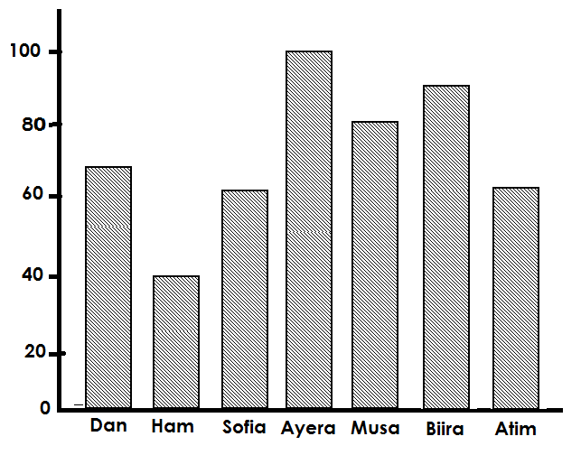
a) Find the range of their marks scored. (2 marks)

b) Calculate the mean score of Sofia, Musa and Ham. (3 marks)

***END***

