SECTION A.(40 MARKS)
- Work out: 52 x 3

- Write four hundred fifty thousand, ninety in figures.

- Given that set A ={all prime numbers less than 7}. How many proper subsets can be got from set A?

- Simplify: ⁻7 - ⁻6.

- Find the LCM of 6 and 8

- What is the value of 8 in the figure 3876?

- How many similar strides of 20cm can a boy make to cover a distance of four metres?

- Using a pair of compasses, a ruler and a sharp pencil only, construct an angle of 105⁰ in the space provided below.

- Use set notations to describe the shaded region on the venn diagram below.
ε
K
L

- Five pens cost shs. 15000. How many similar pens can one buy with sh. 45000 at the same rate?

- Solve for M: 2(m – 6)=8.

- The headteacher distributed 2525 books equally among the five streams. How many books did each stream get?

- A P.7 candidate did seven consecutive tests and scored. 60, 90, 45, 58, 60, 82, 76. Work out the candidate’s modal frequency.

- Express 20cm as a ratio of 2m.

- There are 20 electric poles in a straight line. If the distance from the first to the 20th Pole is 380m, find the interval between every two poles.

- The figure below is a cube. Use it to answer the question that follow
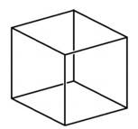
12cm

Find the capacity of the cube in litres.

- When a dice is tossed once, what is the probability of picking a factor of six at random?

- Uganda Cranes match against Egypt kicked off at a quarter to 4:00p.m. Write this time in a 24 hour clock time.

- A tourist has Ug shs. 159750 and wants to buy US dollars from a forex bureau. How many US dollars will the tourist get?
Rate at which the bureau buys | Rate at which bureau sells
UD $ 1 = Ug sh. 3500 | US $ 1 = Ug shs. 3550

N
W
N
P
40⁰

What is the bearing of town W from town P?

SECTION B.(60 MARKS)
- In a class of 48 pupils, 27 like Science(S) , y pupils like English(E) only, 7 like both subjects and 5 dislike Science and English.
- Use the information given to complete the Venn diagram below.
ε= 48
n(S) = 27
n(E) = …..
(3 marks)

- Find the value of y (2 marks)

- How many pupils like only one subject? (1 mark)

- (a) Express 142 in powers of 3. (2 marks)

(b) Write the number whose standard form is 8.74 x 10³. (2 marks)

- (a) In the diagram below, PQ is parallel to RS. Study the diagram and use it to find the size of angle K. (2 marks)
55⁰

130⁰

R

S

Q

P

K

(b) What angle is 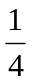 of its supplement? (3 marks)

- A man bought the following items from quality super market.
2 loaves of bread at shs. 4500 per loaf.
600g of sugar at shs. 4500 per kg
1 ½ kg of meat at shs. 15000
A dozen of glasses at shs. 3000 a pair.
- Calculate the Man’s total expenditure. (3 marks)

- If the man was given a discount of 10%, find his change if he went with shs. 50000. ( 2 marks)

- (a) Using a ruler, a pair of compasses and a pencil only, construct an isosceles trapezium in which PQ = 8cm, PS = QR = 4.5cm, angle SPQ = angle RQP = 60⁰. Join point R to point S. (5 marks)

(b) Measure SR (1 mark)

- A book cost (x + sh400) while a pen cost (x – sh100). If the total cost of three pens and two books is shs. 6500, find the cost of each item. (5 marks)

- The figure below shows a circle inscribed in a triangle whose base is 24cm and height 36cm. Given that the area of the shaded part is 124cm². (Use =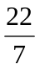)
K
M
36cm
•
24cm
N

•

- Find the area of the circle.

- Find the radius of the circle. (3 marks)

- Kigumba learns a new dance in which he takes 6 steps forward followed by 4 steps backward. Represent the above 2 measures of the dance on a numberline to find how far away the dancer was from his starting point. (4 marks)

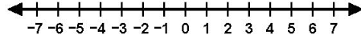

- Matania gave of his land to his brother Joseph, to Maria his sister and he was left with 40 acres of land.
- What fraction did he give to both Joseph and Maria? (2 marks)

- How big was Matania’s land before giving part of it to Joseph and Maria?
(3 marks)

- A bus travelled from Kisoro to Kabale at a speed of 90km/hr for 2hrs 30 minutes and later returned to Kisoro at a steady speed of 100km/hr.

- How far is Kisoro from Kabale? (2 marks)

- Calculate the return time to Kisoro (1 mark)

- Calculate the average speed for the whole journey. (2 marks)

- Study the diagrams below and use them to answer questions that follow.

A
42cm
30cm
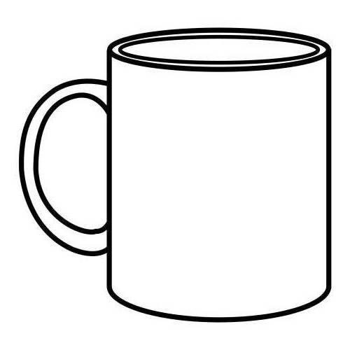
B
14cm
C

35cm
5cm
10cm

- How many cubes of type B can be packed in prism A? (2 marks)

- How many layers of tins C can be arranged in Prism A? (1 marks)

- If prism A contains water and John uses tin C to draw water from it, how many cupfuls of C can he get? (2 marks)

- On the grid below plot points K(⁻3, ⁻3) L(2, ⁻3) M(5, 4) N(0, 4) (4 marks)

Y – Axis

 |  |  |  |  |  |  | 8
 |  |  |  |  |  |  | 7
 |  |  |  |  |  |  | 6
 |  |  |  |  |  |  | 5
 |  |  |  |  |  |  | 4
 |  |  |  |  |  |  | 3
 |  |  |  |  |  |  | 2
 |  |  |  |  |  |  | 1
-7 | -6 | -5 | -4 | -3 | -2 | -1 | 0 | 1 | 2 | 3 | 4 | 5 | 6 | 7 | 8
 |  |  |  |  |  |  | -1
 |  |  |  |  |  |  | -2
 |  |  |  |  |  |  | -3
 |  |  |  |  |  |  | -4
 |  |  |  |  |  |  | -5
 |  |  |  |  |  |  | -6
 |  |  |  |  |  |  | -7
X – Axis

END.

