|  |
| --- |
| 18.8 Applications of Electrostatics - College Physics 2e | OpenStax |
| Electrostatics  Intro |
| |  |  |  | | --- | --- | --- | | Kintu Evans | [Date] | [Course title] | |

**Electrostatics: An Introduction to Static Electricity**Electrostatics is a branch of physics that focuses on the study of stationary electric charges and their behavior in various materials and circumstances. It deals with the phenomena arising from the fundamental property of matter called electric charge. The word "electrostatics" is derived from the Greek words "ēlektron" (meaning amber, a material known for its electric properties) and "statikós" (meaning causing to stand still). Electrostatics primarily revolves around the interaction of charged objects at rest.

**Key Concepts in Electrostatics:**

**1. Electric Charge:**

* **Definition:** Electric charge is a fundamental property of matter responsible for electromagnetic interactions.
* **Types of Charge:**
  + **Positive Charge:** Protons carry a positive charge.
  + **Negative Charge:** Electrons carry a negative charge.

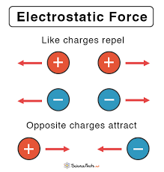

**Electric field**

Electric field lines help visualize the electric field. Field lines begin on a positive charge and terminate on a negative charge. Electric field lines are parallel to the direction of the electric field, and the density of these field lines is a measure of the magnitude of the electric field at any given point.

We show charge with “q” or “Q,” and the smallest unit charge is 1.6021 x 10-19 Coulomb (C). One electron and a proton have the same amount of charge.

**Positively Charged Particles**

In these particles, the numbers of positive ions are larger than the numbers of negative ions. This means the numbers of protons are larger than the number of electrons. To neutralize positively charged particles, electrons from the surroundings come to this particle until the number of protons and electrons becomes equal.

**Negatively Charged Particles**

Similarly numbers of [electrons](https://byjus.com/physics/electrons-and-photons/) are larger than the number of protons. To neutralize negatively charged particles, since protons cannot move and cannot come to negatively charged particles, electrons move to the ground or any other particle around.

**Neutral Particles**

Neutral particles include equal numbers of protons and electrons. They have both protons, neutrons and electrons; however, the numbers of positive ions equal the numbers of negative ions. 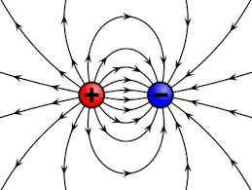

**Electrostatics Examples**

There are many examples of electrostatic phenomena:

* The attraction of the plastic wrap to your hand after you remove it from a package.
* The attraction of paper to a charged scale.
* The apparently spontaneous explosion of grain silos.
* The damage of electronic components during manufacturing.
* Photocopier and laser printer operation.

**Conductors and Insulators in Electrostatics: Understanding Charge Flow**

In the realm of electrostatics, materials are broadly classified into conductors and insulators based on their ability to facilitate the flow of electric charge:

**Conductors:**

* **Definition:** Conductors are materials that allow electric charges to flow easily within them.
* **Characteristics:**
  + Abundant free electrons that are not tightly bound to atoms.
  + When a conductor is subjected to an electric field, these free electrons move and create an electric current.
  + Examples include metals like copper, aluminum, silver, and gold.

**Insulators:**

* **Definition:** Insulators (or dielectrics) are materials that do not allow the flow of electric charges easily.
* **Characteristics:**
  + Few or no free electrons available for charge movement.
  + Electrons are tightly bound to atoms, making it difficult for them to move.
  + Examples include rubber, plastic, glass, wood, and air.

**Charging by Electron Transfer:**

Materials can acquire an electric charge through the transfer of electrons, either by gaining or losing them. Here's an overview of different charging processes:

**Gaining Electrons (Negative Charge):**

* **Electron Transfer:** Electrons move from a neutral or positively charged object to another, making the former negatively charged.
* **Example:** When a neutral insulating rod is rubbed with a wool cloth, electrons move from the rod to the cloth, leaving the rod negatively charged.

**Losing Electrons (Positive Charge):**

* **Electron Deficit:** A material can lose electrons, resulting in a positive charge due to an electron deficit.
* **Example:** When a glass rod is rubbed with silk, the glass loses electrons to the silk and becomes positively charged.

**Examples of Charging Scenarios:**

**1. Van de Graaff Generator:**

* **Principle:** The generator accumulates charge on a metal sphere using a moving belt.
* **Process:** Friction between the belt and a comb transfers charge to the belt, which is then deposited on the metal sphere, creating a high voltage potential.

**2. Triboelectric Series:**

* **Concept:** Materials can be ranked based on their tendency to gain or lose electrons when in contact.
* **Example:** Rubbing a plastic pen against a piece of fur (like wool) can transfer charge from the fur to the pen, making the pen negatively charged (plastic gains electrons).

**3. Lightning:**

* **Natural Charging:** Lightning occurs due to the accumulation of charge in clouds. The negatively charged base of the cloud induces a positive charge on the ground, leading to a lightning strike to neutralize the charge imbalance.

**Earthing (Grounding) in Electrostatics: Ensuring Safety and Stability**

Earthing, also known as grounding, is a crucial aspect of electrical and electrostatic systems. It involves connecting a conducting object or system to the Earth or a large conducting body to ensure safety, stability, and efficient functioning. In the context of electrostatics, earthing plays a significant role in dissipating excess charge and neutralizing objects or systems.

**Key Concepts and Applications:**

**1. Safety and Protection:**

* **Preventing Electric Shocks:** Earthing ensures that excess electrical charge, including static charge, can flow harmlessly into the ground, minimizing the risk of electric shocks.

**2. Charge Dissipation:**

* **Excess Charge Removal:** Earthing provides a pathway for excess charge to flow into the ground, neutralizing objects or systems and maintaining electrical balance.

**3. Stabilizing Voltage:**

* **Voltage Regulation:** Earthing helps in stabilizing the voltage levels in electrical systems, especially during surges or sudden changes in electrical potential.

**4. Electrostatic Discharge (ESD) Control:**

* **Preventing Damage:** In sensitive electronic devices, earthing prevents damage from electrostatic discharges by providing a path for excess charge to dissipate safely.

**5. Electromagnetic Interference (EMI) Reduction:**

* **Enhanced Performance:** Proper earthing reduces EMI, improving the performance of electronic devices and communication systems.

**6. Lightning Protection:**

* **Path for Lightning Discharge:** Earthing systems, such as lightning rods connected to the ground, provide a safe path for lightning to dissipate its charge into the Earth, safeguarding structures and systems.

**How Earthing Works:**

* **Direct Connection:** In a typical earthing system, a conducting wire is directly connected to the object or system to be grounded and to a grounding rod buried in the ground.
* **Electric Potential Equalization:** The potential of the grounded object becomes equal to the potential of the Earth, allowing charge to flow freely between them.
* **Electrical Grounding Systems:** Common grounding systems include single-point grounding, multiple-point grounding, and equipment grounding.

**Components of an Earthing System:**

**1. Grounding Rod:**

* A long, buried metal rod (often copper or steel) that establishes the electrical connection between the grounded object and the Earth.

**2. Grounding Conductor:**

* A conducting wire that connects the grounding rod to the object or system to be grounded.

**3. Earth Electrode Substation:**

* A facility where multiple grounding rods and conductors are interconnected for effectively grounding an entire electrical substation.

The Gold Leaf Electroscope (GLE) is used for detecting and quantifying electric charges. Let's explore how it is used and how it can be charged positively and negatively, along with some additional relevant information.

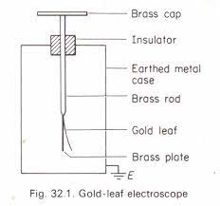 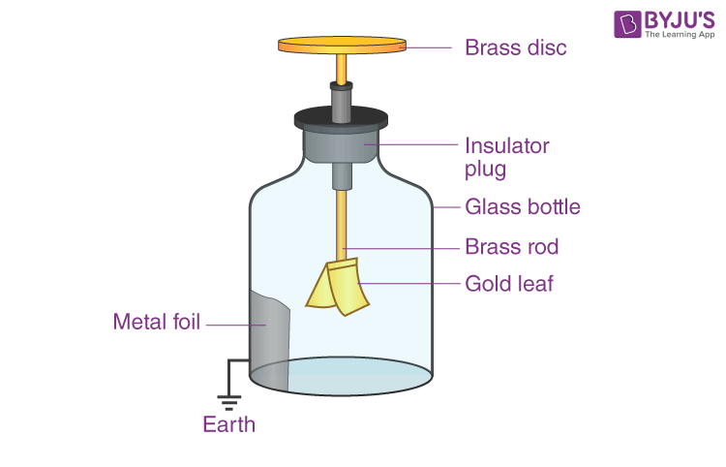

**1. Using the Gold Leaf Electroscope:**

1. **Charge Detection:**
   * To use the GLE, you start by bringing a charged object close to the brass rod or terminal at the top of the electroscope.
   * If the charged object is positively charged, electrons in the brass rod are repelled, and they move down into the gold leaves, making them negatively charged and causing them to repel each other, thus spreading apart.
   * If the charged object is negatively charged, the electrons in the gold leaves move away, leaving the leaves positively charged, also resulting in repulsion and leaf separation.
2. **Observing Leaf Movement:**
   * You observe the movement of the gold leaves to determine whether the electroscope is charged and the type of charge present (positive or negative).
   * If the leaves separate, it indicates the presence of a charge. The degree of separation can provide a qualitative estimation of the charge's magnitude.
3. **Grounding:**
   * To discharge the electroscope, you can touch the brass rod with your hand. This allows excess charges to flow to or from the ground, neutralizing the electroscope.

**2. Charging the Gold Leaf Electroscope:**

* **Positive Charging:**
  + To charge the electroscope positively, you can bring a positively charged object (e.g., a glass rod rubbed with silk) close to the brass rod.
  + Electrons in the electroscope are repelled, moving to the leaves and making them negatively charged while leaving the brass positively charged.

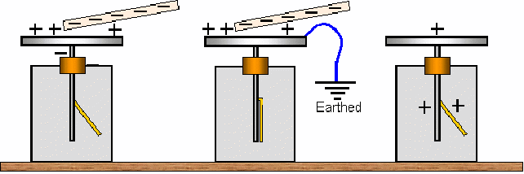

* **Negative Charging:**
  + To charge the electroscope negatively, bring a negatively charged object (e.g., a rubber rod rubbed with fur) close to the brass rod.
  + Electrons are attracted to the brass rod, leaving the leaves positively charged.

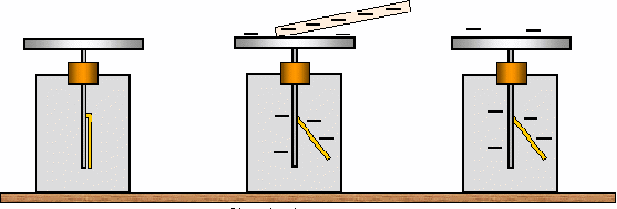

**Additional Information:**

* **Leaf Collapse:**
  + If the leaves initially have a significant separation due to a charge, over time, they may slowly come closer due to air ionization and loss of charge through the air.
* **Calibration:**
  + The electroscope's sensitivity and response can vary based on factors like humidity and the geometry of the leaves, necessitating careful calibration for accurate measurements.
* **Educational Tool:**
  + The GLE is an essential tool in physics education for demonstrating principles of electrostatics and charge behavior.

**Conductors and Insulators in Electrostatics: Understanding Charge Flow**

In the realm of electrostatics, materials are broadly classified into conductors and insulators based on their ability to facilitate the flow of electric charge:

**Conductors:**

* **Definition:** Conductors are materials that allow electric charges to flow easily within them.
* **Characteristics:**
  + Abundant free electrons that are not tightly bound to atoms.
  + When a conductor is subjected to an electric field, these free electrons move and create an electric current.
  + Examples include metals like copper, aluminum, silver, and gold.

**Insulators:**

* **Definition:** Insulators (or dielectrics) are materials that do not allow the flow of electric charges easily.
* **Characteristics:**
  + Few or no free electrons available for charge movement.
  + Electrons are tightly bound to atoms, making it difficult for them to move.
  + Examples include rubber, plastic, glass, wood, and air.

**Charging by Electron Transfer:**

Materials can acquire an electric charge through the transfer of electrons, either by gaining or losing them. Here's an overview of different charging processes:

**Gaining Electrons (Negative Charge):**

* **Electron Transfer:** Electrons move from a neutral or positively charged object to another, making the former negatively charged.
* **Example:** When a neutral insulating rod is rubbed with a wool cloth, electrons move from the rod to the cloth, leaving the rod negatively charged.

**Losing Electrons (Positive Charge):**

* **Electron Deficit:** A material can lose electrons, resulting in a positive charge due to an electron deficit.
* **Example:** When a glass rod is rubbed with silk, the glass loses electrons to the silk and becomes positively charged.

**Examples of Charging Scenarios:**

**1. Van de Graaff Generator:**

* **Principle:** The generator accumulates charge on a metal sphere using a moving belt.
* **Process:** Friction between the belt and a comb transfers charge to the belt, which is then deposited on the metal sphere, creating a high voltage potential.

**2. Triboelectric Series:**

* **Concept:** Materials can be ranked based on their tendency to gain or lose electrons when in contact.
* **Example:** Rubbing a plastic pen against a piece of fur (like wool) can transfer charge from the fur to the pen, making the pen negatively charged (plastic gains electrons).

**3. Lightning:**

* **Natural Charging:** Lightning occurs due to the accumulation of charge in clouds. The negatively charged base of the cloud induces a positive charge on the ground, leading to a lightning strike to neutralize the charge imbalance.

Understanding conductors, insulators, and the processes through which materials gain or lose electrons is fundamental in comprehending how electric charge behaves and flows, impacting various aspects of our daily lives and technological advancements.

A spark or crackling sound emerges when our synthetic garments or sweaters are removed from our bodies, especially in dry weather. This is virtually unavoidable with feminine apparel, such as polyester sarees. Lightning, in the sky during thunderstorms, is another case of electric discharge. It is an electric shock always felt while opening a car door or grabbing the iron bar of a bus after sliding out of our seats. The cause of these sensations is the discharge of electric charges that have collected as a result of rubbing insulating surfaces. This is due to static electricity generation. Anything that does not have movement or change with time is referred to as static. The study of forces, fields, and potentials coming from static charges is known as Electrostatics.

Electrical neutrality refers to the presence of an equal amount of positive and negative charges in most bodies. To charge a neutral body, the balance of positive and negative charges has to be changed. The methods of altering the charge balance of a neutral body are:

* Friction
* Conduction
* Induction

**Charging by Friction**

The charging by friction method includes rubbing one particle against another, causing electrons to move from one surface to the next. This procedure can be used to charge insulators.

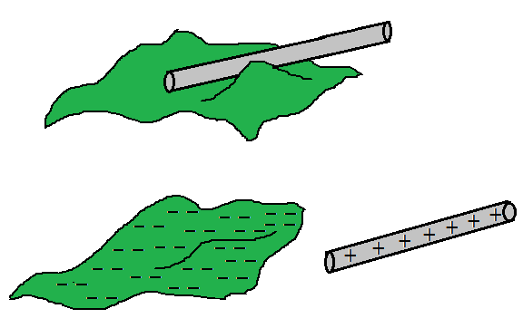

*Charging by friction*

Different types of atoms and atom combinations make up material objects. Various items have different electrical characteristics due to the existence of different atoms in them. Electron affinity is one of these properties. Simply described, electron affinity is a feature that describes how much a substance cares about electrons. If a substance’s atoms have a high electron affinity, the material will have a strong affection for electrons as well. As one of the most prevalent types of charging, turboelectric charging, commonly known as charging by friction or rubbing, this property of electron affinity will be crucial.

Consider rubbing a rubber balloon with a piece of animal fur. The atoms of the rubber are pressed into proximity with the atoms of the animal fur during the rubbing process. The electron clouds of the two types of atoms are squeezed together, bringing the nuclei of the other atoms closer together. The protons in one material’s atoms begin to interact with the electrons in the other material’s atoms. You might almost hear the atoms remark, “I like your electrons,” in the midst of the crackling air. Of course, the atoms of one material – in this case, the atoms of rubber – take their claim for electrons more seriously. As a result, rubber atoms begin to steal electrons from animal fur atoms. The two things have become charged after the rubbing has stopped.

One another example is when two glass rods that have been rubbed with a piece of cloth of wool or silk are brought close together, they repel each other. The two strands of wool or two pieces of silk cloth used to rub the rods repel each other as well. The glass rod and a piece of cloth of wool, on the other hand, were attracted to one other.

**Charging by Conduction**

Charging by conduction occurs when a charged particle comes into contact with a neutral conductive medium. Charges are transmitted from the charged substance to the neutral conductor. This approach can be used to charge conductors.

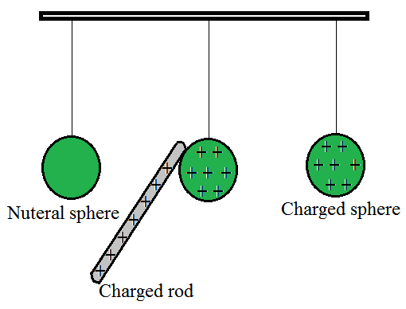

*Charging by Conduction.*

**Conduction charging**occurs when a charged object makes contact with a neutral object. Assume a positively charged aluminum plate is brought into contact with a neutral metal spherical. When the neutral metal sphere comes into touch with the charged aluminum plate, it becomes charged.

* Consider the case of a negatively charged metal spherical being pressed against the top plate of a neutral needle electroscope. When the metal sphere makes contact with the neutral electroscope, it charges it.
* Finally, imagine that an uncharged physics scholar is standing on an insulating platform when a scholar comes into contact with a negatively charged Van de Graaff generator causes the neutral physics scholar to become charged.
* Each of these cases includes a charged object making contact with a neutral object. In contrast to induction charging, which involves bringing the charged object close to but never touching the object being charged, conduction charging entails physically connecting the charged object to the neutral object.
* Charging by conduction is sometimes known as charging by touch since it involves contact.

**Charging By Induction**

**Induction charging** is a charging method in which a neutral object is charged without actually touching another charged object. The charged particle is held near a neutral or uncharged conductive material that is grounded on a neutrally charged material. When a charge flows between two objects, the uncharged conductive material develops a charge with the polarity opposite that of the charged object.

**(1) Charging by induction using a positively charged rod:**

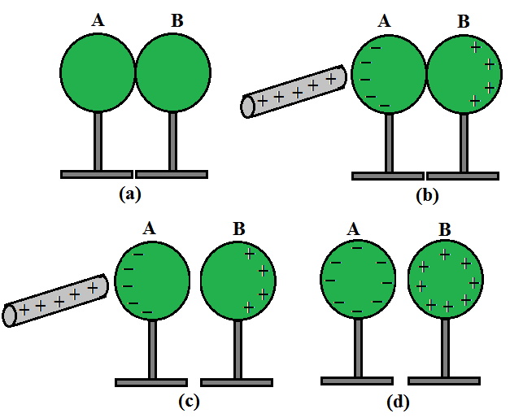

*Charging by induction using a positively charged rod.*

* Place two metal spheres, A and B, on insulating platforms and bring them together.
* Bring a positively charged rod close to one of the spheres, say A, but don’t let it touch it. The rod attracts the free electrons in the spheres. The rear surface of sphere B now has an excess of positive charge. Both types of charges are encased in metal spheres and are unable to escape. As a result, they live on the surfaces. The left surface of sphere A has a negative charge surplus, while the right surface of sphere B has a positive charge excess. On the left surface of A, not all the electron particles in the spheres have collected. Other electron particles are repelled by the negative charge that is building upon A’s left surface. Under the operation of the rod’s attraction force and the force of repulsion caused by the accumulated charges, equilibrium is achieved in a short period. The equilibrium situation is depicted in Fig. 1.4(b).
* Induction of charge is the name for the process, which occurs nearly quickly. The collected charges remain visible on the surface until the glass rod is held close to the sphere, as shown. When the rod is withdrawn, the charges are no longer affected by external forces and revert to their original neutral condition.
* As indicated in Figure separate the spheres by a modest distance while holding the glass rod near sphere A. (c). The two spheres are found to be charged in opposite directions and are attracted to each other.
* Take out the rod. As demonstrated in Figure the charges on spheres rearrange themselves (d). Separate the spheres completely now. As illustrated in Figure the charges on them are uniformly spread over them (e).

The metal spheres will be equal and oppositely charged in this operation. This is known as induction charging. In contrast to charging through contact, the positively charged glass rod does not lose any of its charges.

**(2) Charging by induction using a negatively charged rod:**

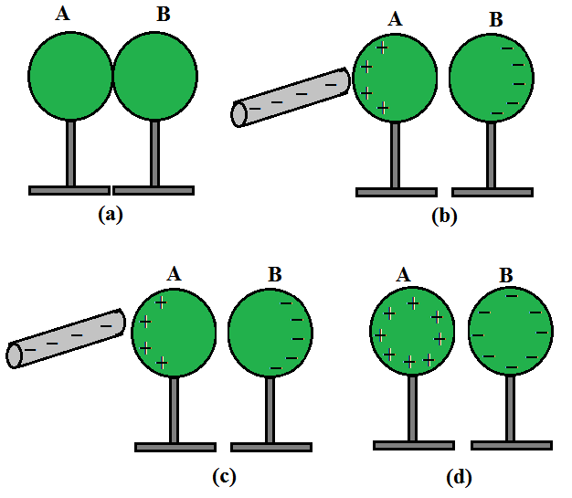

*Charging by induction using a negatively charged rod.*

* Consider two metal spheres A and B, which are touching in the illustration. Take a charged rod that is negatively charged. When a charged rod is kept close to the spheres, the repulsion between the charged rod’s electrons and the spheres causes electrons in the two-sphere system to move away.
* The electrons from sphere A are transported to sphere B as a result. Sphere A becomes positively charged and sphere B becomes negatively charged due to electron migration.
* As a result, the entire two-sphere system is electrically neutral. As illustrated, the spheres are then separated (avoiding direct contact with the metal). When the charged rod is removed, the charge is redistributed throughout the spheres, as indicated in the diagram.

**Earthing (Grounding) in Electrostatics: Ensuring Safety and Stability**

Earthing, also known as grounding, is a crucial aspect of electrical and electrostatic systems. It involves connecting a conducting object or system to the Earth or a large conducting body to ensure safety, stability, and efficient functioning. In the context of electrostatics, earthing plays a significant role in dissipating excess charge and neutralizing objects or systems.

**Key Concepts and Applications:**

**1. Safety and Protection:**

* **Preventing Electric Shocks:** Earthing ensures that excess electrical charge, including static charge, can flow harmlessly into the ground, minimizing the risk of electric shocks.

**2. Charge Dissipation:**

* **Excess Charge Removal:** Earthing provides a pathway for excess charge to flow into the ground, neutralizing objects or systems and maintaining electrical balance.

**3. Stabilizing Voltage:**

* **Voltage Regulation:** Earthing helps in stabilizing the voltage levels in electrical systems, especially during surges or sudden changes in electrical potential.

**4. Electrostatic Discharge (ESD) Control:**

* **Preventing Damage:** In sensitive electronic devices, earthing prevents damage from electrostatic discharges by providing a path for excess charge to dissipate safely.

**5. Electromagnetic Interference (EMI) Reduction:**

* **Enhanced Performance:** Proper earthing reduces EMI, improving the performance of electronic devices and communication systems.

**6. Lightning Protection:**

* **Path for Lightning Discharge:** Earthing systems, such as lightning rods connected to the ground, provide a safe path for lightning to dissipate its charge into the Earth, safeguarding structures and systems.

**How Earthing Works:**

* **Direct Connection:** In a typical earthing system, a conducting wire is directly connected to the object or system to be grounded and to a grounding rod buried in the ground.
* **Electric Potential Equalization:** The potential of the grounded object becomes equal to the potential of the Earth, allowing charge to flow freely between them.
* **Electrical Grounding Systems:** Common grounding systems include single-point grounding, multiple-point grounding, and equipment grounding.

**Components of an Earthing System:**

**1. Grounding Rod:**

* A long, buried metal rod (often copper or steel) that establishes the electrical connection between the grounded object and the Earth.

**2. Grounding Conductor:**

* A conducting wire that connects the grounding rod to the object or system to be grounded.

**3. Earth Electrode Substation:**

* A facility where multiple grounding rods and conductors are interconnected for effectively grounding an entire electrical substation.

**Conclusion:**

Earthing is an essential practice in electrical and electrostatic systems, ensuring safety, stability, and efficient operation. By providing a safe path for excess charge and potential equalization, earthing prevents electrical hazards and enhances the performance and reliability of various systems and devices. Understanding and implementing proper earthing techniques are paramount in both residential and industrial settings.

**Lightning in Electrostatics: The Electrifying Natural Phenomenon**

Lightning is a dramatic and powerful natural electrostatic discharge that occurs during thunderstorms. It is a spectacular display of electrostatic phenomena involving the buildup and release of electrical charge in the atmosphere. Understanding lightning within the context of electrostatics involves delving into its formation, the charge distribution in a thunderstorm, and the discharge process.

**Key Concepts and Processes:**

**1. Charge Separation:**

* **Formation of Charge:** Inside a thunderstorm, various particles (ice, water, and dust) collide, creating friction and leading to the separation of charges.
* **Charge Distribution:** The upper part of the storm tends to accumulate positive charge, while the lower part accumulates negative charge.

**2. Electric Field:**

* **Buildup of Electric Field:** The charge separation creates a significant electric field within the thunderstorm.
* **Ionization:** This electric field ionizes air molecules, turning them into charged particles.

**3. Formation of Lightning:**

* **Leader Formation:** The negative charges at the base of the cloud induce a positive charge on the Earth's surface, creating an electric field between the cloud and the ground.
* **Stepped Leader:** A stepped leader, a channel of partially ionized air, descends from the cloud towards the ground, seeking the path of least resistance.

**4. Lightning Strike:**

* **Connection to the Ground:** When the stepped leader gets close to the ground, it often connects with a positively charged streamer rising from the ground.
* **Main Discharge:** The completed path forms a highly conductive channel, allowing the main lightning discharge to flow from the cloud to the ground.

**5. Return Stroke:**

* **Illuminating Stroke:** The lightning bolt we see is the return stroke, where a huge current flows from the ground back to the cloud.
* **Characteristics:** The return stroke happens in less than a millisecond, producing intense light and heat, giving lightning its characteristic appearance.

**Types of Lightning:**

**1. Intra-Cloud (IC) Lightning:**

* Lightning that occurs within the cloud itself, involving discharges between different regions of charge within the cloud.

**2. Cloud-to-Ground (CG) Lightning:**

* The more recognizable lightning, where a lightning bolt extends from the cloud to the ground.

**3. Cloud-to-Cloud (CC) Lightning:**

* Lightning that travels horizontally between different charged areas in separate clouds.

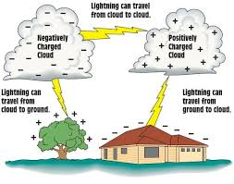

**Safety Measures and Impact:**

**1. Safety Precautions:**

* **Indoor Safety:** During a thunderstorm, it's safest to stay indoors, away from windows, and avoid using electrical appliances connected to power outlets.
* **Outdoor Safety:** If caught outside, seek shelter in a sturdy building or a hard-topped metal vehicle. Avoid open fields and elevated places.

**2. Impact on Infrastructure:**

* Lightning can cause power surges, damage electronic devices, start fires, and harm electrical systems.

**Conclusion:**

Lightning is a fascinating display of electrostatic discharge resulting from charge separation within thunderstorms. Understanding its electrostatic principles is not only scientifically intriguing but also crucial for our safety and for protecting our infrastructure from its potential destructive effects.

Electrostatics, the study of stationary electric charges and their behavior, has a wide range of practical applications across various fields. Here are some significant applications:

**1. Electrostatic Precipitators:**

* **Description:** Used to remove dust and other particles from industrial exhaust gases.
* **Working:** Charged plates or tubes attract and collect the charged particles, purifying the gas before release.

**2. Inkjet Printers:**

* **Description:** Commonly used in both homes and offices to print documents and images.
* **Working:** Electrostatic forces control the movement of ink droplets, enabling precise printing.

**3. Photocopiers:**

* **Description:** Used to make copies of documents and images.
* **Working:** The image to be copied is charged, attracting toner (charged ink), which is then transferred to paper and fused to create the copy.

**4. Laser Printers:**

* **Description:** Widely used for high-quality document and image printing.
* **Working:** Electrostatic principles create a latent image on a drum, attracting toner to produce the final image on paper.

**5. Electrostatic Sprayers:**

* **Description:** Used for applying coatings, disinfectants, or pesticides evenly on surfaces.
* **Working:** Electrically charged droplets repel each other, ensuring uniform coverage and efficient usage of the sprayed substance.

**6. Air Purification Systems:**

* **Description:** Employed to improve indoor air quality by removing airborne particles and pollutants.
* **Working:** Electrostatic filters attract and trap charged particles from the air.

**7. Capacitors:**

* **Description:** Key components in electronic circuits storing and releasing electrical energy.
* **Applications:** Used in power factor correction, energy storage systems, filtering, and coupling in electronic circuits.

**8. Electrostatic Chuck in Semiconductor Manufacturing:**

* **Description:** Holds semiconductor wafers during manufacturing processes.
* **Working:** Utilizes electrostatic attraction to hold the wafers in place without any mechanical contact.

**9. Van de Graaff Generator:**

* **Description:** Used in physics experiments and demonstrations to generate high voltages.
* **Working:** Builds up static electricity through friction, creating high electric potentials.

**10. Electrostatic Discharge (ESD) Control:**

* **Description:** Prevents damage to electronic components from electrostatic discharge.
* **Applications:** ESD protection measures are vital in manufacturing, transportation, and handling of sensitive electronic devices.

**11. Nanotechnology Applications:**

* **Description:** Electrostatic forces are crucial in the manipulation and assembly of nanoparticles and nanostructures.
* **Applications:** Nanoparticle deposition, molecular self-assembly, and nanostructure fabrication.

**12. Electrophoresis:**

* **Description:** A technique used to separate molecules based on their size and charge.
* **Applications:** DNA sequencing, protein analysis, and forensic investigations.

**13. Paint Spraying:**

* **Description:** Utilizes electrostatic charge to improve paint adhesion and reduce overspray.
* **Working:** Paint particles gain a charge and are attracted to the grounded object being painted.

**14. Electrostatic Motors and Actuators:**

* **Description:** Devices that convert electrical energy into mechanical motion using electrostatic forces.
* **Applications:** Micro-electromechanical systems (MEMS), robotics, and automation.

Electrostatics play a critical role in various technologies, contributing to the advancement of industries, electronic devices, healthcare, environmental sustainability, and more. Understanding and utilizing these electrostatic principles are essential for creating efficient and innovative solutions.

**Electrostatic Photocopying and Printing (Xerography):**

1. **Charging the Photoreceptor:**
   * An initially neutral, light-sensitive photoreceptor drum or belt is given a uniform electrostatic charge using a corona wire or roller. The charge is typically negative.
2. **Exposing the Photoreceptor:**
   * A bright light (or laser, in the case of laser printers) is shone onto the document or image to be copied or printed.
   * The light hits the photoreceptor, causing the charged surface to discharge in the illuminated areas.
3. **Formation of an Electrostatic Image:**
   * The areas hit by light lose their charge, creating an electrostatic image of the original document on the photoreceptor.
   * The remaining areas (unexposed or shadowed areas) still hold a negative charge.
4. **Toner Application:**
   * Toner, a fine powder consisting of tiny, charged particles (usually positively charged), is then applied to the photoreceptor.
   * The negatively charged areas of the photoreceptor attract the positively charged toner particles, adhering to the image areas.
5. **Transfer to Paper:**
   * A sheet of paper is fed through the printer or copier, passing close to the photoreceptor.
   * The toner is transferred from the photoreceptor onto the paper, which is charged with a stronger negative charge compared to the photoreceptor.
   * The paper is then passed through heated rollers (fuser) to melt and permanently fuse the toner onto the paper.
6. **Cleaning and Recharging:**
   * Any remaining toner on the photoreceptor is cleaned off by a rotating brush or blade.
   * The photoreceptor is then uniformly recharged, ready for the next image.

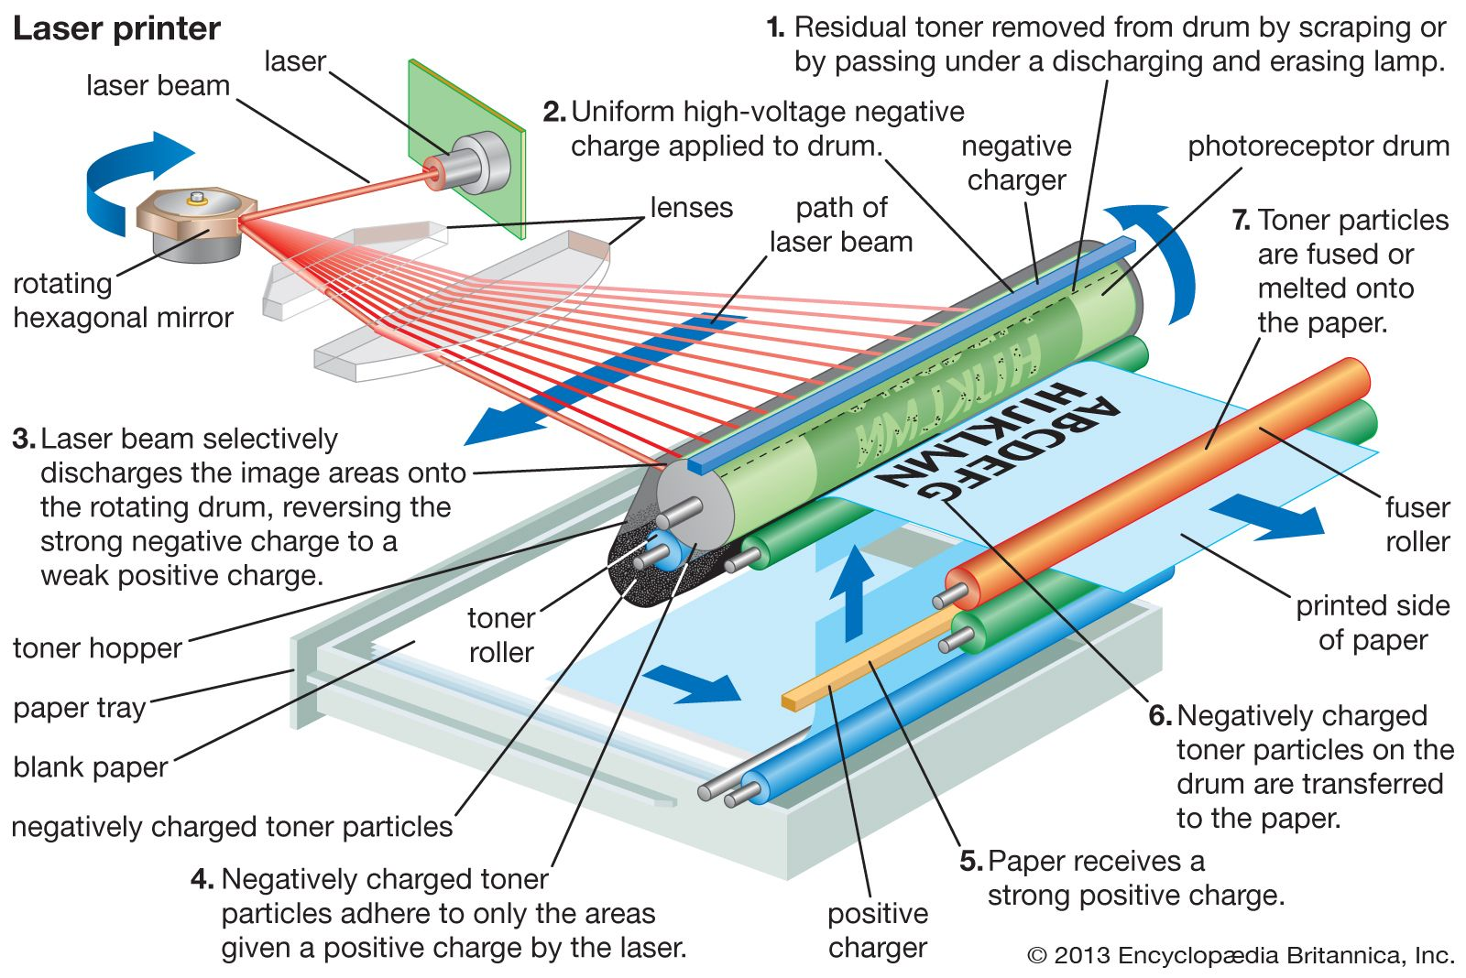

**Inkjet Printers:**

Inkjet printers use a different mechanism involving electrostatics:

* Tiny droplets of ink are electrically charged within the printer.
* The droplets are then propelled through a nozzle towards the paper using electrostatic repulsion (like charges repel).
* By controlling the charge on each droplet and the position of the nozzle, the printer creates the desired image on the paper.

**Electrostatic Principles Involved:**

* **Charge Interaction:** Oppositely charged particles (toner and charged areas on the photoreceptor or paper) are attracted to each other, facilitating the transfer of toner.
* **Electrostatic Repulsion:** Like charges (charges on toner droplets in inkjet printing) repel each other, allowing precise control of ink droplet placement.