**273/1**

**GEOGRAPHY**

**PAPER 1**

**2**Hours **45** minutes

**Instructions**

1. *This paper consists of* ***two*** *sections* ***A*** *and* ***B.*** *It has six examination items.*
2. *Section A has* ***two*** *compulsory items.*
3. *Section B has* ***two*** *parts; I and II. Answer* ***one*** *item from each part.*
4. *Answer* ***four*** *examination items in all.*
5. *You may use diagrams where applicable to illustrate your answers.*
6. *Any additional item(s) answered will* ***not*** *be scored.*
7. *All answers must be written in the answer booklet(s) provided.*

**SECTION A: Map and Photographic Skills**

Answer **all** items in this section

**Item 1: Map skills**

The people living in the area shown on the map extract of Lukaya sheet 79/2 East of Easting 80 have stayed in this area for long.Of late they are realizing that the water levels of Lake Victoria which has been a major source of water for domestic use and a fishing ground have started reducing. Equally in the same way, the surrounding swamp has started drying up. The local people have greatly encroached on the swamp for crop cultivation. All the above are worrying the local leaders who have decided to contact NEMA officials to meet the members of the community and address them.

**Support material: Map of Lukaya**

**TASK.**

1. The local residents have converged at Kankobe church hall. Locate that place on the map.
2. The lake in the south of the area has greatly reduced from the original size. What could be the current size of this water body?
3. Draw a sketch map of the area showing the major physical features.
4. Using evidence from the map extract, explain to the local residents the challenges the NEMA officials will face while in this area.

**Item 2: Photograph Skills**

The area seen in the photograph is rich in vegetation and other types of wildlife. The government authorities are aware that the wildlife across the country is under threat. In order to guard against this, the government has put in place laws to guard against destruction of wildlife. Different areas have been gazetted but man has continued to encroach on the conserved areas, killed the animals that are threatening their lives, animals and crops. Man has also started destroying the forests to reduce on the threat posed by the wild animals. Conservation teams have been set up at village level to change people’s attitude and conserve nature.

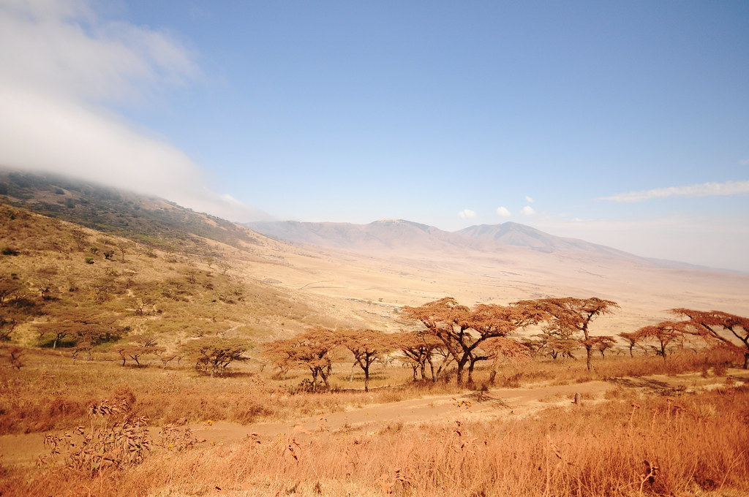

**Task:**

1. Draw a sketch of the area shown in the photograph.
2. Using specific examples from the photograph, advise the people in the above area on ways of conserving the environment.

**SECTION B**

This section has **two** parts **I** and **II**

**Part I**

Answer **one** item from this part

**Item 3.**

Uganda has numerous rivers that have their origin in the mountainous region. The government officials have on several occasions advised the people to utilize this natural resource to change their lives. On the other hand the same officials have warned residents to be careful with the rivers. Unfortunately the residents have failed to listen to that important message and some want to leave for other areas. A meeting has been organized to sensitize communities where you are expected to take part.

**Support material**

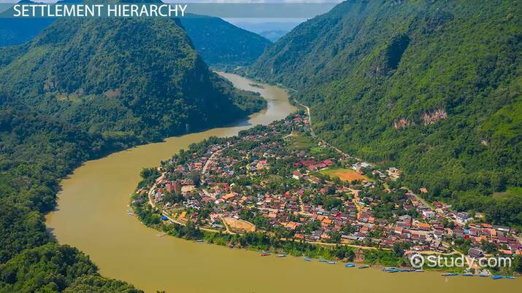

**Task**

1. Explain to the members of the community in this area on the dangers they are likely to encounter.
2. Guide the people in this community on how they can use the drainage feature.

**Item 4**

The coastal areas of East Africa are rich in tourism potentials. Tourists from all over the world visit this part of East Africa because of the wave erosional features which exist in this area. The local residents who have been in this place for many years cannot explain their origin. The local leaders on the other hand are not different from the residents though they benefit the community. The tour companies always seek guidance from the tour guides for explanation. A local tour company has contacted you to perform the task.

**Support material**

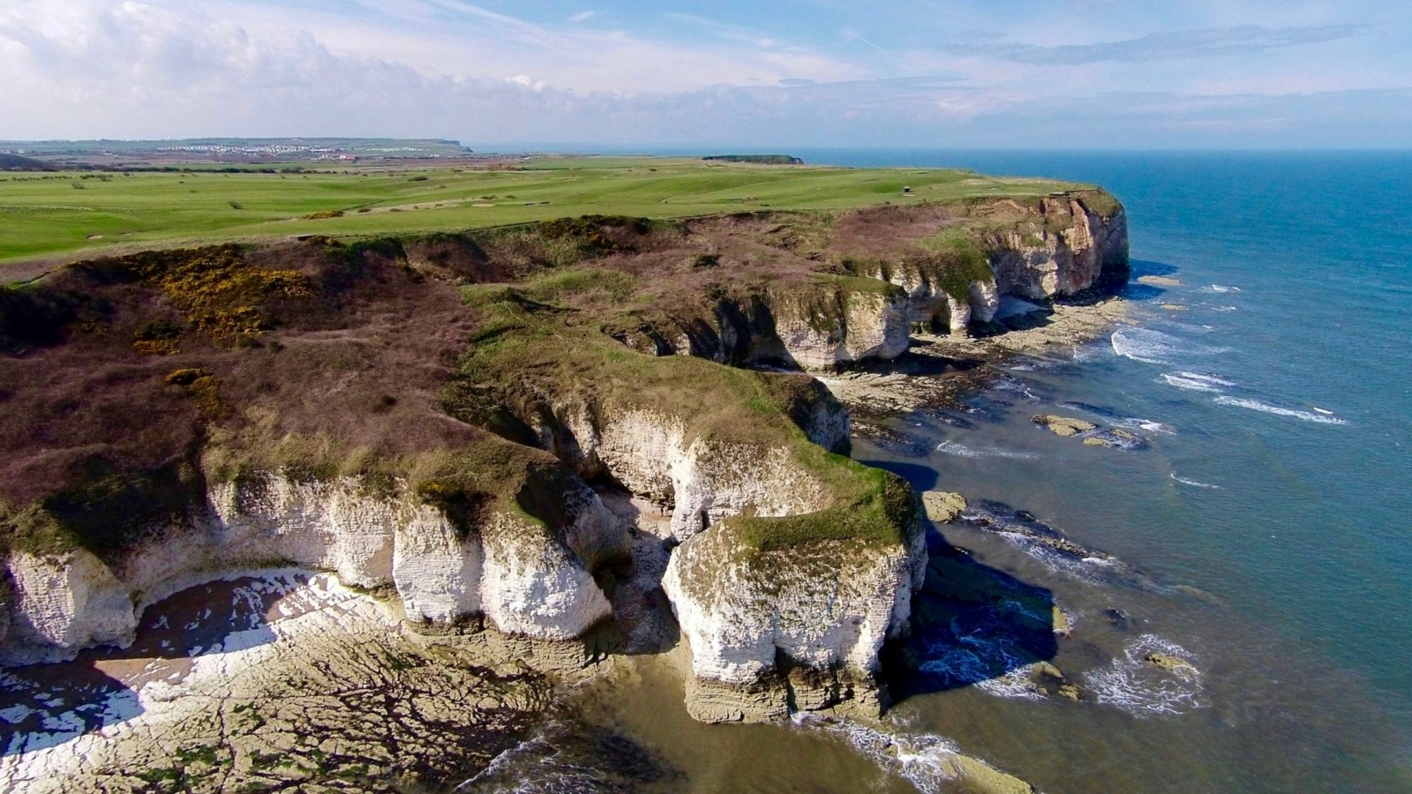

**Task**

1. Describe to the people living in this area the formation of the above features.
2. Explain to the community the importance of the major landform features

**Part II**

Answer **one** item from this part.

**Item 5**

The common modes of transport used in East Africa cut across all countries. These modes are used to transport goods and services from one place to another. Trade among the three countries is booming. However, the traders have on several occasions lost their merchandise because of the poor transport networks. Through their umbrella bodies, they have petitioned their governments. The concerned governments have therefore decided to organize a conference involving different stake holders to address the problems in the transport sector to minimize the loss. You have been invited for that conference as one of the presenters representing the youth.

**Support material: Modes of transport used in East Africa**

|  |  |
| --- | --- |
| **Transport mode** | **Percentage** |
| Water | 18.4 |
| Air | 16.4 |
| Road | 57.7 |
| Pipeline | 2.1 |
| Others | 5.4 |

**Task**

1. Draw a suitable statistical diagram to represent the information in the table above.
2. Explain to the different stakeholders the challenges that have led to the above loss.
3. Advise the local government officials on the ways of reducing those challenges.

**Item 6**

In the different cities of the East African community member states, population size has doubled in the recent years due to increased job opportunities, better social services and others. The city planners are worried of this increase and have organized a meeting with the city authorities to address the challenges before it is too late. You have been invited to that meeting to address the leaders.

**Support material**

**Urban population living in slum areas (2001)**

|  |  |
| --- | --- |
| **Country** | **Urban population(000)** |
| Uganda | 261 |
| Tanzania | 232 |
| Rwanda | 141 |
| Kenya | 292 |
| Burundi | 133 |

**Task**

1. Draw a bar graph to represent the information in the table.
2. Advise the city authorities on how to handle the challenges.