CIRCLES, CHORDS AND TANGENTS
- In the figure below, PQ is a tangent to the circle at point Q. PQ meets chord SU produced at point P. QR is a diameter of the circle. O is the centre of the circle. QR meets SU at point T.

(i) Given that QP = 15cm and UP = 10cm. Calculate the length of line SU (2 marks)
(ii) If RT = 2.5cm and ST: TU = 5:3. Calculate the length of line QT (2 marks)

- The figure below shows a circle centre O, AB is a diameter. Chords ED and BH are equal NHJ, FET, STD are tangents to the circle angle ECD = 20º and ∠AHE = 30º. The figure is not drawn to scale.

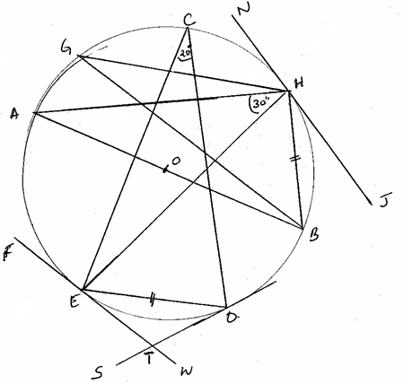

Determine angles.
(i) EHB. (2 marks)
(ii) ETS. (2 marks)
(iii) HGB. (2 marks)
(iv) EHJ. (2 marks)
(v) AOE. (2 marks)

- In the figure below, chords PQ and RS intersect externally at T.
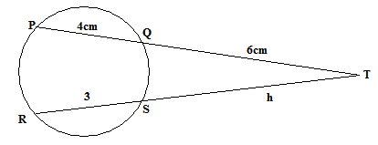

Given that PQ = 4cm, QT = 6cm and RS = 3cm, find RT. (3 mks)

- Two chords PQ and RS are produced to meet at T. Given that PQ = 8cm, QT = 6cm and ST = 5cm. Find the length RS. (3 mks)
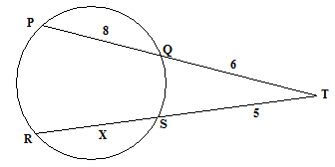

- In the figure below, AB is a tangent, meeting chord CDE at B. AD = 5cm, CD = 4cm, DF = 2cm, EB = 7.5cm and DE = x cm.

Determine:
- The value of x (1mark)
(b) The length of AB. (2 marks)
- In the figure below, chords AB and CD are produced to meet at T. AB - 4cm, BT CD=6cm. Find the length of DT.
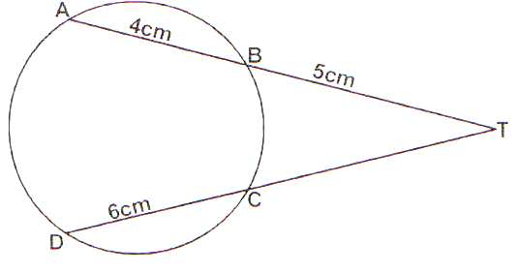

- Chords AB and CD of a circle meet at X as shown in the figure below. If AB = 8cm, BX = 5cm and DX = 6cm.
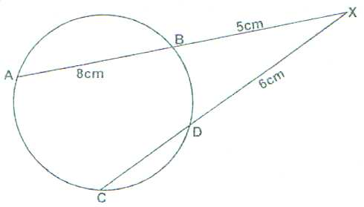

Calculate the length of chord CD to 1 d.p (2 marks)

- Chords AB and CD of a circle intersect at E. If AB = 8cm and BE = 7cm and BE = 7cm and DE = 5cm, what is the length of chord CD?
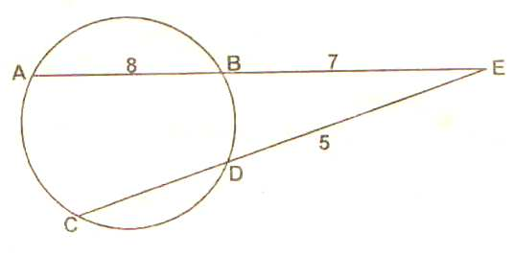

- Chords AB and CD in the figure shown below intersect externally at Q. If AB = 5cm, BQ = 6cm and DQ = 4cm. Calculate the length of chord CD. (2 marks)
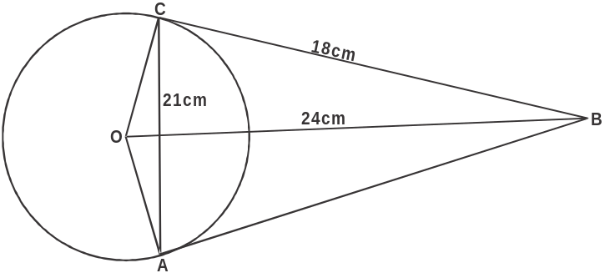

- In the figure below, TD is a tangent to the circle at T. chord AC produced intersects TD and D. CD = 4.1cm, TD =7cm and angle TAC = 33ºC
B

A

33º

C

4.1cm

T 7cm D

a) Giving a reason, find the size of angle CTD. (2 marks)
b) Calculate the length of AC correct to one decimal place. (3 marks)
c) Calculate to the nearest degree the value of;
i) the obtuse angle TCD (3 marks)
ii) angle ABC (2 marks)

- In the figure below P, Q, R and S are points on the circle centre O. PRT and USTV are straight lines.
Line UV is a tangent to the circle at S, <RST = 50° and <RTV = 150°.
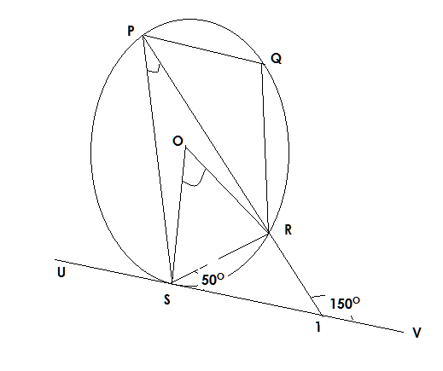

- Calculate the size of:
- < ORS (1 mark)

- < USP (2 marks)

- <PQR (2 marks)
- Given that RT = 7cm and ST = 9cm, calculate to 3 significant figures.
- length of line PR (2 marks)
- The radius of the circle. (3 marks)

- In the figure below, circle ABDF has centre O. CE is a tangent to the circle at D and AF = 12cm is the diameter, AB = BD and angle DAF = 27º.
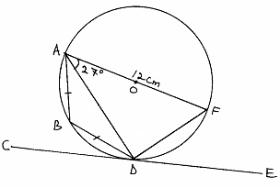

- Find the size of
(i) Angle ADE. (2mks)
(ii) Angle ADB. (2mks)
- Find the length of
(i) AD. (2mks)
(ii) BD. (4mks)

- In the figure below < EDG = 590 and < ABG = 430. The lines EDC and ABC are tangents to the circle at D and B respectively and DF = BF.
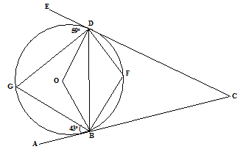

Find giving reasons:-
a) <DGB (2 mks)
b) Obtuse angle DOB (2 mks)
c) <DFB (2 mks)
d) <BCD (2 mks)
e) GDF (2 mks)

- In the figure below points O and P are centres of intersecting circles ABD and BCD respectively. Line ABE is a tangent to circle BCD at B. Angle BCD = 420.
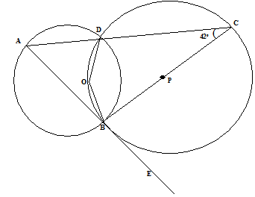

a) Stating reasons, determine the sizes of
i) <CBD (2 mk)
ii) Reflex <BOD (3 mk)
iii) <DAB (2 mk)
b) Show that triangle ABD is isosceles. (3 mk)

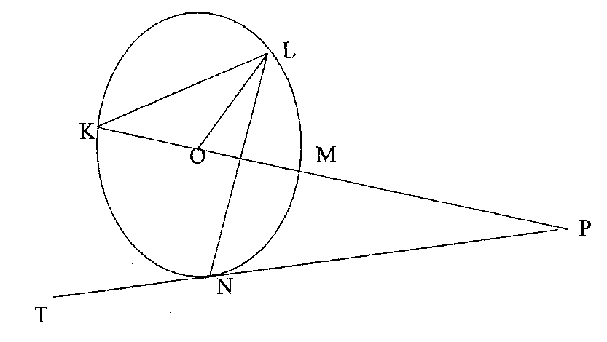
- In the figure K, L, M and N are points on the circumference of a circle centre O. The points K, O, M and P lie on a straight line.

PT is a tangent to the circle at N. Given that <MKN = 40⁰. find the values of the following angles stating reasons.
- <MLN (2 marks)
- <OLN (2 marks)
- <LNP (2 marks)
- <MPN (2 marks)
- <KLM (2 marks)
- The diagram below shows a circle centre O. PQ is a tangent to the circle at Q and PTOR is a straight line QRST is a cyclic
quadrilateral in which angle RTS = 35⁰ and RT and QS are diameters.

S

T
R R

Q

Giving reasons for your answer, find the size of:-
  - Acute angle ROS. (2mks)
- Angle RQS. (2mks)
- Angle PQR. (2mks)
- Angle QPT. (2mks)
- Angle PQT. (2mks)

- In the figure below, line BD is the diameter of the circle, centre O and AE is a tangent.
Angle CBA = 110⁰ and angle BAC =26⁰.
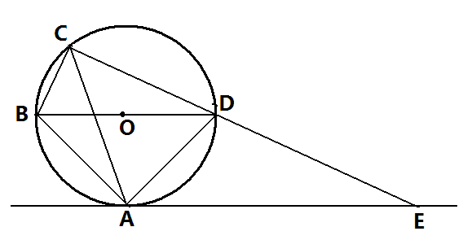

Find the following angles, giving reasons for each answer.
- (3marks)
- 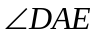 (1mk)
- 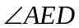 (3marks)
- 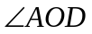 (3marks)
- In the diagram below O is the centre. PTQ is a tangent at T. If PT = ST and ZSRT =52°. Determine the size of the angles below giving reasons.
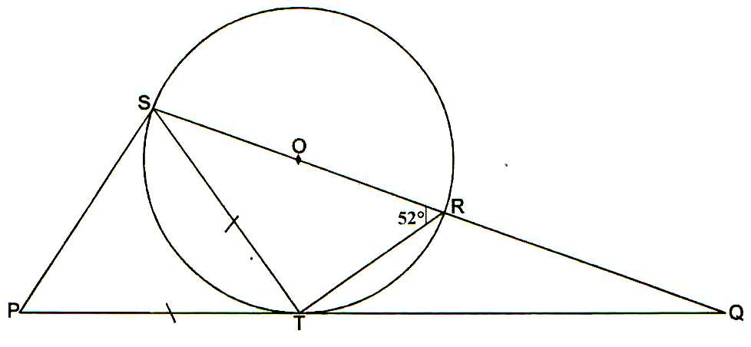

- PTS (2mks)
- RTQ (2mks)
- TSR (2mks)
- TQR (2mks)
- RSQ (2 mks)

- In the figure below, ABCD is a cyclic quadrilateral and that nagle ABD = 42⁰ and angle BAC = 58⁰ and angle DBC = 36⁰
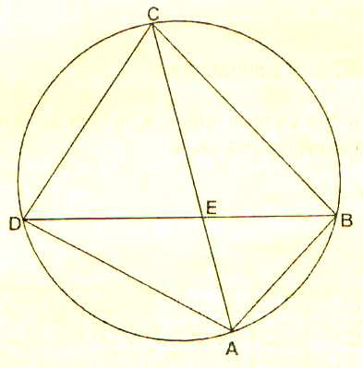
Giving reasons, find the values of:

- DAC (2marks)
- ADB (2marks)
- ACD (2marks)
- CDB (2marks)
- CEB (2marks)
- In the figure below, ABCDE is a pentagon inscribed in a circle. CX is a tangent to the circle at C and EDX is a straight line < ADE = 34⁰, <CAD = 40⁰, AB = BC and BC is parallel to AD.
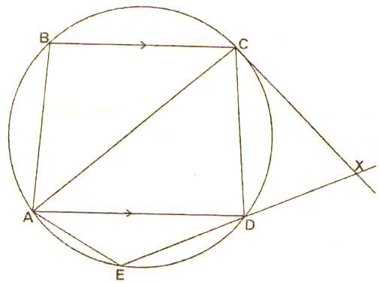

Giving reasons in each case, determine:
- <ABC (2marks)
- < ACD (2marks)
- <EAD (2 marks)
- <CXD (2 marks)
- Given that ED = 5cm and DX = 4cm, calculate length CX. (2marks)

- The figure below shows a circle centre O. FAE is a tangent to the circle. ABCGD are points on the circumference. Angle BAE = 30⁰, angle ABC = 115⁰ and angle ACD = 40⁰
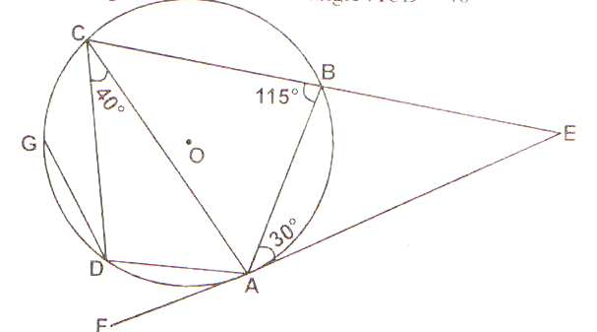

Find the following angles giving the reasons in each case.
  - ( 2marks)
  - ( 2marks)
  - ( 2marks)
  - ( 2marks)
  - ( 2marks)

- The figure below represents two pulley wheels, centres A and B with a rubber band CDEFGHC stretched round them. Radius of wheel centre A = 16cm, AB = 30cm, CD and GF are tangents to the circles. <CAB = 86.30.
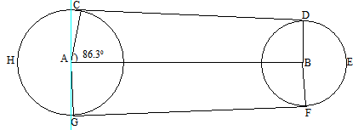

a) Calculate the length of CD. (3mks)
b) Find the angle ABD. (1mk)
c) Find the length of the belt that would go round the pulley CDEFGHC. (6mks)

- the figure below A, B and D are points on the circumference of a circle centre O. The points A, O, C and E are on straight line ED is a tangent to the circle at D. Angle AOB = 140⁰ and angle CAD = 30⁰.
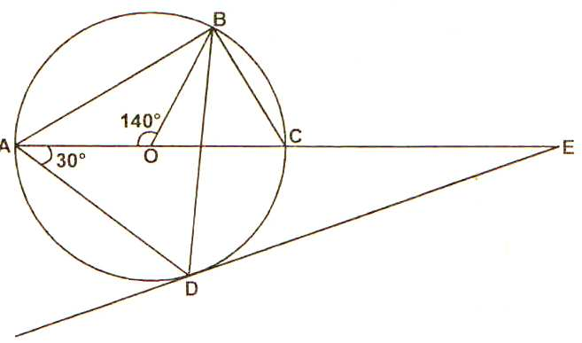

- ∠CBD (2 marks)
- ∠OBD (2 marks)
- ∠BDE (2 marks)
- ∠CED (2 marks)
- ∠BCD (2 marks)

- The diagram below not drawn to scale shows a circle in which BD is the diameter and ABC is a tangent to the circle at point B. EXTC is a straight line.
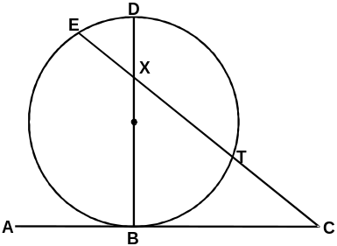

Given that BC = 6cm, BX=8cm, EX=2cm. Calculate
i) XC (2 marks)
ii) TC (2 marks)
iii) DX (3 marks)
iv) The radius of the circle (2 marks)
v) Angle BCE (1 mark)

- In the circle below, O is the centre; AB and AD are tangents to the circle.
Angle ABC = 30⁰, angle ADC = 40⁰ and Angle DOB = 140⁰
A
B
E
D
C
o

Find: Giving reasons:
(a) Angle DEB (2 marks)
(b) Angle DAB (2 marks)
(c) Angle ODB (2 marks)
(d) Reflex Angle DOB (2 marks)
(e) Angle DBC (2 marks)

- In the figure below, TD is a tangent to the circle at T. chord AC produced intersects TD and D. CD = 4.1cm, TD =7cm and angle TAC = 33ºC
B

A

33º

C

4.1cm

T 7cm D

a) Giving a reason, find the size of angle CTD. (2 marks)
b) Calculate the length of AC correct to one decimal place. (3 marks)
c) Calculate to the nearest degree the value of;
i) the obtuse angle TCD (3 marks)
ii) angle ABC (2 marks)

