**ALINYIIKIRA JUNIOR SCHOOL, NAKWERO**

**BEGINNING OF TERM 3 ASSESSMENT 2024**

**MIDDLE CLASS**

**LANGUAGE DEVELOPMENT II (READING)**

Name: _________________________________________________

1. **Circle picture for the sound.**

|  |  |  |
| --- | --- | --- |
| f |  |  |
| b |  |  |
| l |  |  |
| k |  |  |
| p |  |  |
| j |  |  |
| r |  |  |

1. **Match picture to word.**

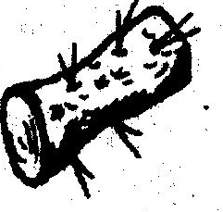 bed

 mat

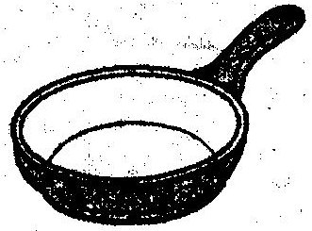 bag

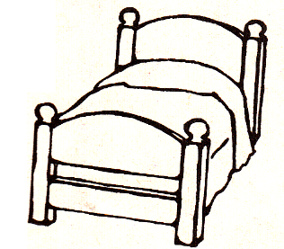 yam

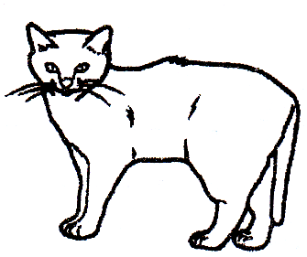 van

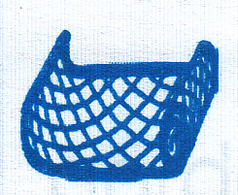 cat

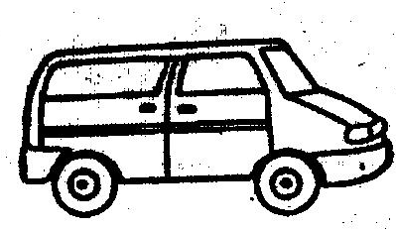 pan

 hat

1. **Draw and write sound (e)**

|  |  |  |  |  |
| --- | --- | --- | --- | --- |
|  |  |  |  |  |
| vest | net | bell | leg | bed |
|  |  |  |  |  |
| vest |  |  |  |  |

1. **Circle words with sound “i”**

insect pot in on

pin doll mat tin

cat jik rat moon

ink bed six mill

bird soap sand mix

1. **Match and write.**

p  book

g 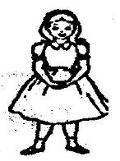______________

d 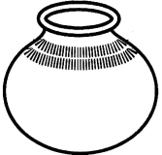______________

b 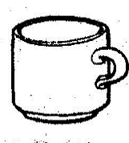______________

c 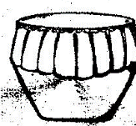______________

**cup, pot, girl, drum**

1. **Read and draw.**

|  |  |
| --- | --- |
| It is a cow |  |
| It is a tree |  |
| It is a doll |  |
| It is a duck |  |