

**Top class: package II**

1. **Read and match**

mosque

hospital

P1

P2

P4

P3

church

school

1. **Shade this**

P1

P2

P4

P3

**3. Read and match things found in class**

book

table

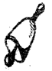pencil

chair

bell

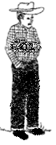**4. Name these people at home**

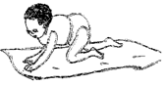

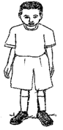

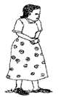

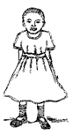

(mother, sister, baby,

brother, father)

**5.Read and draw**

|  |  |
| --- | --- |
|  |  |
| Rake | panga |
|  |  |
| Axe | broom |
|  |  |
| Pin | basket |

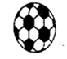 **6.Name the pictures**

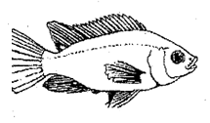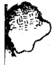

(fish, ball, moon, stone

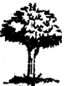**7. Write correctly**

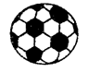



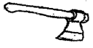

8. Make sentences



___________________________________

____________________________________

____________________________________

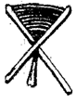

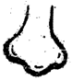 **9. Read and match a picture to a word**

leg

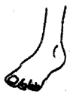ear

eye

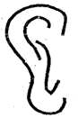mouth

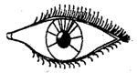nose

**10. Circle the body parts**

ear pot eye

tree girl leg

nose box boy

book hand ball

**11. Match the same and write**

dress pant______________

short trousers__________

skirt vest_____________

pant dress____________

trousers short_____________

vest skirt______________

**12. Match and draw**.

towel water

soap toothbrush

water comb

sponge towel

toothbrush toothpaste

comb sponge

toothpaste soap

**13. Count, read and match**

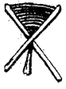

nineteen

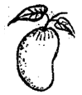

five

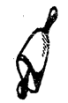

fourteen



eight

three

eleven

14**.Shade well**

**15. Write the next numbe**

**21 _____ 23, 24, _____.**

11, 12, __­­­­­­­­­­­­__ 14 15 _____

17, ____, 19, ________

25, 26, ____, 28, ______30

5, ___, ____, 8, _____, 10

____, ____, 3, 4, _____.

**16. Circle the number for the given word**

|  |  |  |  |  |
| --- | --- | --- | --- | --- |
| Seven | 1 | 7 | 17 | 6 |
| Fifteen | 5 | 11 | 15 | 8 |
| two | 17 | 2 | 3 | 9 |
| Thirty | 30 | 5 | 3 | 5 |
| Thirteen | 3 | 6 | 13 | 7 |
| Twenty | 1 | 2 | 3 | 20 |
| Five | 2 | 3 | 5 | 4 |
| Eight | 6 | 7 | 8 | 9 |
| One | 11 | 4 | 1 | 9 |
| Seventeen | 4 | 6 | 17 | 8 |

**17.Count and add**

2 + 1 = 3 1 + 1 = _____

1 + 1 = ____ 3 + 0 = ____

3 + 0 = ____ 2 + 2 = _____

2 + 2 = ______ 4 + 1 =______

**18. Match and write**

20 25 __________

21 24 __________

22 20 __________

23 21__________

24 22 __________

25 23 __________

**19.Take away**

= ____________

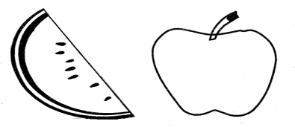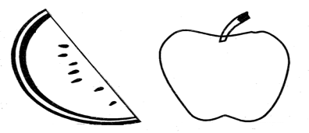= ____________

= ____________

= ____________

**20.**  **Write three words for the given sound**

|  |  |  |  |
| --- | --- | --- | --- |
| **igh** |  |  |  |
| **ai** |  |  |  |
| **tion** |  |  |  |
| **ea** |  |  |  |
| **bl** |  |  |  |
| **ay** |  |  |  |
| **br** |  |  |  |

**21. Fill in the missing sound and read the word**

ment__ __n

b____ ___k

d____ ___p

D___ctor

Moth__ __

T__ ___cher

C ___ p

Pr__ __st

Fa___ ___er

D___ck

Br___ther

Ch____rch

22. Match animal and their young ones.

dog baby

pig kid

lion calf

duck chicks

goat piglet

hen duckling

cow cub

mother puppy

**Writing**

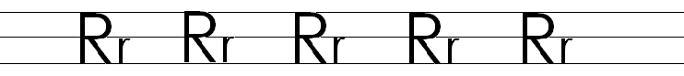

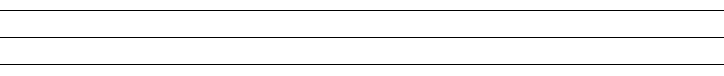





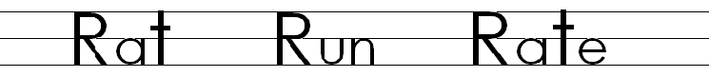











**2. Write well**



























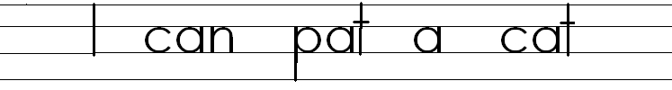**Read and write**

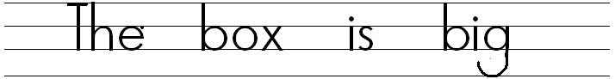

Read the story and answer the questions.

Once upon a time, there lived a man and a woman. They had two children, one was Rose and another was Tom.

Rose was so stubborn at home and Tom was a good and quiet boy

One day, when they were going to school Rose knocked her foot when she was running because she could not move properly on the way and what Tom did, he ran back home and called their mother to come and take Rose to the clinic.

**Question**s

1. How many children are in the story?

____________________________

1. What was the name of the girl?

____________________________

1. What was the name of the boy?

__________________________

1. Who was the stubborn child?

_______________________

1. Who knocked the foot?

____________________

***end***