Contents
Line 1
Bar 3
Pie 5
Table 7
Bar 9
Process 11
Comparison 13
Sample ‘map’ reports 15

Line
The graph below shows electricity production (in terawatt hours) in France between 1980 and 2012.

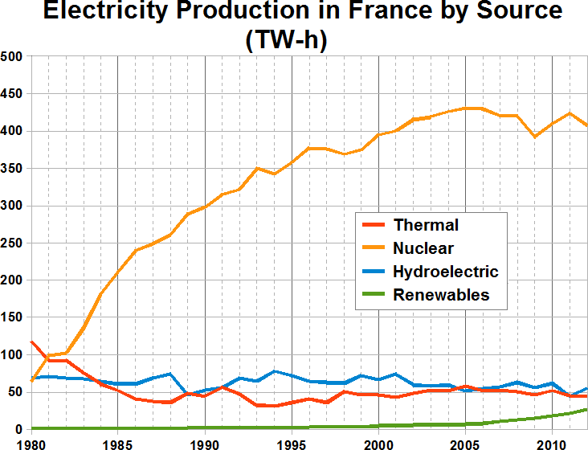

The line graph compares the amount of electricity produced in France using four different sources of power over a period of 32 years.

It is clear that nuclear power was by far the most important means of electricity generation over the period shown. Renewables provided the lowest amount of electricity in each year.

In 1980, thermal power stations were the main source of electricity in France, generating around 120 terawatt hours of power. Nuclear and hydroelectric power stations produced just under 75 terawatt hours of electricity each, and renewables provided a negligible amount. Just one year later, nuclear power overtook thermal power as the primary source of electricity.

Between 1980 and 2005, electricity production from nuclear power rose dramatically to a peak of 430 terawatt hours. By contrast, the figure for thermal power fell to only 50 terawatt hours in 1985, and remained at this level for the rest of the period. Hydroelectric power generation remained relatively stable, at between 50 and 80 terawatt hours, for the whole 32-year period, but renewable electricity production saw only a small rise to approximately 25 terawatt hours by 2012.

(187 words, band 9)

Analysis task:

- Underline examples of paraphrasing in the introduction, comparing it with the question.
- Look again at the 2 main points that I chose for the overview (paragraph 2).
- Underline the numbers and years that I mentioned in paragraphs 3 and 4. How many numbers did I mention in the report?
- Underline examples of ‘comparing’ language in the report.
- How many sentences did I write in each paragraph?

Vocabulary task:

Watch the video lesson again. Near the end of the lesson, find the list of good vocabulary. Underline those phrases in the full report on page 1 of this worksheet.

Extra task:

Try to write your own report about the same line graph using what you remember from the lesson (but without looking at my answer).
Compare your finished report with mine, and look for areas where you could improve.

Bar
The chart below shows global sales of the top five mobile phone brands between 2009 and 2013.

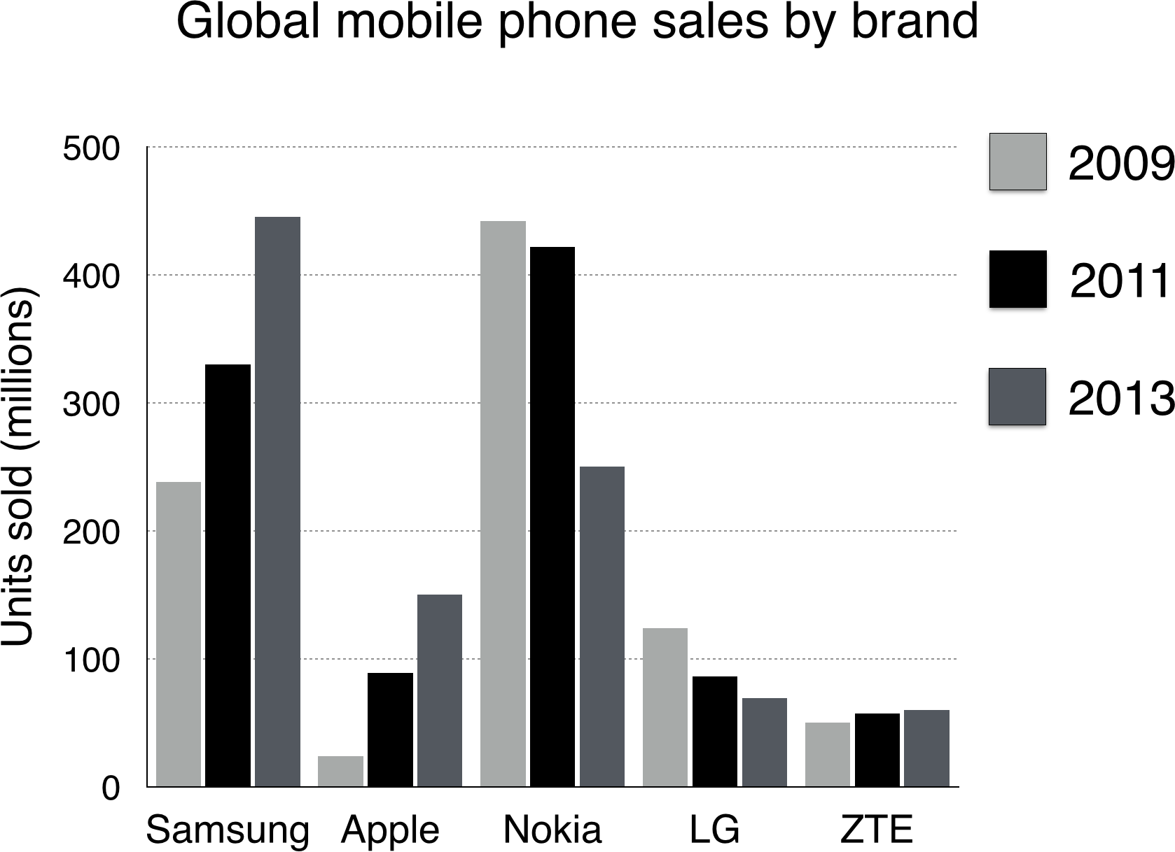

The bar chart compares the number of mobile phones sold worldwide by the five most popular manufacturers in the years 2009, 2011 and 2013.

It is clear that Nokia sold the most mobile phones between 2009 and 2011, but Samsung became the best selling brand in 2013. Samsung and Apple saw the biggest rises in sales over the 5-year period.

In 2009, Nokia sold close to 450 million mobile phones, which was almost double the number of handsets sold by the second most successful manufacturer, Samsung. Over the following four years, however, Nokia’s sales figures fell by approximately 200 million units, whereas Samsung saw sales rise by a similar amount. By 2013, Samsung had become the market leader with sales reaching 450 million units.

The other three top selling mobile phone brands between 2009 and 2013 were LG, ZTE and Apple. In 2009, these companies sold around 125 million, 50 million and 25 million mobile handsets respectively, but Apple overtook the other two vendors in 2011. In 2013, purchases of Apple handsets reached 150 million units, while LG saw declining sales and the figures for ZTE rose only slightly.

(190 words, band 9)

Analysis task:

- Underline examples of paraphrasing in the introduction, comparing it with the question.
- Look again at the 2 main points that I chose for the overview (paragraph 2).
- Underline the numbers and years that I mentioned in paragraphs 3 and 4. How many numbers did I mention in the report?
- Underline examples of ‘comparing’ language and ‘change’ language in the report.
- How many sentences did I write in each paragraph?

Vocabulary task:

Watch the video lesson again. Near the end of the lesson, find the list of good vocabulary. Underline those phrases in the full report on page 1 of this worksheet.

Extra task:

Try to write your own report about the same bar chart using what you remember from the lesson (but without looking at my answer).
Compare your finished report with mine, and look for areas where you could improve.

Pie
The charts below show household spending patterns in two countries between 1980 and 2008.

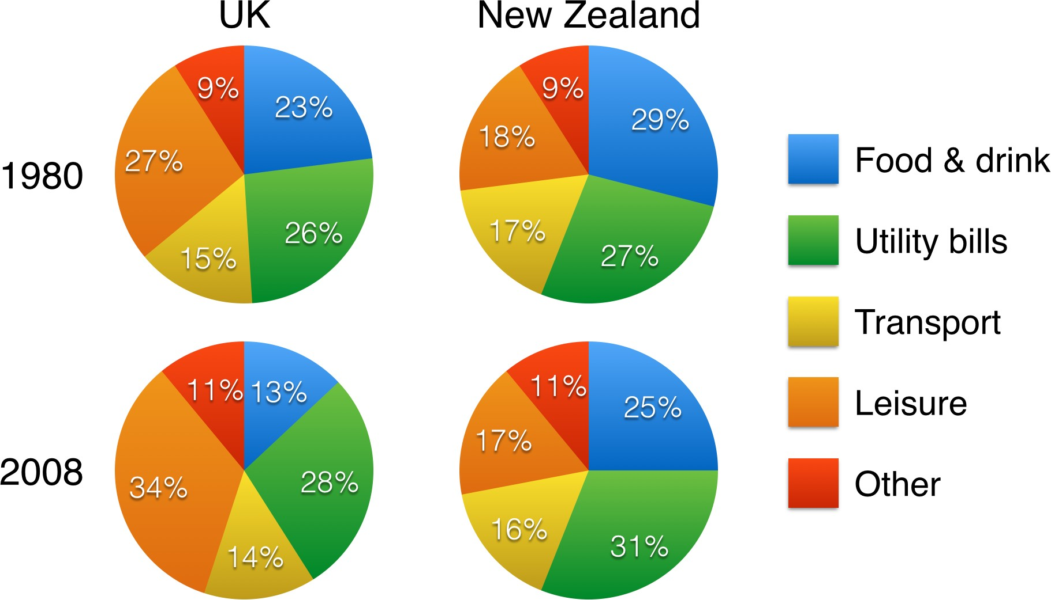

The pie charts compare five categories of household expenditure in the UK and New Zealand in the years 1980 and 2008.

It is noticeable that the proportion of spending on food and drink fell in both countries over the 28- year period, while spending on utility bills rose. Also, UK residents spent a significantly larger percentage of their household budgets on leisure than their New Zealand counterparts.

In 1980, 29% of an average New Zealand household budget went on food and drink, while the equivalent figure for a UK home was 23%. By 2008, expenditure on food and drink had fallen by 4% in New Zealand, and by a full 10% in the UK. By contrast, both countries saw an increase in expenditure on utility bills for the average home, from 27% to 31% in New Zealand and from 26% to 28% in the UK.

Leisure activities accounted for the highest proportion of UK household spending in both years, but only the third highest proportion in New Zealand. In fact, in 2008, New Zealanders spent only half as much in relative terms on recreation (17%) as UK residents (34%). In both countries, transport costs and other costs took roughly 15% and 10% of household budgets respectively.

(206 words, band 9)
Note: word count includes all numbers

Analysis task:

- Underline examples of paraphrasing in the introduction, comparing it with the question.
- Look again at the 2 main points that I chose for the overview (paragraph 2).
- Underline the numbers and years that I mentioned in paragraphs 3 and 4. How many numbers did I mention in the report?
- Underline examples of ‘comparing’ language and ‘change’ language in the report.
- How many sentences did I write in each paragraph?

Vocabulary task:

Watch the video lesson again. Near the end of the lesson, find the list of good vocabulary. Underline those phrases in the full report on page 1 of this worksheet.

Extra task:

Try to write your own report about the same pie charts using what you remember from the lesson (but without looking at my answer).
Compare your finished report with mine, and look for areas where you could improve.

Table
The table below shows statistics about the top five countries for international tourism in 2012 and 2013.

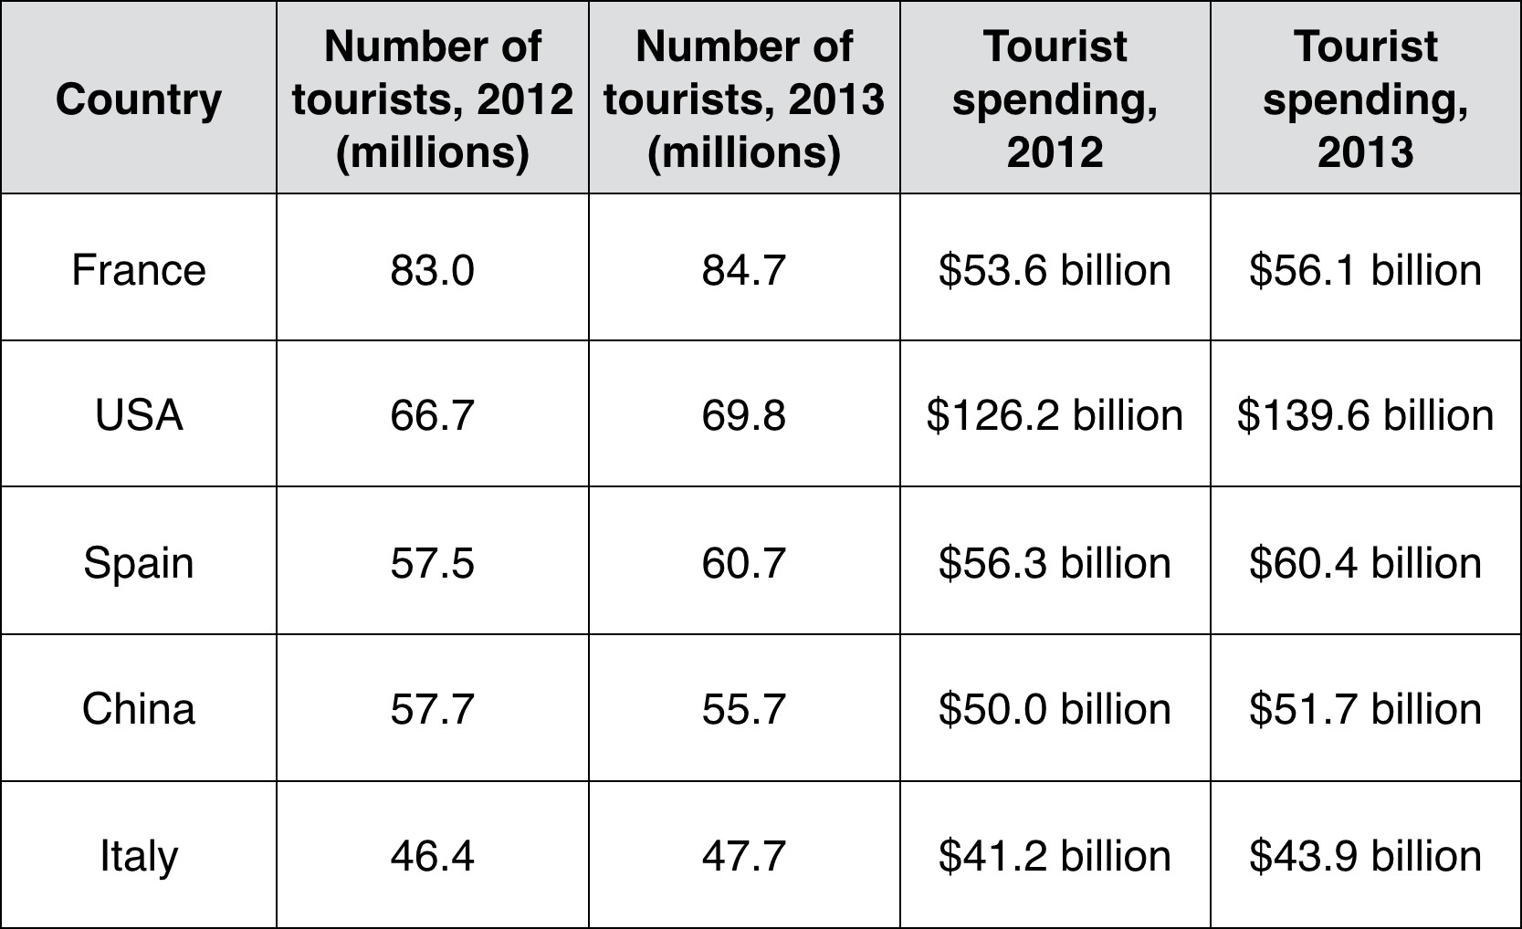

Here’s the report that I wrote in the video lesson:

The table compares the five highest ranking countries in terms of the numbers of visits and the money spent by tourists over a period of two years.

It is clear that France was the world’s most popular tourist destination in the years 2012 and 2013. However, the USA earned by far the most revenue from tourism over the same period.

In 2012, 83 million tourists visited France, and the USA was the second most visited country, with
66.7 million tourists. Spain and China each received just under 58 million visitors, while Italy was ranked fifth with 46.4 million tourists. 2013 saw a rise of between 1 and 4 million tourist visits to each country, with the exception of China, which received 2 million fewer visitors than in the previous year.

Spending by tourists visiting the USA increased from $126.2 billion in 2012 to $139.6 billion in 2013, and these figures were well over twice as high as those for any other country. Spain received the second highest amounts of tourist revenue, rising from $56.3 billion to $60.4 billion, followed by France, China and Italy. Interestingly, despite falling numbers of tourists, Chinese revenue from tourism rose by $1.7 billion in 2013.

(200 words, band 9)
Note: word count includes all numbers

Analysis task:

- Underline examples of paraphrasing in the introduction, comparing it with the question.
- Look again at the 2 main points that I chose for the overview (paragraph 2).
- Underline the numbers and years that I mentioned in paragraphs 3 and 4. How many numbers did I mention in the report?
- Underline examples of ‘comparing’ language and ‘change’ language in the report.
- How many sentences did I write in each paragraph?

Vocabulary task:

Watch the video lesson again. Near the end of the lesson, find the list of good vocabulary. Underline those phrases in the full report on page 1 of this worksheet.

Extra task:

Try to write your own report about the same table using what you remember from the lesson (but without looking at my answer).
Compare your finished report with mine, and look for areas where you could improve.

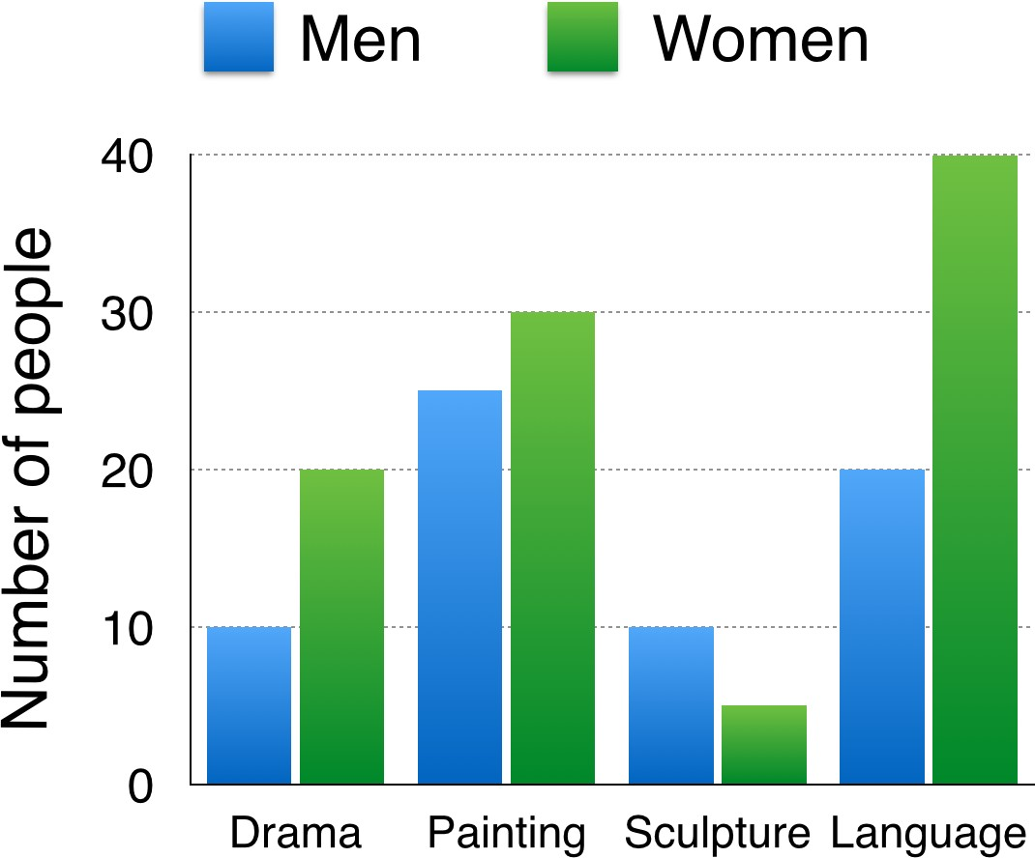
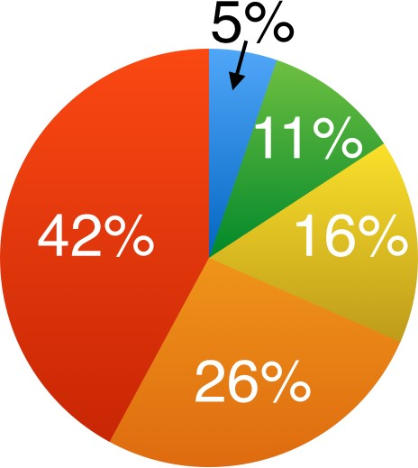
Bar
The bar chart below shows the numbers of men and women attending various evening courses at an adult education centre in the year 2009. The pie chart gives information about the ages of these course participants.

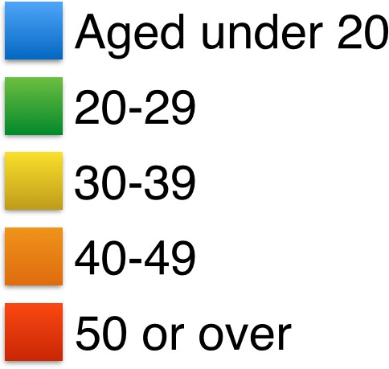
Here’s the report that I wrote in the video lesson:

The bar chart compares the numbers of males and females who took four different evening classes in 2009, and the pie chart shows the age profile of these attendees.

It is clear that significantly more women than men attended evening classes at the education centre. We can also see that evening courses were much more popular among older adults.

According to the bar chart, drama, painting and language courses all attracted more women than men to the education centre in 2009. Language classes had the highest number of participants overall, with 40 female and 20 male students, while painting was a popular choice among both genders, attracting 30 female and 25 male attendees. The only course with a higher number of males was sculpture, but this course was taken by a mere 15 people in total.

Looking at the age profile pie chart, we can see that the majority of people attending evening lessons were over 40 years of age. To be precise, 42% of them were aged 50 or more, and 26% were aged between 40 and 49. Younger adults were in the minority, with only 11% of students aged 20 to 29, and only 5% aged under 20.

(200 words, band 9)
Note: word count includes all numbers

Analysis task:

- Underline examples of paraphrasing in the introduction, comparing it with the question.
- Look again at the 2 main points that I chose for the overview (paragraph 2).
- How did I divide the information into two ‘details’ paragraphs (3 and 4)?
- Was it necessary to compare the bar chart with the pie chart?
- Underline the numbers that I mentioned in paragraphs 3 and 4. How many numbers did I mention in total?
- Underline examples of ‘comparing’ language in the report.
- Why didn’t I use any ‘change’ language (e.g. increase, decrease)?
- How many sentences did I write in each paragraph?

Vocabulary task:

Watch the video lesson again. Near the end of the lesson, find the list of good vocabulary. Underline those phrases in the full report on page 1 of this worksheet.

Extra task:

Try to write your own report about the same two charts using what you remember from the lesson (but without looking at my answer).
Compare your finished report with mine, and look for areas where you could improve.

Process
The diagrams* below show how glass containers, such as bottles, are produced and recycled.
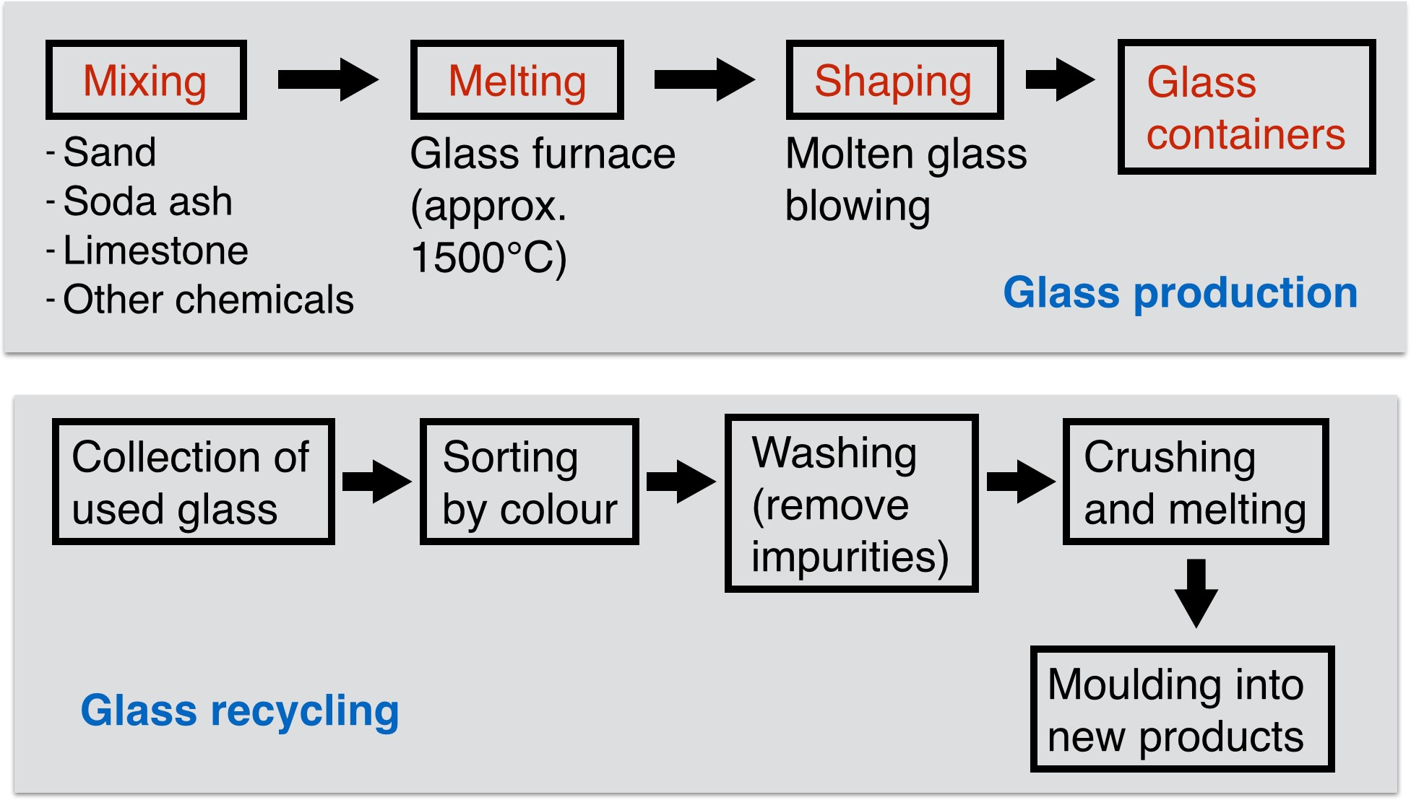

*Please note:
A diagram question would normally show pictures to help you understand the steps. I omitted pictures from the above question, so it would be more accurate to use the term “flow chart” instead of “diagram”. However, I’ll continue to use “diagram” because most IELTS questions of this type do include pictures.

Here’s the report that I wrote in the video lesson:

The first flow diagram illustrates the process of glass container production, and the second diagram shows steps in the process of recycling used glass.

We can see that glass is made using three main raw materials, and that the manufacturing process consists of four distinct stages. It requires five steps to turn used glass into new glass products.

At the first stage in the production of glass, sand, soda ash, limestone and other chemicals are mixed together. Next, this mixture is heated in a glass furnace at approximately 1500℃ to produce molten glass. The molten glass can then be shaped, by blowing, to create the end products, namely glass containers.

Glass recycling begins with the collection of used glass products. The collected glass is sorted according to its colour, and then washed in order to remove any impurities. At the fourth stage of recycling, the glass is crushed and melted, and the resulting molten glass can finally be moulded to create new items.

(163 words, band 9)

Analysis task:

- Underline examples of paraphrasing in the introduction, comparing it with the question.
- Which two main points did I choose for the overview (paragraph 2)?
- Underline the ‘steps language’ in paragraphs 3 and 4.
- Underline the passive verb forms in the report.
- How many sentences did I write in each paragraph?

Vocabulary task:

Watch the video lesson again. Near the end of the lesson, find the list of good vocabulary. Highlight those phrases in the report on page 1 of this worksheet.

Extra task:

Try to write your own report about the same flow diagrams using what you remember from the lesson (but without looking at my answer).
Compare your finished report with mine, and look for areas where you could improve.

Comparison
The diagrams below show the existing ground floor plan of a house and a proposed plan for some building work.

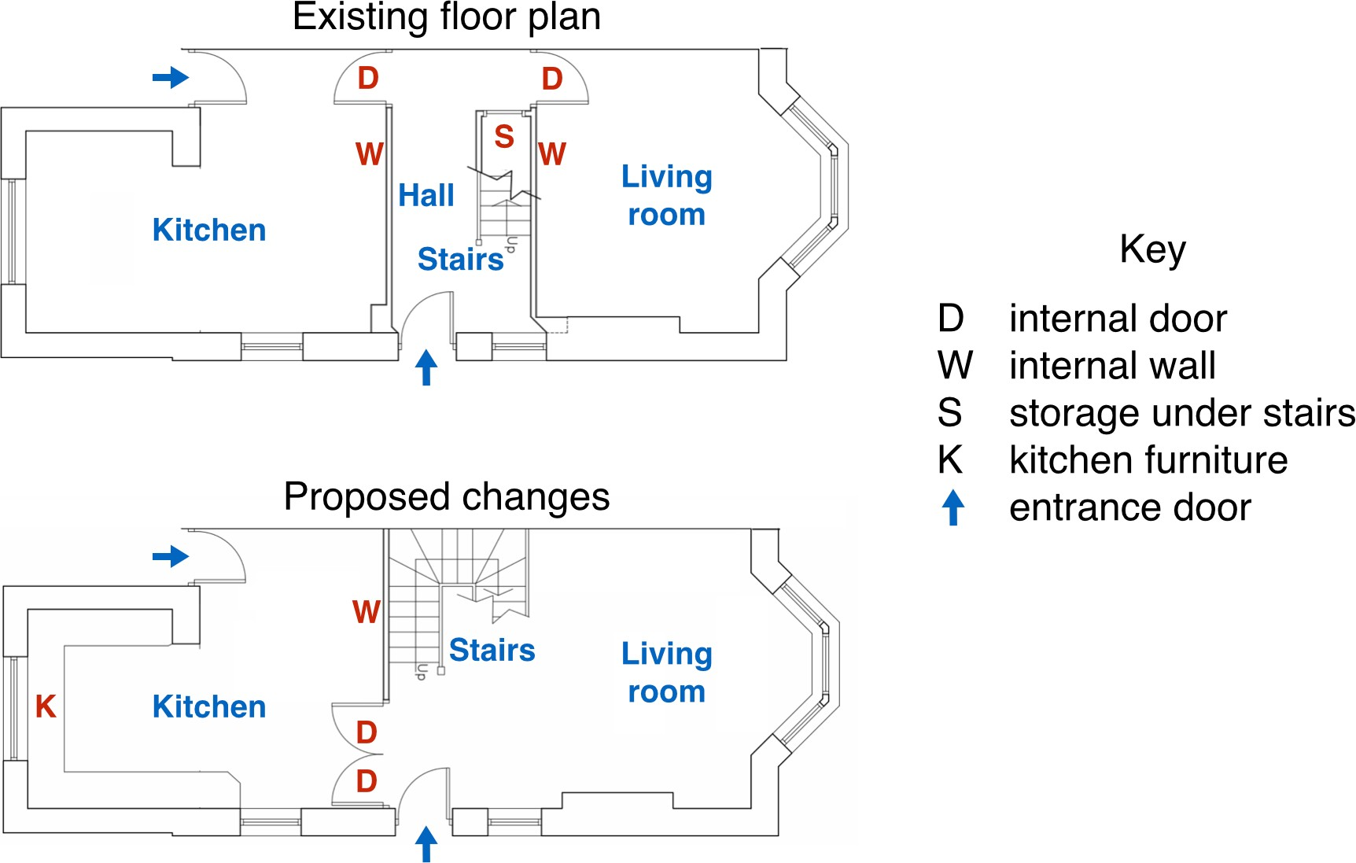

Here’s the report that I wrote in the video lesson:

The two pictures compare the current layout of the ground floor of a house with a plan to redesign the same living space.

We can see that the new design proposal involves making a number of changes to the ground floor of the house, mainly in the central hall area. There are no plans to change external walls or entrances.

The most noticeable change from the existing to the proposed floor plan is that there will no longer be a separate hall area when the building work has been done. This will be achieved by removing the internal wall and door between the hall and living room, along with the current staircase and under-stair storage cupboard. With no separate hall area, the proposed living room will also contain the staircase to the first floor.

To replace the current straight staircase, a new set of winding stairs will be installed in the corner of the living room. The internal door between the hall and kitchen will also be replaced with double doors connecting the kitchen with the new living room. Finally, the planned building work will also include the installation of some kitchen furniture.

(194 words, band 9)

Analysis task:

- Underline examples of paraphrasing in the introduction, comparing it with the question.
- Which two main points did I choose for the overview (paragraph 2)?
- How many changes did I describe in paragraphs 3 and 4?
- Underline examples of different verb tenses? Why did I use these different tenses?
- How many sentences did I write in each paragraph?

Vocabulary task:

Watch the video lesson again. Near the end of the lesson, find the list of good vocabulary. Highlight those phrases in the report on page 1 of this worksheet.

Extra task:

Try to write your own report about the same diagrams using what you remember from the lesson (but without looking at my answer).
Compare your finished report with mine, and look for areas where you could improve.

Sample ‘map’ reports

On the following pages, you’ll see three sample reports about three different types of map. All three reports are taken from lessons on my blog

ielts-simon.com, so you may have seen them before.

I’m attaching these sample map reports to this video lesson to show you that maps are the same as any other type of diagram. Analyse the reports carefully, and compare them to the reports that I wrote in the video lessons about ‘process’ diagrams and ‘comparison’ diagrams. You should see that my approach / method is the same.

“Development map” - This is similar to a “process diagram” because your task is to describe stages. This question comes from Cambridge IELTS book 1.

Chorleywood is a village near London whose population has increased steadily since the middle of the 19th century. The map below shows the development of the village.

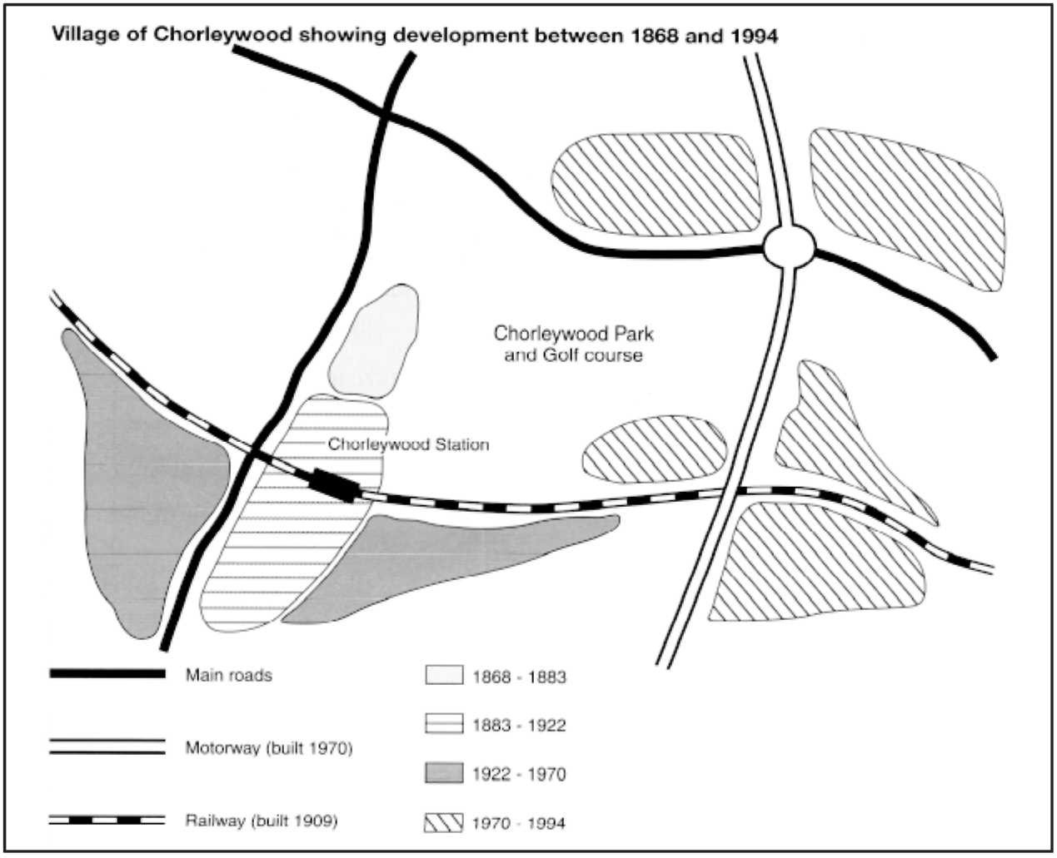

The map shows the growth of a village called Chorleywood between 1868 and 1994.

It is clear that the village grew as the transport infrastructure was improved. Four periods of development are shown on the map, and each of the populated areas is near to the main roads, the railway or the motorway.

From 1868 to 1883, Chorleywood covered a small area next to one of the main roads. Chorleywood Park and Golf Course is now located next to this original village area. The village grew along the main road to the south between 1883 and 1922, and in 1909 a railway line was built crossing this area from west to east. Chorleywood station is in this part of the village.

The expansion of Chorleywood continued to the east and west alongside the railway line until 1970. At that time, a motorway was built to the east of the village, and from 1970 to 1994, further development of the village took place around motorway intersections with the railway and one of the main roads.

(174 words, band 9)

“Before and after map” - This is the same as a “before and after diagram” (see the lesson about “comparison diagrams”). This question comes from Cambridge IELTS book 9.

The two maps below show an island, before and after the construction of some tourist facilities.
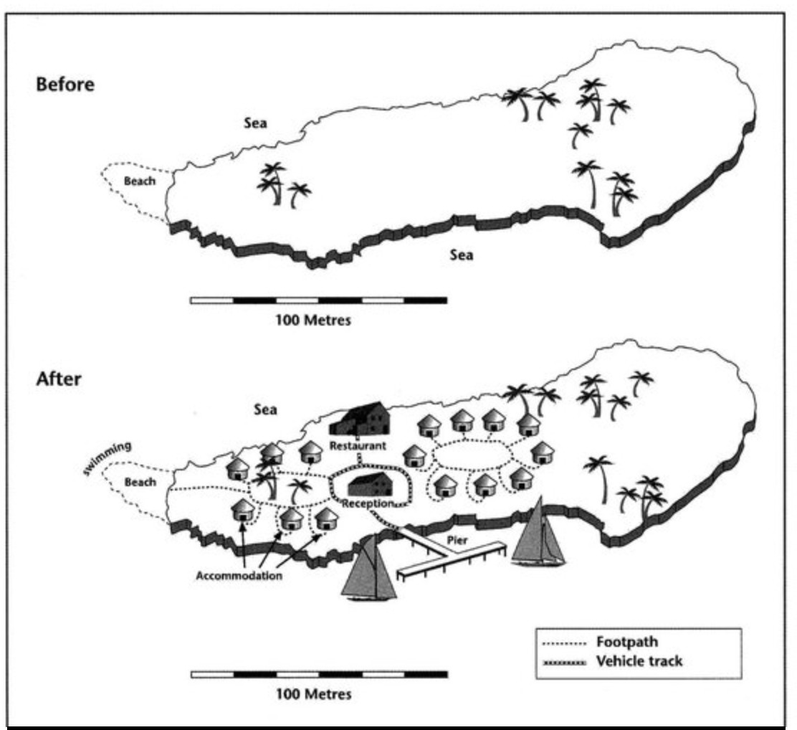

The diagrams illustrate some changes to a small island which has been developed for tourism.

It is clear that the island has changed considerably with the introduction of tourism, and six new features can be seen in the second diagram. The main developments are that the island is accessible and visitors have somewhere to stay.

Looking at the maps in more detail, we can see that small huts have been built to accommodate visitors to the island. The other physical structures that have been added are a reception building, in the middle of the island, and a restaurant to the north of the reception. Before these developments, the island was completely bare apart from a few trees.

As well as the buildings mentioned above, the new facilities on the island include a pier, where boats can dock. There is also a short road linking the pier with the reception and restaurant, and footpaths connect the huts. Finally, there is a designated swimming area for tourists off a beach on the western tip of the island.

(175 words, band 9)

“Locations map” - This is similar to a “comparison diagram” because your task is to compare the locations. This question comes from Cambridge IELTS book 5.

The map below is of the town of Garlsdon. A new supermarket (S) is planned for the town. The map shows two possible sites for the supermarket.

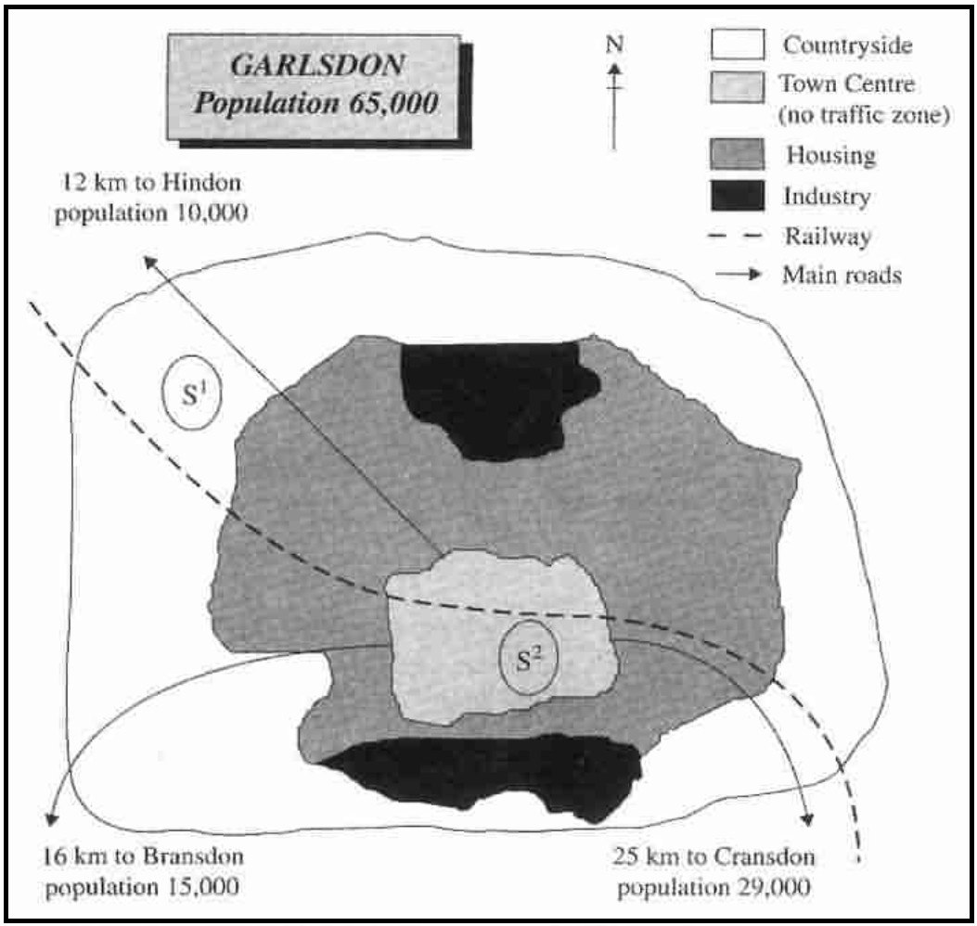

The map shows two potential locations (S1 and S2) for a new supermarket in a town called Garlsdon.

The main difference between the two sites is that S1 is outside the town, whereas S2 is in the town centre. The sites can also be compared in terms of access by road or rail, and their positions relative to three smaller towns.

Looking at the information in more detail, S1 is in the countryside to the north west of Garlsdon, but it is close to the residential area of the town. S2 is also close to the housing area, which surrounds the town centre.

There are main roads from Hindon, Bransdon and Cransdon to Garlsdon town centre, but this is a no traffic zone, so there would be no access to S2 by car. By contrast, S1 lies on the main road to Hindon, but it would be more difficult to reach from Bransdon and Cransdon. Both supermarket sites are close to the railway that runs through Garlsdon from Hindon to Cransdon.

(171 words, band 9)

