# 1. INTRODUTION

## 1.1 Overview

Fresh bites catering is a contract based company. Fresh bites catering, a fast growing the catering food company

The company provides a host of realty services to clients which include contract services and food services. We are leading contract company committed to delivery the food item.

# 1.2 Purpose

It is a service that delivers, cooks and serves food on site at a clients location. Options can range from full service to mobile or industrial caterers so that providing food to guests is easy as possible on the host or client.

In the past, were primarily focused on providing lodging, while catering businesses focused on providing food and beverages for events. However, today’s catering businesses have expanded their offering to include various services, including events planning, dining experiences.

# 2. PROBLEM DEFINITION &DESIGN THINKING

## 2.1. Empathy map

An empathy map is a collaborative tool teams can use to gain a deeper insight into their customers. Much like a user person, an empathy map can present a group of user, such as a customer segment.

# Image_1696772857.jpg

## 2.2 ideation & brain stroming map

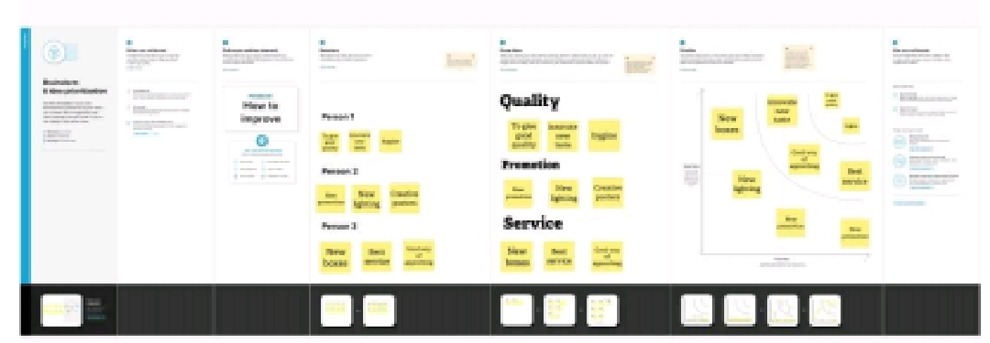

## 3.Result

Dashboard

Home

**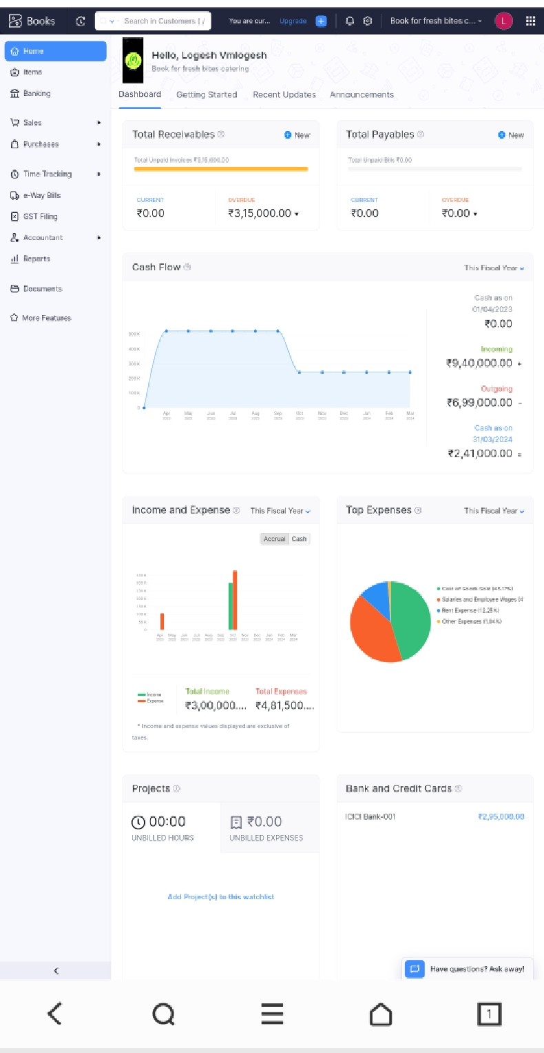**

**Item creation**

**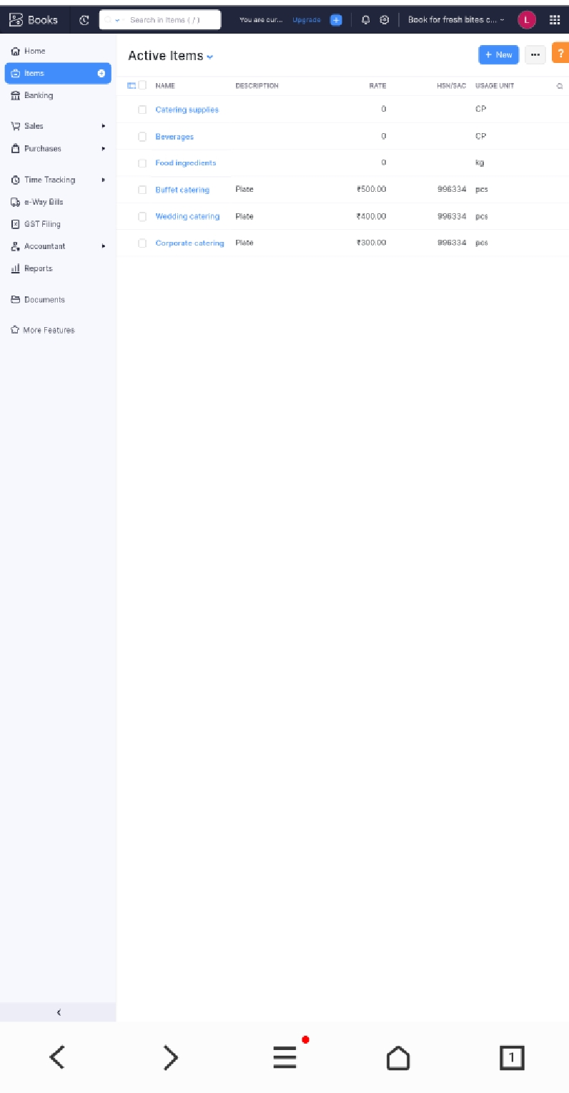  
vendor creation**

**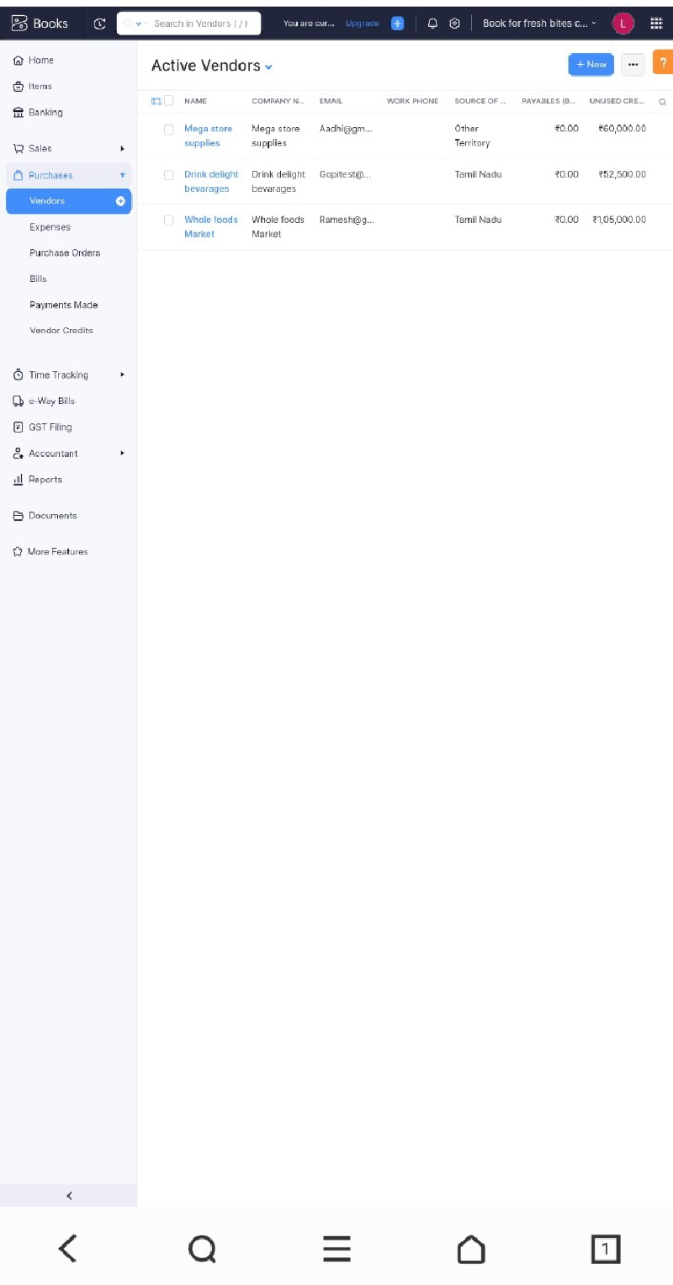**

**Purchase**

**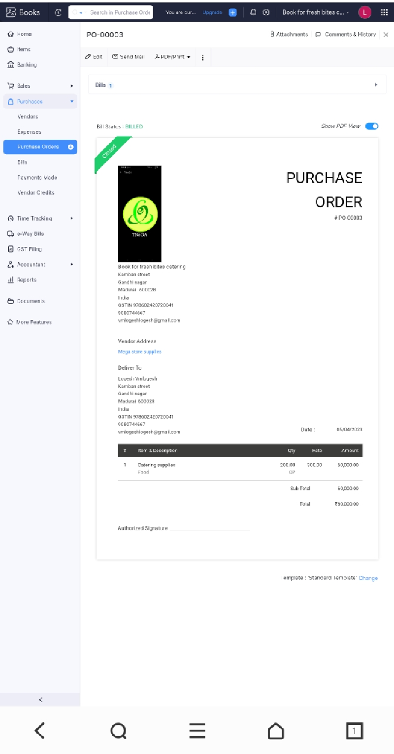**

**Bills**

**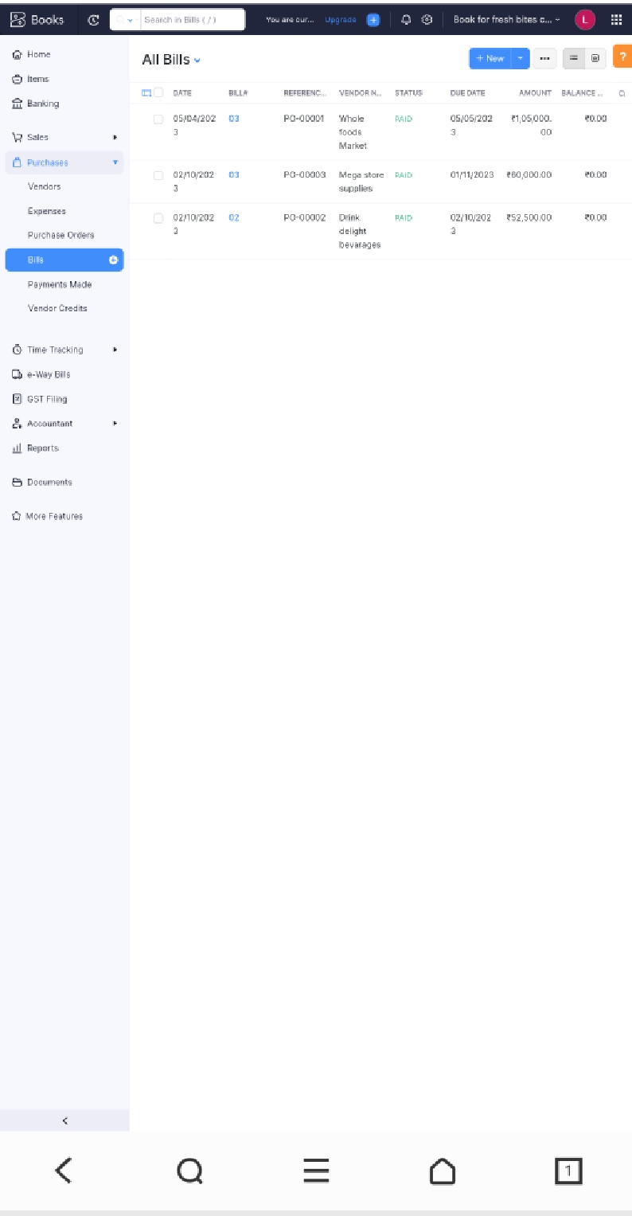**

**Customer creation**

**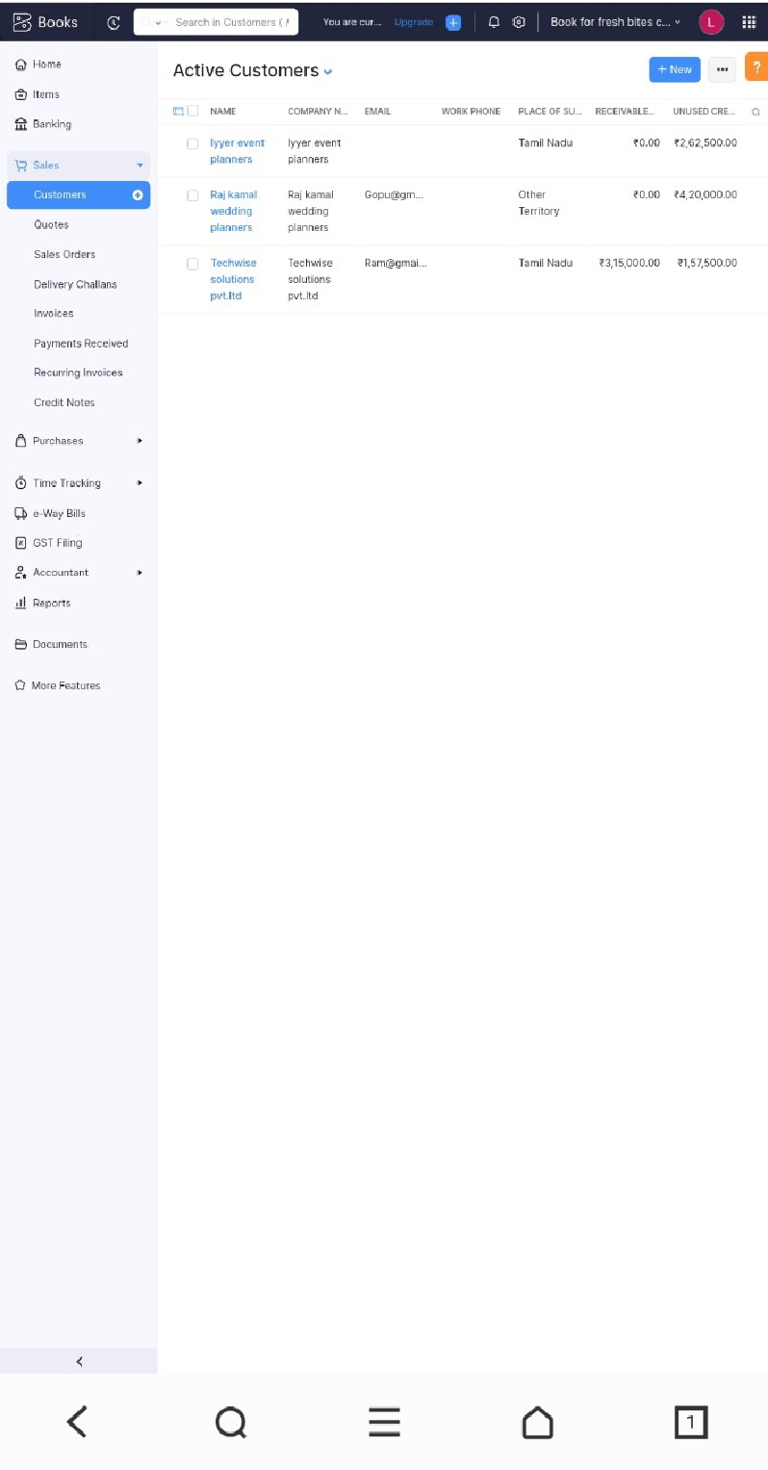**

## Sales

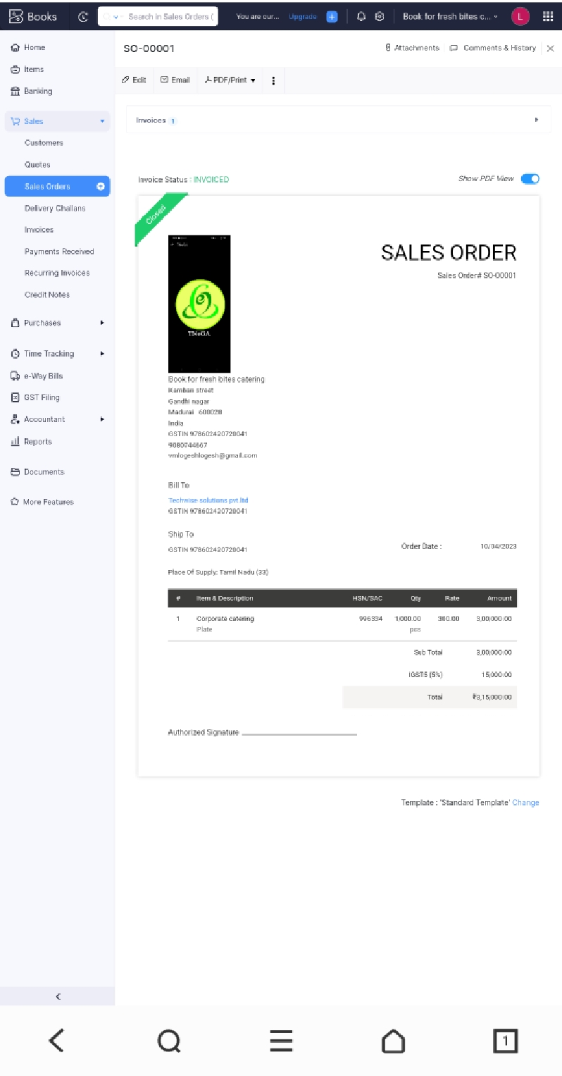

## Sales invoice

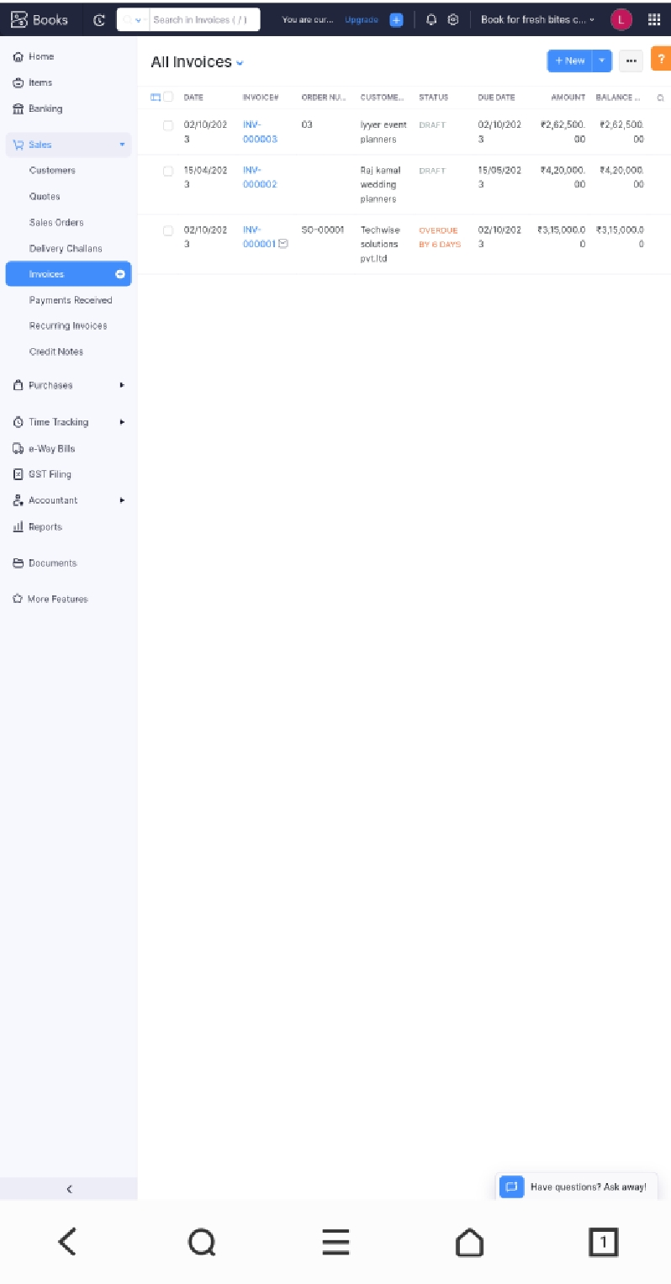

## Profit & loss account

## profi and loss.jpg

## Balance sheet

## balance sheet.jpg

## Expenses

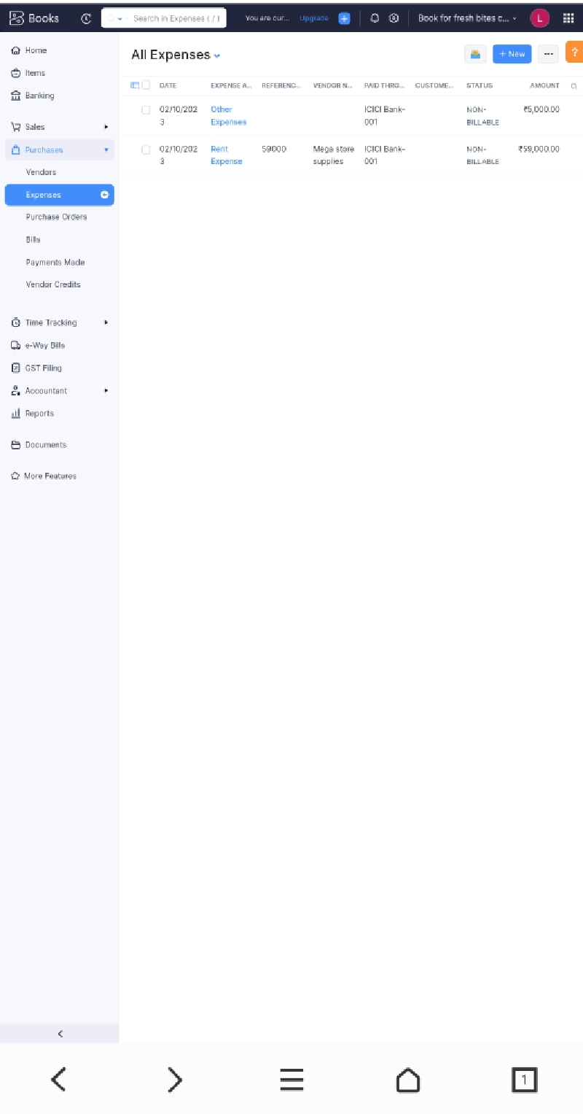

## Bank accounts

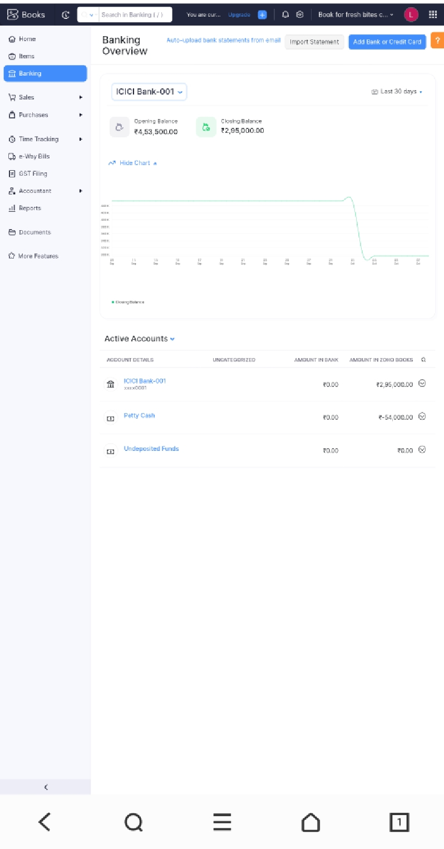

## GST Entries

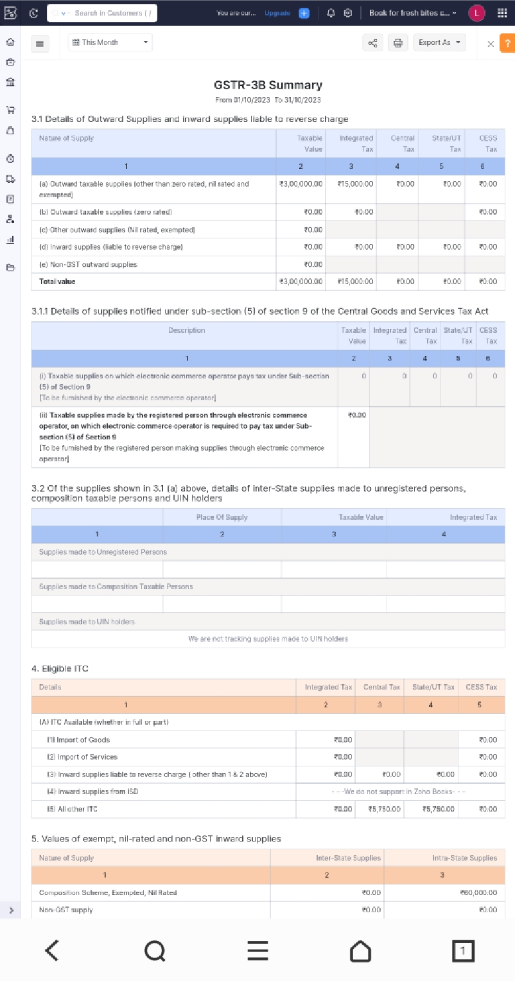

## Journal reports

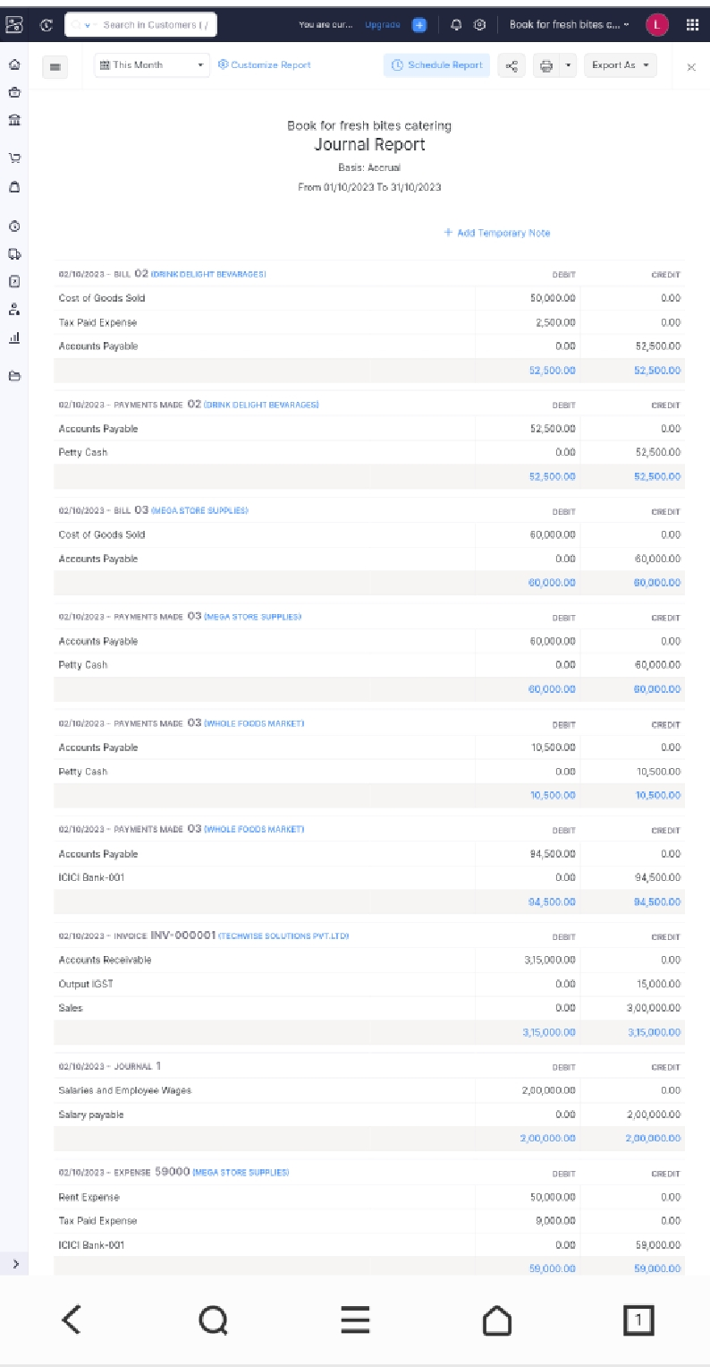

# 4. Advantages & disadvantages

Naanmudhalvan in zoho books was gave a better performance and better experience for all user. Because it was very simple and easy to record and maintain the business transaction.

User restriction although zoho books gives you four plants choose from, they do restrict the number of users you can have on your account.

# 5. Application

Zoho books in my application was surre to use all business sectors in the world. It is very easy to record the transactions. This application was suitable to all size of business. Because it is a advanced version compare to tally.

# 6. Conclusion

Zoho books in my conclusion was it is gave a better experience to me. And I know how record the transaction in record zoho books. I am consider zoho books projects was like skill development course that’s it

# 7. Future scope

Zoho books was becomes a powerfull accounting software. So, the majority of business was using this software. So, I know how to handle the zoho books application. So, I have chance to join the this company.