Software Requirements Specification (SRS) Document

Social Venture Partner - Engagement Analytics Dashboard
Version: 1.0
Team Number: 49
Team Members: Navneet Kumar Gupta, Sambhavi Singh, Yogansh Somisetty, Athmeeya Kashyap, Prashant Vinod

Brief problem statement

Social Venture Partners (SVP) engages over 600 partners and 120 not-for-profits across India to facilitate philanthropic impact. Currently, partner information discovery, engagement tracking, and contribution management are handled manually using disparate tools like Excel and NotebookLM, making it difficult to maintain data integrity and generate insights. The proposed solution is a centralized web application to manage partner and investee profiles, automate appointment scheduling, and provide detailed analytics on engagement hours and contributions to ensure mutual satisfaction with the engagements.

System requirements
- Frontend: React.js for the user interface.
- Backend: Node.js and Express.js using TypeScript for API management.
- Database: PostgreSQL for relational data storage (replacing Excel). The system uses UUIDs for primary keys and enforces multi-tenancy via chapter_id.
- Analytics: Data visualization tools (e.g., Superset or React Charts) to display metrics like meetings attended and hours spent.

Users profile
- Administrator (SVP Operations Team): The primary user. They are familiar with the organizational workflow but require an efficient, consolidated interface to replace manual spreadsheets. They handle data entry, scheduling, and report generation.
- Partner (Future Release v3.0): Philanthropic partners who will eventually access the system to view their schedules and engagement analytics.

Feature requirements (described using use cases)

No. | Use Case Name | Description | Release
1. | Authentication | Secure login for Admins using Email/Password with JWT and bcrypt. Enforces strict multi-tenancy where emails are unique per Chapter. | R1
2. | Manage Partners | Admin adds/edits partners. Includes "Soft Delete" logic (setting end_date) to preserve history. Deletion is blocked if the partner is linked to active Groups or Appointments. | R1
3. | Manage Investees | Admin manages NGO profiles. Must include Start dates (mandatory) and End dates (optional/fixed 3-5 years) to track engagement periods. | R1
4. | Manage Groups | Creation of partner cohorts (e.g., Mentorship Cohort). Groups act as UI helpers to organize partners for easier selection during scheduling. | R1
5. | Create Appointment | Admin schedules meetings. Partners are copied from Groups at the moment of creation (Snapshot logic). Supports Standalone and Group-based appointments. | R1
6. | Manage Recurring Appointments | Admin creates templates for repeating events (Weekly/Monthly). Max duration is 1 year. These are "Virtual" and only materialize into real records upon completion. | R1
7. | Mark Attendance | Admin marks a scheduled or virtual appointment as "Completed." This action triggers the recording of actual hours and attendance. | R1
8. | View Analytics Dashboard | Admin views metrics like "Hours spent," "Meetings attended," and "Distinct Partners engaged," filterable by Month, Investee, or Partner. | R2

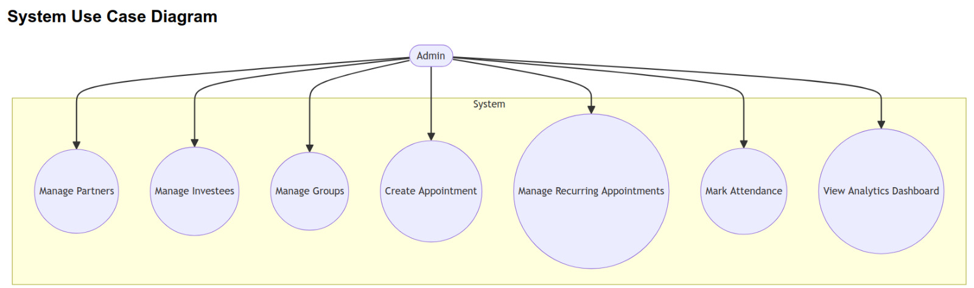

USE CASE 01: AUTHENTICATION
Field | Description
Use Case Number | UC-01
Use Case Name | Authentication
Overview | Allows the Admin to securely log in to the system to access the dashboard. The system ensures data isolation via chapter_id.
Actors | Admin
Pre-condition | The Admin must have an account in the database.
Main Success Flow | 1. Admin accesses the application URL.  2. System presents the Login screen.  3. Admin enters Email and Password.  4. System validates credentials using bcrypt.  5. System generates a JWT containing the user's chapter_id.  6. System redirects Admin to the Home Dashboard.
Alternate Flows | Invalid Credentials: System displays an error message "Invalid Email or Password" and keeps the user on the login screen.
Post Condition | Admin is authenticated, and all subsequent API requests include the JWT for authorization.

USE CASE 02: MANAGE PARTNERS
Field | Description
Use Case Number | UC-02
Use Case Name | Manage Partners
Overview | Admin creates or updates partner profiles. This is the core entity for tracking philanthropic contributions.
Actors | Admin
Pre-condition | Admin is logged in.
Main Success Flow | 1. Admin navigates to the Partners tab.  2. Admin selects Add Partner.  3. Admin enters Name, Email, Start Date, and optional LinkedIn URL.  4. Admin saves the record.  5. System assigns a UUID and the Admin's chapter_id to the partner.  6. System displays the new partner in the list.
Alternate Flows | Deletion Blocked: If partner is in an active Group or Appointment, system prevents deletion.
Post Condition | Partner database records are updated.

USE CASE 03: MANAGE INVESTEES
Field | Description
Use Case Number | UC-03
Use Case Name | Manage Investees
Overview | The Admin creates and manages profiles for Investees (NGOs).
Actors | Admin
Pre-condition | Admin is logged in and authenticated.
Main Success Flow | 1. Admin navigates to the Investees section of the dashboard.  2. Admin selects Add Investee.  3. Admin enters Investee Name, Email, Start Date, and End Date.  4. Admin submits the form.  5. System generates a UUID, assigns the Admin's chapter_id, and saves the record.  6. System displays the new Investee in the list.
Alternate Flows | Edit Engagement Period: Admin updates end_date and system saves changes.  Delete Blocked: If Investee is linked to Groups or Appointments, system shows error message.
Post Condition | Investee profile is active and available for Group creation and Appointment scheduling.

USE CASE 04: MANAGE GROUPS
Field | Description
Use Case Number | UC-04
Use Case Name | Manage Groups
Overview | Admin creates cohorts of partners to simplify appointment scheduling.
Actors | Admin
Pre-condition | Partners must already exist in the system.
Main Success Flow | 1. Admin navigates to the Groups tab.  2. Admin clicks Create Group and provides Group Name and Type.  3. Admin optionally selects an Investee.  4. Admin selects multiple Partners.  5. System saves the group.
Post Condition | Group is created and available for appointment selection.

USE CASE 05: CREATE APPOINTMENT
Field | Description
Use Case Number | UC-05
Use Case Name | Create Appointment
Overview | Admin schedules a single meeting with snapshot logic applied to groups.
Actors | Admin
Pre-condition | Partners or Groups must exist.
Main Success Flow | 1. Admin navigates to Calendar.  2. Admin selects date and time.  3. Admin selects Create Appointment.  4. If Group-based, system retrieves active partners.  5. System populates attendees.  6. Admin confirms attendees.  7. System saves appointment.
Post Condition | Appointment appears on the calendar without group_id linkage.

USE CASE 06: MANAGE RECURRING APPOINTMENTS
Field | Description
Use Case Number | UC-06
Use Case Name | Manage Recurring Appointments
Overview | Admin creates repeating meeting templates without generating database records upfront.
Actors | Admin
Pre-condition | A Group must be selected.
Main Success Flow | 1. Admin selects Create Recurring Appointment.  2. Admin selects Group, Frequency, Start and End dates.  3. System stores configuration in recurring_appointments table.  4. Calendar displays virtual appointment slots.
Post Condition | Virtual appointments appear on the calendar.

USE CASE 07: MARK ATTENDANCE
Field | Description
Use Case Number | UC-07
Use Case Name | Mark Attendance
Overview | Converts scheduled or virtual appointments into completed records for analytics.
Actors | Admin
Pre-condition | Meeting time has passed or is ongoing.
Main Success Flow | 1. Admin selects appointment on calendar.  2. Admin clicks Mark Complete.  3. System materializes appointment if virtual.  4. Admin marks Present attendees.  5. Admin saves.  6. System updates status.
Post Condition | Engagement hours are permanently recorded for analytics.

USE CASE 08: VIEW ANALYTICS DASHBOARD
Field | Description
Use Case Number | UC-08
Use Case Name | View Analytics Dashboard
Overview | Admin views engagement analytics for partners and investees.
Actors | Admin
Pre-condition | Appointments must be completed.
Main Success Flow | 1. Admin navigates to Analytics menu.  2. System queries DataMart tables.  3. Admin selects analytics view.  4. Admin applies filters.  5. System renders charts and metrics.
Post Condition | Admin gains insights into engagement and performance.

