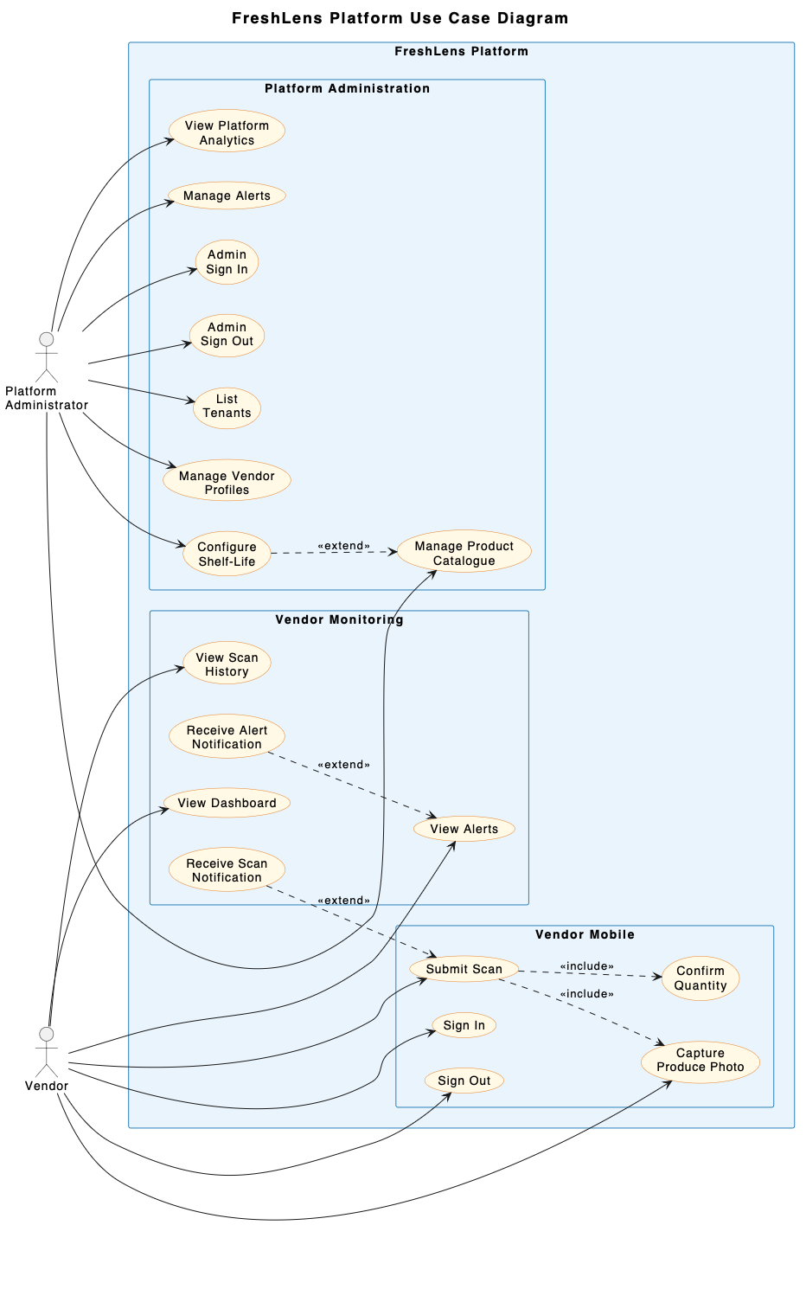
4.1Use-Case Realizations

Actor: Vendor (mobile app)

UC-01: Sign In
Use Case Name | UC-01: Sign In
Actor | Vendor (mobile app)
Description | Vendor authenticates via Supabase Auth; session JWT stored securely on-device for API calls.
Preconditions | Vendor has a registered account and mobile app installed with network connectivity.
Main Flow | 1. Vendor opens mobile app and navigates to Sign In screen.  2. Vendor enters email/username and password.  3. App submits credentials to Supabase Auth over HTTPS.  4. Supabase Auth validates the credentials and issues a JWT session token.  5. App securely stores JWT locally and registers device push token.  6. Vendor is redirected to the home/dashboard view.
Successful End/Post Condition | Vendor is authenticated; active JWT session stored; device push token registered; dashboard displayed.
Fail End/Post Condition | Authentication fails; inline error displayed; session is not established.
Extensions | 3a. Invalid credentials: System displays 'Incorrect email or password' message and remains on Sign In screen.  3b. Network error: System displays connectivity error and prompts user to retry.

UC-02: Sign Out
Use Case Name | UC-02: Sign Out
Actor | Vendor (mobile app)
Description | Vendor clears local session; further API calls are unauthorized until re-sign-in.
Preconditions | Vendor is currently signed in with an active JWT session.
Main Flow | 1. Vendor selects 'Sign Out' option from app menu/settings.  2. App clears locally stored JWT session tokens and user state.  3. App unregisters or invalidates active session context.  4. Vendor is redirected to the unauthenticated login screen.
Successful End/Post Condition | Local session cleared; vendor logged out; app redirected to login screen.
Fail End/Post Condition | N/A
Extensions | N/A

UC-03: Capture Produce Photo
Use Case Name | UC-03: Capture Produce Photo
Actor | Vendor (mobile app)
Description | Vendor captures a produce image using the device camera.
Preconditions | Vendor is authenticated and on the scan capture screen.
Main Flow | 1. Vendor launches the camera interface within the app.  2. App verifies camera permissions before opening the camera.  3. Vendor frames a single produce item and triggers capture.  4. App holds image locally and presents a preview to the vendor.  5. Vendor confirms photo or chooses to retake.
Successful End/Post Condition | Single produce photo captured and stored locally in temporary memory, ready for quantity confirmation.
Fail End/Post Condition | No photo stored; app remains on camera preview or returns to capture screen.
Extensions | 2a. Camera permission denied: App shows explanatory prompt and offers a link to the device settings to enable camera permission.

UC-04: Confirm Scan Quantity
Use Case Name | UC-04: Confirm Scan Quantity
Actor | Vendor (mobile app)
Description | Vendor enters/confirms an integer quantity (≥ 1) before submitting.
Preconditions | Produce photo has been captured and validated locally (UC-03).
Main Flow | 1. App displays captured produce image preview alongside a quantity input field.  2. Vendor enters or adjusts the stock quantity (integer ≥ 1).  3. Vendor taps 'Confirm' to attach quantity to the pending submission context.
Successful End/Post Condition | Validated image and positive integer quantity pair prepared for submission.
Fail End/Post Condition | Quantity context remains unconfirmed; submit action prevented.
Extensions | 2a. Vendor enters quantity < 1, non-integer, or empty field: App displays inline validation error prompt.

UC-05: Submit Scan
Use Case Name | UC-05: Submit Scan
Actor | Vendor (mobile app)
Description | Vendor submits image + quantity to POST /api/v1/scans, receiving 202 acceptance.
Preconditions | Vendor has captured a valid photo (UC-03) and confirmed a valid quantity (UC-04).
Main Flow | 1. Vendor taps 'Submit Scan' button.  2.App submits the image and quantity to the FastAPI backend. The backend validates the request, stores the image in Cloudflare R2, creates the scan record with Pending status, and enqueues the Celery background job.  3. API returns HTTP 202 Accepted response immediately without waiting for ML classification.  4. App confirms receipt to vendor and updates UI state.
Successful End/Post Condition | Scan submission accepted with HTTP 202; scan status set to 'pending'; ML inference background job queued.
Fail End/Post Condition | Submission rejected (e.g., HTTP 401/422/500); error message shown to vendor; scan not queued.
Extensions | 4a. Network timeout/error: App displays error message and allows vendor to retry submission.

UC-06: Receive Scan Result Notification
Use Case Name | UC-06: Receive Scan Result Notification
Actor | Vendor (mobile app)
Description | Vendor gets a push notification when a scan reaches completed/failed, then views result.
Preconditions | Scan has been submitted (UC-05) and push notifications are enabled on device.
Main Flow | 1. Async ML worker finishes processing scan and updates record status to 'completed' or 'failed'.  2. System triggers mobile push notification (via Expo Push/FCM/APNs) to vendor's device.  3. Vendor receives notification and taps it (or opens app).  4. App fetches authoritative status from GET /api/v1/scans/{id}.  5. App displays scan result details (produce identity, freshness label, freshness score).
Successful End/Post Condition | Vendor views detailed scan classification result in-app.
Fail End/Post Condition | Vendor does not receive notification, but can still view updated status via manual scan list (UC-07).
Extensions | 3a. Push permission disabled: Vendor opens app manually; app fetches latest status upon viewing scan list or dashboard.

UC-07: View Scan History
Use Case Name | UC-07: View Scan History
Actor | Vendor (mobile app)
Description | Vendor views a scrollable list of recent scans for their tenant.
Preconditions | Vendor is authenticated.
Main Flow | 1. Vendor navigates to 'Scan History' tab/screen.  2. App issues GET /api/v1/scans with tenant Bearer JWT.  3. API returns list of scan records scoped strictly to vendor's tenant ID via RLS.  4. App renders scrollable list showing image thumbnail, status, timestamp, produce type, and freshness classification.
Successful End/Post Condition | Tenant-scoped scan history displayed to vendor.
Fail End/Post Condition | Error message displayed if request fails; empty state shown if no scans exist.
Extensions | 3a. No scans exist: System displays explicit empty state screen.

UC-08: Receive Alert Notification
Use Case Name | UC-08: Receive Alert Notification
Actor | Vendor (mobile app)
Description | Vendor gets a push notification when a new/updated tenant alert is raised.
Preconditions | Alert rule (low-stock, aging, or spoilage) is triggered by the backend system; push token registered.
Main Flow | 1. Backend system creates/updates an alert record for the tenant.  2. System dispatches a push notification to vendor's device.  3. Vendor taps notification (or opens alerts screen).  4. App fetches alert details via GET /api/v1/alerts and navigates to Alert view.
Successful End/Post Condition | Vendor is notified of new/updated alert and views details.
Fail End/Post Condition | Push notification fails, but alert remains retrievable in alerts list (UC-09).
Extensions | 3a. Push permission disabled: Alert remains accessible in-app via Alerts tab.

UC-09: View Alerts List
Use Case Name | UC-09: View Alerts List
Actor | Vendor (mobile app)
Description | Vendor views tenant alerts in-app with batch context (intake date, qty, shelf-life).
Preconditions | Vendor is authenticated.
Main Flow | 1. Vendor navigates to 'Alerts' screen.  2. App issues GET /api/v1/alerts with vendor JWT.  3. API returns tenant-scoped alerts.  4. App renders list displaying alert type, severity, message, and linked batch context (intake date, quantity received, remaining quantity, category shelf-life).
Successful End/Post Condition | Alerts list rendered with full batch context.
Fail End/Post Condition | Error displayed or empty state shown if no alerts exist.
Extensions | 4a. No active alerts: System renders explicit empty state.

UC-10: View Inventory/Freshness Dashboard
Use Case Name | UC-10: View Inventory/Freshness Dashboard
Actor | Vendor (mobile app)
Description | Vendor views a summary dashboard of recent scan and inventory data.
Preconditions | Vendor is authenticated.
Main Flow | 1. Vendor opens Dashboard screen.  2. App requests summary inventory, scan stats, and active alerts from API.  3. Backend queries tenant-isolated database tables.  4. App displays aggregated metrics, recent scans, and inventory freshness overview.
Successful End/Post Condition | Summary inventory and freshness dashboard displayed.
Fail End/Post Condition | Dashboard fails to load; retry button presented.
Extensions | N/A

Actor: Platform Administrator (web app)

UC-11: Admin Sign In
Use Case Name | UC-11: Admin Sign In
Actor | Platform Administrator (web app)
Description | Admin authenticates via Supabase Auth and calls admin APIs with Bearer JWT.
Preconditions | Admin user exists with 'platform_admin' role.
Main Flow | 1. Admin accesses web admin portal login page.  2. Admin enters credentials.  3. System authenticates via Supabase Auth and generates admin Bearer JWT.  4. Web app stores session JWT and redirects to Admin Dashboard.
Successful End/Post Condition | Admin authenticated; JWT stored for subsequent API calls.
Fail End/Post Condition | Authentication fails; error displayed; no session established.
Extensions | 2a. Invalid credentials: Inline error message displayed.

UC-12: Admin Sign Out
Use Case Name | UC-12: Admin Sign Out
Actor | Platform Administrator (web app)
Description | Admin signs out, clearing the session.
Preconditions | Admin is currently signed in.
Main Flow | 1. Admin clicks 'Sign Out' in navigation header.  2. Web app clears local stored session tokens and credentials.  3. Web app redirects to Admin Sign In page.
Successful End/Post Condition | Admin session terminated; user redirected to login.
Fail End/Post Condition | N/A
Extensions | N/A

UC-13: List Tenants
Use Case Name | UC-13: List Tenants
Actor | Platform Administrator (web app)
Description | Admin views the list of vendor tenants (id, name, created_at).
Preconditions | Admin is authenticated with platform_admin role.
Main Flow | 1. Admin navigates to 'Tenants' section.  2. App issues GET /api/v1/admin/tenants with Admin JWT.  3. Backend verifies admin role and queries tenants table.  4. App renders table displaying tenant ID, name, status, and created_at timestamp.
Successful End/Post Condition | List of vendor tenants displayed to platform admin.
Fail End/Post Condition | Access denied (403) if user lacks admin role; error displayed if backend fails.
Extensions | N/A

UC-14: Manage Vendor Profiles
Use Case Name | UC-14: Manage Vendor Profiles
Actor | Platform Administrator (web app)
Description | Admin views/updates basic vendor/tenant profile fields (name, status).
Preconditions | Admin is authenticated and viewing tenant list.
Main Flow | 1. Admin selects a specific vendor tenant profile.  2. Admin modifies basic profile fields (e.g., tenant name, account status active/inactive).  3. Admin submits changes.  4. Backend updates tenant record in database and returns updated profile.
Successful End/Post Condition | Vendor profile updated successfully.
Fail End/Post Condition | Update fails; error message displayed; changes reverted.
Extensions | N/A

UC-15: Manage Product Catalogue
Use Case Name | UC-15: Manage Product Catalogue
Actor | Platform Administrator (web app)
Description | Admin creates/lists/updates produce types and catalogue metadata.
Preconditions | Admin is authenticated.
Main Flow | 1. Admin navigates to 'Product Catalogue' section.  2. Admin views list of produce types.  3. Admin chooses to create a new product or update an existing entry.  4. Admin fills/updates attributes (produce name, category, standard shelf life).  5. Backend saves product metadata to catalogue table.
Successful End/Post Condition | Product catalogue entry created or updated.
Fail End/Post Condition | Validation error or database failure stops update.
Extensions | N/A

UC-16: Configure Shelf-Life for Aging Alerts
Use Case Name | UC-16: Configure Shelf-Life for Aging Alerts
Actor | Platform Administrator (web app)
Description | Admin sets/updates typical shelf-life (days) per category/product.
Preconditions | Admin is authenticated and viewing product/category management.
Main Flow | 1. Admin selects a product category or specific produce item.  2. Admin inputs or modifies the standard shelf-life duration in days.  3. Admin saves configuration.  4. Backend updates shelf-life rules referenced by static aging alert evaluators.
Successful End/Post Condition | Category/product shelf-life updated and stored.
Fail End/Post Condition | Configuration update fails; inline error shown.
Extensions | N/A

UC-17: View Platform Analytics
Use Case Name | UC-17: View Platform Analytics
Actor | Platform Administrator (web app)
Description | Admin views a basic waste/spoilage or classification aggregate view.
Preconditions | Admin is authenticated.
Main Flow | 1. Admin navigates to 'Analytics' section.  2. App fetches aggregated scan, classification, and waste statistics across tenants.  3. Backend performs aggregation queries (non-vendor-private access restricted to summaries).  4. App presents graphical charts and aggregate tables.
Successful End/Post Condition | Platform-wide aggregate analytics presented.
Fail End/Post Condition | Analytics fetch fails; error state displayed.
Extensions | N/A

UC-18: Manage Alerts (CRUD)
Use Case Name | UC-18: Manage Alerts (CRUD)
Actor | Platform Administrator (web app)
Description | Admin creates, updates, or dismisses alerts beyond the vendor's read-only list.
Preconditions | Admin is authenticated.
Main Flow | 1. Admin navigates to 'System Alerts' management panel.  2. Admin views, creates, updates, or dismisses tenant alert records.  3. Backend persists alert changes.
Successful End/Post Condition | Alert record created, modified, or dismissed by admin.
Fail End/Post Condition | Alert action fails; error shown.
Extensions | N/A

Actor: System (async backend / ML worker)

UC-19: Run Freshness Classification Asynchronously
Use Case Name | UC-19: Run Freshness Classification Asynchronously
Actor | System (async backend / ML worker)
Description | Worker accepts the scan (202), advances it pending→processing→completed/failed, runs Tier-1/Tier-2 FL-2TC (or stub), and persists result fields — never inline in the API handler.
Preconditions | Scan request accepted by API with HTTP 202 and Celery job queued in Redis.
Main Flow | 1. Celery ML worker picks up scan job from Redis queue.  2. Worker updates scan status in the database from 'pending' to 'processing'.  3. Worker retrieves image from Cloudflare R2 object storage.  4. Worker executes the Tier-1 produce identification model using the selected pretrained CNN.  5. Worker executes the Tier-2 freshness classification model(fresh, medium, or spoiled).  6. Worker updates scan record in database: status 'completed', classification, freshness score, model version.  7. System triggers push notification event to vendor (UC-06).
Successful End/Post Condition | Scan status updated to 'completed'; classification result and score stored; vendor notified.
Fail End/Post Condition | Scan status set to 'failed'; failure reason logged.
Extensions | 4a/5a. Model execution fails or invalid image: Worker catches exception, updates scan status to 'failed', records error message, and triggers notification.

UC-20: Trigger Low-Stock and Aging Alerts
Use Case Name | UC-20: Trigger Low-Stock and Aging Alerts
Actor | System (async backend / ML worker)
Description | System compares remaining quantity to threshold (low-stock) and batch age to configured shelf-life (aging), creating alert records.
Preconditions | Scheduled worker job or inventory/scan update event executes.
Main Flow | 1. System evaluates active inventory batches for all tenants.  2. System compares batch quantity_remaining against configured low-stock threshold.  3. If remaining quantity < threshold, system generates 'low_stock' alert.  4. System compares (current_date - intake_date) against configured category shelf-life in days.  5. If time-since-intake > shelf-life and unsold quantity remains high, system generates 'aging' alert.  6. Alert records are written to alerts table with tenant context and linked batch ID.  7. System triggers push notification (UC-08).
Successful End/Post Condition | Low-stock and aging alerts generated and persisted; push notifications triggered.
Fail End/Post Condition | Evaluation process encounters error; error logged in background.
Extensions | N/A

UC-21: Trigger Spoilage Alert from Classification
Use Case Name | UC-21: Trigger Spoilage Alert from Classification
Actor | System (async backend / ML worker)
Description | System creates/updates a spoilage-type alert when a completed scan's classification is "spoiled".
Preconditions | UC-19 completes with classification = 'spoiled'.
Main Flow | 1. ML classification finishes with result 'spoiled'.  2. System creates or updates a 'spoilage' alert record for the tenant.  3. Alert is linked to the scan ID, produce type, and batch context.  4. System dispatches push notification to vendor (UC-08).
Successful End/Post Condition | Spoilage alert generated and linked to scan; push notification dispatched.
Fail End/Post Condition | Alert creation fails; error logged.
Extensions | N/A

