

Technical Design

for the

Weather Station Project

Version

Technical Design for

|  |  |
| --- | --- |
| Project Information | |
| Project Name | Raspberry Pi Weather Station | |
| Document Version | 1.0 | |
| Revision Date | 8/27/13 | |
| Document Name | IT2PIE_Weather_station_Design.docx | |

|  |
| --- |
| Referenced Documents |

|  |  |
| --- | --- |
| Document Name and Location | Description |
| [www.adafruit.com](http://www.adafruit.com) | Spec sheets and info on sensors |

|  |  |  |  |
| --- | --- | --- | --- |
| Version | Date | User | Description |
| 1.0 | 8/27/2013 | Greg | Initial document creation |
|  |  |  |  |
|  |  |  |  |
|  |  |  |  |
|  |  |  |  |
|  |  |  |  |

Table of Contents

1. Overview 5

2. Temperature 5

3. Barometric Pressure 5

4. Rain Sensor 5

5. Rain Measurement 6

6. Wind Speed 6

7. Database 6

8. Web Service 6

9. Web Site 6

10. Hardware/Software Requirements 6

# Overview

The purpose of this project is to build a weather station, using the Raspberry Pi microcomputer. This weather station will be capable of measuring temperature, barometric pressure, and rain fall amounts.

The overall goal of this project is to capture and log this data, via an SQL database. Then make it available to the public via a web page, Twitter, and shared with Weather Underground ([www.wunderground.com](http://www.wunderground.com)).

# Temperature

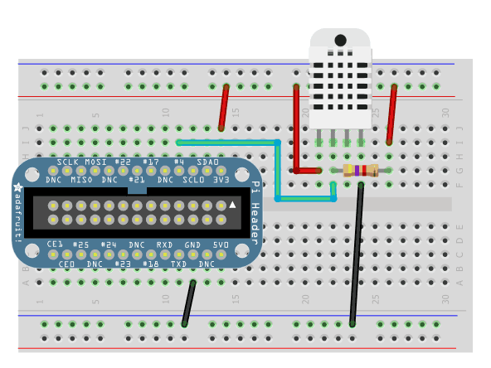

# Barometric Pressure

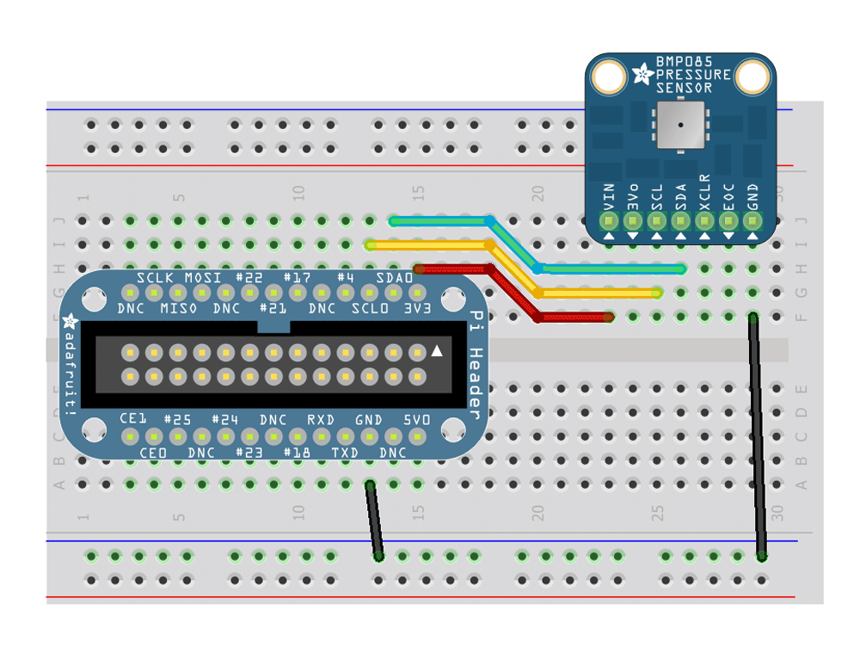

# Rain Sensor

# Rain Measurement

# Wind Speed

# Database

# Web Service

# Web Site

# Hardware/Software Requirements

|  |  |  |
| --- | --- | --- |
| Part | Vendor | Cost |
| Raspberry Pi | [www.adafruit.com](http://www.adafruit.com) | $35.00 |
| DHT022 | [www.adafruit.com](http://www.adafruit.com) |  |
| BMP |  |  |
|  |  |  |
|  |  |  |
|  |  |  |
|  |  |  |