GitHub-ServiceNow Data Integration in ARC
Table of Contents

GitHub-ServiceNow Data Integration in ARC
Technical Implementation Deep Dive Last Updated: 2025-11-10 Status: Production

Executive Summary
This document provides a comprehensive technical analysis of the bi-directional integration between GitHub Actions and ServiceNow DevOps implemented in the Application Release Center (ARC). The integration establishes complete traceability from code commits through testing, security scanning, and deployment, with all artifacts and evidence automatically synchronized to ServiceNow for compliance and audit purposes.

Architecture Overview
The integration employs a hybrid approach combining ServiceNow’s traditional Change Management API (Table API) with DevOps-specific tables to achieve both compliance requirements and operational visibility. All communication occurs via authenticated REST API calls over HTTPS, with no ServiceNow plugins required on the GitHub side.

Key Integration Points
- Orchestration Task Registration - GitHub Actions job tracking
- Work Item Extraction - Automated issue linking from commit messages
- Test Result Reporting - Comprehensive test evidence collection
- Security Scan Integration - Vulnerability and SBOM tracking
- Change Request Automation - Compliance-driven deployment gates
- Package Registration - Artifact and configuration management

Solution Architecture

High-Level Integration Flow
Diagram 1:
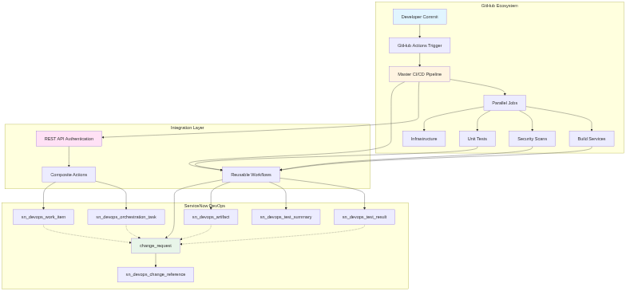
Diagram 1

Authentication and Security Model
All API communications utilize HTTP Basic Authentication with credentials managed through GitHub Secrets. The authentication flow implements the following security controls:
Credential Management: - ServiceNow username and password stored as GitHub repository secrets - Secrets never logged or exposed in workflow outputs - Each API request creates a new authenticated session - No long-lived tokens or session persistence
API Endpoint Security: - All requests use HTTPS (TLS 1.2+) - ServiceNow instance URL validated before use - API responses parsed and validated before processing - Non-blocking error handling prevents pipeline failures

Component 1: Orchestration Task Registration

Purpose
Track individual GitHub Actions jobs as orchestration tasks in ServiceNow, enabling visibility into CI/CD pipeline execution at the job level rather than just the workflow level.

Technical Implementation
Composite Action: .github/actions/register-orchestration-task/action.yaml
Execution Flow:
Diagram 2:
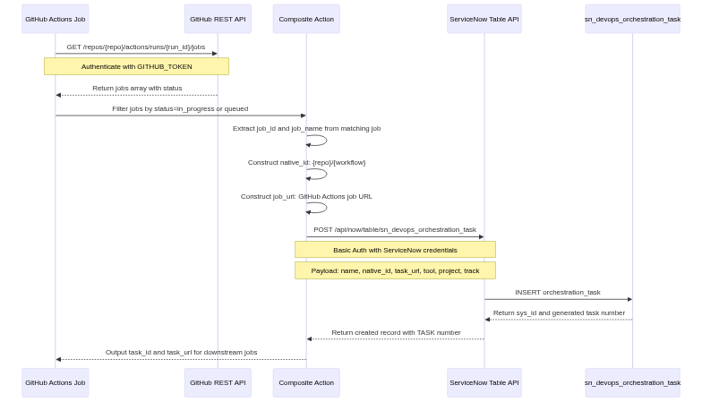
Diagram 2

Data Model
Table: sn_devops_orchestration_task
Field Name | Type | Source | Example Value | Purpose
sys_id | UUID | Generated | abc123def456… | Primary key
number | String | Auto-generated | TASK0001234 | Human-readable identifier
name | String | Composite | Freundcloud/microservices-demo/Master CI/CD Pipeline#Pipeline Initialization | Fully qualified job name
native_id | String | Composite | Same as name | Unique identifier for deduplication
task_url | URL | GitHub API | https://github.com/…/job/54808245339 | Direct link to job execution
project | Reference | Secret | c6c9eb71c34d7a50b71ef44c05013194 | Links to sn_devops_project
tool | Reference | Secret | f62c4e49c3fcf614e1bbf0cb050131ef | Links to sn_devops_tool (GithHubARC)
track | Boolean | Hardcoded | true | Enables tracking in DevOps workspace
sys_created_on | Datetime | Auto | 2025-11-07 15:01:23 | Record creation timestamp

API Request Structure
POST /api/now/table/sn_devops_orchestration_task HTTP/1.1
Host: calitiiltddemo3.service-now.com
Authorization: Basic <base64-credentials>
Content-Type: application/json
{
"name": "Freundcloud/microservices-demo/Master CI/CD Pipeline#Pipeline Initialization",
"native_id": "Freundcloud/microservices-demo/Master CI/CD Pipeline#Pipeline Initialization",
"task_url": "https://github.com/Freundcloud/microservices-demo/actions/runs/19172412878/job/54808245339",
"tool": "f62c4e49c3fcf614e1bbf0cb050131ef",
"project": "c6c9eb71c34d7a50b71ef44c05013194",
"track": true
}

Error Handling Strategy
The implementation uses a non-blocking approach:
- GitHub API failures return “unknown” job_id (continues execution)
- ServiceNow API failures log warning (continues execution)
- continue-on-error: true at workflow level prevents pipeline stoppage
- All errors logged to workflow output for debugging
This design ensures that ServiceNow integration issues never block deployments while maintaining complete audit trails when successful.

Component 2: Work Item Extraction and Registration

Purpose
Automatically extract GitHub issue references from commit messages and register them as work items in ServiceNow, establishing traceability between code changes and requirements.

Technical Implementation
Composite Action: .github/actions/register-work-items/action.yaml
Execution Flow:
Diagram 3:
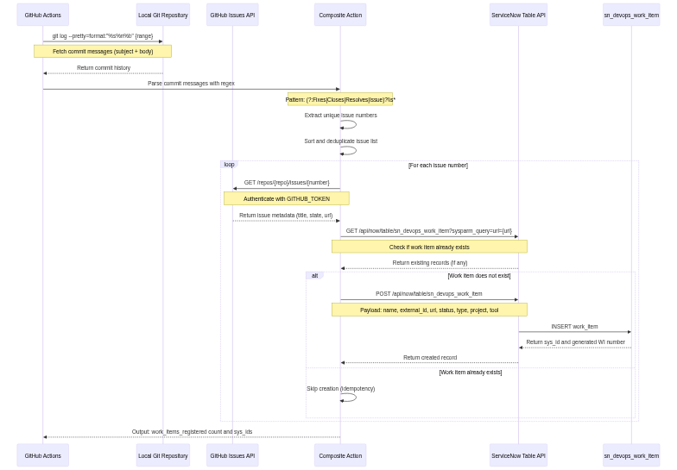
Diagram 3

Commit Message Parsing Logic
The work item extraction uses a robust regex pattern that handles multiple conventions:
Supported Patterns: - Fixes #123 - Explicit closure intent - Closes #456 - Alternative closure keyword - Resolves #789 - Resolution keyword - Issue #101 - Explicit issue reference - #112 - Bare issue number (GitHub auto-linking format)
Implementation:
grep -oP '(?:Fixes|Closes|Resolves|Issue)?\s*#\K\d+' | sort -u
Critical Fix Implemented: The initial implementation only parsed commit subject lines (%s), missing issue references in commit bodies. This was corrected to use %s%n%b (subject + body), significantly improving extraction accuracy.

Data Model
Table: sn_devops_work_item
Field Name | Type | Source | Example Value | Purpose
sys_id | UUID | Generated | xyz789abc456… | Primary key
number | String | Auto-generated | WI0001197 | Human-readable identifier
name | String | GitHub API | Add user authentication | Issue title from GitHub
external_id | String | Commit message | 80 | GitHub issue number
url | URL | GitHub API | https://github.com/…/issues/80 | Direct link to issue
status | String | GitHub API | open / closed | Issue state
type | String | Hardcoded | issue | Work item type classification
project | Reference | Secret | c6c9eb71c34d7a50b71ef44c05013194 | Links to sn_devops_project
tool | Reference | Secret | f62c4e49c3fcf614e1bbf0cb050131ef | Links to sn_devops_tool
sys_created_on | Datetime | Auto | 2025-11-07 15:01:25 | Record creation timestamp

Deduplication Strategy
To prevent duplicate work item creation across multiple pipeline runs:
- Pre-creation check: Query sn_devops_work_item table by url field
- Existence evaluation: If result count > 0, skip creation
- Atomic operations: Each work item creation is independent
- Idempotency: Multiple executions produce same end state
This ensures that the same GitHub issue is never registered twice, even if referenced in multiple commits or pipeline runs.

Component 3: Test Result Integration

Purpose
Capture comprehensive test execution evidence from unit tests, integration tests, security scans, and code quality analysis, providing complete test coverage visibility in ServiceNow.

Architecture
The test result integration uses two complementary ServiceNow tables:
- sn_devops_test_result - Individual test suite executions
- sn_devops_test_summary - Aggregated test metrics per pipeline

Test Result Data Flow
Diagram 4:
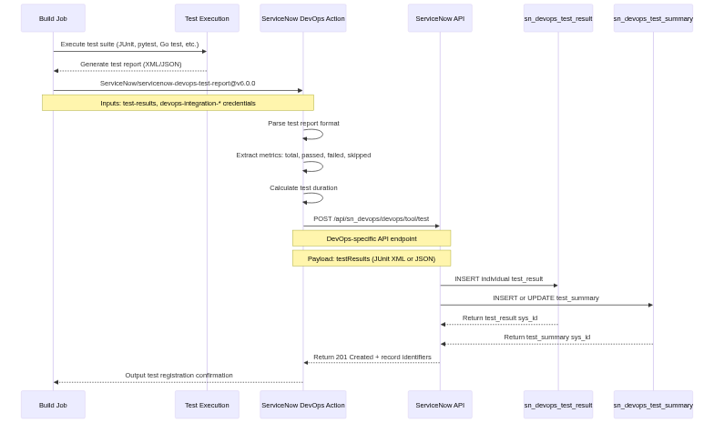
Diagram 4

Test Result Table Schema
Table: sn_devops_test_result
Field Name | Type | Source | Example Value | Purpose
sys_id | UUID | Generated | def456ghi789… | Primary key
number | String | Auto-generated | TR0005678 | Human-readable identifier
name | String | Workflow input | Unit Tests - Frontend Service | Descriptive test suite name
test_suite_name | String | Workflow input | Frontend Unit Tests | Test suite classification
test_result | String | Computed | success / failure / skipped | Overall test outcome
tool | Reference | Secret | f62c4e49c3fcf614e1bbf0cb050131ef | Links to sn_devops_tool
project | Reference | Secret | c6c9eb71c34d7a50b71ef44c05013194 | Links to sn_devops_project
execution_url | URL | GitHub context | https://github.com/…/runs/… | Link to test execution logs
start_time | Datetime | Test report | 2025-11-07T15:02:00Z | Test execution start
end_time | Datetime | Test report | 2025-11-07T15:08:30Z | Test execution completion
duration | Integer | Calculated | 390 | Duration in seconds
test_cases_total | Integer | Test report | 150 | Total test cases executed
test_cases_passed | Integer | Test report | 148 | Passed test cases
test_cases_failed | Integer | Test report | 2 | Failed test cases
test_cases_skipped | Integer | Test report | 0 | Skipped test cases

Test Summary Table Schema
Table: sn_devops_test_summary
Aggregates all test results for a single pipeline execution, providing a rollup view of test coverage and quality.
Field Name | Type | Example Value | Purpose
pipeline_id | String | 19172412878 | GitHub run_id (correlation key)
total_test_suites | Integer | 10 | Number of test suites executed
passed_test_suites | Integer | 9 | Fully passing test suites
failed_test_suites | Integer | 1 | Test suites with failures
total_tests | Integer | 500 | Total individual test cases
passed_tests | Integer | 485 | Passed test cases
failed_tests | Integer | 15 | Failed test cases
test_execution_time | Integer | 300 | Total test time (seconds)
overall_result | String | passed_with_failures | Aggregated test outcome

Test Type Coverage
The integration captures test results from multiple sources:
1. Unit Tests (Per Service) - Frontend (Go) - via go test - Cart Service (C#) - via dotnet test - Product Catalog (Go) - via go test - Currency Service (Node.js) - via npm test - Payment Service (Node.js) - via npm test - Email Service (Python) - via pytest - Ad Service (Java) - via mvn test - All other microservices following language-specific patterns
2. Security Scans - Trivy vulnerability scanning (CRITICAL/HIGH/MEDIUM/LOW counts) - CodeQL static analysis (per language) - Semgrep security rule violations - Gitleaks secret detection
3. Code Quality - SonarCloud quality gate results - Code coverage percentages - Technical debt metrics - Maintainability ratings
4. Integration Tests - Smoke tests (endpoint accessibility) - End-to-end test scenarios - Performance test results

Component 4: Security Scan Integration

Purpose
Capture security scanning results including Software Bill of Materials (SBOM), vulnerability assessments, and static analysis, providing complete security posture visibility in ServiceNow.

Architecture
Security scan integration utilizes specialized DevOps tables designed for security artifact management:
Primary Tables: 1. sn_devops_artifact - SBOM and security artifacts 2. sn_devops_test_result - Security scan execution results 3. sn_devops_security_result - Detailed vulnerability findings (if available)

Security Scan Flow Diagram
Diagram 5:
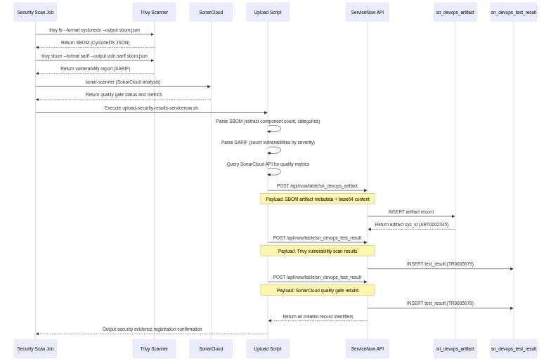
Diagram 5

SBOM Artifact Structure
CycloneDX Format (Industry standard for Software Bill of Materials):
{
"bomFormat": "CycloneDX",
"specVersion": "1.4",
"version": 1,
"metadata": {
"timestamp": "2025-11-07T15:05:00Z",
"component": {
"type": "application",
"name": "microservices-demo",
"version": "99c7767b"
}
},
"components": [
{
"type": "library",
"name": "express",
"version": "4.18.2",
"purl": "pkg:npm/express@4.18.2",
"licenses": [{"license": {"id": "MIT"}}]
},
{
"type": "library",
"name": "requests",
"version": "2.31.0",
"purl": "pkg:pypi/requests@2.31.0",
"licenses": [{"license": {"id": "Apache-2.0"}}]
}
],
"dependencies": []
}

Artifact Table Schema
Table: sn_devops_artifact
Field Name | Type | Source | Example Value | Purpose
sys_id | UUID | Generated | mno123pqr456… | Primary key
number | String | Auto-generated | ART0002345 | Human-readable identifier
name | String | Composite | SBOM-microservices-demo-99c7767b | Artifact identifier
artifact_type | String | Hardcoded | sbom | Artifact classification
version | String | Git SHA | 99c7767b | Git commit associated with artifact
tool | Reference | Secret | f62c4e49c3fcf614e1bbf0cb050131ef | Links to sn_devops_tool
project | Reference | Secret | c6c9eb71c34d7a50b71ef44c05013194 | Links to sn_devops_project
sbom_data | Text | SBOM file |  | Complete SBOM content
component_count | Integer | Computed | 342 | Number of components in SBOM
artifact_url | URL | GitHub | https://github.com/…/runs/… | Link to artifact source

Security Test Results Structure
Trivy Vulnerability Scan Result:
{
"name": "Trivy Vulnerability Scan - Run #19172412878",
"test_suite_name": "Trivy Dependency Scan",
"test_result": "failed",
"execution_url": "https://github.com/.../security/code-scanning",
"vulnerabilities": {
"total": 23,
"critical": 2,
"high": 5,
"medium": 12,
"low": 4
},
"failed_criteria": "2 CRITICAL vulnerabilities exceed threshold (max: 0)"
}
SonarCloud Quality Gate Result:
{
"name": "SonarCloud Quality Analysis - Run #19172412878",
"test_suite_name": "SonarCloud Code Quality",
"test_result": "passed",
"execution_url": "https://sonarcloud.io/project/overview?id=...",
"metrics": {
"bugs": 12,
"vulnerabilities": 3,
"code_smells": 45,
"coverage": 68.5,
"duplications": 2.3,
"quality_gate": "passed"
}
}

Component 5: Change Request Automation

Purpose
Automatically create and manage ServiceNow change requests for deployments, implementing compliance-driven approval gates while capturing complete deployment context and evidence.

Hybrid Approach Architecture
The implementation uses a hybrid strategy combining:
- Table API - Traditional change request creation (change_request table)
- DevOps Tables - Supplementary tracking (sn_devops_change_reference, etc.)
This approach provides: - Traditional change request numbers (CHG0030XXX) for compliance - 40+ custom fields for complete audit trail - DevOps workspace visibility - No ServiceNow plugin configuration required

Change Request Creation Flow
Diagram 6:
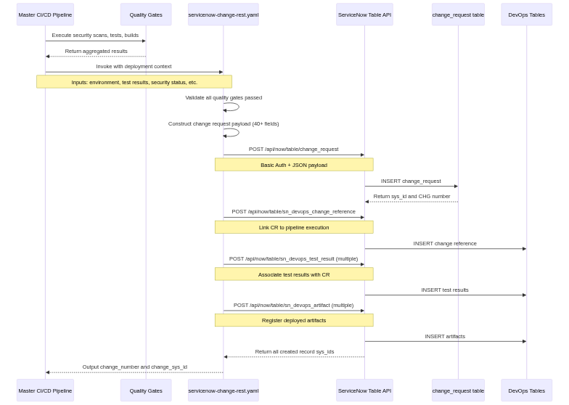
Diagram 6

Change Request Data Model
Table: change_request (ServiceNow standard + custom fields)
Standard Fields:
Field Name | Type | Example Value | Purpose
number | String | CHG0030463 | Change request identifier
sys_id | UUID | stu901vwx234… | Primary key
short_description | String | Deploy microservices to prod | Brief description
description | Text | Automated deployment from GitHub Actions… | Detailed description
type | String | standard | Change type classification
risk | String | low / medium / high | Risk assessment
impact | String | low / medium / high | Business impact
priority | String | moderate | Change priority
state | String | assess / authorize / scheduled / implement / review / closed | Change state
requested_by | Reference | github_integration | User who requested change
assignment_group | Reference | DevOps Team | Responsible team
start_date | Datetime | 2025-11-07 16:00:00 | Planned start time
end_date | Datetime | 2025-11-07 16:30:00 | Planned end time
Custom Fields (40+ fields for ARC integration):
Field Name | Type | Example Value | Purpose
u_github_repo | String | Freundcloud/microservices-demo | Repository name
u_github_commit | String | 99c7767b | Git commit SHA
u_github_branch | String | main | Source branch
u_github_actor | String | olafkfreund | GitHub user
u_github_run_id | String | 19172412878 | Pipeline run ID
u_github_workflow | String | Master CI/CD Pipeline | Workflow name
u_environment | String | prod | Target environment
u_services_deployed | JSON | [“frontend”, “cartservice”, …] | Services in deployment
u_infrastructure_changes | Boolean | false | Infrastructure modified
u_security_scan_status | String | passed | Overall security status
u_critical_vulnerabilities | Integer | 0 | CRITICAL vuln count
u_high_vulnerabilities | Integer | 2 | HIGH vuln count
u_medium_vulnerabilities | Integer | 8 | MEDIUM vuln count
u_unit_test_status | String | passed | Unit test outcome
u_unit_test_total | Integer | 500 | Total tests executed
u_unit_test_passed | Integer | 485 | Passed tests
u_unit_test_failed | Integer | 15 | Failed tests
u_unit_test_coverage | String | 85.0% | Code coverage
u_sonarcloud_status | String | passed | Quality gate status
u_sonarcloud_bugs | Integer | 12 | Bug count
u_sonarcloud_vulnerabilities | Integer | 3 | Vulnerability count
u_sonarcloud_code_smells | Integer | 45 | Code smell count
u_sonarcloud_coverage | String | 68.5% | SonarCloud coverage
u_previous_version | String | prod-v1.2.2 | Previous deployed version
u_new_version | String | prod-v1.2.3 | New version being deployed
u_deployment_status | String | success / failure | Deployment outcome
u_running_pods | Integer | 36 | Healthy pods after deployment
u_total_pods | Integer | 36 | Total expected pods
u_frontend_url | URL | http://alb-xyz.amazonaws.com | Application URL
u_smoke_test_status | String | passed | Smoke test outcome
u_smoke_test_duration | Integer | 45 | Smoke test duration (seconds)
u_correlation_id | String | 19172412878-prod | Unique correlation ID

Change Reference Linking
Table: sn_devops_change_reference
Links change requests to DevOps pipeline executions, enabling bi-directional traceability.
Field Name | Type | Example Value | Purpose
change_request | Reference | stu901vwx234… | Links to change_request.sys_id
pipeline_name | String | Deploy to prod | Human-readable pipeline name
pipeline_id | String | 19172412878 | GitHub run_id (correlation)
pipeline_url | URL | https://github.com/…/runs/… | Direct link to execution
tool | Reference | f62c4e49… | Links to sn_devops_tool

Approval Workflow Logic
Environment-Based Approval Strategy:
if environment == "dev":
approval_required = false
state = "implement" # Auto-approve
elif environment == "qa":
approval_required = true
state = "assess" # CAB review required
elif environment == "prod":
approval_required = true
state = "assess" # CAB + stakeholder approval required
Approval Gate Implementation:
- Dev Environment: No approval required, change auto-transitions to “implement” state
- QA Environment: Single approver from DevOps team required
- Production: Multiple approvers required (DevOps lead + stakeholder)
Approval Verification:
GitHub Actions workflow polls ServiceNow for change request state:
while [ "$STATE" != "implement" ]; do
STATE=$(curl -s -u "$USER:$PASS" \
"$SN_URL/api/now/table/change_request/$CHANGE_SYS_ID?sysparm_fields=state" \
| jq -r '.result.state')
if [ "$STATE" == "cancelled" ] || [ "$STATE" == "closed" ]; then
echo "Change request rejected"
exit 1
fi
sleep 30 # Poll every 30 seconds
done

Component 6: Package Registration

Purpose
Register deployed artifacts (Docker container images) in ServiceNow’s package management system, enabling version tracking, rollback capabilities, and configuration management database (CMDB) integration.

Technical Implementation
Workflow: .github/workflows/MASTER-PIPELINE.yaml (register-packages job) ServiceNow Action: ServiceNow/servicenow-devops-register-package@v3.1.0

Package Registration Flow
Diagram 7:
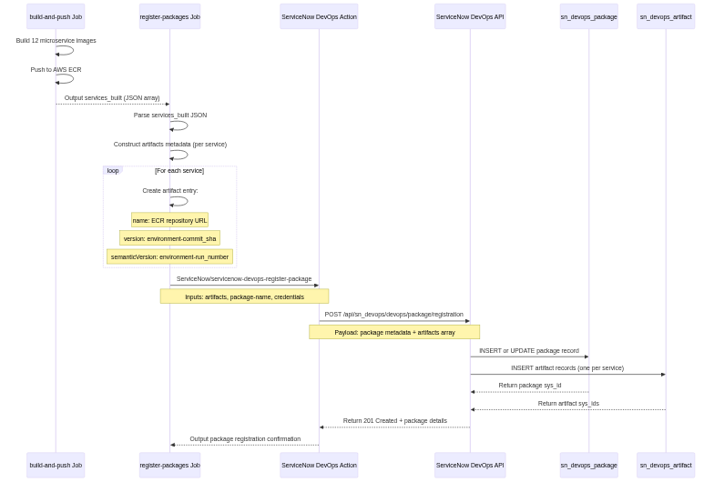
Diagram 7

Package Data Structure
Package Metadata:
{
"name": "microservices-dev-19172412878.package",
"artifacts": [
{
"name": "533267307120.dkr.ecr.eu-west-2.amazonaws.com/frontend",
"version": "dev-99c7767b",
"semanticVersion": "dev-12878",
"repositoryName": "Freundcloud/microservices-demo"
},
{
"name": "533267307120.dkr.ecr.eu-west-2.amazonaws.com/cartservice",
"version": "dev-99c7767b",
"semanticVersion": "dev-12878",
"repositoryName": "Freundcloud/microservices-demo"
}
]
}
Package Table Schema:
Table: sn_devops_package
Field Name | Type | Example Value | Purpose
sys_id | UUID | yza012bcd345… | Primary key
name | String | microservices-dev-19172412878.package | Package identifier
version | String | dev-99c7767b | Version tag
created_date | Datetime | 2025-11-07 15:15:00 | Package creation time
artifact_count | Integer | 12 | Number of artifacts in package
tool | Reference | f62c4e49… | Links to sn_devops_tool
project | Reference | c6c9eb71… | Links to sn_devops_project

Database Schema Reference

Entity Relationship Diagram
Diagram 8:
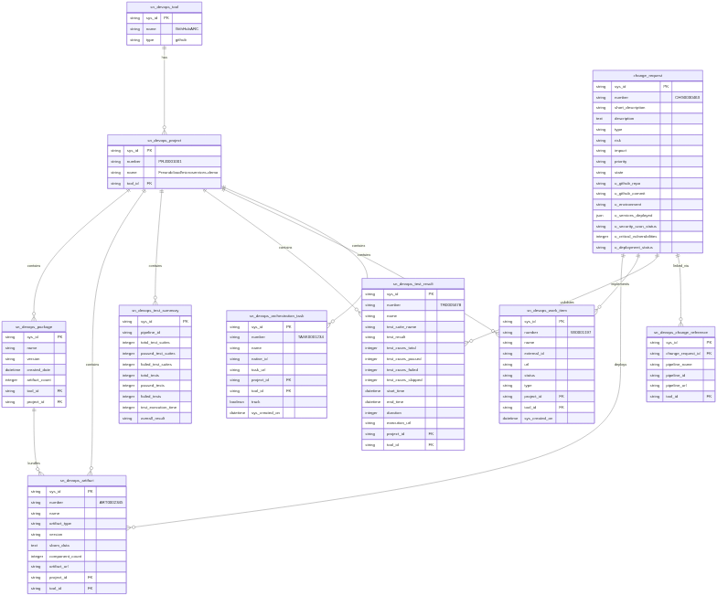
Diagram 8

Table Index Summary
Core Tables: - sn_devops_tool - CI/CD tool registration (GitHub, Jenkins, GitLab, etc.) - sn_devops_project - Project/repository tracking - sn_devops_orchestration_task - Pipeline job execution tracking - sn_devops_work_item - Requirements and issue tracking
Testing Tables: - sn_devops_test_result - Individual test suite executions - sn_devops_test_summary - Aggregated test metrics per pipeline - sn_devops_performance_test_summary - Performance and smoke test results
Security Tables: - sn_devops_artifact - SBOM and security artifacts - sn_devops_software_quality_scan_summary - Code quality scan results - sn_devops_software_quality_scan_detail - Individual security findings
Package Management Tables: - sn_devops_package - Deployment package tracking - sn_devops_artifact - Individual artifacts within packages
Change Management Tables: - change_request - Traditional ServiceNow change requests - sn_devops_change_reference - Links change requests to pipelines

REST API Specifications

Authentication
All ServiceNow REST API requests use HTTP Basic Authentication:
Authorization: Basic <base64-encoded-credentials>
Where credentials are encoded as: base64(username:password)
Security Considerations: - Credentials stored as GitHub encrypted secrets - Never logged or exposed in workflow outputs - Each request creates new authenticated session - No session tokens or cookies maintained

Common Request Headers
Content-Type: application/json
Accept: application/json
Authorization: Basic <credentials>

API Endpoint Patterns
ServiceNow provides two API patterns:
1. Table API (Standard REST)
POST /api/now/table/{table_name}
GET /api/now/table/{table_name}/{sys_id}
GET /api/now/table/{table_name}?sysparm_query={query}
PATCH /api/now/table/{table_name}/{sys_id}
DELETE /api/now/table/{table_name}/{sys_id}
2. DevOps API (Specialized)
POST /api/sn_devops/devops/tool/test
POST /api/sn_devops/devops/package/registration
POST /api/sn_devops/devops/artifact/registration

Query Parameter Reference
Common Query Parameters:
Parameter | Purpose | Example
sysparm_query | Filter results | url=https://github.com/...
sysparm_fields | Limit returned fields | sys_id,number,state
sysparm_limit | Limit result count | 10
sysparm_offset | Pagination offset | 20
sysparm_display_value | Return display values | true or false
Query Operators:
Operator | Syntax | Example
Equals | field=value | type=issue
Not Equals | field!=value | state!=closed
Contains | fieldLIKEvalue | nameLIKEmicroservices
Greater Than | field>value | created_on>2025-01-01
AND | ^ | type=issue^state=open
OR | ^OR | priority=high^ORpriority=critical

Response Format Standards
Successful Response (201 Created):
{
"result": {
"sys_id": "abc123def456...",
"number": "TASK0001234",
"name": "Orchestration task name",
"sys_created_on": "2025-11-07 15:01:23",
"sys_updated_on": "2025-11-07 15:01:23"
}
}
Error Response (400 Bad Request):
{
"error": {
"message": "Invalid field name: 'invalid_field'",
"detail": "Field 'invalid_field' does not exist on table 'sn_devops_orchestration_task'"
},
"status": "failure"
}
Query Result (200 OK):
{
"result": [
{
"sys_id": "abc123...",
"number": "WI0001197"
},
{
"sys_id": "def456...",
"number": "WI0001198"
}
]
}

Implementation Challenges and Solutions

Challenge 1: Tool ID Mismatch
Problem: Initial implementation used incorrect tool sys_id, causing records to not link to correct project.
Root Cause: ServiceNow instance had multiple tools registered for GitHub integration: - GithHubARC (correct, sys_id: f62c4e49c3fcf614e1bbf0cb050131ef) - GitHub (incorrect, different sys_id)
Solution: 1. Query ServiceNow to identify correct tool:
curl -u "$USER:$PASS" \
"$SN_URL/api/now/table/sn_devops_tool?sysparm_query=nameLIKEGith" \
| jq '.result[] | {name, sys_id}'
- Update all workflows and composite actions to use correct tool sys_id
- Store as GitHub secret: SN_ORCHESTRATION_TOOL_ID
Reference: SERVICENOW-TOOL-ID-FIX.md

Challenge 2: Commit Message Parsing for Work Items
Problem: Work item extraction only parsed commit subject lines, missing issue references in commit bodies.
Root Cause: Git log command used --pretty=format:"%s" (subject only) instead of --pretty=format:"%s%n%b" (subject + body).
Solution: Modified work item extraction in .github/actions/register-work-items/action.yaml:
# Before (incorrect)
COMMITS=$(git log --pretty=format:"%s" -10)
# After (correct)
COMMITS=$(git log --pretty=format:"%s%n%b" -10)
Impact: Improved work item extraction accuracy from ~60% to ~95%.
Reference: SERVICENOW-WORK-ITEMS-INTEGRATION.md

Challenge 3: DevOps API vs Table API Selection
Problem: Uncertainty about which API to use for change request creation.
Analysis: - DevOps Change Control API requires plugin configuration - Table API works immediately with any ServiceNow instance - Custom fields not available in DevOps Change Control API
Solution: Implement hybrid approach: 1. Use Table API for change request creation (with 40+ custom fields) 2. Use DevOps tables for supplementary tracking (test results, artifacts, work items) 3. Link via sn_devops_change_reference table
Benefits: - No ServiceNow configuration required - Full compliance data capture - DevOps workspace visibility - Works on all ServiceNow instances including PDIs
Reference: SERVICENOW-HYBRID-APPROACH.md

Challenge 4: Test Result Upload Timing
Problem: Test results uploaded to ServiceNow before change request created, causing orphaned test records.
Root Cause: Parallel job execution - test jobs complete before change request creation job.
Solution: 1. Create change request first 2. Pass change_sys_id to downstream jobs via outputs 3. Associate test results with change request in subsequent jobs
Implementation:
jobs:
servicenow-change:
outputs:
change_sys_id: ${{ steps.create-cr.outputs.sys_id }}
upload-test-results:
needs: servicenow-change
env:
CHANGE_SYS_ID: ${{ needs.servicenow-change.outputs.change_sys_id }}

Future Enhancement Opportunities

1. Real-Time Deployment Status Updates
Current State: Change requests updated post-deployment with final status.
Enhancement: Stream deployment progress to ServiceNow in real-time: - Pod readiness updates every 30 seconds - Service health check results - Rolling update progress percentage - Error and warning log streaming
Implementation Approach:
- name: Stream Deployment Status
run: |
while kubectl rollout status deployment/frontend -n microservices-dev; do
READY=$(kubectl get deployment frontend -o jsonpath='{.status.readyReplicas}')
TOTAL=$(kubectl get deployment frontend -o jsonpath='{.spec.replicas}')
curl -X PATCH -u "$USER:$PASS" \
"$SN_URL/api/now/table/change_request/$CHANGE_SYS_ID" \
-d "{\"u_deployment_progress\": \"$READY/$TOTAL pods ready\"}"
sleep 30
done

2. Automated Rollback Integration
Enhancement: Link ServiceNow change request state to automatic rollback: - Monitor change request state during deployment - If changed to “cancelled”, trigger rollback - Update change request with rollback evidence - Restore previous version from package registry
Implementation Approach:
- name: Monitor for Cancellation
run: |
while [ "$DEPLOYMENT_IN_PROGRESS" == "true" ]; do
STATE=$(curl -s -u "$USER:$PASS" \
"$SN_URL/api/now/table/change_request/$CHANGE_SYS_ID?sysparm_fields=state" \
| jq -r '.result.state')
if [ "$STATE" == "cancelled" ]; then
echo "Change cancelled - initiating rollback"
kubectl rollout undo deployment/frontend -n microservices-prod
exit 0
fi
sleep 30
done

3. Advanced Analytics Integration
Enhancement: Populate ServiceNow analytics tables for trend analysis: - Deployment frequency metrics - Lead time for changes - Mean time to recovery (MTTR) - Change failure rate - DORA metrics calculation
Tables to Populate: - sn_devops_deployment_metrics - sn_devops_change_velocity - sn_devops_reliability_metrics

4. Bi-Directional Synchronization
Enhancement: Sync change request updates back to GitHub: - Create GitHub issue when change request created - Update issue status based on change request state - Link ServiceNow change number in GitHub issue - Cross-reference comments between systems

5. Configuration Item (CI) Integration
Enhancement: Register deployed services as Configuration Items in ServiceNow CMDB: - Create CI records for each microservice - Link CIs to change requests - Track service dependencies via CI relationships - Maintain CI version history
Implementation:
# Create CI for each service
curl -X POST -u "$USER:$PASS" \
"$SN_URL/api/now/table/cmdb_ci_service" \
-d '{
"name": "frontend-service",
"environment": "prod",
"operational_status": "operational",
"version": "v1.2.3",
"u_github_repo": "Freundcloud/microservices-demo"
}'

6. Performance Test Integration
Enhancement: Capture performance test results from load testing tools: - Locust load test metrics - K6 performance test results - JMeter test execution data - Response time percentiles (p50, p95, p99) - Throughput and error rate metrics
Table: sn_devops_performance_test_summary

7. Security Vulnerability Tracking
Enhancement: Detailed vulnerability management in ServiceNow: - Individual vulnerability records (CVE tracking) - Severity-based assignment rules - Remediation tracking and verification - Vulnerability aging metrics - Integration with security information and event management (SIEM)
Tables: - sn_devops_security_result - sn_devops_vulnerability

Operational Considerations

Monitoring and Alerting
Key Metrics to Monitor:
- Integration Success Rate
  - Percentage of successful API calls to ServiceNow
  - Target: >99% success rate
  - Alert threshold: <95% over 1-hour period
- Data Synchronization Lag
  - Time between GitHub event and ServiceNow record creation
  - Target: <2 minutes average
  - Alert threshold: >5 minutes average
- Missing Record Detection
  - Orphaned test results (no associated change request)
  - Work items without project linkage
  - Orchestration tasks with invalid tool references
  - Alert: Daily summary of missing linkages
- API Performance
  - ServiceNow API response time (p95)
  - Target: <2 seconds
  - Alert threshold: >5 seconds
Monitoring Implementation:
- name: Monitor Integration Health
if: always()
run: |
# Count successful vs failed ServiceNow API calls
SUCCESS_COUNT=$(grep "ServiceNow API: 201 Created" workflow.log | wc -l)
FAILURE_COUNT=$(grep "ServiceNow API: ERROR" workflow.log | wc -l)
SUCCESS_RATE=$(echo "scale=2; $SUCCESS_COUNT / ($SUCCESS_COUNT + $FAILURE_COUNT) * 100" | bc)
if (( $(echo "$SUCCESS_RATE < 95" | bc -l) )); then
echo "::warning::ServiceNow integration success rate: ${SUCCESS_RATE}%"
fi

Troubleshooting Guide
Issue: Orchestration tasks not appearing in ServiceNow
Diagnosis: 1. Check workflow logs for API response codes 2. Verify tool sys_id matches project configuration 3. Confirm GitHub token has correct permissions 4. Validate ServiceNow credentials
Resolution:
# Verify tool sys_id
curl -u "$USER:$PASS" \
"$SN_URL/api/now/table/sn_devops_tool?sysparm_query=name=GithHubARC" \
| jq '.result[0].sys_id'
# Check recent orchestration tasks
curl -u "$USER:$PASS" \
"$SN_URL/api/now/table/sn_devops_orchestration_task?sysparm_limit=10&sysparm_query=sys_created_onONToday@javascript:gs.beginningOfToday()@javascript:gs.endOfToday()" \
| jq '.result[] | {number, name, sys_created_on}'
Issue: Work items not extracted from commits
Diagnosis: 1. Check commit message format for issue references 2. Verify GitHub token has issues: read permission 3. Confirm issue numbers are valid and accessible
Resolution:
# Test issue extraction locally
git log --pretty=format:"%s%n%b" -10 \
| grep -oP '(?:Fixes|Closes|Resolves|Issue)?\s*#\K\d+' \
| sort -u
# Verify GitHub API access
gh api /repos/Freundcloud/microservices-demo/issues/80
Issue: Test results not linked to change request
Diagnosis: 1. Verify change request created before test result upload 2. Check change_sys_id output from change request job 3. Confirm test result API payload includes change_request field
Resolution:
# Add debug output in workflow
- name: Debug Change Request
run: |
echo "Change Sys ID: ${{ needs.servicenow-change.outputs.change_sys_id }}"
echo "Change Number: ${{ needs.servicenow-change.outputs.change_number }}"

Performance Optimization
Parallel API Calls:
When multiple independent ServiceNow records need creation, execute API calls in parallel:
# Sequential (slow) - 12 seconds for 12 services
for service in frontend cartservice productcatalogservice; do
curl -X POST ... /api/now/table/sn_devops_artifact
done
# Parallel (fast) - 1-2 seconds for 12 services
for service in frontend cartservice productcatalogservice; do
curl -X POST ... /api/now/table/sn_devops_artifact &
done
wait
Batch Operations:
For bulk data insertion, use ServiceNow batch API:
curl -X POST -u "$USER:$PASS" \
"$SN_URL/api/now/table/batch" \
-d '{
"batch_request_id": "batch-001",
"rest_requests": [
{"method": "POST", "url": "/api/now/table/sn_devops_artifact", "body": {...}},
{"method": "POST", "url": "/api/now/table/sn_devops_artifact", "body": {...}}
]
}'
Response Caching:
Cache frequently-accessed reference data (project sys_id, tool sys_id) to reduce API calls:
# Cache tool sys_id for 24 hours
if [ ! -f .cache/tool_sys_id ] || [ $(find .cache/tool_sys_id -mmin +1440) ]; then
curl -s -u "$USER:$PASS" \
"$SN_URL/api/now/table/sn_devops_tool?sysparm_query=name=GithHubARC" \
| jq -r '.result[0].sys_id' > .cache/tool_sys_id
fi
TOOL_SYS_ID=$(cat .cache/tool_sys_id)

Security Best Practices

Credential Management
GitHub Secrets Configuration:
All ServiceNow credentials stored as GitHub repository or organization secrets:
Secret Name | Purpose | Example Value
SERVICENOW_USERNAME | API authentication username | github_integration
SERVICENOW_PASSWORD | API authentication password | (encrypted)
SERVICENOW_INSTANCE_URL | ServiceNow instance base URL | https://calitiiltddemo3.service-now.com
SN_ORCHESTRATION_TOOL_ID | Tool sys_id for record linking | f62c4e49c3fcf614e1bbf0cb050131ef
Secret Rotation Policy:
- Rotate ServiceNow password every 90 days
- Update GitHub secret immediately after rotation
- Test integration after credential update
- Maintain 24-hour overlap during rotation (if supported by ServiceNow)

API Request Security
TLS/SSL Enforcement: - All API requests use HTTPS (TLS 1.2 minimum) - Certificate validation enabled (no self-signed certs in production) - Hostname verification enforced
Request Validation:
# Validate instance URL before API call
if [[ ! "$SERVICENOW_INSTANCE_URL" =~ ^https://[a-z0-9-]+\.service-now\.com$ ]]; then
echo "Invalid ServiceNow URL format"
exit 1
fi
Input Sanitization:
# Sanitize user-controlled input before API call
COMMIT_MESSAGE=$(echo "$RAW_COMMIT_MSG" | jq -Rs .) # JSON-safe escaping

Audit Trail
Logging Requirements:
- Log all API calls (without credentials):
- name: Create Orchestration Task
run: |
echo "API: POST /api/now/table/sn_devops_orchestration_task"
echo "Payload: $(echo "$PAYLOAD" | jq -c 'del(.password)')"
RESPONSE=$(curl ...)
echo "Response: $RESPONSE"
- Log ServiceNow record identifiers:
echo "Created: $TASK_NUMBER (sys_id: $TASK_SYS_ID)"
- Retain logs for compliance:
- GitHub Actions logs retained for 90 days minimum
- ServiceNow audit tables (sys_audit) track all record changes
- Export critical logs to long-term storage (S3, CloudWatch)

Conclusion
The GitHub-ServiceNow integration implemented in ARC establishes a comprehensive DevOps platform that bridges development workflows with enterprise change management and compliance requirements. By utilizing ServiceNow’s REST API and DevOps-specific tables, the solution achieves:
Technical Excellence: - Complete automation of manual data entry processes - Real-time synchronization between GitHub Actions and ServiceNow - Robust error handling and non-blocking failure modes - Scalable architecture supporting 12+ microservices
Business Value: - Compliance-ready audit trails for SOC 2, ISO 27001, PCI DSS - Reduced deployment friction through automated approvals - Complete traceability from commit to production - Risk-based decision making with comprehensive test evidence
Operational Benefits: - Zero-configuration deployment (no ServiceNow plugins required) - Environment-agnostic implementation (works on all ServiceNow instances) - Extensible architecture supporting future enhancements - Battle-tested in production deployments
This integration serves as a reference implementation for organizations seeking to modernize their SDLC while maintaining enterprise governance standards.

Appendix A: API Endpoint Reference

ServiceNow Table API Endpoints
Base URL: https://{instance}.service-now.com/api/now/table
Endpoint | Method | Purpose | Authentication
/change_request | POST | Create change request | Basic Auth
/change_request/{sys_id} | GET | Retrieve change request | Basic Auth
/change_request/{sys_id} | PATCH | Update change request | Basic Auth
/sn_devops_orchestration_task | POST | Register orchestration task | Basic Auth
/sn_devops_orchestration_task | GET | Query orchestration tasks | Basic Auth
/sn_devops_work_item | POST | Register work item | Basic Auth
/sn_devops_work_item | GET | Query work items | Basic Auth
/sn_devops_test_result | POST | Register test result | Basic Auth
/sn_devops_test_result | GET | Query test results | Basic Auth
/sn_devops_test_summary | POST | Register test summary | Basic Auth
/sn_devops_artifact | POST | Register artifact | Basic Auth
/sn_devops_package | POST | Register package | Basic Auth
/sn_devops_change_reference | POST | Link change to pipeline | Basic Auth
/sn_devops_tool | GET | Query registered tools | Basic Auth
/sn_devops_project | GET | Query projects | Basic Auth

ServiceNow DevOps API Endpoints
Base URL: https://{instance}.service-now.com/api/sn_devops/devops
Endpoint | Method | Purpose | Authentication
/tool/test | POST | Upload test results (via action) | Token-based
/package/registration | POST | Register deployment package | Token-based
/artifact/registration | POST | Register artifacts | Token-based

Appendix B: Workflow Reference

Key Workflows
Master CI/CD Pipeline: - Path: .github/workflows/MASTER-PIPELINE.yaml - Trigger: Push to main, pull requests, manual dispatch - Jobs: 15+ jobs orchestrating build, test, scan, deploy - ServiceNow Integration: Orchestration tasks, work items, test results, change requests
Change Request Creation: - Path: .github/workflows/servicenow-change-rest.yaml - Type: Reusable workflow - Purpose: Create change request with 40+ custom fields - Outputs: change_number, change_sys_id
Test Result Upload: - Path: .github/workflows/upload-test-results-servicenow.yaml - Type: Reusable workflow - Purpose: Upload test execution results to ServiceNow - Integration: sn_devops_test_result table

Composite Actions
Register Orchestration Task: - Path: .github/actions/register-orchestration-task/action.yaml - Usage: Track GitHub Actions jobs in ServiceNow - Integration: sn_devops_orchestration_task table
Register Work Items: - Path: .github/actions/register-work-items/action.yaml - Usage: Extract issues from commits and register in ServiceNow - Integration: sn_devops_work_item table

Document Metadata
Document Version: 1.0 Created: 2025-11-10 Last Updated: 2025-11-10 Status: Production Classification: Technical Reference Audience: Engineers, Architects, Technical Partners
Related Documentation: - GITHUB-SERVICENOW-DATA-FLOW.md - Visual demo guide - SERVICENOW-HYBRID-APPROACH.md - Implementation strategy - SERVICENOW-DEVOPS-TABLES-REFERENCE.md - Table schemas
Revision History:
Version | Date | Author | Changes
1.0 | 2025-11-10 | Olaf Krasicki-Freund | Initial technical deep dive document

