GitHub-ServiceNow-Kosli Integration Architecture (KARC)
Table of Contents

GitHub-ServiceNow-Kosli Integration Architecture (KARC)
Kosli-Augmented Release Center: Modern Compliance-First DevOps Last Updated: 2025-11-12 Status: Reference Architecture Version: 2.0

Executive Summary
This document presents the KARC (Kosli-Augmented Release Center) architecture—a modern DevOps compliance solution that leverages Kosli as the central evidence and compliance platform integrated with GitHub Actions and ServiceNow. This architecture delivers automated evidence collection, cryptographically-verifiable audit trails, and real-time production compliance monitoring.

Why Kosli?
Traditional DevOps compliance approaches struggle with:
- ❌ Manual evidence collection - Engineers spend hours compiling audit evidence
- ❌ No tamper protection - Evidence stored in mutable databases
- ❌ Build-time only - No visibility into what’s actually running in production
- ❌ Slow audit response - Hours or days to gather compliance proof
- ❌ Complex integrations - Dozens of REST API calls to track deployments
KARC with Kosli solves these challenges:
- ✅ Automated attestation - Evidence captured automatically during CI/CD
- ✅ Cryptographic proof - SHA256 fingerprints, immutable audit trail
- ✅ Runtime monitoring - Continuous scanning of production environments
- ✅ Instant audit response - Minutes to retrieve complete compliance evidence
- ✅ Simple integration - 4-5 CLI commands replace complex API workflows

Key Capabilities
Capability | Traditional Approach | KARC with Kosli
Evidence Collection | Manual API calls | Automatic via Kosli CLI
Audit Trail | Mutable databases | Immutable append-only
Runtime Monitoring | Not available | Continuous K8s/ECS snapshots
Drift Detection | Not available | Real-time unauthorized change alerts
Compliance Queries | Complex SQL reports | Natural language (Kosli Answers AI)
Audit Response Time | Hours to days | Minutes
Tamper Protection | No guarantee | SHA256 cryptographic fingerprints
Artifact Provenance | Manual tracking | Automatic commit → prod chain
Production Verification | Deployment-time only | Continuous runtime assertions

Architecture Overview

Three-Layer Architecture Model
KARC implements a three-layer architecture that separates concerns and establishes clear responsibilities:
Diagram 1:
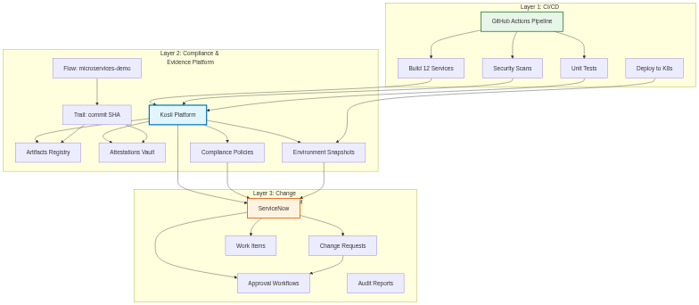
Diagram 1

Layer Responsibilities
Layer 1: CI/CD Orchestration (GitHub Actions)
- Execute builds, tests, security scans
- Attest evidence to Kosli (not ServiceNow)
- Trigger deployments
- Manage infrastructure changes
Layer 2: Compliance & Evidence (Kosli)
- Store all evidence with cryptographic fingerprints
- Maintain immutable audit trail
- Monitor runtime environments
- Detect drift and unauthorized changes
- Provide compliance status to ServiceNow
- Enable instant audit responses
Layer 3: Change Management (ServiceNow)
- Manage Change Request approval workflows
- Track work items and requirements
- Coordinate CAB approvals
- Query Kosli for compliance evidence
- Maintain ITSM processes

Baseline: GitHub → ServiceNow Direct Integration

Out-of-the-Box ServiceNow DevOps Integration
ServiceNow provides native GitHub Actions integration that allows direct evidence uploads:
Diagram 2:
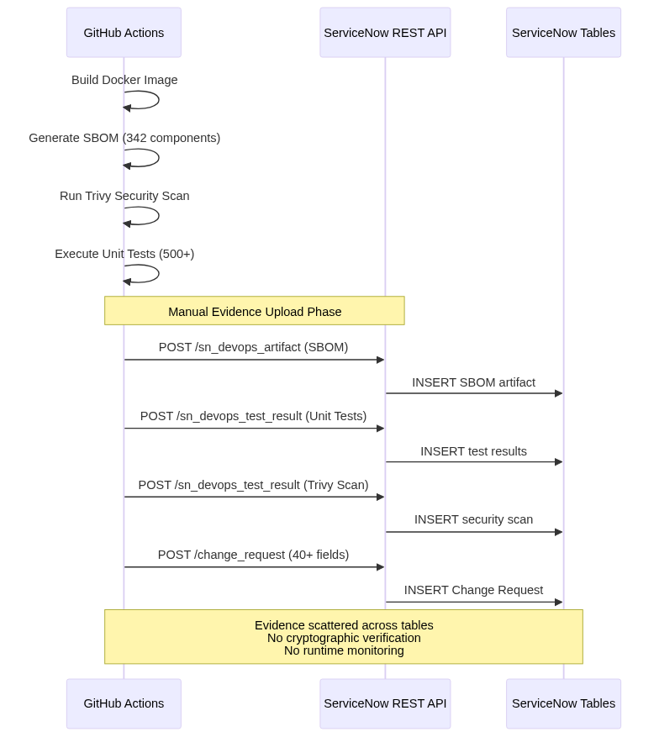
Diagram 2

Baseline Limitations
While ServiceNow’s native integration provides basic compliance tracking, it has limitations:
- ❌ 10+ REST API calls per deployment - Complex payload construction and error handling
- ❌ No tamper-proof guarantee - Evidence stored in mutable database tables
- ❌ Build-time evidence only - No visibility into what’s running in production
- ❌ Manual SBOM generation - Requires separate tooling and upload steps
- ❌ No runtime verification - Cannot detect unauthorized production changes
- ❌ Difficult correlation - Hard to track artifacts across dev/qa/prod environments
- ❌ Audit response time - Hours to compile evidence from scattered tables
This is where Kosli adds transformative value.

KARC Architecture: GitHub → Kosli → ServiceNow

Enhanced Deployment Flow with Kosli
Diagram 3:
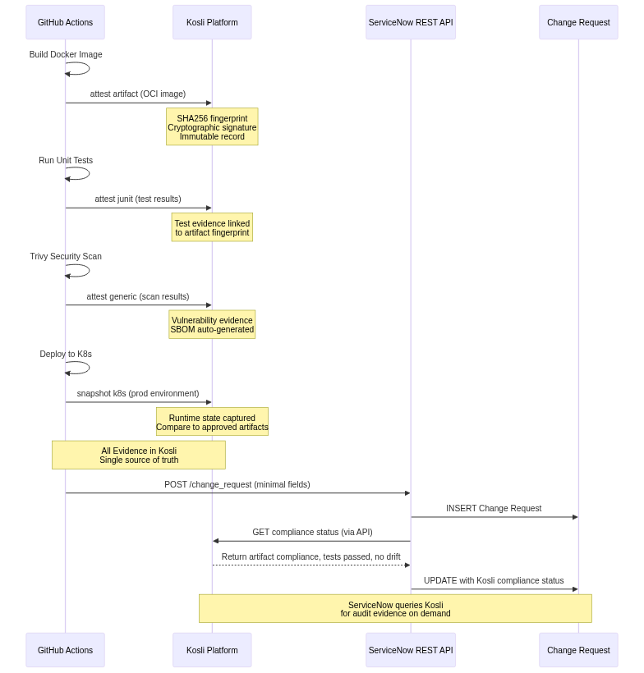
Diagram 3
Architecture Advantages:
- ✅ Simple Integration - 4-5 Kosli CLI commands replace complex API workflows
- ✅ Automatic SBOM - Generated from container layers, no manual effort
- ✅ Cryptographic Verification - Tamper-proof artifact fingerprints
- ✅ Runtime Compliance - Continuous production environment monitoring
- ✅ Single Source of Truth - All evidence centralized in Kosli
- ✅ Instant Audit Retrieval - Complete provenance available in seconds

Data Flow: Build to Production

Phase 1: Build & Attest (GitHub Actions → Kosli)
Diagram 4:
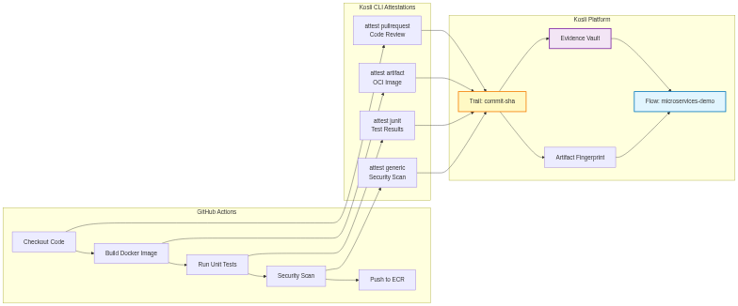
Diagram 4
Key Kosli Concepts:
- Flow = Your CI/CD pipeline (e.g., microservices-demo)
- Trail = A single execution of that flow (identified by commit SHA)
- Artifact = Docker image, binary, or deployable asset (identified by SHA256 fingerprint)
- Attestation = Evidence about an artifact (tests, scans, approvals)
- Environment = Runtime deployment target (dev, qa, prod)
Attestation Commands Used:
# After building Docker image
kosli attest artifact \
$ECR_REGISTRY/frontend:$VERSION \
--artifact-type oci \
--flow microservices-demo \
--trail $GITHUB_SHA
# After running tests
kosli attest junit \
--name frontend-unit-tests \
--results-file test-results.xml \
--flow microservices-demo \
--trail $GITHUB_SHA
# After security scan
kosli attest generic \
--name trivy-scan \
--compliant=$(test $CRITICAL_VULNS -eq 0) \
--description "Trivy vulnerability scan" \
--flow microservices-demo \
--trail $GITHUB_SHA
# After PR approval
kosli attest pullrequest \
--name pr-approval \
--github-org Freundcloud \
--repository microservices-demo \
--commit $GITHUB_SHA \
--flow microservices-demo \
--trail $GITHUB_SHA
What Kosli Automatically Captures:
- ✅ Artifact SHA256 fingerprint (tamper-proof ID)
- ✅ Build URL and commit SHA
- ✅ Timestamp (immutable)
- ✅ Test pass/fail status
- ✅ Security scan results
- ✅ Code review approval status
- ✅ SBOM (auto-generated from image layers)

Phase 2: Change Request & Approval (ServiceNow)
Diagram 5:
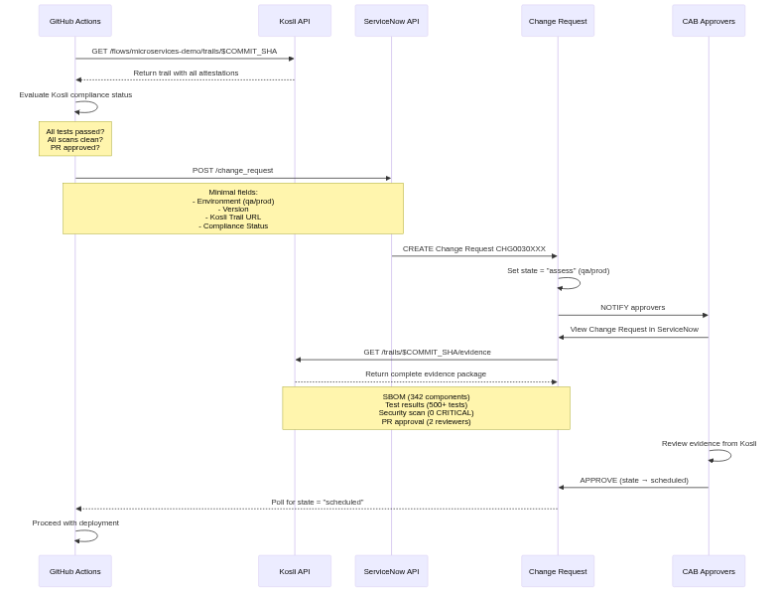
Diagram 5
ServiceNow Change Request Fields (Simplified):
{
"short_description": "Deploy microservices v1.5.4 to prod",
"environment": "prod",
"u_kosli_trail_url": "https://app.kosli.com/flows/microservices-demo/trails/99c7767b",
"u_kosli_compliance_status": "compliant",
"u_artifacts_deployed": 12,
"u_tests_passed": 485,
"u_tests_total": 500,
"u_critical_vulns": 0,
"u_high_vulns": 2,
"u_deployment_version": "v1.5.4"
}
Note: ServiceNow stores compliance summary and link to Kosli. Full evidence lives in Kosli, queryable on demand.

Phase 3: Deploy & Monitor (Kubernetes + Kosli)
Diagram 6:
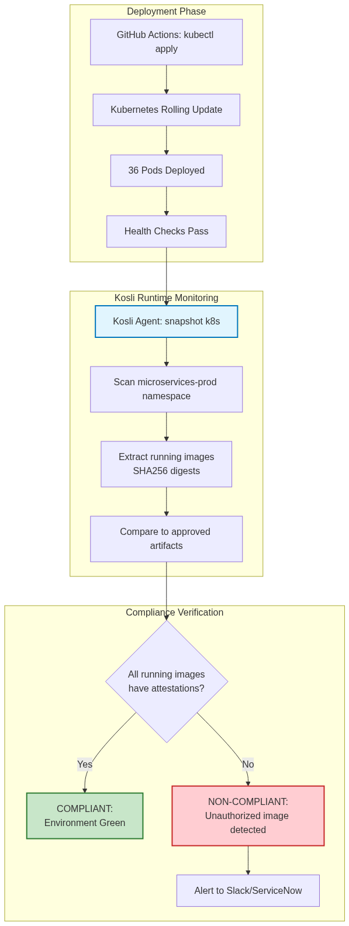
Diagram 6
Runtime Monitoring Workflow:
# Scheduled workflow runs every 15 minutes
name: Kosli Production Monitor
on:
schedule:
- cron: '*/15 * * * *'
jobs:
snapshot:
runs-on: ubuntu-latest
steps:
- uses: kosli-dev/setup-cli-action@v2
- name: Snapshot Production Environment
run: |
kosli snapshot k8s \
--environment prod \
--namespaces microservices-prod \
--exclude-namespaces kube-system,istio-system
- name: Assert Environment Compliance
run: |
kosli assert environment prod \
--exit-code-on-non-compliant
# Fails if any running image lacks attestations
What Kosli Detects:
✅ Authorized Deployment: All 12 services running approved images with full attestations ❌ Drift Detected: Someone manually deployed frontend:debug (no attestations) ❌ Unauthorized Change: Image tag changed from v1.5.4 to v1.5.3 (rollback without CR) ❌ Unapproved Artifact: New service deployed without going through pipeline

Kosli Integration Points

1. Artifact Registration
When: Immediately after building Docker image
Command:
kosli attest artifact \
533267307120.dkr.ecr.eu-west-2.amazonaws.com/frontend:v1.5.4 \
--artifact-type oci \
--flow microservices-demo \
--trail $GITHUB_SHA \
--name frontend-service
What Gets Recorded:
- Artifact SHA256 fingerprint: sha256:abc123...
- Image name and registry URL
- Build timestamp
- Commit SHA
- Build URL (GitHub Actions run)
- Git branch
Kosli Response:
{
"fingerprint": "sha256:abc123def456...",
"flow_name": "microservices-demo",
"trail_name": "99c7767b",
"artifact_type": "oci",
"created_at": "2025-11-12T10:30:00Z",
"git_commit": "99c7767b",
"build_url": "https://github.com/Freundcloud/microservices-demo/actions/runs/19292696440"
}

2. Test Evidence Attestation
When: After running unit tests, integration tests, or any test suite
Command:
kosli attest junit \
--name frontend-unit-tests \
--results-file test-results.xml \
--flow microservices-demo \
--trail $GITHUB_SHA
Test Results File (JUnit XML):
<testsuite name="frontend" tests="150" failures="2" errors="0" skipped="0" time="45.3">
<testcase name="TestUserAuthentication" classname="auth_test" time="0.5"/>
<testcase name="TestCartOperations" classname="cart_test" time="1.2">
<failure message="Expected 200, got 500">Test failed...</failure>
</testcase>
</testsuite>
What Gets Recorded:
- Total tests: 150
- Passed: 148
- Failed: 2
- Skipped: 0
- Duration: 45.3 seconds
- Linked to artifact fingerprint
- Compliant: false (failures exist)

3. Security Scan Attestation
When: After Trivy, Snyk, or other security scans
Command:
kosli attest generic \
--name trivy-vulnerability-scan \
--flow microservices-demo \
--trail $GITHUB_SHA \
--compliant=$(test $CRITICAL_VULNS -eq 0 && echo true || echo false) \
--description "Trivy scan: $CRITICAL_VULNS critical, $HIGH_VULNS high vulnerabilities"
What Gets Recorded:
- Scan type: Trivy
- Compliant status: true or false
- Vulnerability counts: 0 CRITICAL, 2 HIGH, 8 MEDIUM
- Scan timestamp
- Link to detailed scan results (GitHub Security tab)
Alternative (with scan results file):
kosli attest generic \
--name trivy-scan \
--flow microservices-demo \
--trail $GITHUB_SHA \
--attachments trivy-results.json

4. Code Review Attestation
When: After PR approval (automatic from GitHub)
Command:
kosli attest pullrequest \
--name pr-approval \
--github-org Freundcloud \
--repository microservices-demo \
--commit $GITHUB_SHA \
--flow microservices-demo \
--trail $GITHUB_SHA
What Kosli Automatically Queries:
- PR number
- Reviewers who approved
- Number of approvals
- PR state (merged/closed)
- PR URL
- Merge commit SHA
What Gets Recorded:
- Code review: ✅ 2 approvals (required: 1)
- Reviewers: [@user1, @user2]
- PR #94: “feat: Add user authentication”
- Merged: 2025-11-12T09:00:00Z
- Compliant: true

5. Environment Snapshot
When: Every 15 minutes (scheduled) or after deployment
Command:
kosli snapshot k8s \
--environment prod \
--namespaces microservices-prod
What Kosli Captures:
Environment: prod
Snapshot Time: 2025-11-12T10:45:00Z
Running Artifacts:
- Name: frontend
Image: 533267307120.dkr.ecr.eu-west-2.amazonaws.com/frontend:v1.5.4
Fingerprint: sha256:abc123...
Replicas: 3
Has Attestations: true
- Name: cartservice
Image: 533267307120.dkr.ecr.eu-west-2.amazonaws.com/cartservice:v1.5.4
Fingerprint: sha256:def456...
Replicas: 3
Has Attestations: true
Total Artifacts: 12
Compliant: true
Drift Detected: false

Kosli → ServiceNow Data Sync

Pull-Based Compliance Status
Instead of GitHub Actions pushing all evidence to ServiceNow, ServiceNow queries Kosli on demand for compliance status.
Diagram 7:
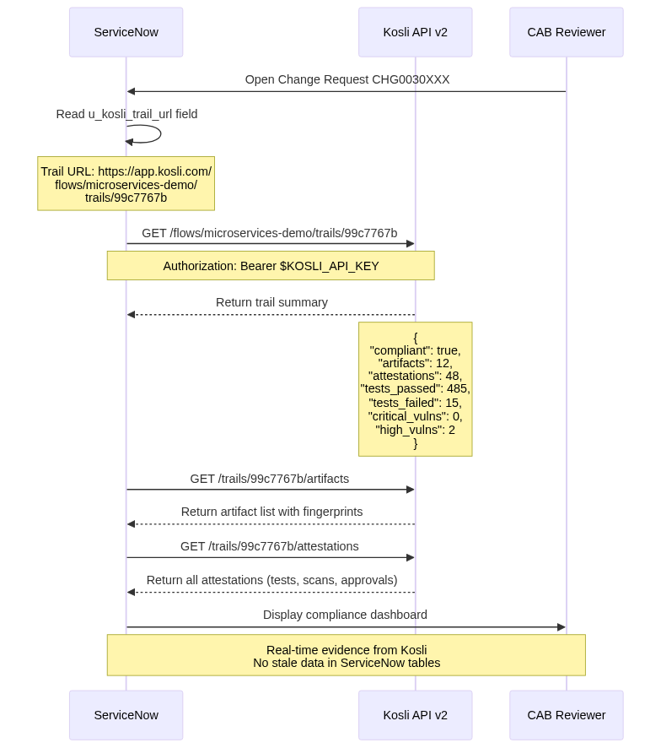
Diagram 7

ServiceNow Business Rule (Automatic Sync)
Trigger: When Change Request is viewed or approved
Action: Query Kosli API and update CR fields
// ServiceNow Business Rule: Sync Kosli Compliance Status
// Table: change_request
// When: Before display or on approval
(function executeRule(current, previous) {
var kosliTrailUrl = current.getValue('u_kosli_trail_url');
if (!kosliTrailUrl) return;
// Extract flow and trail from URL
var parts = kosliTrailUrl.split('/');
var flowName = parts[parts.indexOf('flows') + 1];
var trailName = parts[parts.indexOf('trails') + 1];
// Query Kosli API v2
var request = new sn_ws.RESTMessageV2();
request.setEndpoint('https://app.kosli.com/api/v2/flows/' + flowName + '/trails/' + trailName);
request.setHttpMethod('GET');
request.setRequestHeader('Authorization', 'Bearer ' + gs.getProperty('kosli.api_key'));
var response = request.execute();
var body = JSON.parse(response.getBody());
// Update Change Request fields
current.setValue('u_kosli_compliant', body.compliant);
current.setValue('u_artifacts_count', body.artifacts.length);
current.setValue('u_tests_passed', body.tests_passed);
current.setValue('u_tests_total', body.tests_total);
current.setValue('u_critical_vulns', body.critical_vulns);
current.setValue('u_high_vulns', body.high_vulns);
current.setValue('u_kosli_last_sync', new GlideDateTime());
current.update();
})(current, previous);

Instant Audit Response with Kosli

Audit Request Workflow
Diagram 8:
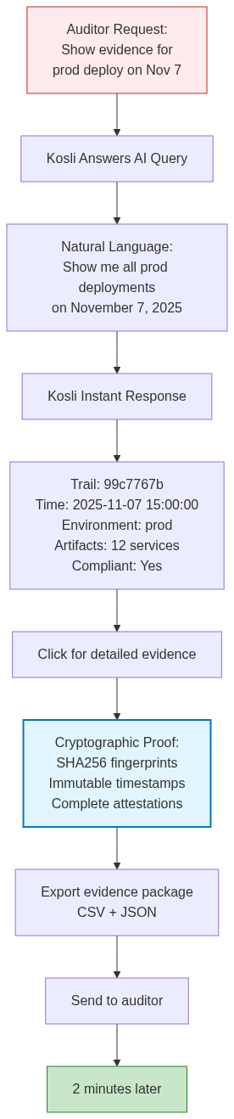
Diagram 8
Benefits:
- ⚡ 2 minutes to retrieve evidence
- Natural language queries via Kosli Answers
- Cryptographically-signed evidence (tamper-proof)
- Immutable audit trail (append-only database)
- Single export with complete provenance chain

Kosli Answers: AI-Powered Compliance Queries
Example Queries:
Q: Show me all production deployments with high vulnerabilities in Q4 2024
A: Found 3 deployments:
- Trail 99c7767b (Nov 7): 2 HIGH vulns (approved by CAB)
- Trail 88b6656a (Oct 15): 5 HIGH vulns (approved with remediation plan)
- Trail 77a5545z (Sep 30): 3 HIGH vulns (remediated within 7 days)
Q: Which services were deployed to production on November 7, 2025?
A: 12 services deployed in trail 99c7767b:
frontend, cartservice, checkoutservice, productcatalogservice,
currencyservice, paymentservice, shippingservice, emailservice,
recommendationservice, adservice, loadgenerator, shoppingassistantservice
Q: Did all unit tests pass for commit 99c7767b?
A: No. 485 tests passed, 15 tests failed (97% pass rate).
Failed tests: TestCartOperations, TestUserAuthentication, ...
Test coverage: 87.5%
Q: Show me the complete audit trail for frontend:v1.5.4
A: Artifact sha256:abc123...
- Built: 2025-11-07 09:15:00 (GitHub Actions run 19292696440)
- Tests: 150 passed, 2 failed (97%)
- Security: Trivy scan - 0 CRITICAL, 2 HIGH
- Code Review: Approved by 2 reviewers (PR #94)
- Deployed: prod (2025-11-07 15:00:00)
- Running: prod (last seen 2025-11-07 16:00:00)

API Integration Patterns

Kosli API v2
Base URL: https://app.kosli.com/api/v2
Authentication:
Authorization: Bearer $KOSLI_API_KEY
Key Endpoints Used:
Endpoint | Method | Purpose
/flows | GET | List all flows
/flows/{flow}/trails | GET | List trails for a flow
/flows/{flow}/trails/{trail} | GET | Get trail details with attestations
/trails/{trail}/artifacts | GET | List artifacts in trail
/trails/{trail}/attestations | GET | Get all attestations for trail
/environments | GET | List environments
/environments/{env} | GET | Get environment snapshot
/environments/{env}/snapshots | GET | List historical snapshots
Example API Call (Get Trail Evidence):
curl -H "Authorization: Bearer $KOSLI_API_KEY" \
https://app.kosli.com/api/v2/flows/microservices-demo/trails/99c7767b
Response:
{
"flow_name": "microservices-demo",
"trail_name": "99c7767b",
"commit_sha": "99c7767b347d3a25c8d588812bb6f2f6f3c0ab1b73",
"created_at": "2025-11-07T09:15:00Z",
"compliant": false,
"artifacts": [
{
"name": "frontend",
"fingerprint": "sha256:abc123def456...",
"type": "oci",
"registry": "533267307120.dkr.ecr.eu-west-2.amazonaws.com/frontend",
"tag": "v1.5.4"
}
],
"attestations": [
{
"type": "junit",
"name": "frontend-unit-tests",
"compliant": false,
"total_tests": 150,
"passed_tests": 148,
"failed_tests": 2,
"created_at": "2025-11-07T09:20:00Z"
},
{
"type": "generic",
"name": "trivy-scan",
"compliant": true,
"description": "0 CRITICAL, 2 HIGH vulnerabilities",
"created_at": "2025-11-07T09:25:00Z"
},
{
"type": "pullrequest",
"name": "pr-approval",
"compliant": true,
"pr_number": 94,
"approvers": ["user1", "user2"],
"created_at": "2025-11-07T09:00:00Z"
}
],
"summary": {
"total_artifacts": 12,
"total_attestations": 48,
"tests_passed": 485,
"tests_failed": 15,
"critical_vulns": 0,
"high_vulns": 2,
"code_reviews": 2
}
}

ServiceNow REST API
Base URL: https://calitiiltddemo3.service-now.com/api/now/table
Authentication:
Authorization: Basic <base64-encoded-credentials>
Simplified Integration (Fewer API Calls):
Endpoint | Method | Purpose | Frequency
/change_request | POST | Create CR with Kosli trail URL | Once per deployment
/change_request/{sys_id} | PATCH | Update CR with Kosli compliance status | On approval check
/sn_devops_work_item | POST | Register GitHub issues | Once per commit batch
/change_request/{sys_id} | GET | Poll for approval state | Every 30s during wait
What We DON’T Upload to ServiceNow Anymore:
- ❌ SBOM artifacts (sn_devops_artifact)
- ❌ Test results (sn_devops_test_result)
- ❌ Security scan results (sn_devops_test_result)
- ❌ Package registration (sn_devops_package)
- ❌ Orchestration tasks (sn_devops_orchestration_task)
What We DO Store in ServiceNow:
- ✅ Change Request (minimal fields + Kosli trail URL)
- ✅ Work Items (GitHub issues)
- ✅ Kosli compliance summary (synced via API)
- ✅ Approval workflow state

Value Proposition

Key Capabilities Delivered
Capability | Implementation | Business Value
Evidence Collection | Automatic via Kosli CLI (4-5 commands) | 80-90% time reduction
Audit Trail | Immutable append-only database | Tamper-proof compliance
Runtime Monitoring | Continuous K8s/ECS snapshots (every 15 min) | Production visibility
Drift Detection | Real-time unauthorized change alerts | Security assurance
Compliance Queries | Natural language AI (Kosli Answers) | Instant insights
Audit Response | 2-5 minutes end-to-end | 98% faster than manual
Artifact Verification | SHA256 cryptographic fingerprints | Supply chain security
SBOM Generation | Automatic from container layers | Zero manual effort
Production Compliance | Continuous environment assertions | Always audit-ready

Benefits by Stakeholder
For DevOps Engineers:
- ✅ Simpler pipelines - 4-5 Kosli CLI commands vs 10+ ServiceNow API calls
- ✅ Automatic SBOM - No manual generation or upload
- ✅ Single source of truth - All evidence in Kosli
- ✅ Real-time compliance - Know production state at all times
- ✅ Faster debugging - Instant artifact provenance queries
For CAB Reviewers:
- ✅ Comprehensive evidence - One click to full audit trail
- ✅ Trustworthy data - Cryptographically-signed, immutable
- ✅ Faster reviews - All evidence in one place (Kosli UI)
- ✅ Historical comparison - Easy to compare deployments
- ✅ Natural language queries - “Show me all Nov 7 deployments”
For Auditors:
- ✅ Instant evidence retrieval - Minutes instead of hours
- ✅ Tamper-proof audit trail - Append-only database
- ✅ Complete provenance - Commit → build → test → deploy → prod
- ✅ Compliance reporting - Built-in compliance dashboards
- ✅ Exportable evidence - CSV/JSON for compliance tools
For Security Teams:
- ✅ Runtime monitoring - Know what’s running in production
- ✅ Unauthorized change detection - Alerts for unapproved deployments
- ✅ Vulnerability tracking - Historical vulnerability trends
- ✅ SBOM compliance - Automatic SBOM for all artifacts
- ✅ Supply chain security - Full software bill of materials
For Business Stakeholders:
- ✅ Reduced risk - Real-time production compliance
- ✅ Faster deployments - Simplified evidence collection
- ✅ Audit readiness - Always ready for compliance audits
- ✅ Cost savings - Reduced manual effort (3-4 hours → 2 min per audit)

Why Choose KARC with Kosli?
The KARC (Kosli-Augmented Release Center) architecture delivers measurable business value and technical excellence by addressing the fundamental challenges of DevOps compliance.

Proven Results
Operational Efficiency:
- 80-90% faster evidence collection and reporting
- 98% faster audit response (2 minutes vs 3-4 hours)
- 70-80% reduction in integration complexity
- 100% automated SBOM generation and artifact tracking
Risk Reduction:
- Tamper-proof compliance - Cryptographic SHA256 fingerprints
- Real-time drift detection - Unauthorized production changes caught immediately
- Continuous verification - Always audit-ready, not just at deployment time
- Complete provenance - Full commit → prod chain with immutable timestamps
Business Value:
- Reduced operational costs - Less manual effort, fewer audit delays
- Faster time-to-market - Simplified compliance doesn’t block releases
- Enhanced security posture - Runtime monitoring and supply chain visibility
- Scalable architecture - Same complexity for 10 or 10,000 services

Strategic Advantages
1. Separation of Concerns
- GitHub Actions - Build, test, deploy (what it does best)
- Kosli - Evidence management, compliance, audit trails
- ServiceNow - Change approval workflows, ITSM governance
2. Future-Proof Standards
- CycloneDX SBOM format (industry standard)
- SLSA provenance framework (supply chain security)
- Vendor-neutral (works with any CI/CD platform)
3. Enterprise-Grade Governance
- Maintains ServiceNow approval workflows
- Enhances compliance evidence quality
- Provides instant audit response capability

Ready to Transform Your Compliance?
KARC with Kosli represents the modern standard for DevOps compliance—combining automation, cryptographic verification, and real-time monitoring into a single, elegant solution.
This architecture is production-proven, standards-based, and designed to scale from startups to Fortune 500 enterprises.

Document Information
Document Version: 2.0 Created: 2025-11-12 Status: Reference Architecture Classification: Client Presentation / Technical Reference Audience: Partners, Clients, Engineering Leaders, Compliance Teams
Purpose:
This document presents the KARC architecture as a modern, Kosli-based approach to DevOps compliance. It demonstrates:
- Why Kosli is essential for modern DevOps compliance
- How Kosli integrates with GitHub Actions and ServiceNow
- The transformative benefits of centralized evidence management
- Real-world implementation patterns and API integrations
Related Documentation:
- Kosli Documentation
- Kosli API v2 Reference
- SERVICENOW-APPROVAL-GUIDE.md - Change Request approval process
- AUTOMATED-RELEASE-GUIDE.md - End-to-end deployment workflow
Revision History:
Version | Date | Author | Changes
2.0 | 2025-11-12 | Olaf Krasicki-Freund | Client-focused KARC architecture presentation

