**Breslow Depth**

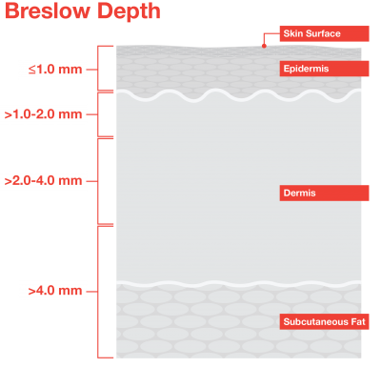

The Breslow Depth is a helpful measure of how far melanoma has invaded the body. Knowing the depth of melanoma is helpful because it is important when considering future treatment.

The Breslow Depth has been replaced by the American Joint Committee on Cancer (AJCC) staging system. The AJCC system assigns a stage based on tumor, node, metastasis (TMN) scores and other prognostic factors. The goal is that melanomas of the same stage will have similar characteristics, treatment options, and outcomes. Learn more about melanoma staging [here](https://www.curemelanoma.org/about-melanoma/melanoma-staging/understanding-melanoma-staging/).

To determine the Breslow Depth, the thickness of your melanoma is measured with a micrometer—essentially a small ruler.

**Clark Level**

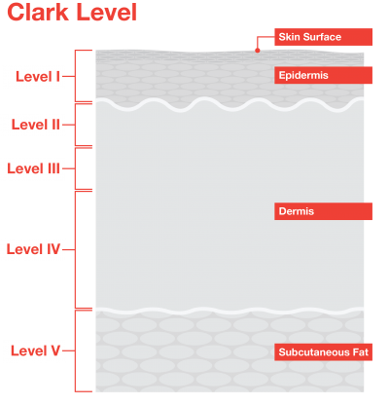

The Clark Level is a staging system that describes the depth of melanoma as it grows in the skin. Your doctor may give you a level for your melanoma in addition to or in place of a stage. **These designations are not interchangeable.**

**The Clark Scale has five levels:**

* **Level 1:** Melanoma is confined to the epidermis (the outer layer of the skin).
* **Level 2:** Melanoma has invaded the papillary dermis (the outermost layer of the dermis, the next layer of skin).
* **Level 3:** Melanoma has invaded throughout the papillary dermis and is touching on the next, deeper layer of the dermis.
* **Level 4:** Melanoma has invaded this next deeper layer, the reticular dermis.
* **Level 5:** Melanoma has now invaded the fat under the dermis.

The current staging system adopted by the American Joint Committee on Cancer (AJCC) no longer considers the Clark Level. This is because the Clark level has been found to be less prognostic and more subjective than other alternatives. The AJCC system assigns a stage based on tumor, node, metastasis (TNM). The goal is that melanomas of the same stage will have similar characteristics, treatment options, and outcomes. Learn more about melanoma staging [here](https://www.curemelanoma.org/about-melanoma/melanoma-staging/understanding-melanoma-staging/).