


EPHI National Genomics Data Engineering Collaborative Research Project.

Database Design:

Prepared By:
Mihret Kitaw
Frew Legese

January, 2026

Addis Ababa, Ethiopia.

Overview
This project proposal is to build a full-fledged genomic data management and visualization platform with Django that supports the complete lifecycle of genomic research data, from sample submission to result delivery. The system will be designed to serve students (MSc and PhD), researchers, laboratories, and external data providers who submit biological samples along with structured metadata through a secure web portal. Once a project is registered, the metadata is stored in a relational database while the physical sample is submitted to a sequencing facility. During the sequencing phase, the project status is tracked within the system to reflect its real-world progress. After sequencing is completed, the resulting genomic files (such as FASTA, BAM, or VCF) are uploaded into the platform by lab tech from EPHI, automatically indexed, and linked back to the original sample metadata without storing raw sequences in the database. Django, which is a Python web framework acts as the central orchestration layer, managing authentication, authorization, metadata persistence, file registration, and API access, while large genomic files are efficiently served from file storage using indexed, region-based access. Users can browse projects and samples through a hierarchical interface, visualize genomic regions directly in the browser using an embedded genome viewer, and explore analytical dashboards that show where data is stored, how it is distributed across projects, and how resources are being utilized. Once sequencing results are released, the system updates the project status to “result released” and automatically notifies the submitting user via email, providing a transparent, traceable, and scalable workflow that integrates laboratory operations, data engineering, and user-facing genomic visualization into a single cohesive platform.

Architecture

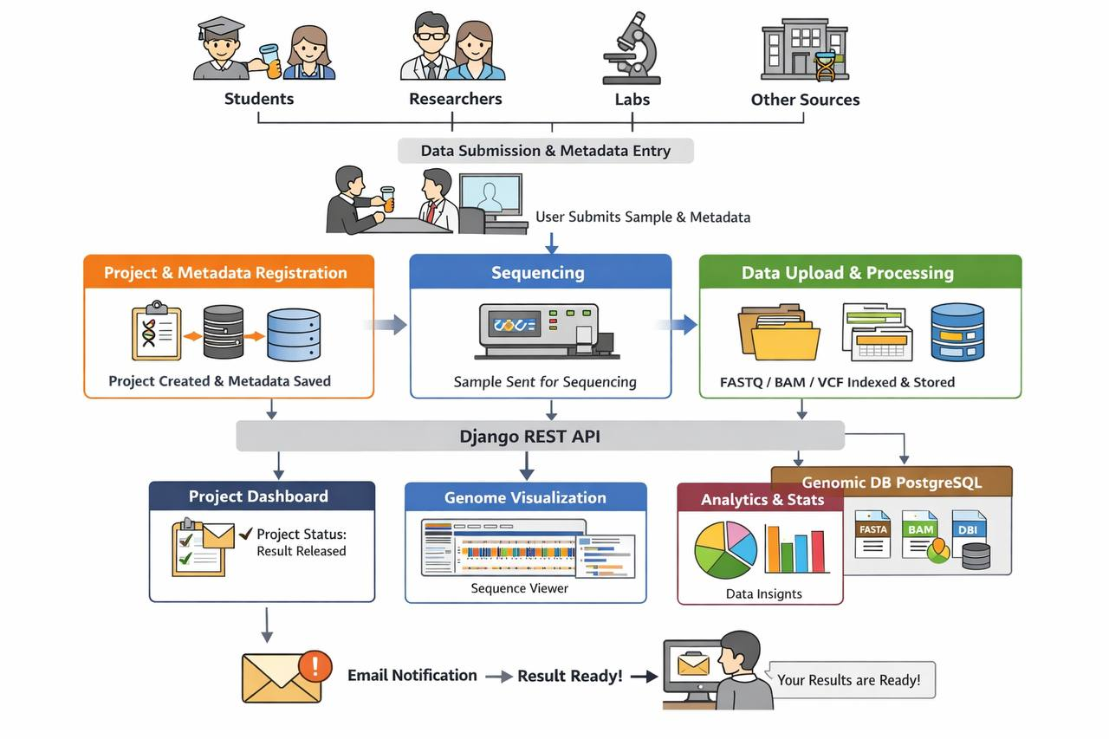
Architecture of the system

Database design

Metadata_table:
All the attributes collected and merged from the metadata template:

Project_submission_id sample_local_id parasite_density life_stage propagation drug_exposure_history serotype_or_lineage viral_load ct_value propagation project_sample_id facility_lab_id referring_lab organism strain isolate serotype collection_date received_date sample_type isolation_source country region district facility_name geo_loc_name latitude longitude host host_age host_age_unit host_sex host_disease clinical_outcome phenotype_Remarks virulence_phenotype biochemical_profile storage_temperature transport_medium sequencing_method sequencing_platform assembly_method data_entered_by entry_date review_status Remarks

All Tables

# | Table Name | Description and Purpose
1 | submission_metadata | Central table capturing all metadata records and linking to related entities
2 | project | Defines the scope and ownership of each submission project
3 | users | Tracks submitters, reviewers, and analysts
4 | facility | Physical facility where samples are processed
5 | organization | Institution responsible for the submission
6 | lab_facility | Laboratory providing or referring samples
7 | country | Country of sample origin or submission
8 | region | Region within the country
9 | district | District within the region
10 | metadata_type | Type of metadata (e.g., clinical, sequencing, environmental)
11 | organism | Biological organism under study
12 | sample_type | Type of biological sample (e.g., blood, tissue, swab)

1. metadata_submission
This is the main table where all the metadata and the project overview data is stored

Column Name | Data Type | Remarks
submission_id | SERIAL PK | Unique identifier
project_id | INT FK | project(project_id)
user_id | INT FK | users(user_id)
facility_lab_id | INT FK | lab_facility(lab_id)
referring_lab | INT FK | lab_facility(lab_id)
organism_id | INT FK | organism(organism_id)
sample_type_id | INT FK | sample_type(sample_type_id)
location_id | INT FK | location(location_id)
host_id | INT FK | host_metadata(host_id)
sequencing_id | INT FK | sequencing_metadata(sequencing_id)
phenotype_id | INT FK | phenotype_metadata(phenotype_id)
entry_date | TIMESTAMP | Default CURRENT_TIMESTAMP
data_entered_by | INT FK | users(user_id)
review_status | VARCHAR(50) | Pending / Approved / Rejected
Remarks | TEXT | Free‑form Remarks

2. Project
The project which all the details overview of metadata overview is captured
Column Name | Data Type | Remarks
project_id | SERIAL PK | Unique project
title | VARCHAR(255) | Project title
description | TEXT | Description
submission_date | DATE | confirmed date
created_date | DATE | Start date of form submission
updated_at | DATE | End date
submitted_by_id | INT FK | users(user_id)
status | INT FK | project_status(id)
attachment | VARCHAR | file
mou | VARCHAR | file
Organization | VARCHAR | Name of the org investigates the project
duration | VARCHAR | Number of time the project lasts
approved_by | INT FK | users(user_id)
metadata_type | INT FK | metadata_type(id)
IRB_CODE | VARCHAR | Url or the code
approved_at | DATE | Submission confirmed date by officials of EPHI-GEN
sample_submitted_at | DATE | Sample Submission date

3. Users
The user who uses the system to register and approve or operate on the data.
Column Name | Data Type | Remarks
user_id | SERIAL PK | Unique user
name | VARCHAR(150) | Full name
email | VARCHAR(255) | Unique email
role | VARCHAR(100) | Submitter / Reviewer
affiliation | VARCHAR(255) | Organization
username | VARCHAR(100)
password | VARCHAR(255)
created_at | TIMESTAMP | Default CURRENT_TIMESTAMP

4. Lab_facility
The lab facility data which is a part of metadata
Column Name | Data Type | Remarks
lab_id | SERIAL PK | Unique lab
lab_name | VARCHAR(255) | Lab name
address | VARCHAR(255) | Address
contact_person | VARCHAR(150) | Contact

5. Location
The
Column Name | Data Type | Remarks
location_id | SERIAL PK | Unique location
country | VARCHAR(150) | Country
region | VARCHAR(150) | Region
district | VARCHAR(150) | District
facility_name | VARCHAR(255) | Facility name
geo_loc_name | VARCHAR(255) | Geographic name
latitude | DECIMAL(9,6) | Latitude
longitude | DECIMAL(9,6) | Longitude

6. organism
Column Name | Data Type | Remarks
organism_id | SERIAL PK | Unique organism
organism_name | VARCHAR(150) | Name
strain | VARCHAR(150) | Strain
isolate | VARCHAR(150) | Isolate
serotype | VARCHAR(150) | Serotype

7. sample_type
Column Name | Data Type | Remarks
sample_type_id | SERIAL PK | Unique sample type
sample_type_name | VARCHAR(150) | Blood, tissue, swab, etc.
isolation_source | VARCHAR(150) | Source of isolation

8. host_metadata
Column Name | Data Type | Remarks
host_id | SERIAL PK | Unique host record
host | VARCHAR(150) | Host species
host_age | INT | Age
host_age_unit | VARCHAR(50) | Years, months
host_sex | VARCHAR(20) | Male / Female
host_disease | VARCHAR(255) | Disease
clinical_outcome | VARCHAR(255) | Outcome

9. phenotype_metadata
Column Name | Data Type | Remarks
phenotype_id | SERIAL PK | Unique phenotype record
phenotype_Remarks | TEXT | Remarks
virulence_phenotype | VARCHAR(255) | Virulence
biochemical_profile | TEXT | Biochemical profile

10. sequencing_metadata
Column Name | Data Type | Remarks
sequencing_id | SERIAL PK | Unique sequencing record
sequencing_method | VARCHAR(150) | Method
sequencing_platform | VARCHAR(150) | Platform
assembly_method | VARCHAR(150) | Assembly method
storage_temperature | VARCHAR(50) | Storage temp
transport_medium | VARCHAR(100) | Transport medium

11. Project_status

Column Name | Data Type | Remarks
id | SERIAL PK | Unique identifier of record
name | TEXT | Name
description | VARCHAR(255) | Description
created_at | DATE | Date

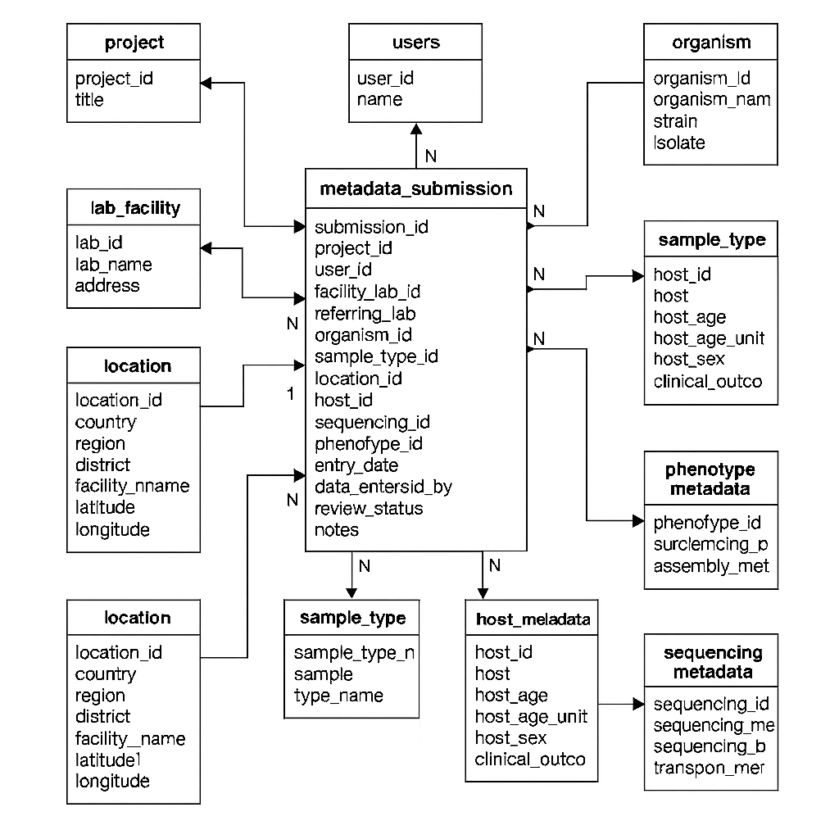

Forms:
The relationship between the forms across the metadata types when rendered after the metadata types are selected:

2. Bacteria metadata form
When bacteria is selected from a metadata registration form, the following attributes are rendered included to those of metadata attributes and removed from the other metadata form.
Column Name | Data Type | Remarks
submission_id | INT PK/FK | submission_metadata(submission_id)
serotype | VARCHAR(150) | Present only in bacteria
strain | VARCHAR(150) | Optional/or removed from the form
isolate | VARCHAR(150) | Optional or removed from the form

3. Virus metadata form
Column Name | Data Type | Remarks
submission_id | INT PK/FK | submission_metadata(submission_id)
life_stage | VARCHAR(100) | Present in virus
parasite_density | FLOAT | Present in virus
drug_exposure_history | TEXT | Present in virus
serotype | VARCHAR(150) | Optional/or removed from the form
viral_load | FLOAT | Optional/or removed from the form
ct_value | FLOAT | Optional/or removed from the form

4. Parasite metadata form
Column Name | Data Type | Remarks
submission_id | INT PK/FK | submission_metadata(submission_id)
serotype_or_lineage | VARCHAR(150) | Present in parasite
viral_load | FLOAT | Present in parasite
ct_value | FLOAT | Present in parasite
propagation | VARCHAR(100) | Present in parasite
life_stage | VARCHAR(100) | Optional/ or removed from the form
parasite_density | FLOAT | Optional/or will be removed from the form

The metadata form fields dynamics
When the user selects the organism type (bacteria, virus, parasite) from the project overview form, the system shall determine which fields are shown and validated.
The central submission table links to specialized sub-tables (bacteria_metadata, virus_metadata, parasite_metadata) that enforce these rules.

Form Fields | Bacteria | Virus | Parasite
parasite_density | Not applicable | Required | Required
life_stage | Not applicable | Required | Optional
propagation | Not applicable | Not applicable | Required
drug_exposure_history | Not applicable | Required | Not applicable
serotype_or_lineage | Not applicable | Not applicable | Required
serotype | Required | Optional | Optional
strain | Optional | Optional | Not applicable
isolate | Optional | Optional | Optional
viral_load | Not applicable | Optional | Required
ct_value | Not applicable | Optional | Required
phenotype_notes | Optional | Optional | Not applicable

Metadata Submission Workflow
Here are the steps of metadata submission starting from the beginning of user account registration.

1. User or the metadata submitter Login/Register
- User authenticates into the system/ Create user account or login if he has one.
- Credentials checked against the users table.
- Session established.

2. The Project Overview Form
There shall be a “Submit a sample” button on a user dashboard to submit a metadata of the sample which is where the user starts to submit metadata, track the progress, communicate with the officer, and receive the result.
- After the user login and clicks a "Submit a sample” button, the project overview form is rendered.
- User either:
Selects an existing project (from project table if he has a draft), or
Creates a new project (new record in project table).
- At this stage, the metadata type (bacteria, virus, parasite) is chosen.
- This choice determines which specialized metadata form will be rendered next.

3. Metadata Form Rendering
- Based on metadata type, the system dynamically shows the correct fields.
- The form is linked to metadata_submission and the appropriate sub‑table.

4. Iterative Metadata Registration
The form shall be active until the submitter confirms he has finished inserting all the metadata to the project.
- Users can register multiple metadata records under the same project.
- Each record is stored in metadata_submission with a foreign key to the project.
- Specialized attributes are saved in the corresponding sub‑table.
- This continues until the user finishes all metadata entries associated with the project overview.

5. Confirmation & Save
Once the user confirms completion:
- All metadata records are committed to the database.
- The project status is updated to “Pending” from the “Draft” phase in the project table.
- This indicates the project is awaiting review/approval.

6. Review Workflow
- Reviewers log in and see projects marked as Pending.
- They can validate metadata entries, update review_status in metadata_submission, and approve/reject the project.

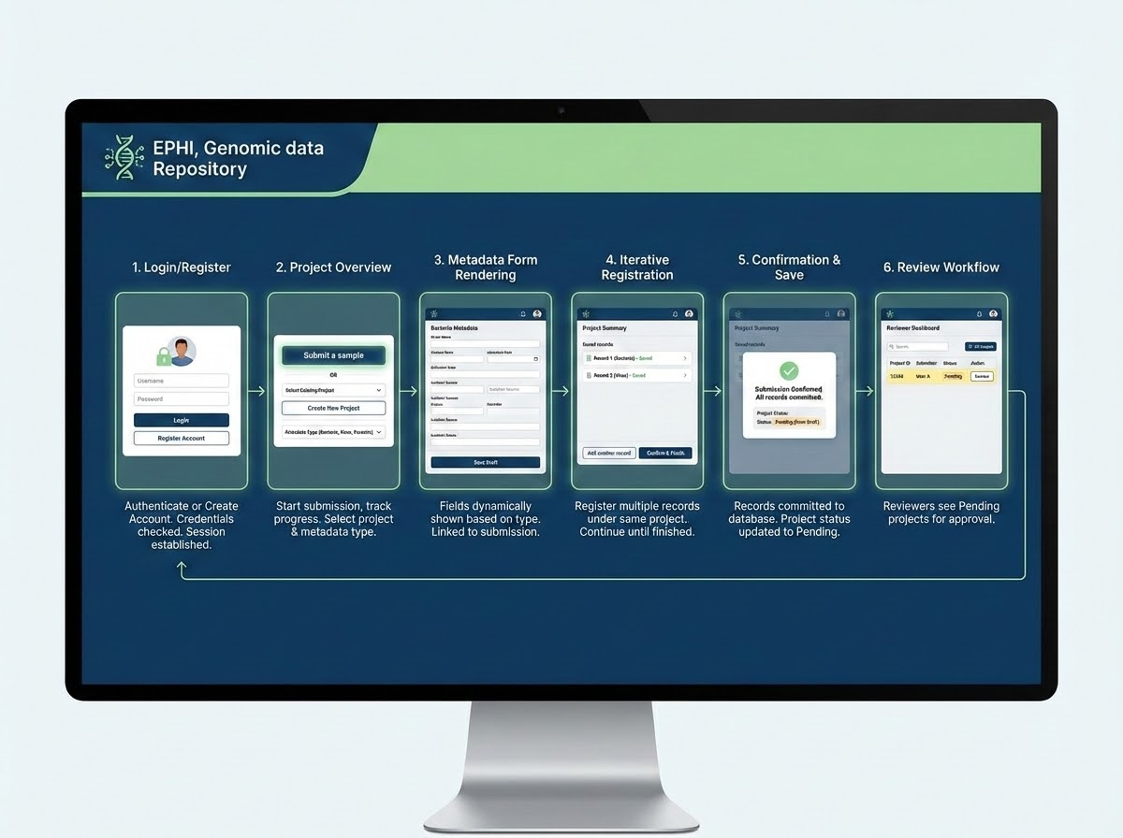
A sample system workflow looks

