INTERNSHIP REPORT
ON
DEVOPS INTERN
By
Frewin Johan Fernandes
4SN24MC008
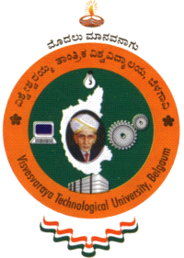

SRINIVAS INSTITUTE OF TECHNOLOGY
(Accredited by NAAC with “A” grade)
MANGALURU-574143, KARNATAKA



Department of Master of Computer Applications

VISVESVARAYA TECHNOLOGICAL UNIVERSITY
Belagavi-590018

2025-2026

