

本科实验报告

课程名称： | 网络安全原理与实践
姓 名： | 展翼飞
学 院： | 计算机科学与技术学院
系： | 计算机科学与技术系
专 业： | 计算机科学与技术
学 号： | 3190102196
指导教师： | 林峰

2024 年 3 月 7 日

浙江大学实验报告

课程名称：网络安全原理与实践
实验名称：Lab 01

- Lab Goal
Lab 01 aims to practice commonly used tools for packet sniffing, packet crafting, and port scanning.

- Lab Steps
(1). http://10.15.111.100/game1
Step 1. view page source
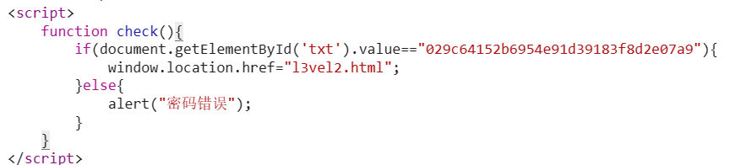
Open the browser's developer tools directly to view the HTML source code and find the hidden password in the check function.
The password is 029c64152b6954e91d39183f8d2e07a9

Step 2. view page source
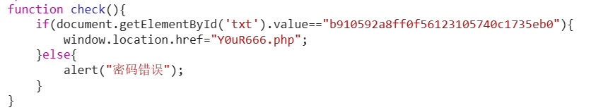
Enter the level 2 page and open the browser’s developer tools to view HTML source code and find the password is b910592a8ff0f56123105740c1735eb0

Step 3. capture RESONSE-packet header using WireShark
Enter next level and use WireShark to capture and view the Response header after the GET method.
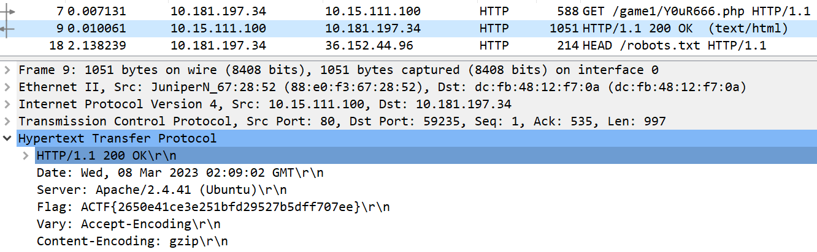
We can use the source address and the type of protocol to distinguish the response packet, and find the Flag is ACTF{2650e41ce3e251bfd29527b5dff707ee}

(2). http://10.15.111.100/game2
Step 1. view page source
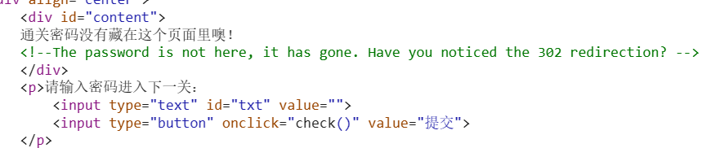
View the source code and find the prompt of 302 redirection.

Step 2. understand 302 redirection
A 302 is a status code in the HTTP protocol that can be interpreted to mean that the resource did exist, but has been temporarily redirected. For servers, the HTTP Location header is usually sent to the browser to redirect to the new location.

Step 3. locate redirected pages and find password
Check the GET request with status code 302 and find the password in the response body.
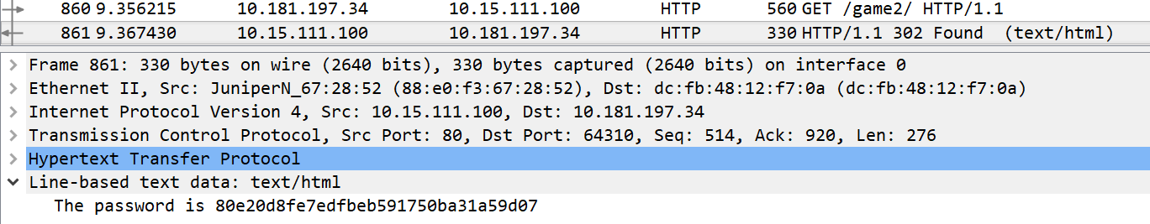
The password is 80e20d8fe7edfbeb591750ba31a59d07

Step 4. understand HTTP Referer field
Referer is a common field in the header of HTTP requests that provides information about the source of the access. The client sends the request with or without this field at its own discretion. Servers generally use the referer to identify the source of a visit, which may be used for statistical analysis, logging, and cache optimization.

Step 5. capture GET-packet and rewrite Referer field using Burp Suite
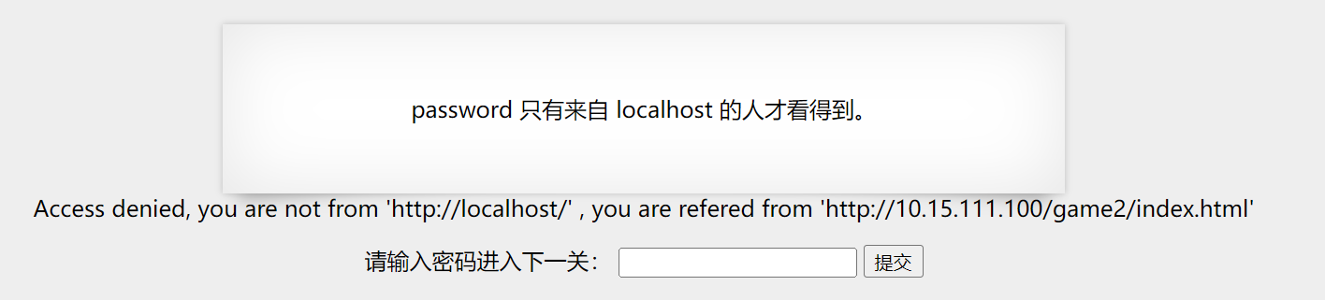
Enter next level and record the required referer ‘http://localhost/’, then go back to last level and intercept the GET-packet.
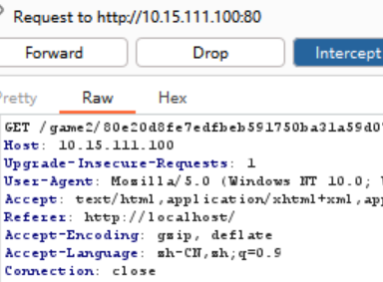
Rewrite the GET-packet and then forward it.
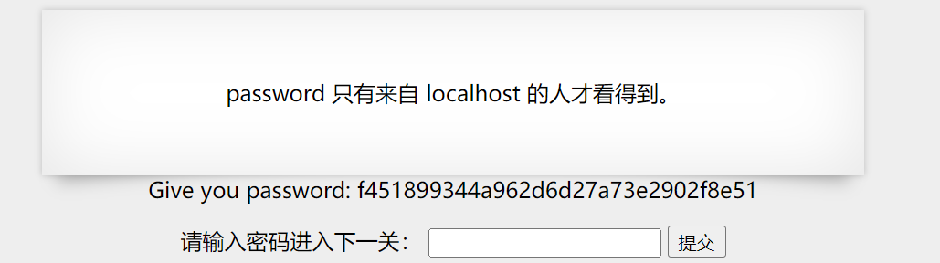
Now we can get the password : f451899344a962d6d27a73e2902f8e51

Step 6. capture GET-packet and rewrite Cookie field with admin privilege using Burp Suite
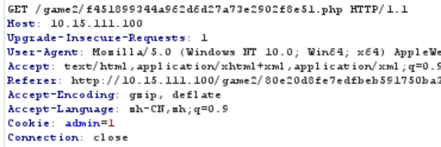
Before we go to next level, we intercept the Get-packet and set Cookie field with admin = 1
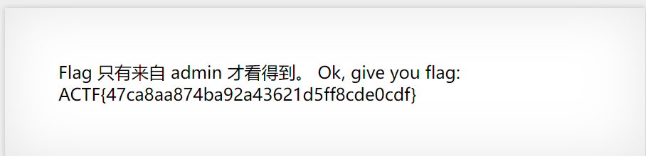
Forward the packet and we can get the Flag : ACTF{47ca8aa874ba92a43621d5ff8cde0cdf}

(3)http://10.214.160.13:10000/
Step 1. view page source
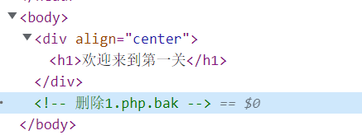

Step 2. get link from .bak file
Change the URL to get the 1.php.bak file and open it in browser with developer tool
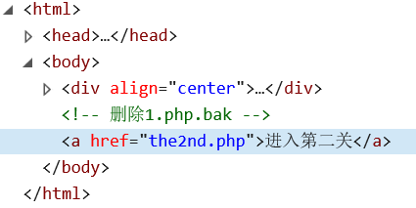
We can get the url to the next level

Step 3. capture GET-packet and null Referer field using Burp Suite
Click the go to the next level button, then there will be a Post request and a lot of Get request without Referer field.
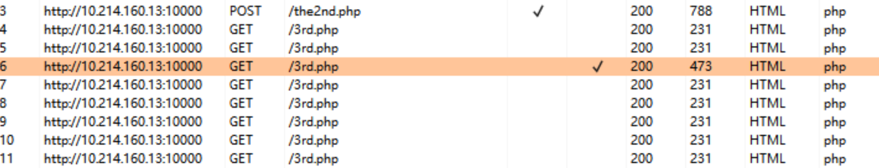
Select a GET request, and add the Referer field with value ‘null’ and then forward it using Burp Suite, then we can get the Response

Step 4. capture RESONSE-packet header with next link included using Burp Suite
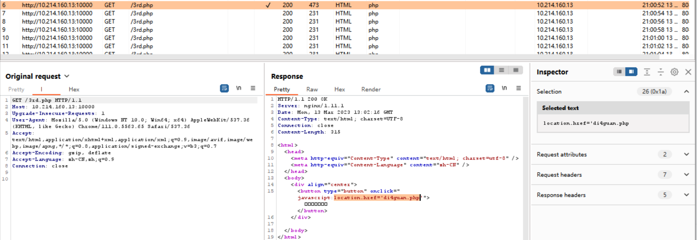
The url of the next level is di4guan.php

Step 5. view page source and try to click the button or craft packet with button click effect

The response packet of Get Method of url di4guan.php give us next level’s url :
wozaizheli.php
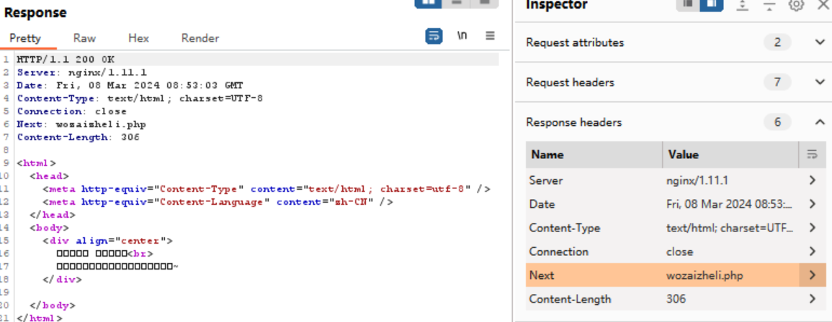
Enter wozaizheli.php then we find hint to click the button but the button disappear quickly.
We can modify the page source and delete the script which hide the button, then we can click the button.
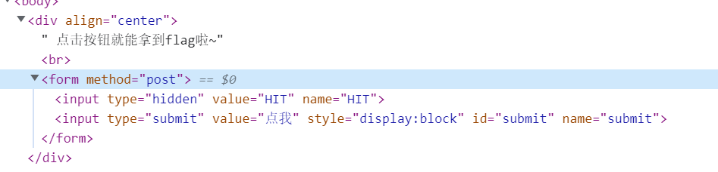
Then we can get the flag
flag: AAA{y0u_2a_g0od_front-end_Web_developer}

