HOVERCRAFT

Abstract:

For controlling the hovercraft, I used my DIY Arduino based Bluetooth RC control. I set the right joystick to control the servo motor for positioning the rudders on the back side of the thrust motor, set one of the potentiometers to control the lift propeller which is actually attached on a brushless DC motor, and set the android app to control the propulsion. So, let’s take a look what it takes to build this RC hovercraft.

Arduino Uno:
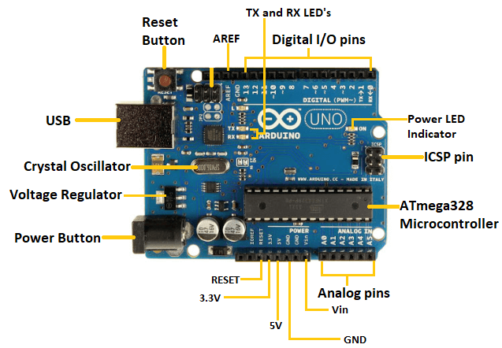
Arduino UNO is a microcontroller board based on the ATmega328P. It has 14 digital input/output pins (of which 6 can be used as PWM outputs), 6 analog inputs, a 16 MHz ceramic resonator, a USB connection, a power jack, an ICSP header and a reset button. It contains everything needed to support the microcontroller; simply connect it to a computer with a USB cable or power it with a AC-to-DC adapter or battery to get started.

Replaceable chip
The ATmega328P can easily be replaced, as it is not soldered to the board.
EEPROM
The ATmega328P also features 1kb of EEPROM, a memory which is not erased when powered off.
Battery Connector
The Arduino UNO features a barrel plug connector, that works great with a standard 9V battery.
Requirments:
- Arduino Uno
- 2 BLDC Motor
- 2 ESC
- HC05-Bluetooth Device
- 12VDc Battery
- Hovercraft 3D Design model

BLDC Motor:

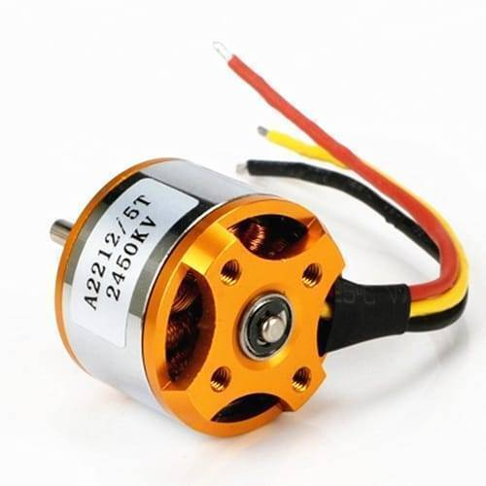

While different ESC types exist for different motor types, the focus here is on Brushless DC (BLDC) motors. BLDC ESCs convert power from a DC supply into a dynamic voltage to drive BLDC motors. This conversion process is flexible, varying the voltage to increase or decrease the motor speed.

HC05-Bluetooth Module:

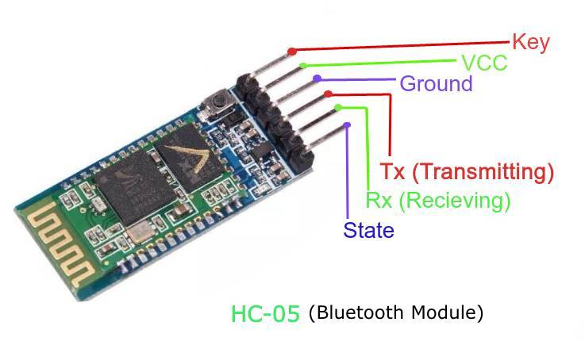
The HC-05 is a class 2 Bluetooth module designed for transparent wireless serial communication. It is pre-configured as a slave Bluetooth device. Once it is paired to a master Bluetooth device such as PC, smart phones and tablet, its operation becomes transparent to the user. All data received through the serial input is immediately transmitted over the air. When the module receives wireless data, it is sent out through the serial interface exactly at it is received.

ESC:

While different ESC types exist for different motor types, the focus here is on Brushless DC (BLDC) motors. BLDC ESCs convert power from a DC supply into a dynamic voltage to drive BLDC motors. This conversion process is flexible, varying the voltage to increase or decrease the motor speed.
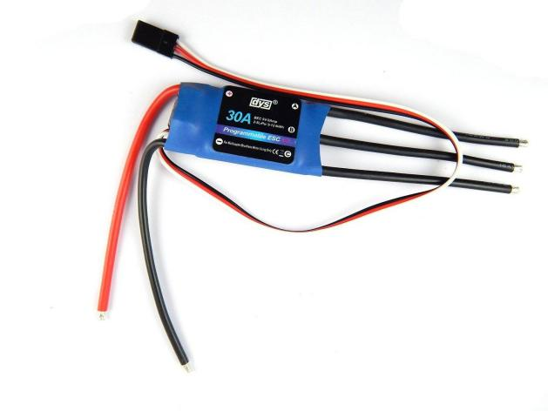

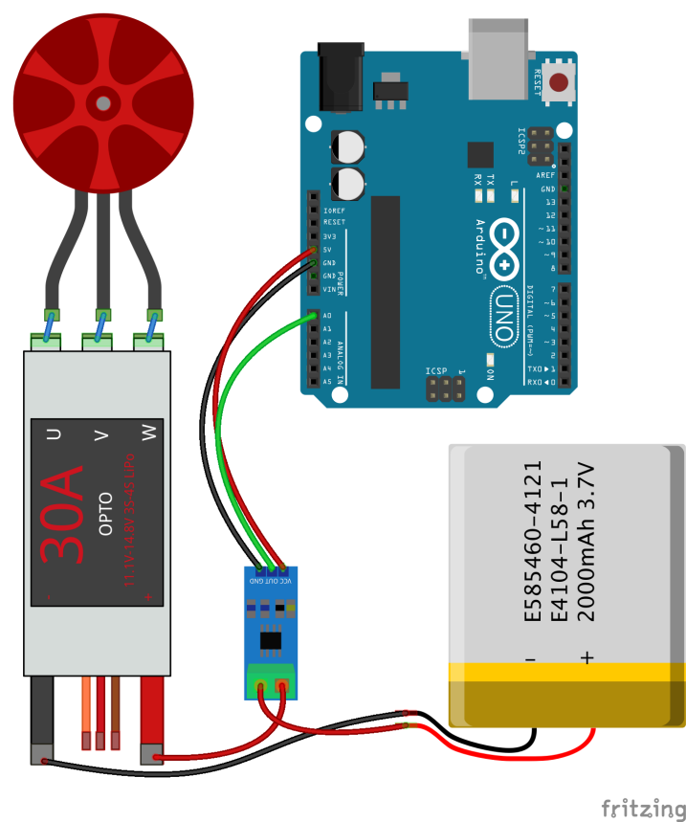

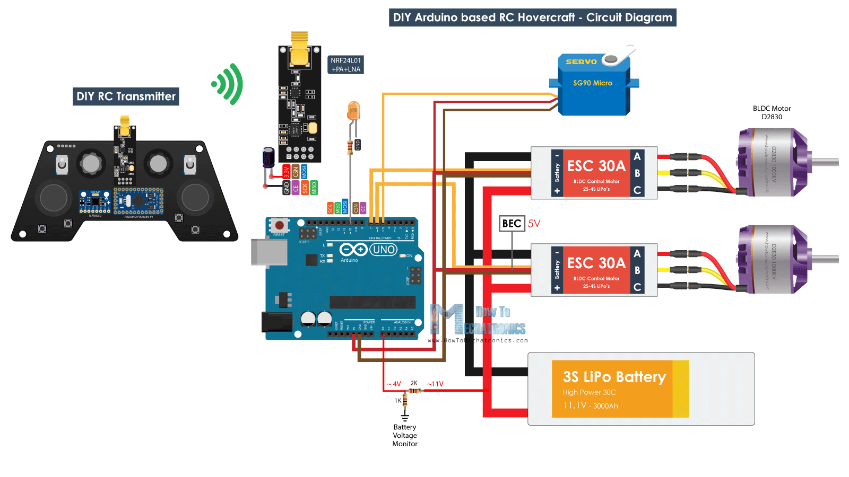

Android App:
https://play.google.com/store/apps/details?id=com.broxcode.arduinobluetoothfree

Code:
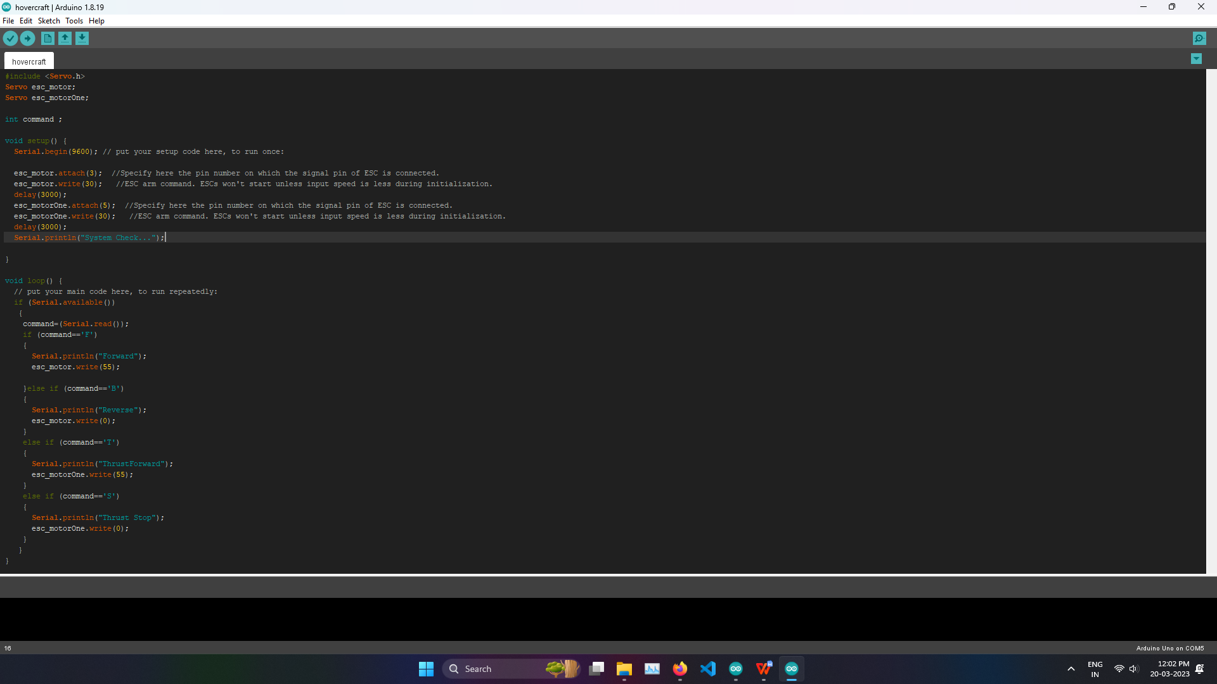

Conclusion:

The developed hovercraft has demonstrated the utilization of low cost and strong materials and has proved its capability as a carrier to transport an I-BE biosensor. Although using light materials, the hovercraft was succeeded to maintain its movement stability while running in its average moving speed. Moreover, the maneuverability performance indicates that the hovercraft’s propellers and servo serve perfectly as propulsion and lifting systems

