Automatic Irrigation
Abstract:
Automatic Irrigation System with an Arduino Uno which will irrigate your plants automatically and keep them healthy even when you are out of the town for weeks or months. In this project, a Moisture sensor will be used to maintain the optimum level of moisture for your plants. This system can be implemented, both for your garden or for your Indoor plants thus taking care of your leafy pets when you are away.
Requirments:
- Arduino * 1
- moisture sensor * 1
- 5v relay module * 1
- 6v Mini water pump with small pipe * 1
- Connecting wires
- 5v battery * 1
Arduino UNO:

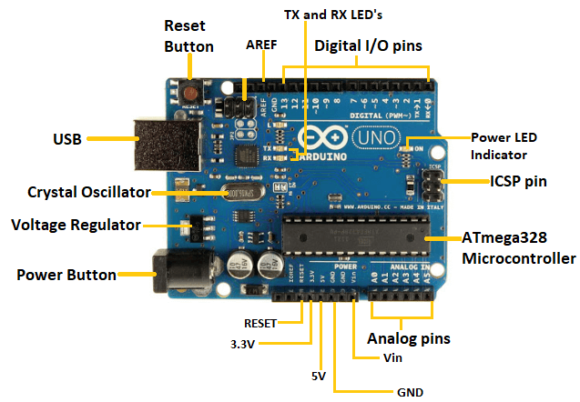

Arduino UNO is a microcontroller board based on the ATmega328P. It has 14 digital input/output pins (of which 6 can be used as PWM outputs), 6 analog inputs, a 16 MHz ceramic resonator, a USB connection, a power jack, an ICSP header and a reset button. It contains everything needed to support the microcontroller; simply connect it to a computer with a USB cable or power it with a AC-to-DC adapter or battery to get started.
Replaceable chip:
The ATmega328P can easily be replaced, as it is not soldered to the board.
EEPROM
The ATmega328P also features 1kb of EEPROM, a memory which is not erased when powered off.
Battery Connector
The Arduino UNO features a barrel plug connector, that works great with a standard 9V battery.

Relay:
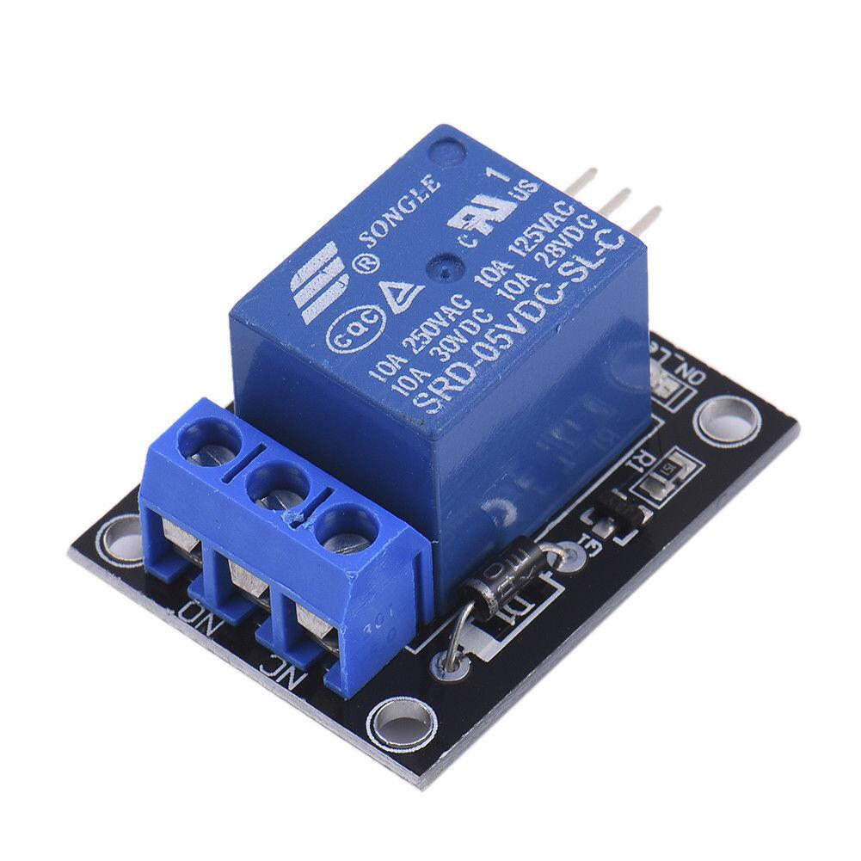
The Relay Module is a convenient board which can be used to control high voltage, high current load such as motor, solenoid valves, lamps and AC load. It is designed to interface with microcontroller such as Arduino, PIC and etc. The relays terminal (COM, NO and NC) is being brought out with screw terminal.

Pump
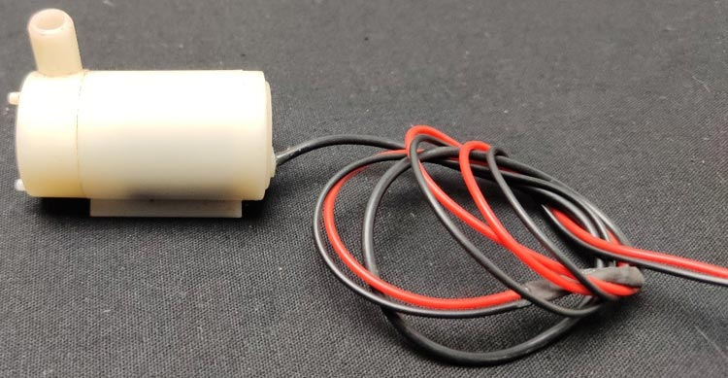
We need a small pump to irrigate the plant, but in the case of a garden, we need to drive a larger pump that can provide a higher volume of water depending on the size of your garden which can’t be directly powered by an Arduino. So in case you need to operate a larger pump, a driver is necessary to provide enough current for the pump, to show that I am using a 5v relay. You can also use an AC-powered pump and use a suitable relay.
Soil Moisture Sensor:
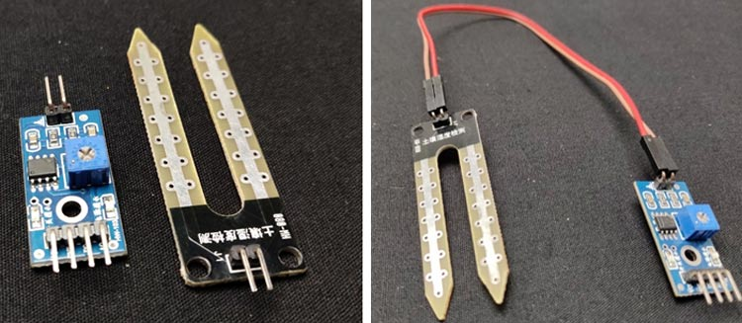
The working of the soil moisture sensor is very easy to understand. It has 2 probes with exposed contacts that act like a variable resistor whose resistance varies according to the water content in the soil. This resistance is inversely proportional to the soil moisture which means that higher water in the soil means better conductivity and hence a lower resistance. While the lower water in the soil means poor conductivity and will result in higher resistance. The sensor produces an analog voltage output according to the resistance.

Circuit Diagram.

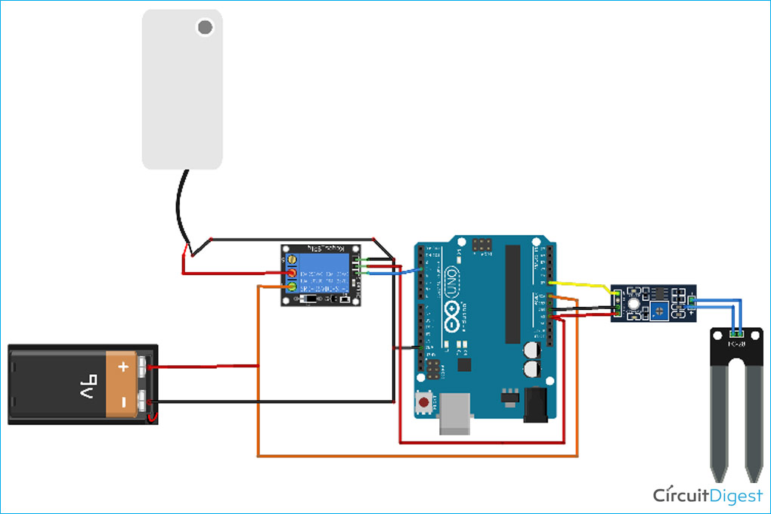

Code:



OUTPUT:

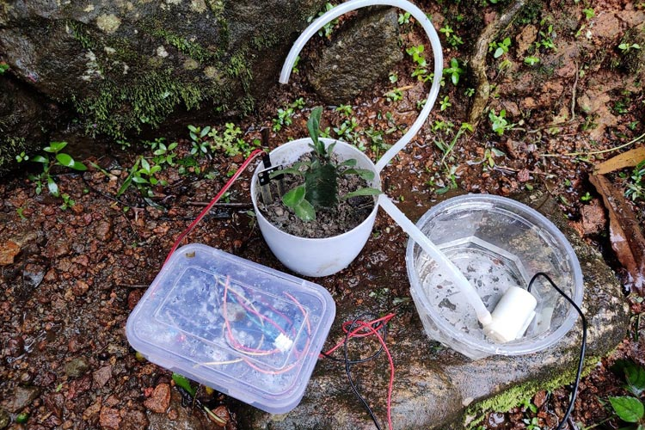

Conclusion:

An automatic plant irrigation system using Arduino is designed in this project. The prototype of the model worked properly when tested on different soils. The components that we use in the system are readily available and easy to operate. Thus, this system acts as an effectual method of irrigation.

