**Ve270 Introduction to Logic Design Homework 10**

**Assigned: November 28, 2019**

**Due: December 5, 2019, 4:00pm.**

**The homework should be submitted in hard copies.**

1. Problem 5.25 (20 points)
2. Problem 5.26 (30 points)



1. Given that an SRAM block has a 32-bit address input, each line of the memory has an address, how many lines does the memory have? (5 points)

If each line is a 32-bit word, how many bytes (8 bits) does the memory have? (2 points)

In that case, how many transistors does the memory have for storage? (3 points)

If we use a decoder to decode the address, how big a decoder will be needed (e.g. a 3x8 decoder)? (2 points)

If the memory is byte addressable, i.e. each byte has an address, how many bits does the memory have? (3 points)

1. Use one 4-input LUT to implement the following Boolean function (15 points)

**f = x2x3’x4’ + x1’x2x4 + x1’x2x3 + x1x2x3**

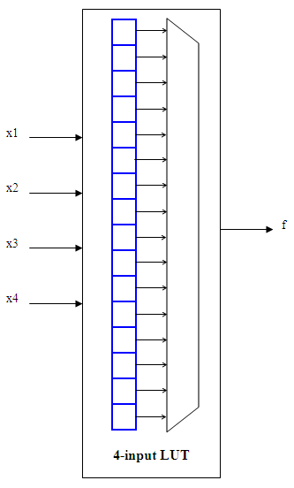

1. Problem 7.20 (20 points)