Freydis Ehrlich

freydis.ehrlich@gmail.com

Software Tester Course

Software Development Academy

Fall 2022

Final portfolio

Testing an E-commerce site

Table of Contents

Document Purpose 3

Testing section 4

Testing checklist 5

Test cases 8

Bug report 18

Improvements 21

Test Design Techniques 22

Reflection 24

# Document Purpose

The aim of this document is to present final project made during the software tester course in Software Development Academy in fall 2022. The final project provides overview of what I have learned during the four-month course. During the final project testing E-commerce site About You: <https://www.aboutyou.com/> This website is popular E-commerce site with large e-shop and commercials in different platforms.

# Testing section

For testing five categories were chosen. All of those are rooted from main page. Firstly, women section, then clothing section, sales section, wishlist and finally the basket. In the following section is a partial diagram of sections in the About You webpage. The elements shown are related to main page and information shown in the diagram is related to the pages tested.

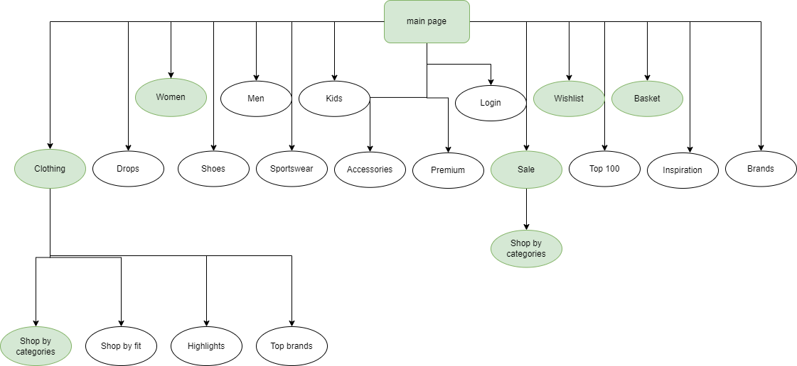

**Figure 1.** Diagram of testing sections inAbout You e-shop. Diagram made in <https://app.diagrams.net/>

# Testing checklist

The checklist was created in TestRail. Below a checklist for testing is provided containing 36 test case. A sample of possible test cases were made for checklist and this checklist can be much longer. For testing ten cases were chosen from the checklist and those are presented in the next section of this document. All the screenshots are also present in GitHub:

https://github.com/FreydisEhrlich/sda_tester_final_project

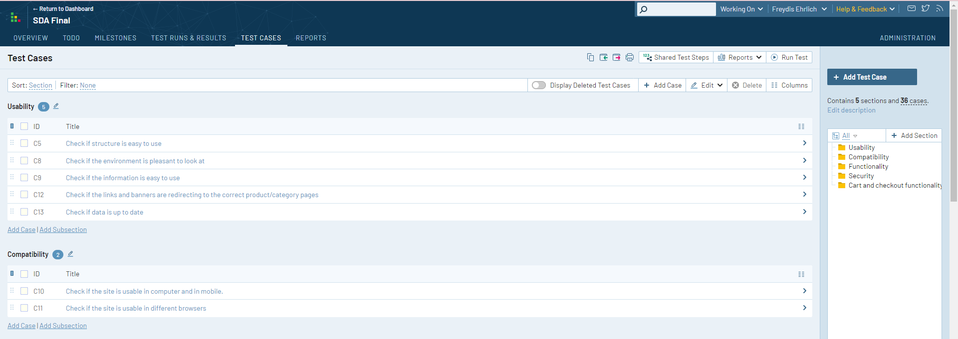

**Figure 2.** First part of testing checklist. Screenshot taken from TestRail.

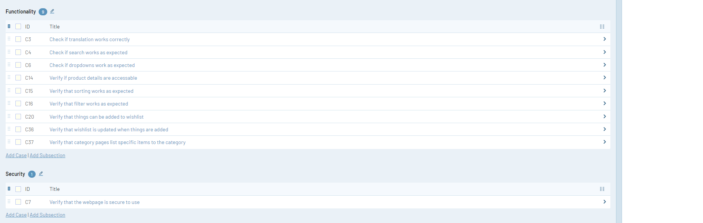

**Figure 3.** Second part of testing checklist. Screenshot taken from TestRail.

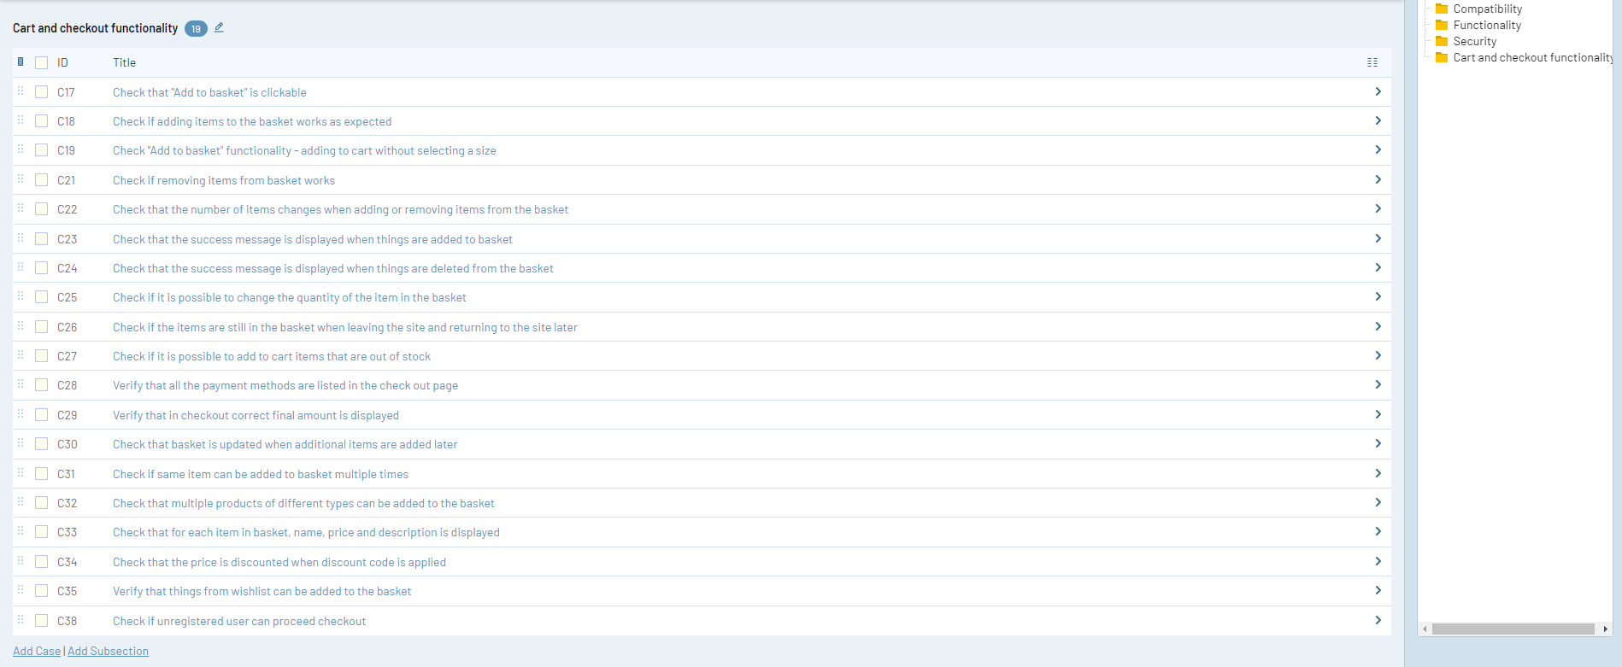

**Figure 4.** Third part of testing checklist. Screenshot taken from TestRail.

# Test cases

Test cases were recorded in TestRail. For this Final Project ten possible test cases were created followed by the requirements of the project. The screenshots of test cases are provided below. All the screenshots are also in GitHub, as those are better to read there. All test were taken using Lenovo Thinkpad Laptop, windows 10 21H2, Chrome. For one test case (sorting) a short video with Screencast-O-Matic was used. Even thought there were no bug, the video was taken for learning purposes. The video can be viewed in the GitHub:

<https://github.com/FreydisEhrlich/sda_tester_final_project/blob/main/TestCase_sorting.mp4>

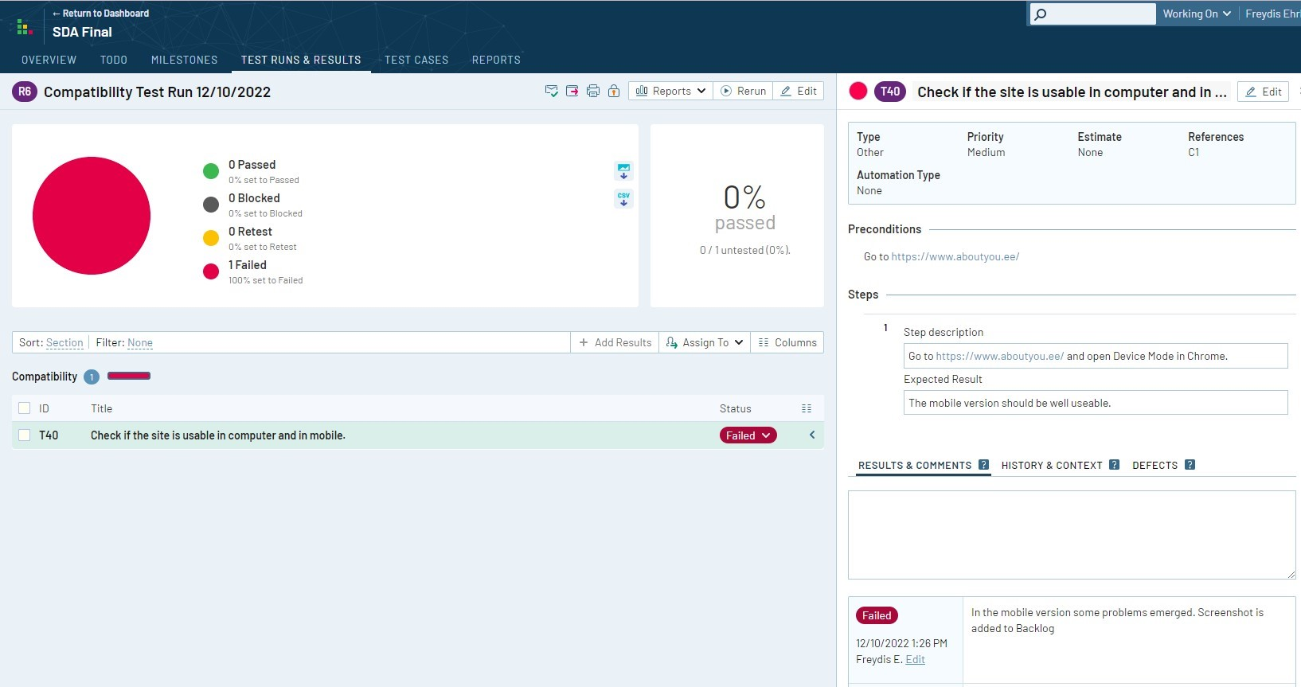

**Figure 5.** First test case. Screenshot taken from TestRail.

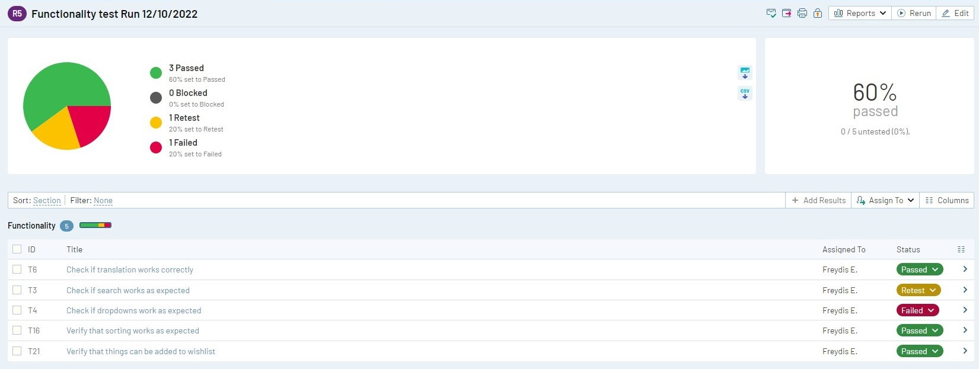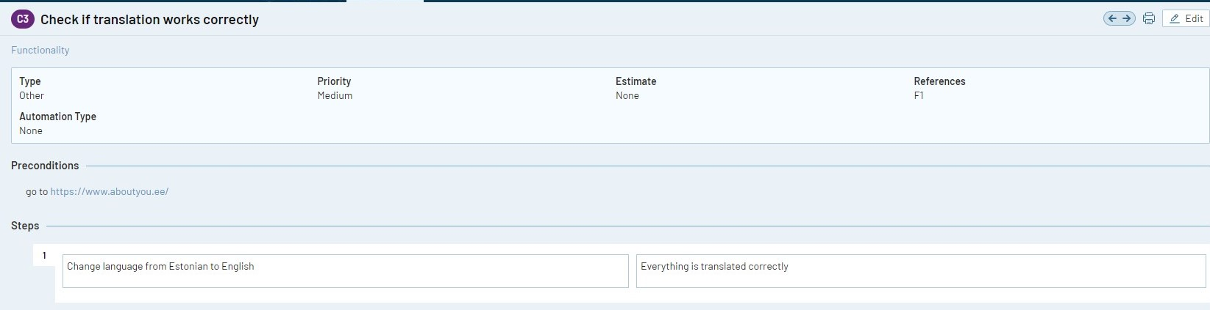

**Figure 6.** Picture of second group of test cases and the second test case. Screenshot taken from TestRail.

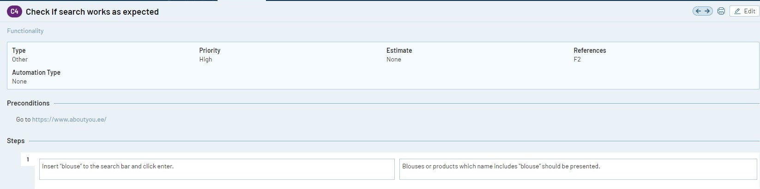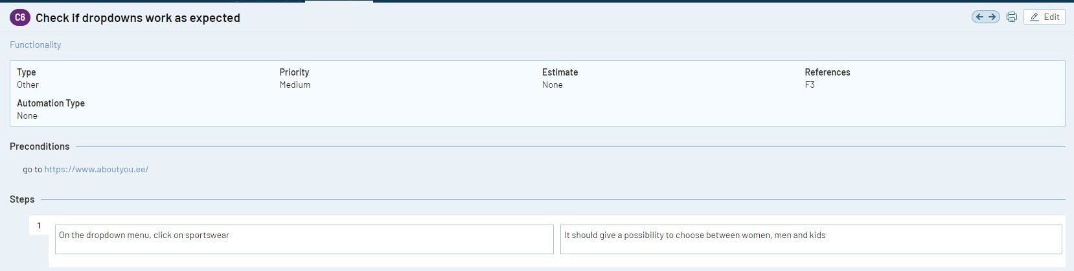

**Figure 7.** Test cases three and four. Screenshot taken from TestRail.

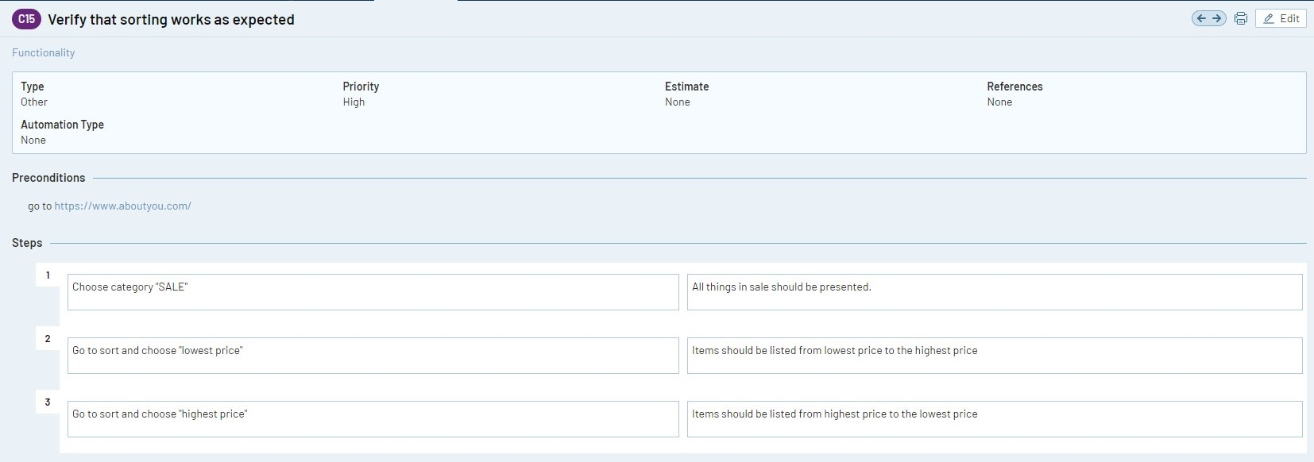

**Figure 8.** Test case five. Screenshot taken from TestRail.

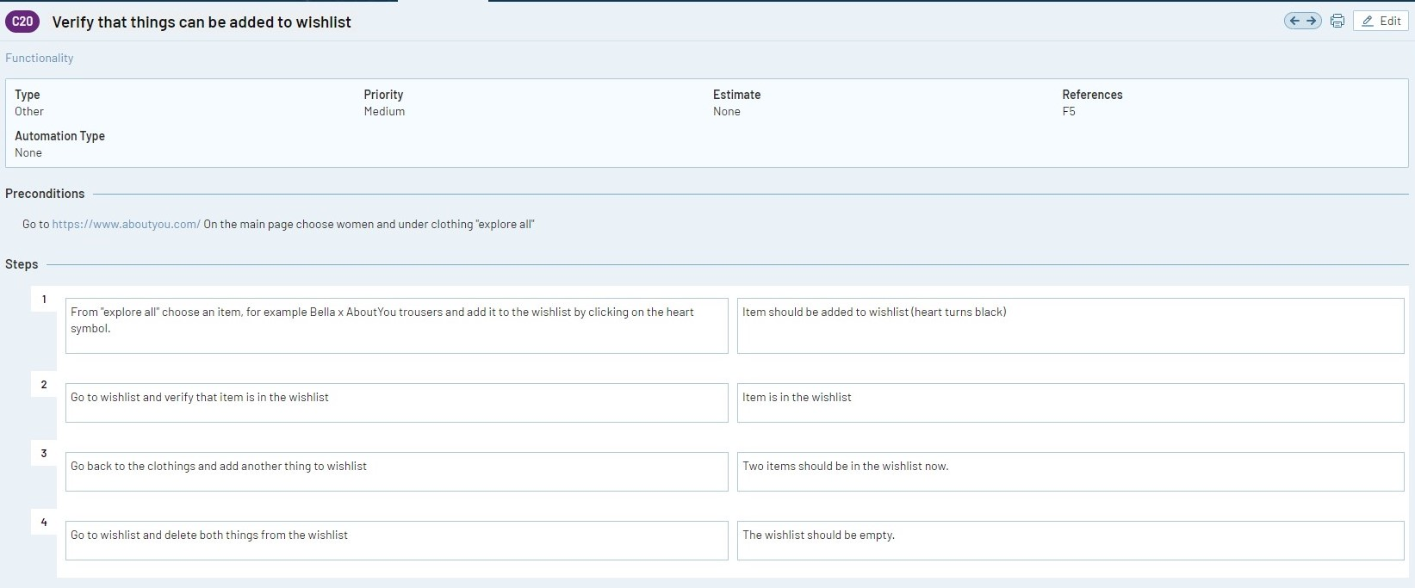

**Figure 8.** Test case six. Screenshot taken from TestRail.

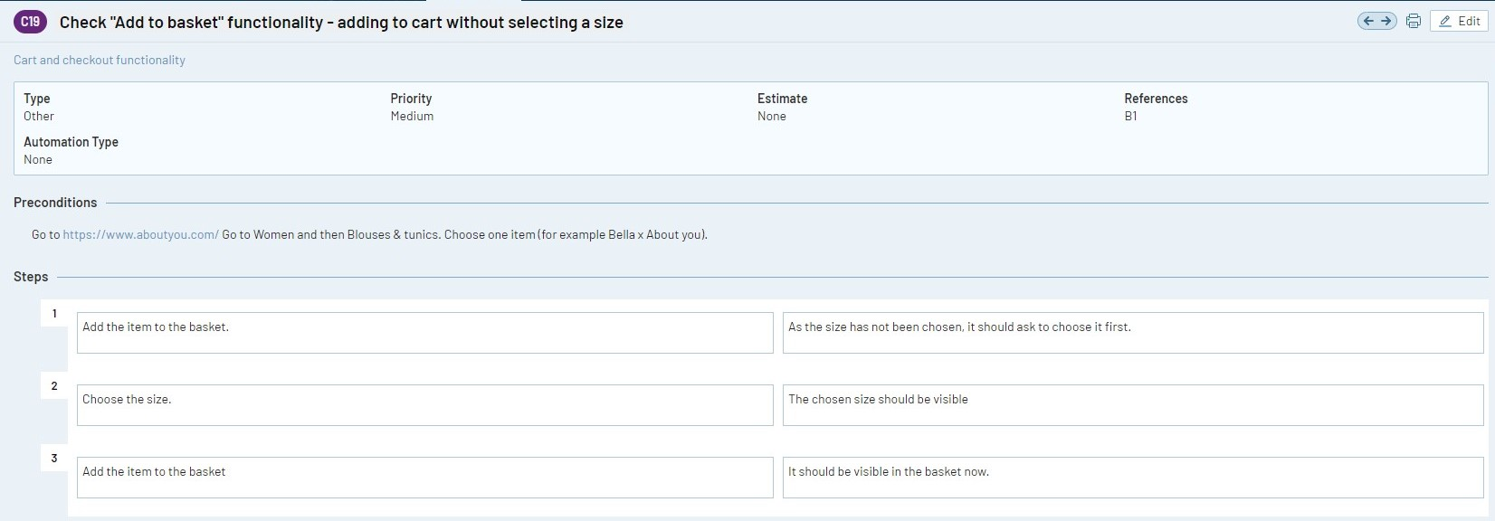

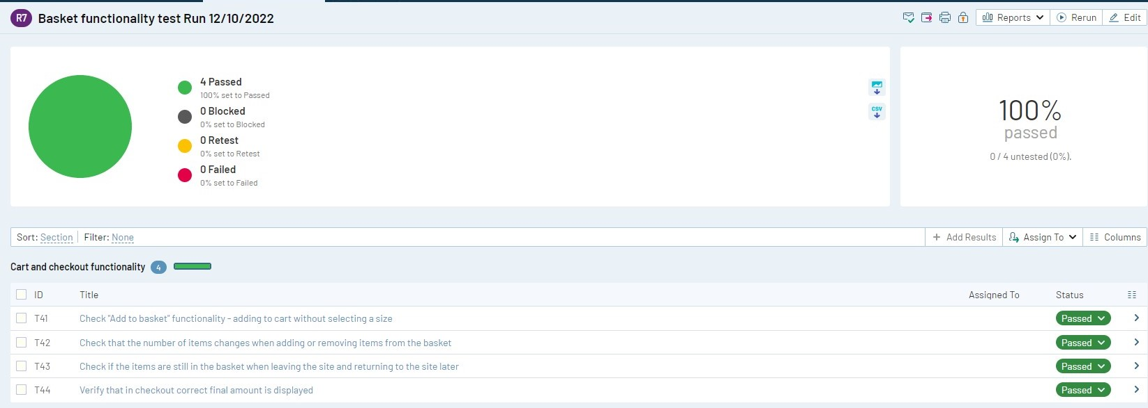

**Figure 9.** Third group of test cases and test case seven. Screenshot taken from TestRail.

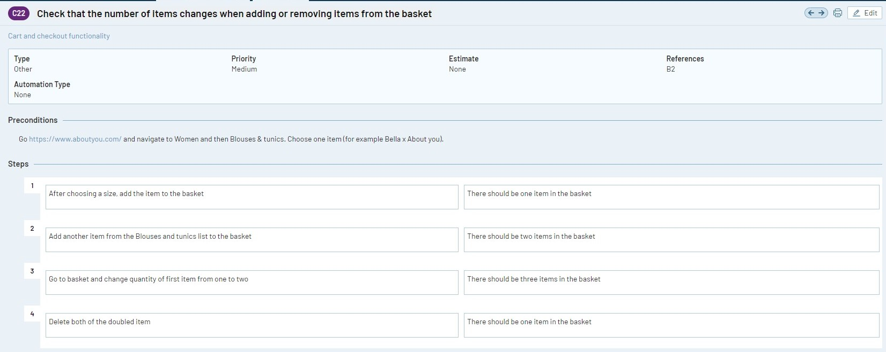

**Figure 10.** Test case eight. Screenshot taken from TestRail.

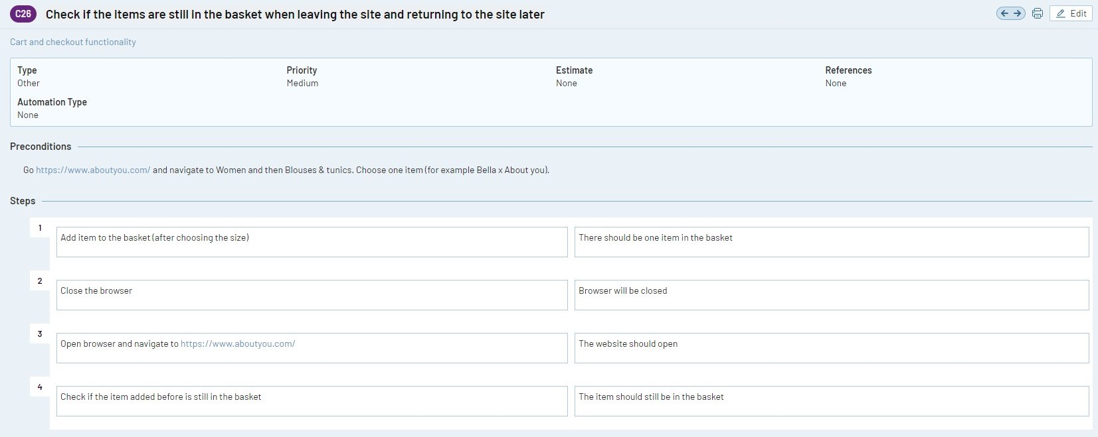

**Figure 11.** Test case nine. Screenshot taken from TestRail.

**Figure 12.** Test case ten. Screenshot taken from TestRail.

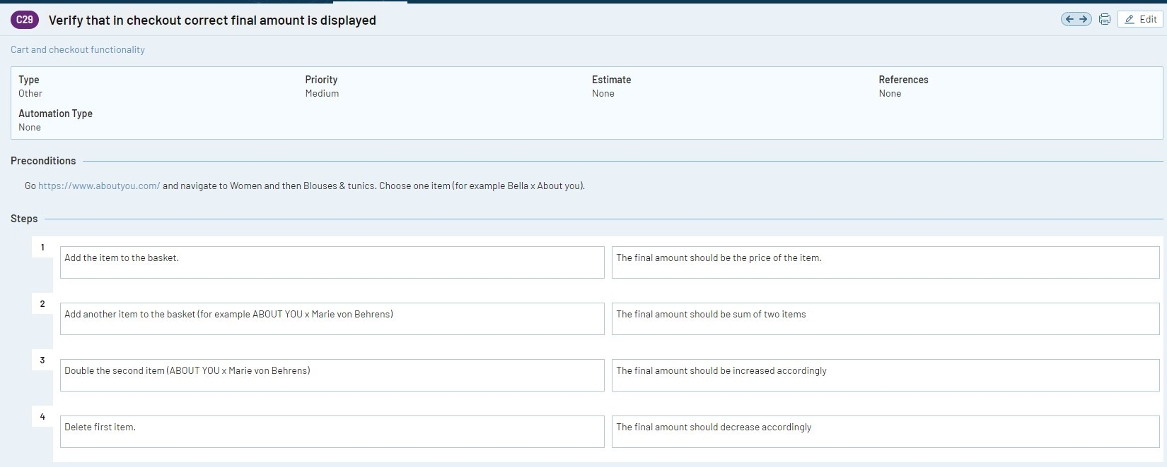

# Bug report

Bug report were created in two environments. At first, bugs were reported in Jira. Later, for learning purposes, those were also created in the Backlog. Of those two, Backlog seemed easier to use, while it also had a small problem. Namely, everything was in English, but when selecting if the issue created is a task, bug or etc., the selection was in Chinese and it did not change when language was changed. All the screenshots of bugs are also presented in GitHub.

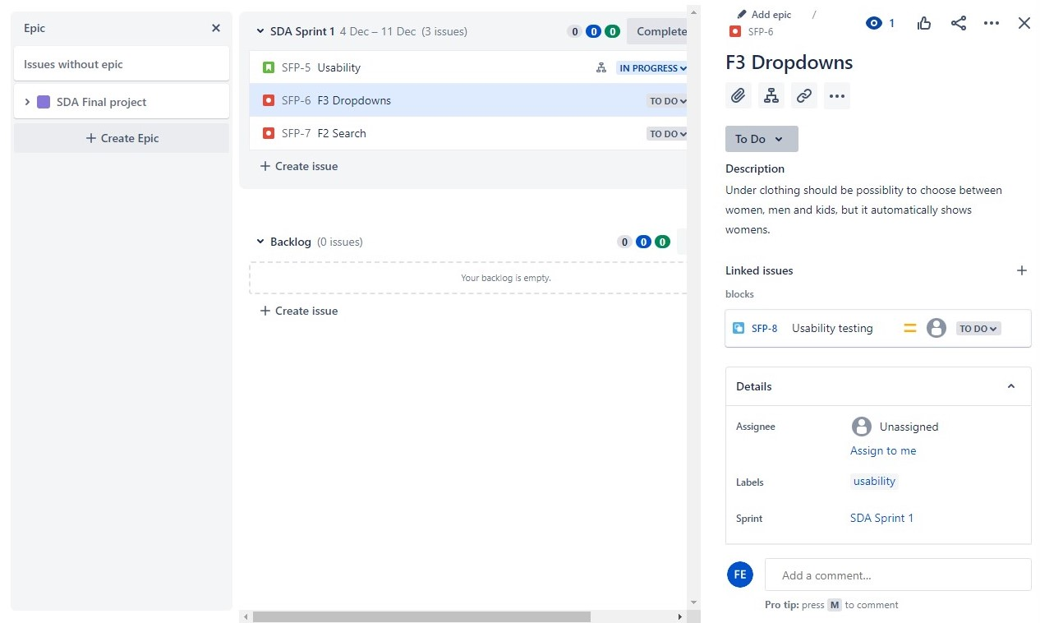

**Figure 13.** Bug one in Jira.

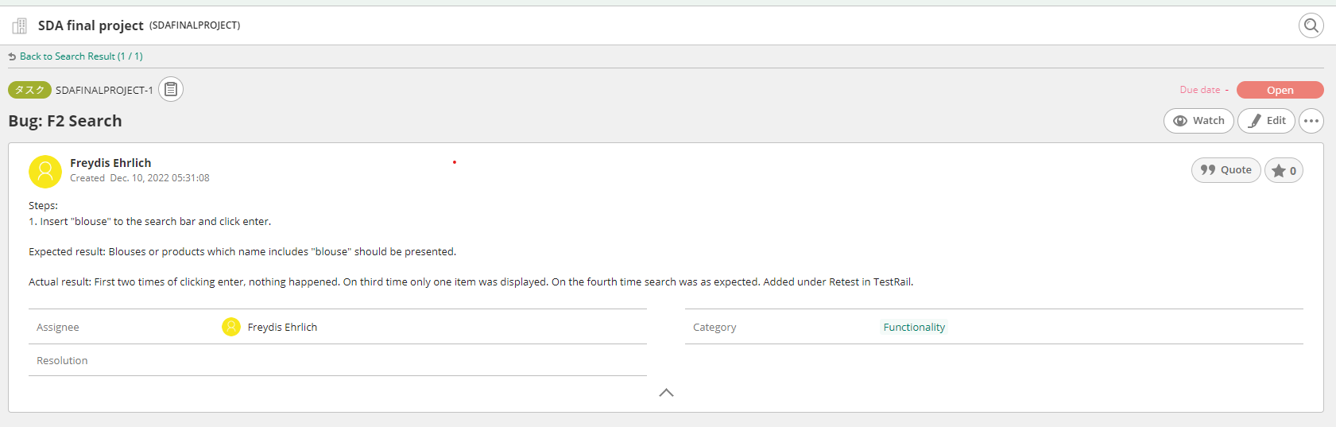

**Figure 14.** Bug two in Backlog. This was not recorded as a bug in TestRail. Rather it seems that it needs a retest.

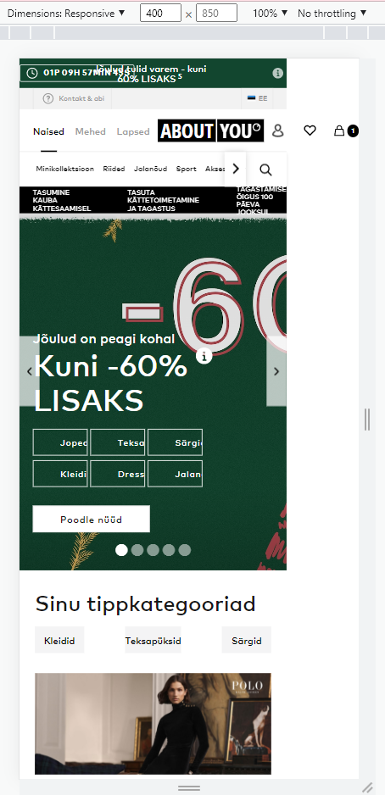

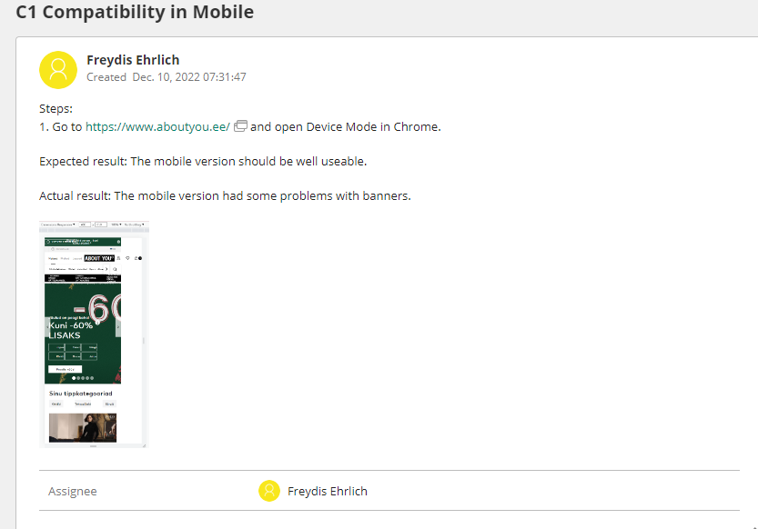

**Figure 15.** Bug three in Backlog and closer screenshot of the problem.

# Improvements

While testing, one thing seemed to need improvement. Namely, when adding a thing to wishlist, there is no button that is named “whislist”. On the picture of the product there is small heart symbol that is filled with white color and this needs to be clicked in order to add it to the list. The problem is that in most cases this white heart is on light background and might be difficult to notice. For outfits the heart is better displayed.



**Figure 16.** The screenshot of the wishlist symbol of item and of outfit.

# Test Design Techniques

The testing started with static testing, as first step was planning – defining the scope and purpose of the testing. Mainly the Ad-hoc technique and exploratory testing was used. Partially, the testing was based on the checklist as well considering typical things that could be tested for e-commerce site. This testing project was based on the black-box technique as no code was analyzed in the process.

The testing section was defined in app.diagrams.net. Testing checklist and test cases were created in TestRail. Bugs were reported in Backlog and in Jira. For screenshots Snip & Sketch and for videos Screencast-O-Matic were used. For one test Simulate mobile devices with Device Mode in Chrome was used to test mobile view of the site. All the information and full files are recorded in: <https://github.com/FreydisEhrlich/sda_tester_final_project>

# Reflection

The final project provided great opportunity to analyse what have been learned during the software tester course. Most of the project did not cause any difficulties. However, as expected, at first, many tools and ideas needed additional reading and practice to better understand and remember the previously studied information. This final project help to go more thorough with some topics. For example it helped to improve the knowledge about testing checklists and test design techniques – the topics covered in the course at the beginning and now needed some reminding. Additionally TestRail was more thoroughly discussed. During this final project, Backlog and Screencast-O-Matic was used. Neither of those were used as an example during previous weeks in the course and therefore final project gave opportunity to learn new programs. This showed also my ability to learn new things quickly. The most difficult part was creating the testing section diagram as I have not done anything like that before. Also, in the future more different environments should be used in testing.

The project help to make better understanding of previously learned things and some new programs was needed to be studied giving opportunity to learn more. Overall, the process were interesting and exciting in every step.