1. Tiitelleht
2. Sisukord

# Document Purpose

The aim of this document is to present final project made during the software tester course in Software Development Academy in fall 2022. The final project provides overview of what I have learned during the four-month course. During the final project testing E-commerce site About You: <https://www.aboutyou.com/> This website is popular E-commerce site with large e-shop and commercials in different platforms.

# Testing section

For testing five categories were chosen. All of those are rooted from main page. Firstly, women section, then clothing section, sales section, wishlist and finally the basket. In the following section is a partial diagram of sections in the About You webpage. The elements shown are related to main page and information shown in the diagram is related to the pages tested.

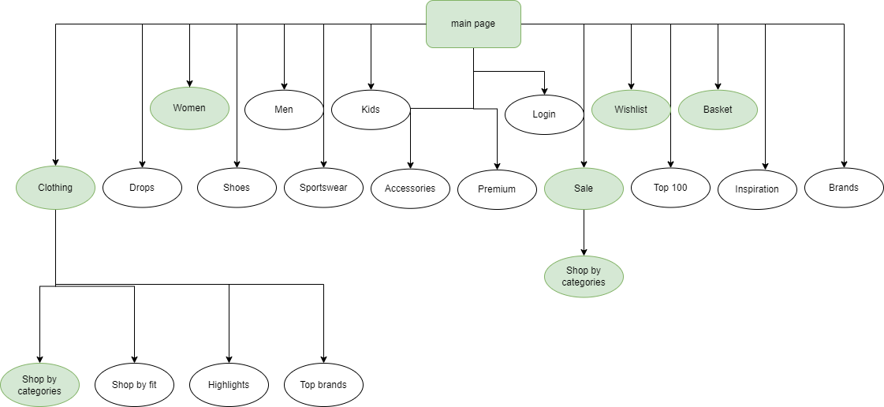

**Figure 1.** Diagram of testing sections inAbout You e-shop.

# Testing checklist

Below a checklist for testing is provided. For test cases only a few topics were chosen.

**Table 1. Testing checklist**

|  |  |  |  |
| --- | --- | --- | --- |
| Section | Id | Work Unit | Requirement |
| Planning |  | Test planning | Test for planning should be created. |
|  | Requirements | Requirements should be clear and understandable. |
| Usability |  | Translation | The translations are correct in both Estonian and English. |
|  | Search | If search is functioning correctly. |
|  | Structure | Structure of the site is easy to use. |
|  | Dropdowns | Dropdowns work correctly. |
|  | Security | The web page uses https for security. |
| E-commerce |  | Access to product details | Clicking leads to product details. |
|  |  | Sorting | Products can be sorted by different characteristics. |
|  |  | Filtering | Products can be sorted by different characteristics. |
|  |  | Add to wishlist | Adding things to wishlist works correctly. |
|  |  | Add to basket | Adding things to basket works correctly. |
|  |  | View basket | Shows the items in basket and it is possible to remove items. |
|  |  | Checkout | Checkout provides information about final amount and provides information for payment. |
|  |  | View products works | When viewing a product site brings customer back to the same place were scrolling were paused. |
|  |  | Main page leads were needed | When clicking buttons on main page, they lead to correct sections. |
|  |  | Payment methods | Variety of payment methods are provided. |
| Compatability |  | Usable in computer and in mobile. | Everything works the same in mobile app and in webApp. |
|  | Useable in different browsers | Works the same in different browsers. |
|  |  |  |  |
|  |  |  |  |
|  |  |  |  |

# Test cases

Test cases were recorded in TestRail. For this Final Project only 10 possible test cases were created followed by the requirements of the project.

# Bug report

Jira

# Improvements

# Test Design Techniques

For learning purposes test cases were made in TestRail and bug reports in Jira. I am aware that Jira could have been used for both.

# Reflection