Welcome to the Setting Up TortoiseSVN guide. I’ll be your host, and let’s get you all situated. Setting up TortoiseSVN is a simple task, just follow these instructions:

1. Visit this direct link to the TortoiseSVN download page: <https://tortoisesvn.net/downloads.html>

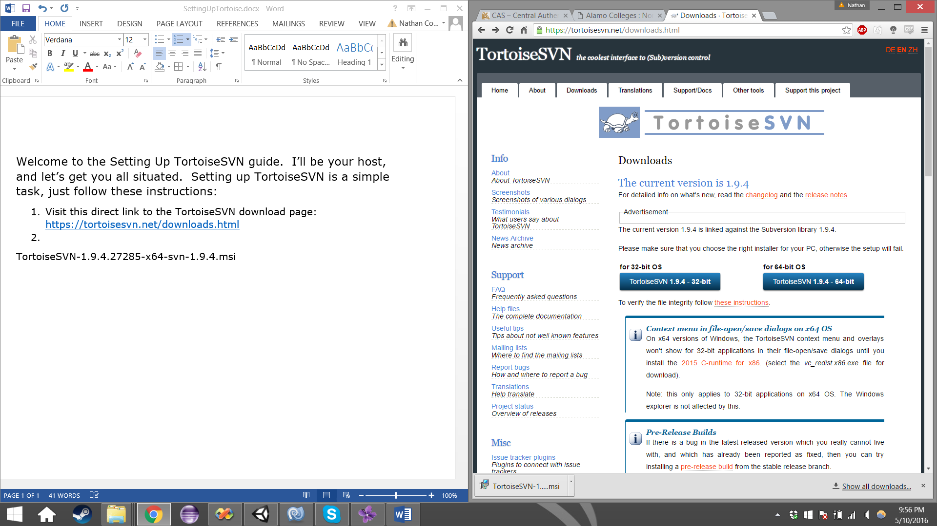

1. If you have a 32-bit OS, select the left button, if you have a 64-bit OS, select the right button. If you are unsure of which you have, select the left button. 32-bit software can work on both 32-bit and 64-bit OS, but no vice-versa.
2. Open the installer, and follow the instructions on screen.
3. If you reach this screen, you will be presented with 2 options.
   1. Close the applications and attempt to restart them.
   2. Do not close applications. A reboot will be required.
4. Choose the option that will best suite you.
5. Click the Finish button when you are done installing.
   1. If you chose option B, you will need to restart your computer before you can utilize the TortoiseSVN tools.
6. Congratulations! You have successfully installed TortoiseSVN!