Contents

Analysis…………………………………………………………………………………………………………

Project Problem Definition

Interview with End User/Client

Observation of Existing Systems

Recurring Limitations of Systems

Analysis

Project Problem Definition

Client/End User: Joanna

Description of the problem:

After using many antiviruses and speaking to a relative who often has to download and open files from clients. It became apparent that modern antiviruses are very intrusive and hardware intensive. Often slowing down the OS for what often equates to a safe file.

Additionally, I find antiviruses never show complications of installing the file. Only saying weather, it is dangerous or not based on the algorithm made.

Finally, linking to the first discovered issue. The fact they are slow, creates a very negative user experience for those with less expensive and powerful devices. Especially laptops. For example, I used to run a windows vista desktop. I disabled the McAfee antivirus because it was so slow it made the system unusable for common web browsing and playing simple games.

Later in this analysis I hope to benchmark antiviruses and see how they favour expensive devices. And overall user experience.

Interview with Client

Observations on Existing Systems:

**Windows Built-In “Defender”:**

|  |  |
| --- | --- |
| Pricing | Insurance |
| Free | None |

|  |  |
| --- | --- |
| PROS | CONS |
| Real-Time Detection | Real-Time Detection to slow for modern viruses |
| Firewall | Non user friendly GUI. Hard to navigate. |
| Parental Controls | No Money back |
| Uses DB for previous viruses | No Adware Prevention |
| Completely free for windows | Doesn’t have profiles for high performance |
| Ransomware Protection | No Support |
| Manual Scanning |  |
| USB Scans |  |
| Can do Registry Scans on Start-up |  |

The Pros Elaborated:

The Cons Elaborated:

Firstly, the GUI is very frustrating to navigate through. When the system detects a virus, it will often remove it and make it hard to recover. And when added to the allowed list of “viruses” it will continue to remove It periodically. While the flow chart seems simple, the reason it is frustrating is because these functions are nested in an application outside of windows defender. Making it hard to locate.

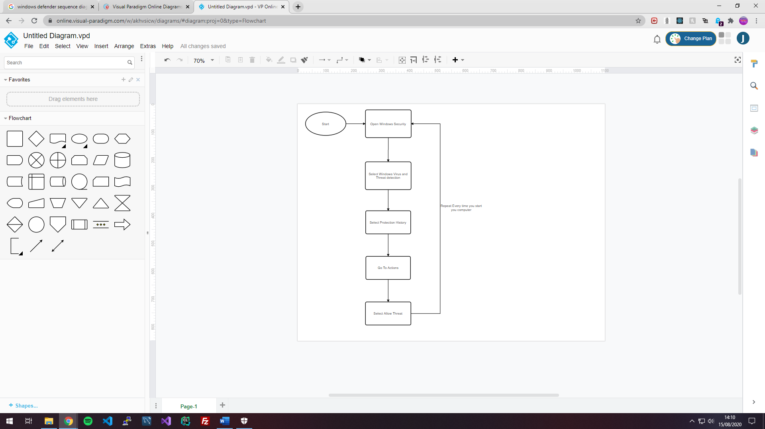

Conclusion of Application:

Windows defender is free. Which means it doesn’t come with guarantees. Additionally, although it comes by default with windows making you device automatically secure and safe, it only works for windows devices. Making it non universal.

Also, the GUI is horrible. Following windows design choices in windows 10. Unifying all windows program applications and making them minimalist hasn’t worked. It creates a clear but very cluttered look. Where colours and bold font aren’t used to make some buttons and headers stand out. I don’t know where I’m supposed to look.

Improvements I Should Include in My Application:

* An intuitive GUI which neatly organises all the features in a way which is easy to uncover and find.
* A faster and more lightweight solution for Realtime file scanning.

McAfee:

|  |  |
| --- | --- |
| Pricing | Insurance |
| Costs Monet | None |
|  |  |

|  |  |
| --- | --- |
| PROS | CONS |
| Very good anti phishing | Full scans take > 1 hour |
| Nice intuitive GUI showing only what’s needed |  |
| Will turn off when playing games |  |
| Can do manual Scans |  |
| Can do automatic Scans |  |
|  |  |
|  |  |