BADGE 2026 REV.00
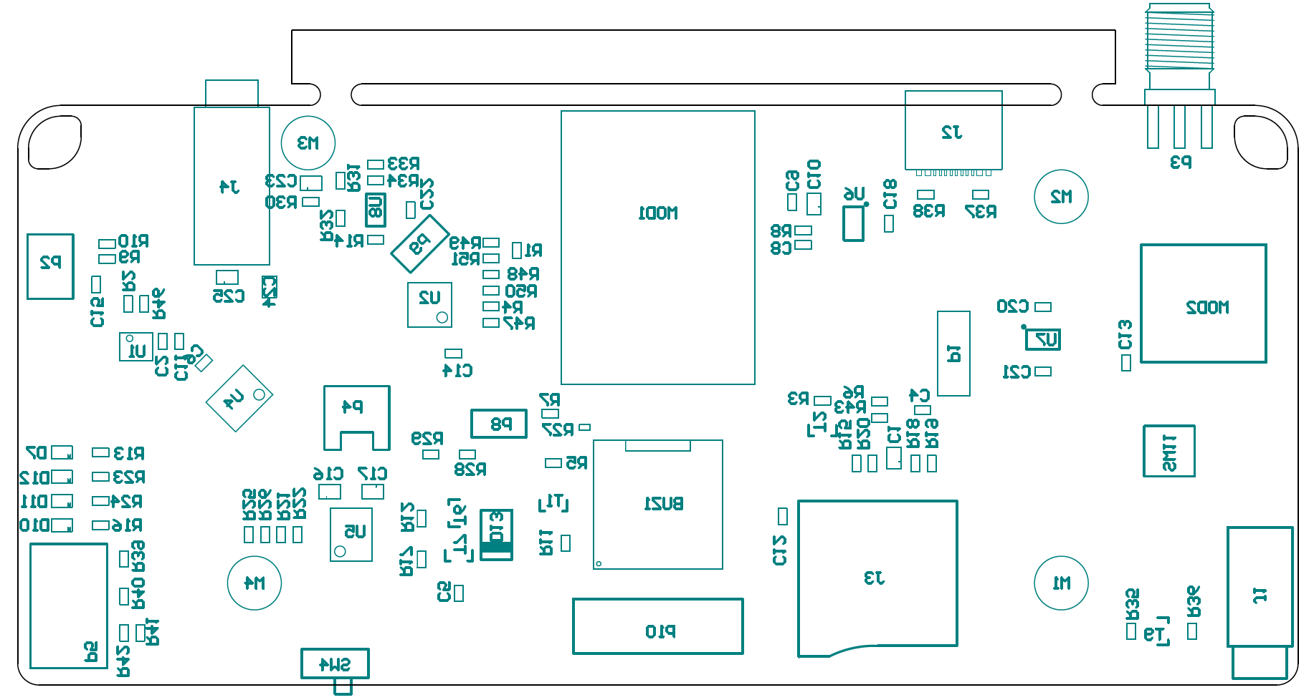
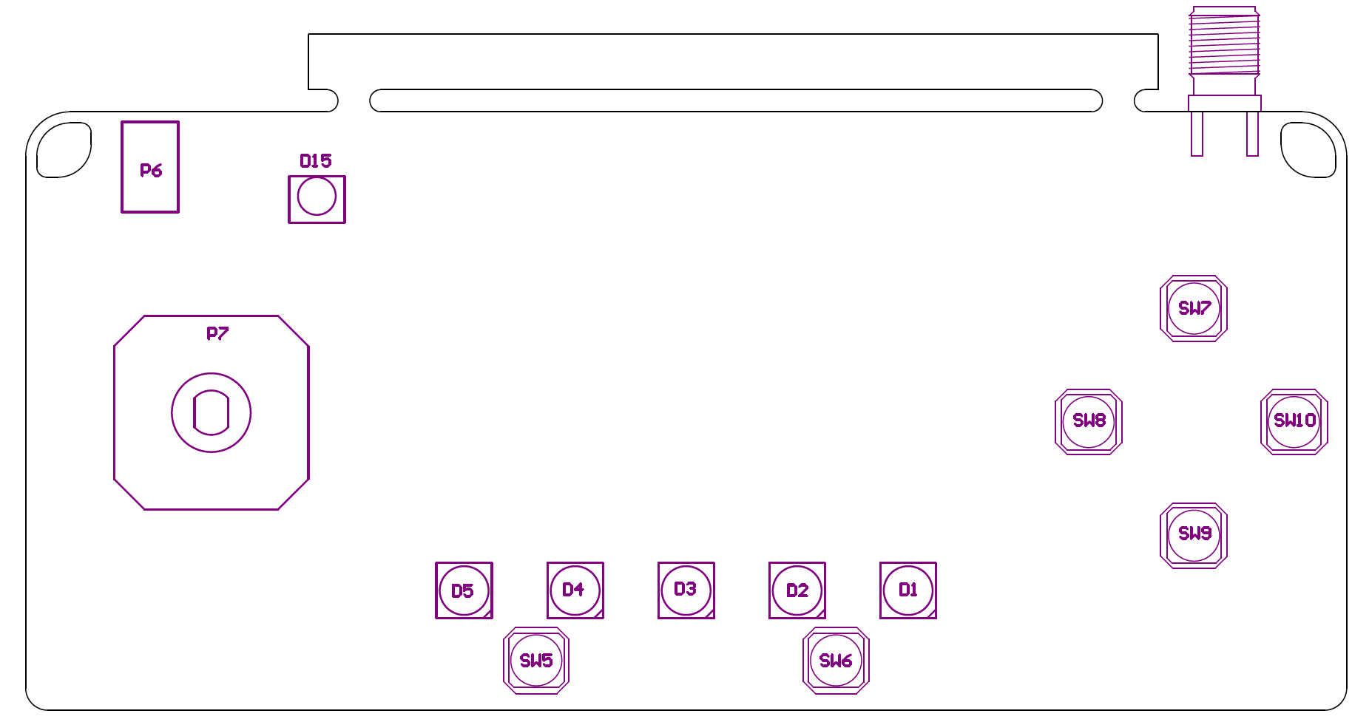

LibRef | Designator | Description | QTY | 10
BUZ # CUI CMT-1203-SMT | BUZ1 | BUZ # CUI CMT-1203-SMT | 1 | 10
CAP # 10uF 10V 0805 | C1, C10, C16, C17, C23, C24, C25 | CAP # 10uF 10V 0805 | 7 | 70
CAP # 100nF 16V 0603 | C2, C4, C6, C8, C9, C14, C15, C22 | CAP # 100nF 16V 0603 | 8 | 80
CAP # 1uF 16V 0603 | C5, C11, C12, C13, C18, C20, C21 | CAP # 1uF 16V 0603 | 7 | 70
LED # RGB WS2812C-5050 WH | D1, D2, D3, D4, D5 | LED # RGB WS2812C-5050 WH | 5 | 50
LED # Red 0805 | D7, D11 | LED # Red 0805 | 2 | 20
LED # Green 0805 | D10, D12 | LED # Green 0805 | 2 | 20
Schottky # SS24-MS | D13 | Schottky # SS24-MS | 1 | 10
PHO # IR Rx 940nm ZIRM-5042B-42-Z2 | D15 | PHO # IR Rx 940nm ZIRM-5042B-42-Z2 | 1 | 10
USB # C 2.0 RCPT TYPEC-304S-ACP16 | J2 | USB # C 2.0 RCPT TYPEC-304S-ACP16 | 1 | 10
MicroSD # TFP09-2-12B Push-Push | J3 | MicroSD # TFP09-2-12B Push-Push | 1 | 10
AUDIO JACK # 3.5 4c HC-PJ-313E8-B-SMT | J4 | AUDIO JACK # 3.5 4c HC-PJ-313E8-B-SMT | 1 | 10
WiFi # MOD ESP32-S3 | MOD1 | WiFi # MOD ESP32-S3-WROOM | 1 | 10
ZIF # 0.3mm 21p FH35C-21S-0.3SHW(50) | P1 | ZIF # 0.3mm 21p FH35C-21S-0.3SHW(50) | 1 | 10
HDR # RA SHR 1.0mm 4way | P2 | HDR # RA SHR 1.0mm 4way - 665104131822 | 1 | 10
HDR # RA SHR 1.5mm 2way | P4 | HDR # RA SHR 1.5mm 2way - S2B-ZR-SM4A-TF | 1 | 10
TB 3.5mm 3way | P5 | Terminal Block 3.5mm 3way | 1 | 10
JOY PSP Mini Joystick | P7 | JOY PSP Mini Joystick | 1 | 10
Receptacle # 2.54mm dual row 12way 610312243021 | P10 | Receptacle # 2.54mm dual row 12way 610312243021 | 1 | 10
RES # 10K 0603 | R1, R14, R15, R18, R19, R20, R30, R32, R40 | RES # 10K 0603 | 9 | 90
RES # 5K1 0603 | R2, R4, R7, R8, R9, R10, R16, R21, R23, R24, R35, R36, R37, R38, R41, R42, R50, R51 | RES # 5K1 0603 | 18 | 180
RES # 100K 0603 | R3, R5, R12, R17, R25, R26, R28, R29, R33, R34 | RES # 100K 0603 | 10 | 100
RES # 100R 0603 | R6, R43, R46 | RES # 100R 0603 | 3 | 30
RES # 1K5 0603 | R11, R13, R22, R31, R39 | RES # 1K5 0603 | 5 | 50
NTC # 10K 0402 | R27 | NTC # 10K 0402 | 1 | 10
RES # 0R 0603 | R47, R48, R49 | RES # 0R 0603 | 3 | 30
SW # 1P2T WS-SLSU mini slide 6,7 x 2,7 mm | SW4 | SW # 1P2T WS-SLSU mini slide 6,7 x 2,7 mm | 1 | 10
SW # TACT ALPS SKPMAME010 | SW5, SW6, SW7, SW8, SW9, SW10 | SW # TACT ALPS SKPMAME010 | 6 | 60
SW # TACT small 4.5x4.5mm | SW11 | SW # TACT small 4.5x4.5mm SMD WS-TASV | 1 | 10
BSS138 N-Ch MOSFET 0.2A 3.2Vgs 60Vds | T1, T2, T9 |  | 3 | 30
SL2301 P-Ch MOSFET -2.3A -20Vds | T6, T7 | SL2301 P-Ch MOSFET -2.3A -20Vds | 2 | 20
ACCELERO GYRO # LSM6DSOTR-C | U1 | ACCELERO GYRO # LSM6DSOTR-C | 1 | 10
RISCV # CH32X035G8U6 | U2 | RISCV # CH32X035G8U6 | 1 | 10
DAC # I2S CJC4334H | U4 | DAC # I2S CJC4334H | 1 | 10
CHG # TP4056 LiIon 1A | U5 | CHG # TP4056 LiIon 1A | 1 | 10
LDO # 3V3 XC6210B33 | U6, U7 | LDO # 3V3 XC6210B33 | 2 | 20
OP # LM321 | U8 | OP # LM321 | 1 | 10

DJ-ADDON 2026 REV.00
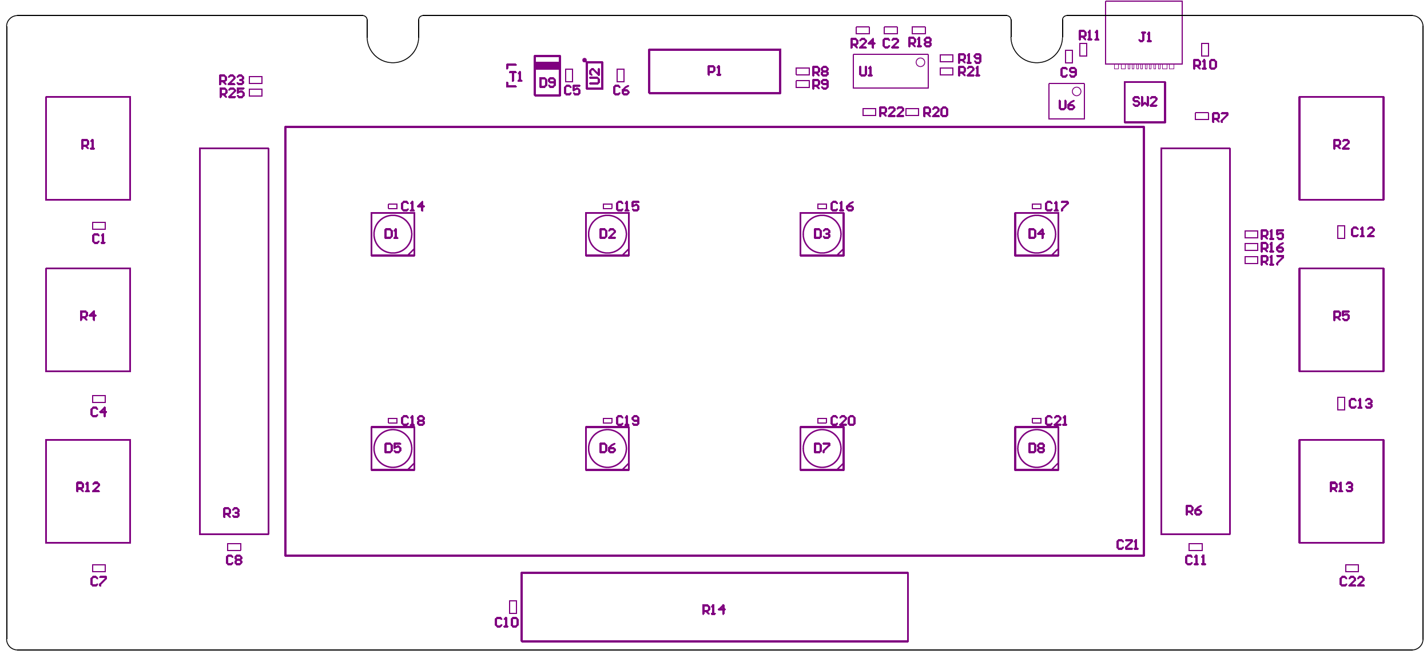

LibRef | Designator | Description | QTY | 5
CAP # 100nF 16V 0603 | C2, C9 | CAP # 100nF 16V 0603 | 2 | 10
CAP # 1uF 16V 0603 | C5, C6 | CAP # 1uF 16V 0603 | 2 | 10
CAP # 100pF 50V 0603 | C22 | CAP # 100pF 50V 0603 | 1 | 5
SW # CZ20 2x4 | CZ1 | SW # CZ20 2x4 | 1 | 5
LED # RGB WS2812C-5050 | D1, D2, D3, D4, D5, D6, D7, D8 | LED # RGB WS2812C-5050 WH | 8 | 40
Schottky # SS24-MS | D9 | Schottky # SS24-MS | 1 | 5
USB # C 2.0 RCPT TYPEC-304S-ACP16 | J1 | USB # C 2.0 RCPT TYPEC-304S-ACP16 | 1 | 5
2.54mm dual row 12way | P1 | Pin Header 2.54mm dual row 12way | 1 | 5
Pin Header 2.54mm 3way | P2, P3 | Pin Header 2.54mm 3way | 2 | 10
RES VAR POT 10k RK09K1130AAU | R1, R2, R4, R5, R12, R13 | RES VAR POT 10k RK09K1130AAU | 6 | 30
RES VAR SLIDE 50k RS301111J00R | R3, R6, R14 | RES VAR SLIDE 50k RS301111J00R | 3 | 15
RES # 10K 0603 | R7, R15, R16, R17, R18, R20, R22, R24 | RES # 10K 0603 | 8 | 40
RES # 0R 0603 | R8, R9 | RES # 0R 0603 | 2 | 10
RES # 5K1 0603 | R10, R11 | RES # 5K1 0603 | 2 | 10
RES # 1K 0603 | R19, R21, R23, R25 | RES # 1K 0603 | 4 | 20
SW # TACT small 4.5x4.5mm SMD WS-TASV | SW2 | SW # TACT small 4.5x4.5mm SMD WS-TASV | 1 | 5
SL2301 # P-Ch MOSFET -2.3A -20Vds | T1 | SL2301 # P-Ch MOSFET -2.3A -20Vds | 1 | 5
OP # LM324 | U1 | OP # LM324 | 1 | 5
LDO # 3V3 300mA RT9078-33GJ5 | U2 | LDO # 3V3 300mA RT9078-33GJ5 | 1 | 5
RISCV # CH32X035G8U6 | U6 | RISCV # CH32X035G8U6 | 1 | 5

TOF-ADDON 2026 REV.00
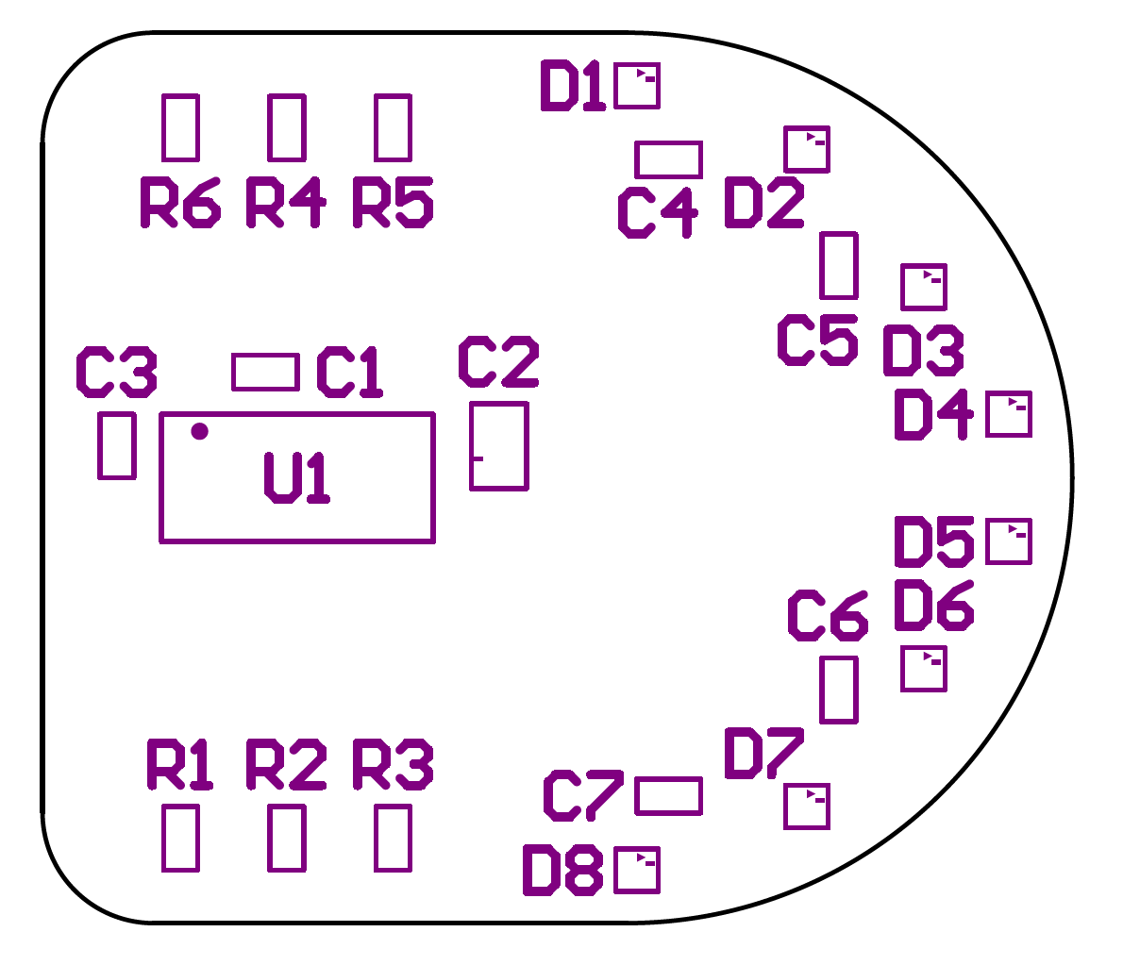
LibRef | Designator | Description | QTY | 9
CAP # 100nF 16V 0603 | C1, C3, C4, C5, C6, C7 | CAP # 100nF 16V 0603 | 6 | 54
CAP # 10uF 10V 0805 | C2 | CAP # 10uF 10V 0805 | 1 | 9
LED # RGB XL-1010RGBC-WS2812B | D1, D2, D3, D4, D5, D6, D7, D8 | LED # RGB XL-1010RGBC-WS2812B | 8 | 72
Header dual row 6way Boxed | P1 | Header 2.54mm dual row 6 Boxed | 1 | 9
RES # 47K 0603 | R1, R4, R5, R6 | RES # 47K 0603 | 4 | 36
TOF # VL53L7CH | U1 | TOF # VL53L7CH | 1 | 9

